Computer Science

A-Level Project

By Ethan Pannell

Student Number: 1717

Center Number: 56215

**Analysis** **4**

Problem Identification 4

Why is it suited to a computational solution? 4

Stakeholders 4

Survey 5

Response analysis 6

**Research** **9**

Existing solutions 9

Essential Features 12

Limitations 13

The Requirements 13

Success Criteria 15

**Design** **18**

Top-Down Design 18

Login server 18

Client program 20

Usability features 24

Form Design 25

Form objects and their states 27

Key variables, data structures and validation 28

Login server 28

Client Form 29

Server Class 30

Message Class 31

Settings Form 31

Login Form 31

Register Form 32

Forgot Form 32

Reset Form 32

Global Module 32

IRC Module 33

Login Module 33

Validation 34

Buttons 34

Text boxes 34

Tabs 34

Images 34

Data files 34

Pseudocode 35

Login server 35

Login procedure pseudocode 35

Reset procedure pseudocode 36

Forgot procedure pseudocode 37

Register procedure pseudocode 39

Login server send procedure pseudocode 40

Login server receive procedure pseudocode 41

Client Program 41

Login Form 41

Register Form 42

Forgot Form 42

Reset Form 44

Login Menu Module 44

Client Form 45

Settings Form 46

Server Class 46

Message Class 49

IRC Module 50

Global Module 50

Test strategy for development. 51

Login window 51

Register window 51

Forgot window 52

Reset window 53

Client window 53

Settings window 54

Login server 55

Post development test strategy. 56

Login window 56

Register window 57

Forgot window 57

Reset window 58

Client window 58

Settings window 59

Login server 60

**Development** **62**

Login Server Iterations 62

First Iteration 62

Testing 66

Review 67

Second Iteration 68

Testing 71

Review 72

Third Iteration 74

Testing 81

Review 82

Explaining IRC 82

IRC Client Iterations 83

First iteration: Login Main Menu 83

Testing 97

Review 98

Second iteration: Register Menu 98

Testing 105

Review 106

Third iteration: Forgot Menu 107

Testing 110

Review 111

Fourth iteration: Reset Menu 111

Testing 121

Review 123

Fifth iteration: Client Stage One 123

Testing 133

Review 134

Sixth iteration: Client Stage Two 135

Testing 146

Review 147

Seventh iteration: Client Stage Three 148

Testing 157

Review 159

Eighth iteration: Client Stage Four 159

Testing 165

Review 167

Ninth iteration: Client Stage Five 167

Testing 172

Review 173

Tenth iteration: Client Stage Six 174

Testing 183

Review 183

Eleventh iteration: Settings and Client Finish up 184

Testing 193

Review 194

Twelfth Iteration: Website 195

Review 198

**Post Development Testing** **198**

Login window 198

Register window 199

Forgot window 200

Reset window 201

Client window 201

Settings window 202

Login server 202

Success Criteria Testing: 204

Points to improve on from testing: 204

**Evaluation** **204**

Success Criteria 204

Success Criteria Testing 205

Limitations 206

Usability 207

Maintenance / In the Future 209

Code 209

# Analysis

## Problem Identification

If a company wants to communicate with each other without their data being potentially harvested and used, or that the servers are insecure and traffic could possibly be unencrypted, there are not many ideal ways with dealing with this problem efficiently. And sending messages in real life is often time-wasting and over large distances is not possible unless waiting a few days is efficient enough.

The features of a computer system that would be required for this solution would be a computer with hardware which allows image processing for the UI, a suitable OS to software on as windows is most used it would likely be that, and a connection to the internet for a client. For the server: a small computer most likely a Raspberry Pi, which has suitable specs to run a service all the time, able to connect to the internet, and a suitable OS to run the server on, which would be raspbian. For the client it would need a normal desktop so it can be used while doing work or playing games etc.

## Why is it suited to a computational solution?

It is suited to a computational approach, as sending messages to staff in real life is tedious and can waste time as you would have to physically travel to and from members of the team, so a digital method will use less time, and make the workplace more efficient and allow the other offices to connect to each other. It can easily be repeated without the worker devoting a lot of time to physically delivering letters. It is also more accurate sending over internet as you can easily read the writing, as handwriting can sometimes be hard to decipher, which makes it more effective, however there can be some typos which can cause confusion.

You would have to have two services on a server, one for logging in, and the other as a server to communicate on. You would then need a client as well for the users to communicate to the server with. The server would need to have storage to store the login script and the irc server, and the client would need to store the client software and the backup logs, this makes it more useful than paper, as it is easily all in one place without having to sort anything. It will be fast, as it will be sent over the internet, and will be small data so it will not delay sending the message. It will be easily repeated, as all you have to do is open the client, then click the user, type the message then send. You can easily share links to other media and to powerpoints, and IRC application-protocol allows the transfer of files, so I could add that as a feature. It will send data accurately, by sending it to the right person you clicked on, and because you are using a keyboard, you can easily read the writing.

## Stakeholders

The clients for this software would be any users of a computer. Because most people who want to use a computer, would want to communicate to each other securely, the stakeholders will be a variety of users, from medium scale companies to activists.

The stakeholders would mostly be companies, company employees and normal people in online communities, however this software can be used for lots of user types.

Companies would normally use a communication software, such as email, which is good however could be more efficient and faster, like morden messaging platforms, however those companies are not too trustworthy, and has limited control over the platform as they can’t directly change it. They might want a open source, private server to talk over without their data being sold to advertisers, and potentially leaking important information, and this is what I would be creating to fix this problem. This could create more secure companies. A login would also be good, to authenticate them, and restricts them to only connect to one server.

Another stakeholder would be online communities, so they can all communicate in real time instead of forum posts over a few days. This can help grow the community as it will make new friendships, as talking real time is more personal. They would also want it to be private, for example, the EFF already has a channel on freenode, a irc server, they would just need to have a private client, with a centralised server to have backups of passwords and usernames to be able to log in everywhere. I would like to add this to my client, so whenever the user logs in, a configuration file for the client I will be created will be downloaded to their system, and when they close the application the configuration file is then uploaded to the server.

Or for people who want to communicate with family or friends, they could join a large server, just to private message others, and see others online. They could make channels for friends to talk on together. They would just need a client to connect to the server mostly, as well as a client. Even families could set up, or get someone to set up a server to send messages to each other. It has more functionality over the most popular social media platforms, excluding discord.

One user is Hannah, below is a record card with a overview of her.

|  |
| --- |
| Client Record Card  **Name**: Hannah  **Occupation**: Software engineer with several other engineers. She has to communicate to her peers and have to contribute to code for her company, she also has to contact other sectors to send prototypes and to know what to do next.  **Likes**: Good communication, documentation and teamwork.  **Dislikes**: Unorganised desktop and workspace, files being in the right order and programs without dark theme.  **Typical day**: Arrives at work and sets up her computer ready for development, she typically starts up vs code then slack however slack takes awhile on their computers. She develops the code and communicates to the other employees of progress and uses gitkraken to push the code to a private gitlab repo. |

She is a stakeholder as she communicates to others over the companies network which could be replaced by a faster less processor intensive, and the she can setup the server and host it herself for the company making it more secure as well as adding a irc server on the network which the users can connect to to communicate on. This will be useful as it will speed up her computer's performance and use less system resources.

## Survey

I will ask some key questions to a typical computer workers, these questions will find their opinion on what to add to the application. I asked staff members of my college to take my quiz by emailing them. 8 of them responded to my question.

The Questions and options I asked were:

1. **What communication application do you use the most at work? \***  
   Facebook / Messenger, Discord / Slack, WhatsApp, Instagram, Other:
2. **Are you part of an online community? \***  
   Yes, No
3. **Have you ever used applications like discord or slack? \***  
   Yes,No
4. **What features do you want in the application? \***  
   Able to send photos, Login, Encryption (SSL/TLS), Channels like Discord / Slack, Private, Configurable, Share files, Other:
5. **Which is your priority from above? \***
6. **How would you like the software to be ran? \***
7. **Would you be interested in this application? \***  
   Yes, No

**The questions on the survey (Responses are under the response analysis):**

Question one will find out what is the most popular platform to talk on, which will help me identify additional features and design to the software.

Question two will find out if they are part of a community to see if the audience would want a large server for others to talk on, or for a smaller server

Question three sees if they have used an application like discord, I am asking this to see if it should be channel and private message based, or just private message based.

Question four and five asks what features they most want in the application which are common features, such as sharing photos. This will help find additional features.

Question six is to find what their priorities are for the software, and what functionalities they mostly want.

Question seven is to see if they are interested in the program, so we can get them to test if they like it or not.

## Response analysis

**Q1**: Most people are using facebook, instagram and discord/slack, this means I should implement the same main features of these applications into my application, as it will be easier to migrate users to this platform. The platforms all support sending multimedia content, text, private messaging and groups/channels.

**Q2**: Surprisingly, 75% of the people who participated were not in online communities, this means that the platform doesn’t have to necessarily support a large amount of members connected at once.

**-+Q3**: Half of the members have also used a channel based social media platform, which means I should implement this, and it can attract that user base to my client. In the next question,

**Q4**, most people want: to send photos; login; encryption and for it to be private. I will also add these features to the end product. This means that the users want their chats to be secure and private, as well as the multimedia standard that all social media platforms have.

**Q5** People mostly prioritised on a login page, and the others were split equally, so I will put more time into login over the other features which I will then split equally with time and priority.

**Q6**: The majority Want it to be fast and secure in the next question, which has been an recurring theme, I will focus on these parts. The others wanted it to use not much space, to be a customisable product or have integrations with other services.

**Q7**: 75% of people are interested in this application, I could possibly get these people to test the product in development.

Question outcomes:

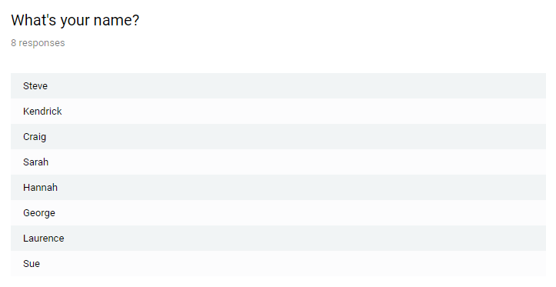: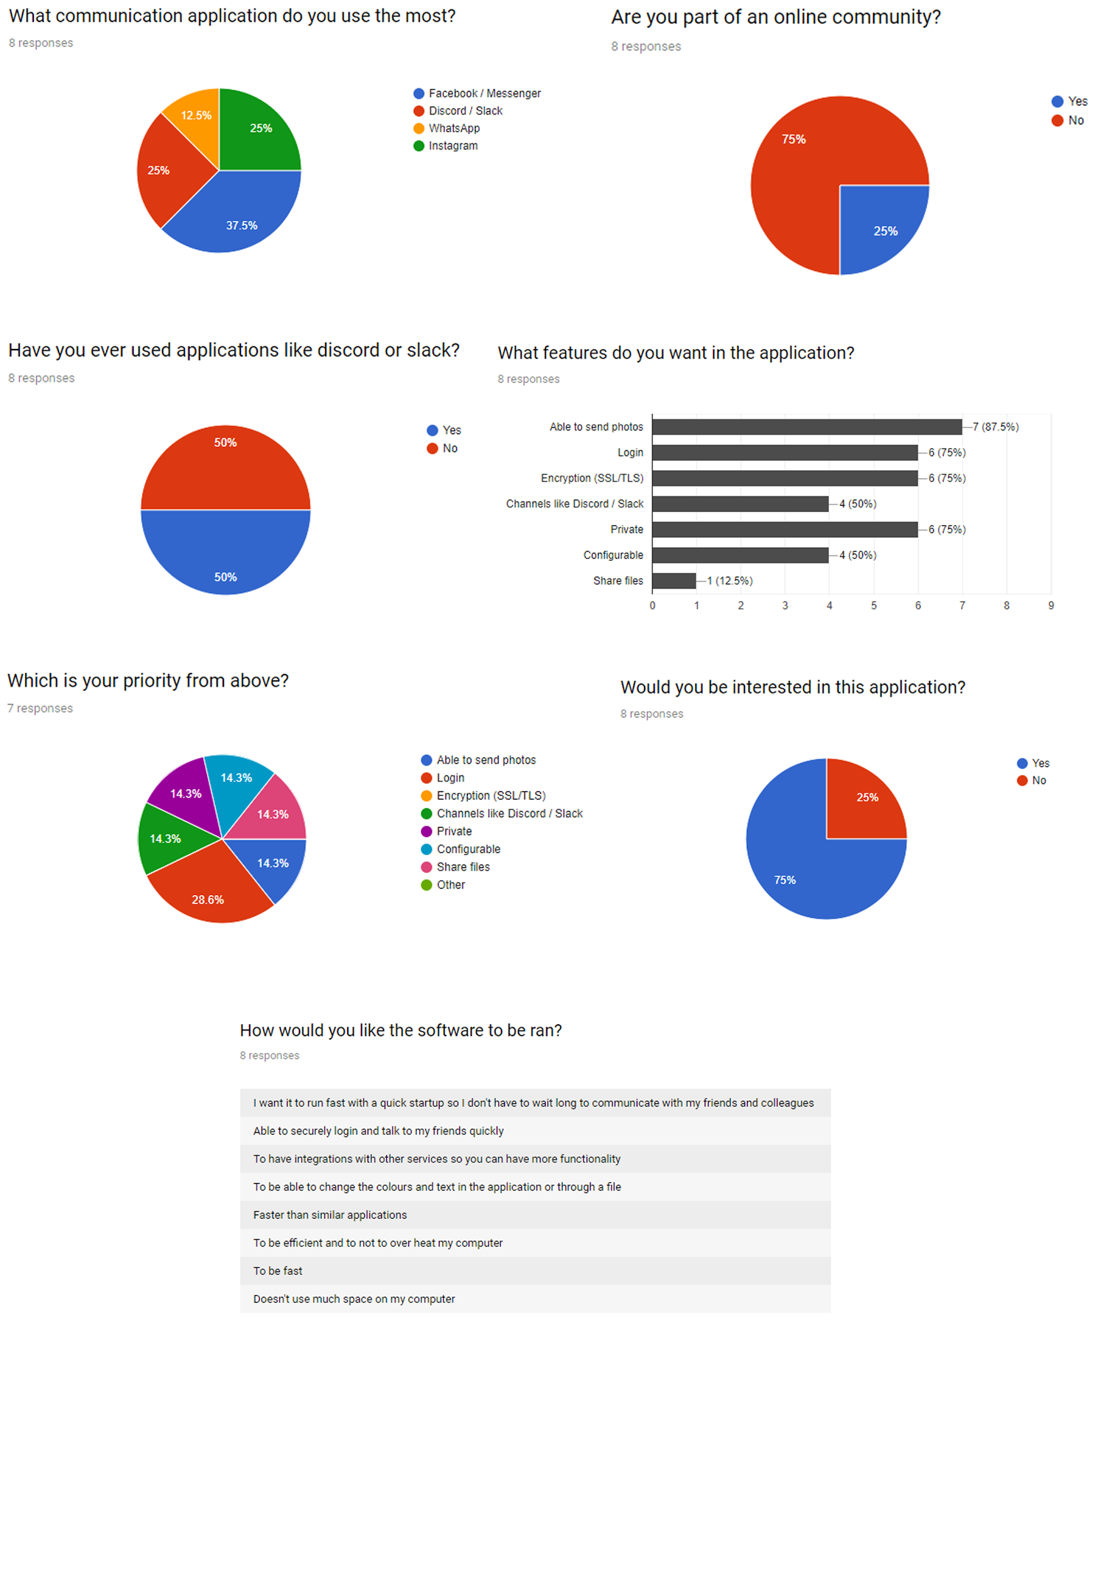

# Research

## Existing solutions

**Discord**

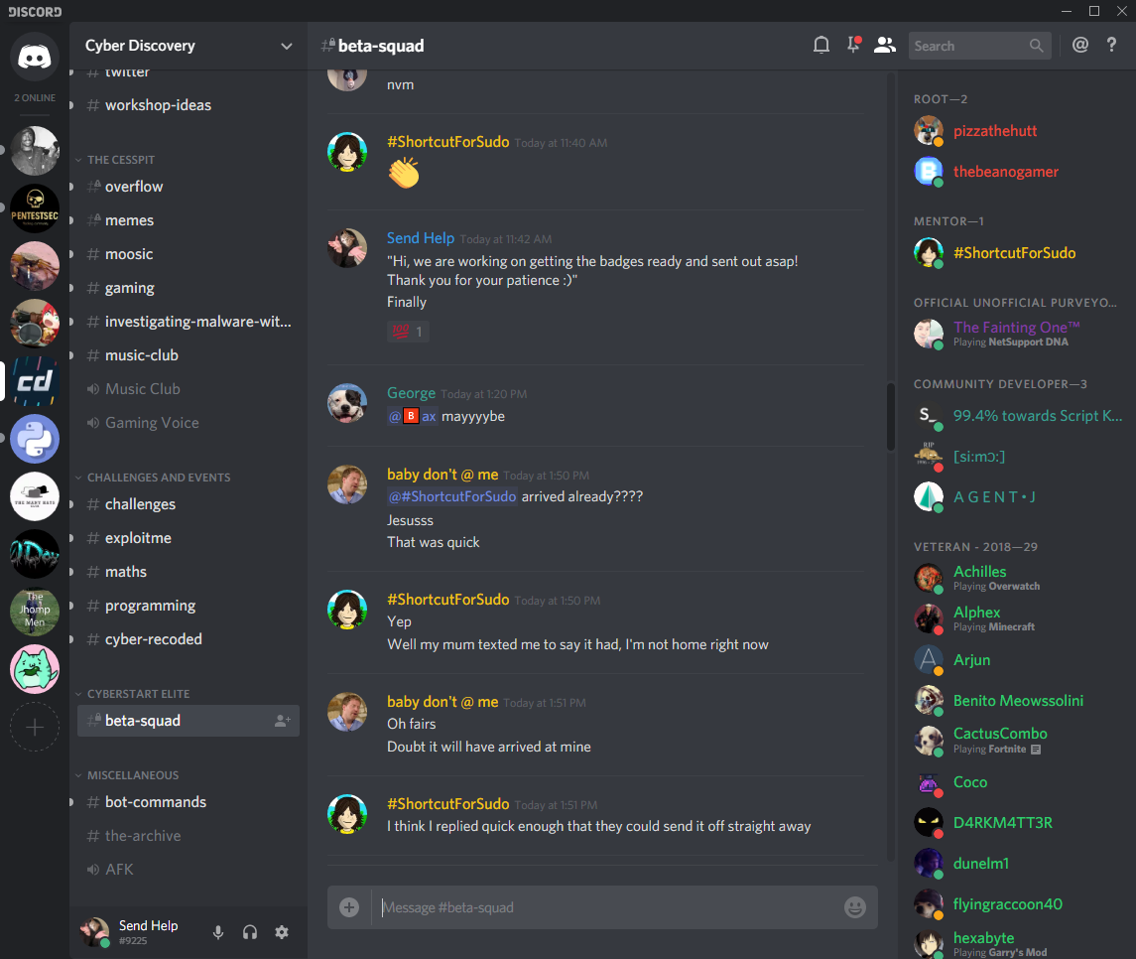

Overview:

Discord is a free communication platform for people who play games, however many communities who are unrelated from gaming have joined this platform to create communities. It allows you to talk as a group on seperate channels, which are on the left. You can also voice chat too on it. On the left it has the names of the users who are online and are currently in the server, you can see the servers on the right as icons. You can join many at once as well. You can talk using text, add emojis and send various multimedia over the client software as well. Another feature is that you can also private message people in the channels, so it also functions like a modern social media website / app.

Good:

* The layout, and colours
* Multimedia content
* Can have multiple servers open at once
* Voice chat
* Large user base from the audience it is directed to

Bad:

* UI is cluttered, Doesn’t necessarily need icons, this makes it bulky

Parts I can apply to my solution:

I could add the different sections to the application, meaning that I could have channels, servers, chat and users section, however I will make it look less cluttered and have less icons. I will do this because it will be faster to load because there isn’t as much to load compared to discord, and it will be easier for users to use as it will be more simple and less cluttered.

**Slack**

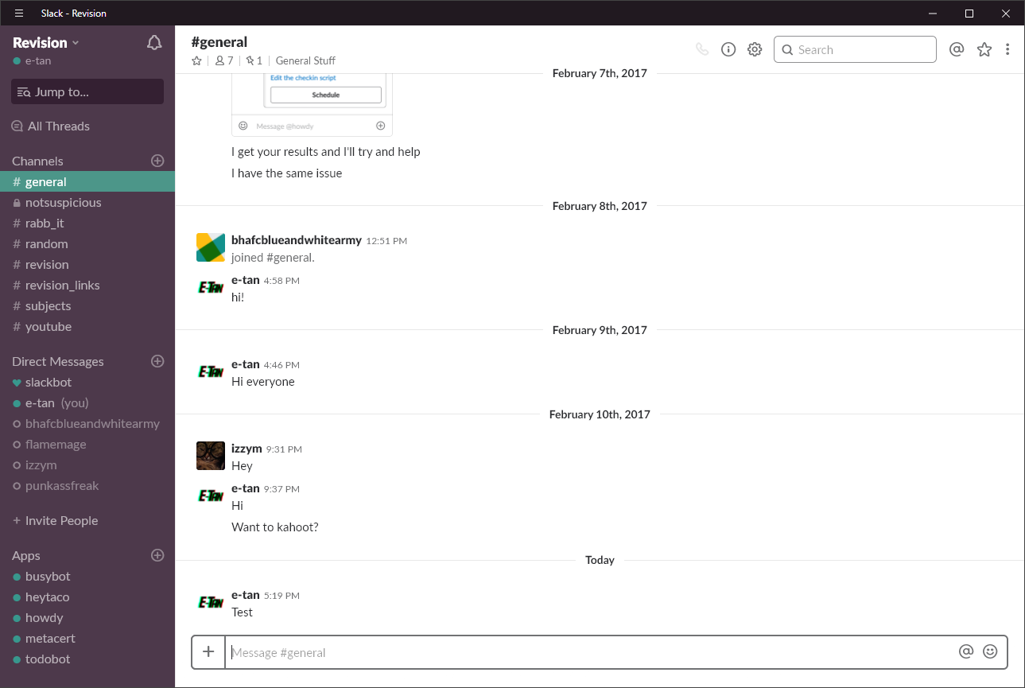

Overview:

This is also a channel based program, however it isn’t as cluttered and is more organized. This program was designed for companies to communicate on, but once again online communities have also repurposed it to talk on. I personally used it a year ago, to create a server for my friends so we could all revise together, however the program took way too much RAM up, which drove away some users. This program follows the same format as the last program I displayed.

Good:

* UI is less cluttered
* Follows same type of social media style as discord (channels and servers)

Bad:

* Uses a lot of RAM

Parts I can apply to my solution:

I could apply the minimalistic UI to my work, this also has some of the features as the one before so I will most likely add it to my program. I will try and make my program not resource hungry by over complicating the program. Slack takes up lots of RAM, and I want to avoid this by making it use resources efficiently. The minimalist GUI builds upon the last justification, as it will be easier to use and less resources will be taken.

**Messenger**

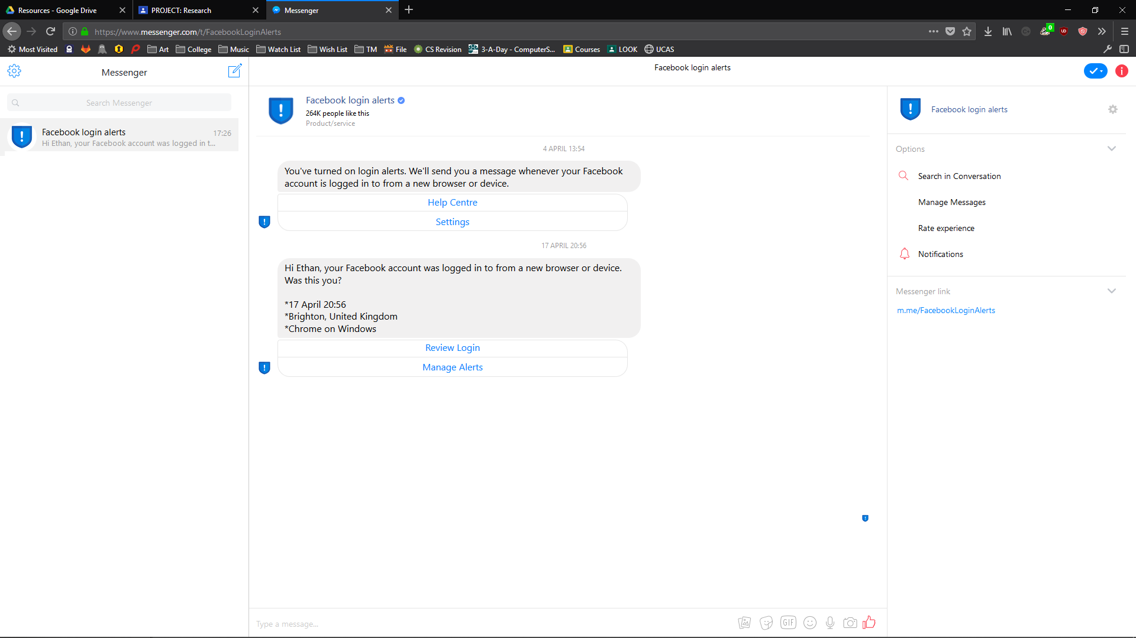

Overview:

This platform is provided by Facebook, which unfortunately has been in the news for selling data from it’s customers.The platform is in the form of a website, you mostly message directly to another person, as it’s the main functionality of the site. You can also message over group chat, however you have to create and invite everyone to it, which means it is more private, however it is more tedious adding others to the group. You can send multimedia content and call other as well as customise the colours and chat emoji which is great as other platforms only allow the one colour.

Good:

* Customisable
* Easy to use

Bad:

* Sells your data
* No channels and servers (lack of control)

Parts I could apply to my solution:

I could add the customization to the application, as well as being able to send multimedia content from one place without having to go to a website then upload it. I could a websites API to upload images, and send the link to it to another user, however I can change that in the future. I will add this because users would like to usually customize their program to suit their needs, and to make them use the software more, and because other software and websites send photos, which has become a standard for social media, and it adds extra functionality to the program.

## Essential Features

My application will be using the same format as discord, using channels and private messaging. I can use an application protocol called IRC, where I am able to communicate with 3rd party servers as well as my own.

The login server will be created by myself, so there will not be any 3rd party involved while logging in who can abuse data. There will be no UI as the server needs as much RAM as possible, however it will have an ascii output so whenever something happens on the server you can see what has happened. It will have five main procedures: login, register, forgot, reset, send and receive. The login procedure will allow or deny users to access the program, if they haven’t registered they don’t have access to the main program. Next is the register procedure, this procedure registers the user into the database. The program will use a database, the first table is called users to store usernames as primary key, passwords, last time logged in and if they are an admin. The other table is called reset codes where there are the reset codes as primary and usernames as foreign key. Forgot procedure generates a reset code, adds it to the database and sends an email with the code in it. The reset code is used for the reset procedure, this allows you to change your password if the code is he same in the db. The last two enable you to send and receive files between client and server. it will backup your settings on your client to the login server. It will log what is happening on the server as well, in case of errors or suspicious activity. This will be written in python, and each procedure will then be ran on another thread separate from the main thread as many people will be joining at once. It will have an open port so the client can communicate with the server.

The other section of the project is the client. When you first open the executable, it will display a login page, where you can login, request to change password, the functions on this page will connect the the server so it can send and receive data to see if the login was successful or not. After logging in, you will then see the main program, it will have several boxes, mostly text boxes, to see: The users online, messages sent and messages received, input box and servers with channels. To get the users online you have to send “NAMES #channel_name” from there, the message sent I would then format the text to be put into the users box so it is easier for the user to see. Messages sent would be messages sent from you, you would have to format the text to the protocol so it understands what the data is, so it knows it is for text and a specific channel. The text sent is then put into the message box so you can visually see the message. Afterwards, there are messages received, where you have to unformat the raw data, in its protocol form, into a normal string, this is more difficult than sending data. Next is the input box, this is where you put the text you want to send to the other users on the channel, it has to then be formatted correctly to the specific channel. There are many commands in the IRC protocol, which I have to make functions for as without these main functions the client could not work well with the server. Lastly there is the servers and channels box. This will simply hold the servers and channels you are currently connected to.You will need to connect to the IRC server so you would need to communicate over a socket as this is the most simplistic way of connecting to the server, It will also support sending over TLS which means all text will be encrypted. The last section of this program is the settings window, this is where you can change the colours and fonts of the program, suiting users needs. I may also add default IRC username and auto sign in to their IRC account too. This program will be written in vb.NET.

## Limitations

The main limitation of solution is that I will not be able to send images without visiting a link as the IRC application protocol only allows text to be sent, however you can send files over the protocol, however that still is not user friendly, and can lead to viruses which could be harmful to the user. So I will use an API to send images and automatically send a link instead because it will be more secure as I will be using a larger platform which will have better security practices that IRC protocol with files, and it will take up less RAM and space.

The second main limitation is that I will be connecting to a preexisting IRC, as it will take a long time to develop a IRC server compared to the login server and client, which will not give me enough time to finish the project to an adequate standard. However I will create bash scripts from linux to automate the setup onto my raspberry pi for testing as a substitute, so you can create the server instantly by running the script, or several ones.

Thirdly I will be not adding all of the commands from the IRC protocol into my client as there are many and I have to parse even more which makes the program harder to make within the deadline. I will also only connect to one server for now too due to time constraints.

The login server will not currently communicate over SSL as it will be harder to implement than the without, but I am planning to add this in the future however I will have to generate a SSL key to securely connect to the server.

I will be coding a file transfer procedure for the login server however I will not make it a function for the client to user due to it not communicating over SSL and uses more of the time needed.

Lastly vb.NET is not supported widley, so I will be creating the program for Windows only because of this, I could port the code into C# however I will not understand fully about how it works, and could possibly inject malicious code into it while generating the C# code, but because windows is the most popular operating system, I still have a wide audience for the program. However the user could use an application called wine, which allows them to run windows programs on their non-windows machines, but this will take up more RAM doing so.

## The Requirements

Each area would be split into two sections, login server + IRC server and the client, as they require different software and hardware.

**Hardware:**

-- Login + IRC server:

The login server doesn’t need too much RAM, as it will be a small program however there are many libraries so it would need a maximum of 1GB, however needs a multiple core CPU to deal with seperate threads as many people could log in at the same time this also takes up RAM as well as CPU time. it would also have to be a 32 bit processor as it needs to be able to run python3. It would need 32Gb secondary storage, for a medium amount of users as the files being uploaded from the clients are kilobytes, and the server database, login config and other files will also be small. I will need these features to enable the client to quickly login and be dealt with, without these features the server will struggle with the users logging in, uploading and downloading files

The IRC server will take up more secondary storage, but it doesn’t need to store the data when passed through, however it needs to have enough for it to run at all points. This means it won’t need much RAM, just a bit more secondary storage to store the program in, as the program will store logs of the channels for security purposes. It would most likely need a 64Gb of secondary storage, and this is most likely an overstatement for a medium sized server, as I will also delete logs monthly however it will generate lots of data from users within that month. It will need a good processor to deal with multiple connections sending data to the device, and at least a 32-bit CPU to install the programs without a problem.

Both of these programs can be ran on a raspberry pi as this can reach the minimum requirements, and can be ran on separate ports from each other, so you wouldn’t need a seperate machine which will make it cheaper for someone who wants to set up their own on a server for their small to medium sized company.

You can run the server headless, so you don’t need a monitor, keyboard or mouse, you would just have to ssh into the pi.

-- Client:

The client would have to have a standard computer, because it doesn't need a lot of RAM or need a good CPU, it’s because it will be used on your personal computer to talk to others while playing games or doing work. It will also need a mouse, keyboard and monitor to use the program. The CPU has to be a minimum of a 32-bit processor as the program runs on modern CPUs. It will not take up much space so you will not need a large hard drive, and the configuration files will only be in the kilobyte range.

**Software:**

-- Login + IRC server:

It will need any linux operating system, with openssh, python3 and pip installed. The python libraries needed are: Validate_email this is needed to validate the email to see if it is a real email or not, time to get the time for the database to input when the user was last logged in incase an attacker gets the users credentials, termcolor to make the terminal have colours as it makes it look better, colorama this fixes termcolor on windows as termcolor is for windows, pathlib to see if the path is real or not, _thread to enable the program to have seperate threads for multiple connections, hashlib to hash the uuid to make it more unique, smtplib to communicate with gmail servers to send emails to clients who have lost their password, sqlite3 to be able to interact with the database, logging so you can see suspicious activity and to identify bugs, getpass to hide the input from others around them in real life, socket to allow the client to communicate with the program, uuid to generate a random code, sys to force quit the program, and to add advanced features to the terminal, such as removing and going up a line, and bcrypt to hash the password securely to make time so users can change their passwords before an attacker successfully gains access to their account.

-- Client:

It will need a windows operating system as the program will be written and compiled for the OS, it is also a popular OS which allows the program to have a large user base, as it is an exe, or linux with the wine installed to run the final exe file if the user is not running windows however still wants to run the program on their machine.

## Success Criteria

|  |  |  |  |
| --- | --- | --- | --- |
| Number | Criteria | How to evidence | Justification |
| 1.1 | Login screen appears when opening program | Screenshot the first screen | If it started with the IRC client there would be no use for the login server |
| 1.2 | Buttons open up the respective form associated with it, e.g. forgot button opens up forgot form | Print Screen before and after | The buttons need to open up the right forms otherwise it will be confusing for the users |
| 2.1.1 | If the username is already used don’t create a new account | Print screen error | This will create database errors and and would not let the user sign in due to this as well as taking up more storage |
| 2.1.2.1 | The login server adds new users to the database when registering | Screenshot the database with the username, as well as screenshotting the login page. | I need this otherwise I would have to manually add them into the database |
| 2.1.2.3 | The server stores the passwords as hashes on the server | Screenshot the database showing hashed password and email | If an hacker gains access to the server or a developer gone rouge gets the passwords they are hashed so it will take a long time for the hacker to get access to the real password. |
| 2.2.1 | If username or password is missing, an alert is sent to the screen | Print screen the alert | If the users didn’t enter a password or username they |
| 2.2.2 | If the client enters correct username and password, as they are in the login server database, it allows them to pass the login | Screenshot the terminal saying success, as well as the client logging in | If I don’t have this it means the user will not be able to |
| 2.2.3 | If the client enters the wrong username and password, they are not able to use the login server | Screenshot the terminal saying denying access and same with the client | Logs and config files would be downloaded onto the wrong machine as well as it holding private information |
| 2.3.1 | When the client requests a recovery using forgot, the client receives a recovery email when requested | Screenshot the terminal saying sent, screenshot the client confirming that, and screenshot the email. | If there was no reset code any user could reset a password, so sending a code to the users email, as we know it is them, from the database will work better than no resetting and having to manually |
| 2.3.2 | When using a username not used it shows an error | Screenshot error on form | If there is no username linked to an email there is no password to reset, so I won’t have to send an email, however I will have to notify the user there is no such user |
| 2.4.1 | The login server adds the recovery code to the database with username | Screenshot recovery code in the database | The server needs to store the code to compare when given it from a user attempting to reset a password as it is a way of verifying it is them changing the password, without storing it there is no way of comparing the strings. |
| 2.4.2 | Resets the password when given correct code with username and other inputs filled correctly | Screenshot the terminal saying it was successful,and screenshot client too | If the code was correct it should change the password as theoretically it is that user, this is the only easy method of resetting. The users would need this if they have forgotten their password leaving them unable to get in and data on the server wasted. |
| 2.4.3 | Doesn’t reset the password when given incorrect code and credentials | Screenshot the terminal saying it was not successful,and screenshot client too | If the codes were not correct that means the user inputted it incorrectly or the inputter isn’t the actual user, resetting it if it wasn’t correct would allow an attacker access to their account. |
| 2.5 | Don’t allow users to enter invalid emails when registering | Screenshot error received | If an invalid email is entered and they lose their password there is no way of getting their account back so having a verified email will allow this. |
| 3.1 | Have the client successfully send a message to the IRC server | Screenshot the client with the sent text and is in the chat text box | This is needed as IRC can be summarised to a messaging application so a main part of this is sending messages. |
| 3.2 | Successfully receive a message from the IRC server | Screenshot a message from someone else in the main chat box | This is also needed as it is a messaging platform otherwise you will not know how to respond to their messages. |
| 3.3.1 | Able to change the RGB colour of the backgrounds | Screenshot the default colour and screenshot with different colour | This is to add personalisation making the user use the platform more as well as it looking nice and easy to read for them. |
| 3.3.2 | Able to change the font colour | Screenshot the window with the option changed as well as showing the main window with colour | This will help the user read on whatever background and if they have difficulty reading a specific colour they can set it to another themself. |
| 3.4.1 | Display the usernames of people in the channel, and display in a seperate box | Screenshot the client with the tab | This helps the user identify who is in the current channel and makes it easier to spell there usernames to mention or message directly to them. |
| 3.4.2 | Display channels and servers in different boxes | Screenshot the main window | This allows the users to switch between servers and |
| 3.4.3 | Able to favourite people, and adds it to another box | Screenshot the main window | Makes it easier to remember the usernames of people you trust. |
| 3.5.1 | Communicate over SSL/TLS | Check by screenshotting /whois client saying I am over SSL/TLS | This will allow encrypted communication between the server and client so it will protect the data the best it can from man in the middle attacks. |
| 3.5.2 | Connects to the IRC server | Screenshotting the data coming through with the debug line | THis initializes the connection allowing you to communicate over an IRC server |
| 3.6 | Log the contents of what people are saying to a file | Screenshot the text from notepad | This will allow the user to look back and will load the file when starting the client so they can look back and see past messages. |
| 3.7.1 | Display messages successfully | Screenshot the chat box with text | If not displayed in a good presentable way it will be frustrating for the user to use and read. |
| 3.7.2 | Send messages to users directly | Screenshot the client with the message sent and a reply | If the client cannot directly message someone a part of the IRC function will not be in use as well as it being a large function of IRC which people want so they can use it like other private messaging applications. |
| 3.7.3 | Send messages to channels | Screenshot the client with the message to the channel to verify it has worked | Channels are also another large function, as it is essentially a group chat so many users can go and talk to each other easily in one place. |
| 3.7.4 | Can join channels | Screenshot of message from a user you haven’t directly messaged | Joining a channel is needed to get data from it, and if this is not used some people might want to talk in groups and cannot driving away potential users from using the software with many other competitors using that feature. |
| 3.8.1 | When switching tabs display the messages sent from that user onto the message box | Screenshot before (on a different tab) and after messaging someone | Text needs to be displayed separately for each user or channel who is messaging the client otherwise it would be confusing to read and understand what messages are from channels, and what are from users. |
| 3.8.2 | When switching to and from channel tabs remove the users from the user box | Screenshot one channel tab, then switch to another channel tab and screenshot | The users per channel are different so they need to change otherwise you might try and mention a wrong nickname from a different tab |

# Design

I started the design process by creating two top down diagrams to simplify the project into its key components. I started breaking down the login server first.

## Top-Down Design

### Login server

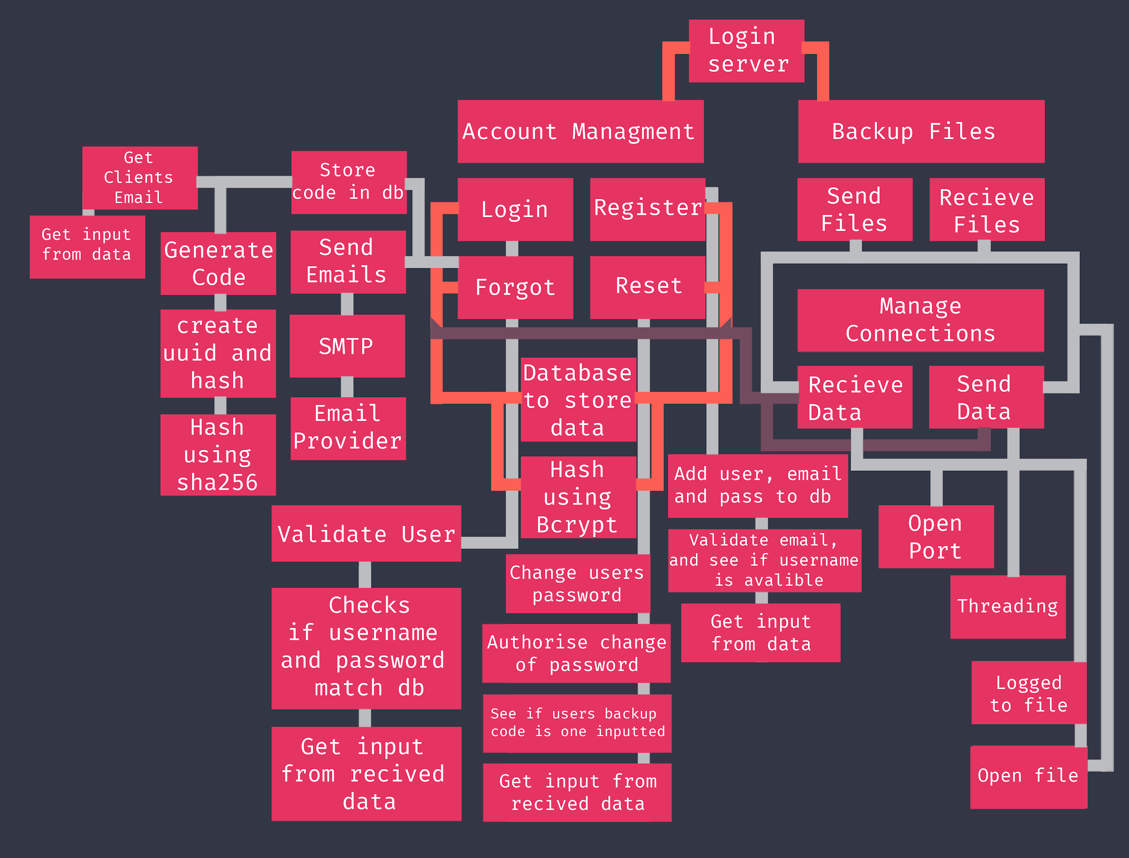

Justification: 36

Starting at the top, there is account management, where you can login, register, request for new password (Forgot) and reset your password. We need these sections, as the login server will not be able to function as you will need a login function to login, and you will need to register for an account. Forgot and reset are for if you forget your password, if I didn’t have these functions, users would not be able to change their password if they had forgotten it.

All functions need to store the data into a database, as it is easier than using several text files to store the usernames, passwords and emails. They also all need to use Bcrypt to hash the passwords, if I didn’t use this and an attacker gained access to the server, they wouldn’t be able to see the password in plain text, they would have to try and bruteforce it which gives time for us to reset the password. The login, register, forgot and reset function need to receive data and send data, from the manage connections section, this is because it will be on an external machine separate from the client, and the only way to communicate with the server would be by sending data over the internet.

To send and receive the data, you would need an open port, as you need a way to listen and to send the information. You need threading so you can accept multiple connections at once, as without threading only one user at a time can connect to the server to login. All connections will be logged into a file, so if there are potential breaches, you can see the activity, and find the suspicious IP and report it to authorities. The logger needs to open a file to save to, otherwise you wouldn’t be able to store the data anywhere. I will also backup my files, which also need to receive data, send data and open files, this is because I wanted to add a feature where you could login from different computers and connect to the same server from different locations. It needs to open a file, as it needs to save the data for later use, and it’s not to be deleted.

Under the forgot tree, I need to send emails to the clients so they can receive their code to reset their password, if I couldn’t send an email, there would be no other reliable way of contacting the user. It needs to have access to SMTP protocol, as if it doesn’t there is no way of sending out the email, but you also need an email provider to send the email from, I have chosen gmail, as it is free, without a email provider I wouldn’t be able to send an email unless I bought a domain name which I cannot do for this project. Also in the forgot tree, I need to store the codes in the database, so if the server goes down, the codes will still be valid. However you also need to get the clients email to assign the code too, if not a random user could try and access your account. You also need to get the email from the received text, otherwise there would be no email for the user to email, which will mean that they never get the code to reset their password. But you need the code to email, if someone tries to reset the password you need validation to know it’s them. Sending an email with a code is a great way of verifying that they are them, which is a popular way of verifying it’s them so they can change their password. To create the code I will generate a uuid using the uuid library, and hash it to make it more difficult to bruteforce. The hashed uuid is then sent to the users email. I will hash using sha256 because it creates a longer string which seems more random. It is not secure, but that’s because I will be sending the hashed uuid to the email and storing the hashed uuid in the database.

In the reset tree, going down once in the tree, the main function of this procedure is to change the users password. This is used so you can change your password if you forgot your password, and that you have the code to reset your password from the forgot procedure. You then also need to authorise the change of the password, because if an attacker tries to change the password, and there is no authentication, everyone would be getting their accounts hacked. So you need to check if the database has the reset code associated with the username which is the next box down. Without this there is no way to verify that it is that user. But you need to get an input for the email and code, so it needs to get the data from the client over the internet. I need to do this otherwise there is no way of inputting data into the server without this.

Next is the register procedure, it needs to add the user, email and password to the database, without this you would not be able to login successfully into the server, as the other functions would need these to be able to reset the password, and to create new passwords. And the main login function won’t work without having an account. Next block, is to validate the email and see if the username is available. If the username has already been used, as the database uses the username as the primary key, there will be errors in the database which will make the database not functional. So we check if it has been used and send to the client if it has been used or not. It will also check if the email is real, just in case if the user enters the email incorrectly. It is also to try and get rid of bots creating new accounts slowing down the database.

Lastly is the login procedure, they need validate the user so they can successfully login. This is how the user logs in. You validate the username and password by comparing the inputted strings to the database. Thi is needed as without this there is no way to identify who is logging in, and it will not give the correct user the right config file if they want to receive it. Going down the chain, we then need to compare the username and password to the db, as we said about it earlier. Without this you can’t identify the user. Lastly you need the input from the received data, otherwise there is no other way of inputting data externally, which we need to do as it will be seperate from the client so many others can login to the server.

### Client program

Justification: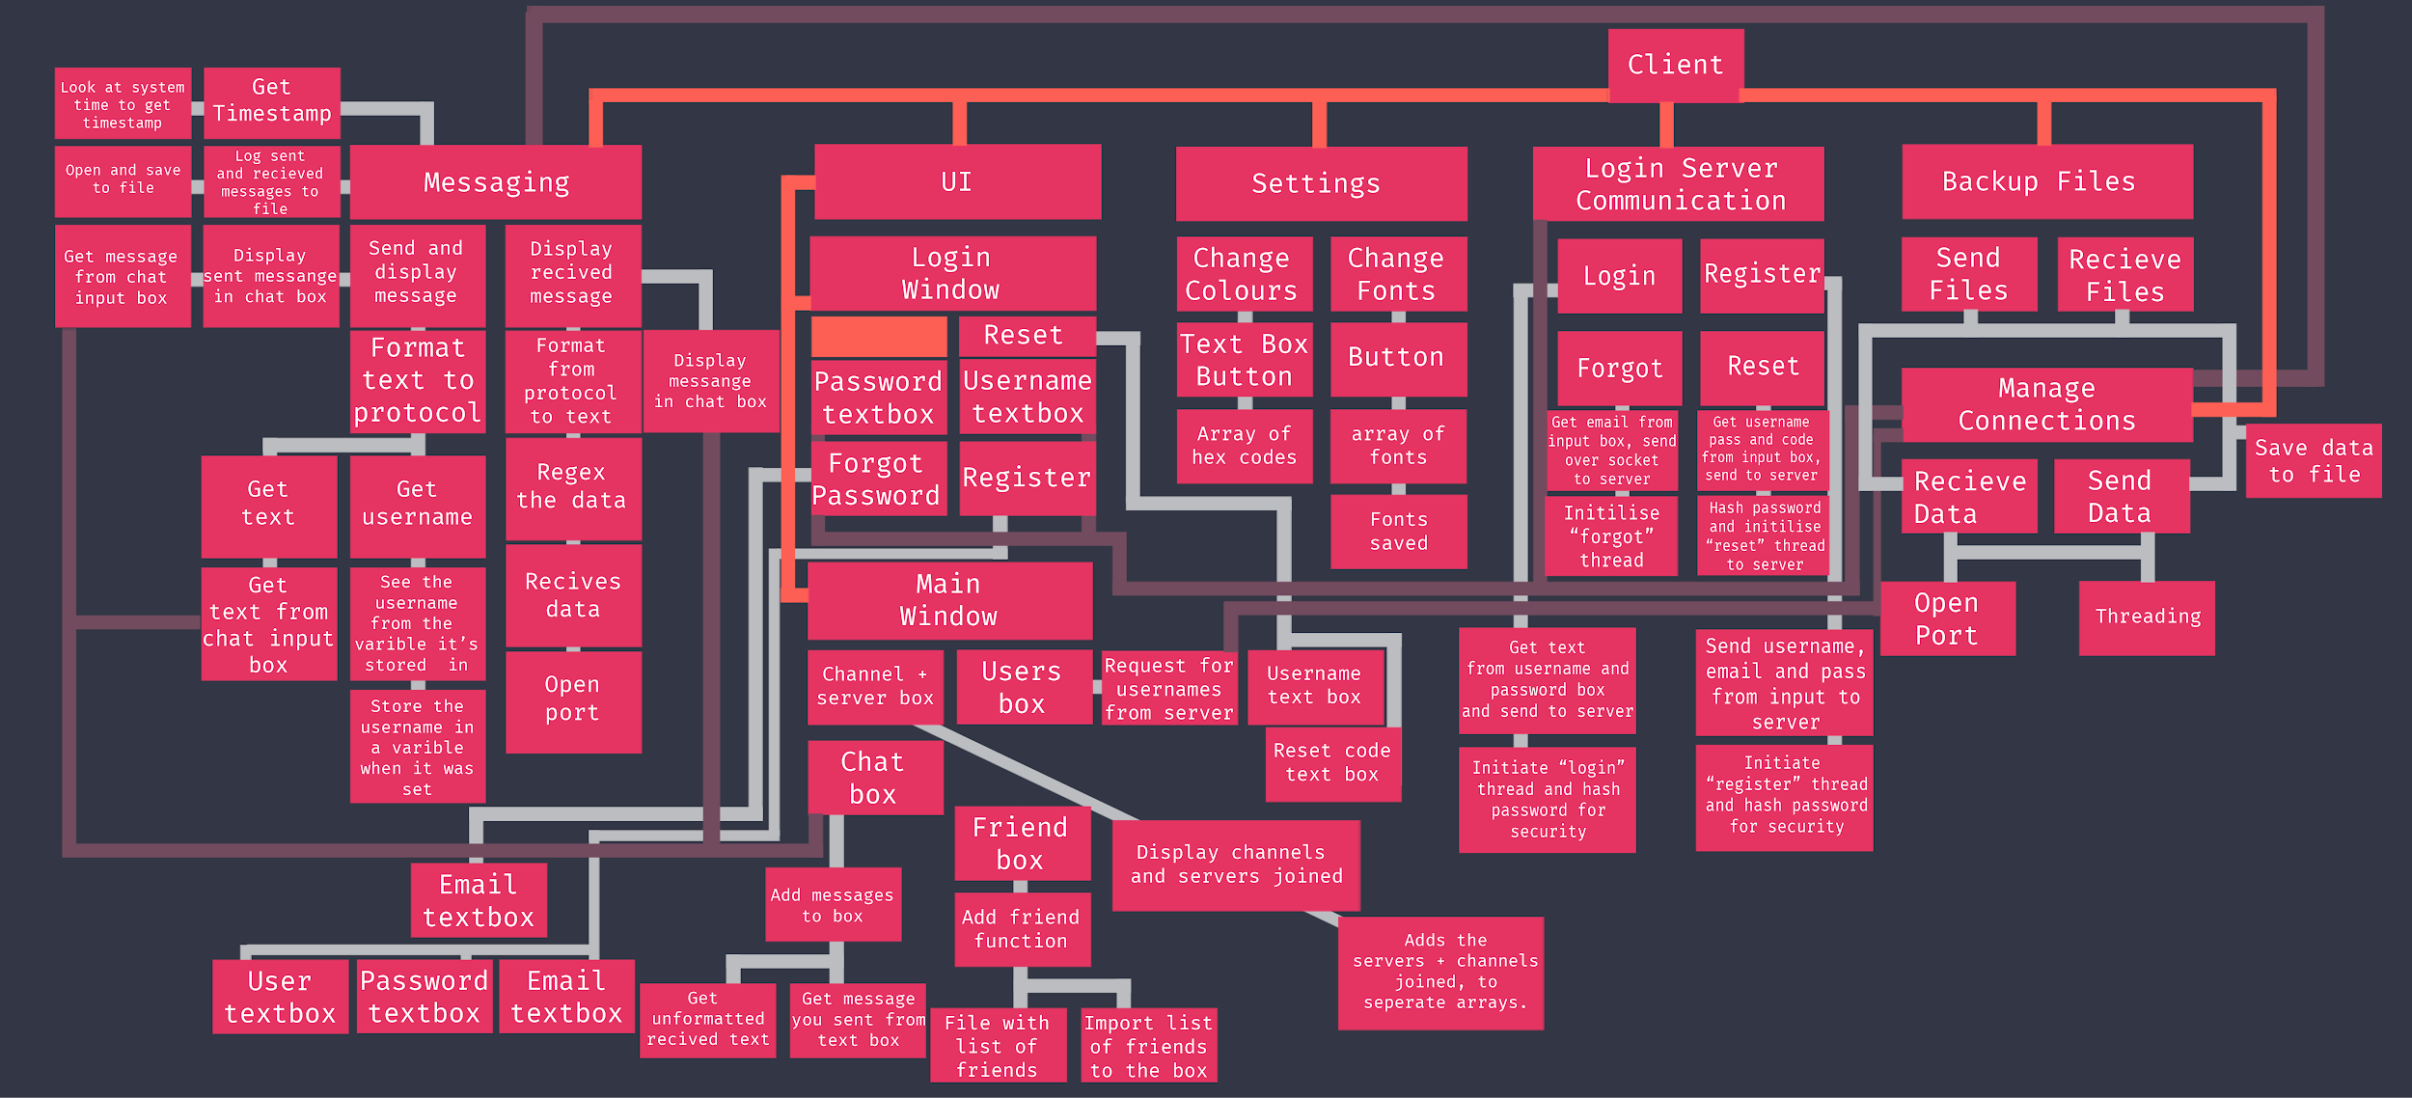

This top-down design is for the client software, where you login to the login server then connect to an IRC server to talk to others on. There are 6 main sections which split into smaller chunks: Messaging, UI, Settings, login server communication, backup files and manage connections. Backup files procedure has the same functions as the login server as they need to be compatible with each other.

Manage Connections: Managing connects will be essentially the same as in the Login server as they need to be compatible with each other, and it needs to take in multiple connections at once. however it does not need to log it to a file as it has no need to log the ip connected and the stuff you are sending, however under the messaging heading I will be logging the received and sent messages as I will process them first then save.

Login Server Communication: in this section, there are four procedures: Login, Register, Forgot and Reset. They are named after the same procedures as the ones in the login server as they are functions to deal with the data transfer between the two servers.

Firstly the login tree, going down the tree, this function is to send the username and password to the server so you can login to the software. I need this as without it there would be no way to log into the software, without the input, I would be sending nothing to the server, and without sending it to the server the data inputted cannot be validated. Going one more down, we need to initiate the “login” thread and hash the password for security. To initiate the login thread I will simple send “LOGIN” to the server to get it to start the login thread, then I will give the username and password. With the password, I will hash it client side and server side, as it will make it more difficult for the attackers to decrypt the password server side as it will take longer to crack because of the randomness of the hash. It will turn some insecure passwords to secure ones, to then be hashed again making it longer to take for the hacker to decrypt and access their data.

Next is the register function, the first block down is to send username, email and password from input to server. These inputs are needed as they are required for server side processing, without this the server will generate an error and could affect its performance because of the lack of input. Going to the next block, we see the same thing as last time, where we have to initiate the “register” thread instead of the login thread, and you hash the password for the server. I need to initiate the register thread otherwise the right procedure will not run and will cause an error.

Then it is the forgot thread. Like the other procedures, you get the email from the input box and send it to the server, this is because there is no other way of changing the password than communicating with the server. You then have to initialize the forgot thread to do the thing I mentioned previously. Without this the data would not be used correctly by the server.

Finally it is the reset section. For this, the procedure needs to get the username, password and code and send it to the server. This is the only way you can reset it as all the functionalities to change the password is stored within the server it needs to communicate to. However to do that it needs to initialize the reset thread so the data is not used incorrectly, and you need to hash the password to make the password more complex and making the final hash longer and more secure as it takes longer to crack. Which means you can report to the users that there was a breach and make them change their password as they only have a certain amount of time, and by doing this method it makes the time much longer.

UI: This section is split into two sections, the login window and main window. The program will start the login window then verify to then go onto the next window where you can message others.

In the login window, it will first show two input boxes with username and password this is needed as it is required for the login server to login. The other sections are three buttons to register, reset and a forgot password button. Going down the reset tree, we will need two boxes: username and reset code. These boxes will appear when you click the reset button on a new window which I mentioned before. These boxes are needed because they are the inputs for the login communication trees reset function. Without this there is nothing to send to the server as there is no input for it. Next is the forgot password tree, where there will be a new window with a input for an email or username. This is needed as there is no way to determine what account to send the reset code to, it will act as the input for the forgot procedure in the login communication tree. Next is the register button which opens up a new window, this will contain three inputs: email, password and username. This is needed for the same function in the login communication tree, called the register function. It is also needed as the server expects three strings inputted to add it to the database.

Next is the main window, this is split into four sections, users box, friend box, chat box and channels + server box. These are needed as without these it would be harder to use to communicate with others as you would have to type everything, and it needs these functions to be able to communicate with servers and channels, as well as easily see who is online in each channel.

The first box I will be going down is the users box, where it will hold the list of users online. I will do this as it will be helpful trying to find the person you want to talk to in the channel you are currently in. Going down one is to request for usernames from the server. This is the way we get the list to display inside the box. I need to do this as there is no other way of doing so.

Next will be the friend box. This box is essentially a bookmark for users who you talk to the most. If you double click on a username it adds it to the list of friends. This is what the add friend function is, it adds it to the friend box from the user box. It will make it faster finding the friend to message them. This function requires two things, the first is a file so the user can save the friends in, otherwise you would have to add them every time. The second is to import the friends list into the function so it can be re added into the index of friends in the box. This is needed so you can see the friends what you have added previously.

Afterwards there is the chat box, this is where all the sent and received messages are stored. This is needed as there as you need to be able to see the messages, without it there is no point of the program. Going down a step, is to add the message to the box. This is because without appending it into the box you cannot see the message as the is no other way of seeing it.Then it splits into two paths, the first is to get the unformatted text, originally the text is sent in a format that the server understand how to use. It is then sent to the user where it needs select the message and display it. If I didn’t include this it would be more difficult to read as you have to find the message within the string. The next box is to get the message you sent from the text box. This is because you still need to visually see your message so you can remember what you have discussed and see what you said before.

Lastly in UI, is the channel and server box. This is because I will be communicating with several servers at once, and be part of multiple channels on each server too. Without this there would be no way of switching to each channel and server, and it will be difficult to remember what servers you are on. The next block is to display the channels and server joined, this is how you visually see what servers you are on. Without this, like I said earlier, it would be difficult remembering what server you are currently on, and the others you have joined. The next block is to add the channels and servers to seperate arrays so it can be easily added to the UI and stored. Without this there would be no way of storing the servers you are on.

Messaging:

This section is to deal with the data received and sent from the IRC server. Without this you would not be able to send or receive data correctly. It is split into three sections: Send and display message; display received message and log sent and received messages to file.

The first tree I will be going down is the log route. The sent and received messages are saved to a file, this is because if you want to look at previous chats you can open up this file and see them. Without this you would have to manually copy and paste them into a file and save it. Going down the chain, we then reach: open and save to file, this is needed because otherwise you will not be able to save the data anywhere which is the core function of this procedure.

The second tree is the “Get timestamp tree” I have included this as it will allow users to see when messages arrive in the program, it will be stressful seeing how late you are to reply. It is also a standard in other IRC applications too. The next block is to look at the system time, as it will be the way we get the time to put it into the program, otherwise there would not be another way of determining it.

Next tree will be to display received messages to the chat box, I require this as there will not be any other way of displaying the messages which is the main point of the program. It now splits into two sections. Firstly it is to format from protocol to text. The data received needs to be parsed so the message is easily understood. The second section is to display the message in the chat box, I will include this as it is an easy way to view the messages. Going down from the “format from protocol to text” chain, you have to regex the data, this means that I get the message from within the string, this is because it will be easier to view the message as it has removed the unnecessary data. The next two blocks are from the manage connection tree, I linked it to the section using the purple line however I added them here too. It needs to receive data, as there would be no message to store and show in the chat box. Lastly you need to open a port, as you cannot receive data without doing so.

The last tree in this section is to send and display message, this is written in the program as you wouldn’t be able to communicate with others on the server. Going to the left of the chain you have to display the sent message in the chat box, I added this as it will enable you to see previous messages and remember them, without it would be difficult to recall what you said. The next box is to get the message from the text box. I included this, as this is how you get the message for the textbox, otherwise there would be no text to display. Going back the the first box, “send and display message”, the next block is to format the text to protocol. This is needed otherwise the server will not understand what you have sent. It now splits into two sections: Get text and get username. The reason why we need to get text, is because this is the contents of the message, the part what you want others to see, otherwise you would be sending nothing. Going down the get text chain, is to get the text from the chat input, this is where the contents get taken from, I added this because it is an easy GUI based way of sending a message. The other tree from earlier was “get username” this is only for the first message, as you need to send to the server who you are and what your username is, this is required because the connection will not start successfully if you do not do this. The next box down is to access the username from the variable. This is how you will store your username so it isn’t just forgotten. This will also be used for displaying the messages. It will display it to the side of the messages to show who it is from. Without this you cannot determine what you have sent and what others have too. Lastly you need to store the username originally, unfortunately without this you cannot show your username as it hasn’t been stored, to fix this you need a variable.

Settings: This is the final section, this section contains two groups: change colours and change fonts. I added change colours as it allows users to modify their program to what they want. Because of this it could attract others to use it. I also will implement a change font function, where a user can write the font name, and it will use it for the program. The first chain will be change font, the first box we meet is text box button, this will run the function to switch the font used, this is added because it will enable to change the font visually. The next block is to store the array of fonts. Each section you can change its font, and it will store it in this array. The last block is for the fonts to be installed, I need this as there would not be another way of importing the fonts into the program.

The last chain is to change the colours, this will allow others to change the program to what they need, and it makes it personalised for them so they can enjoy using it more. The next block in the chain is to use a text box with a button, so you can type the hex code and change the colour of the program to that, this method of input is easy and common, and this is the reason why I have used it. The program will divided in sections, as this is why we need the next block, an array to store them to be used on the windows. I have used this variable type as it will enable me to have several hex values in one variable to be able to set it as the window colour easily.

## Usability features

My login server does not need a GUI as it would take up unnecessary RAM, and normally servers don’t use GUI as it takes up more main memory. I will be creating a GUI for my client program as it needs to be easy to use, intuitive and fast.

* Text boxes are large enough to be able to see the majority of the message, and scrolls across when it has reached the max width.
  + This is necessary, as I want the program to be easy for people to use and access, not seeing the majority of the message will be an inconvenience
* Text is large enough to read
  + Also a vital component, as I want everyone to be able to read the text without any problems
* Buttons and boxes are large enough to interact with
  + If people can’t click the buttons and boxes in the program, they won’t be able to use it
* Links open in default browser
  + Without this the users would have to copy and paste links which would be tedious for them
* Should be fast and efficient on main memory
  + If the program is slow, it would make the user frustrated and close the program, and possibly not use it
* Users should be able to change fonts and colours in settings
  + This will allow people to change the program to their needs making it easier to use.

## Form Design

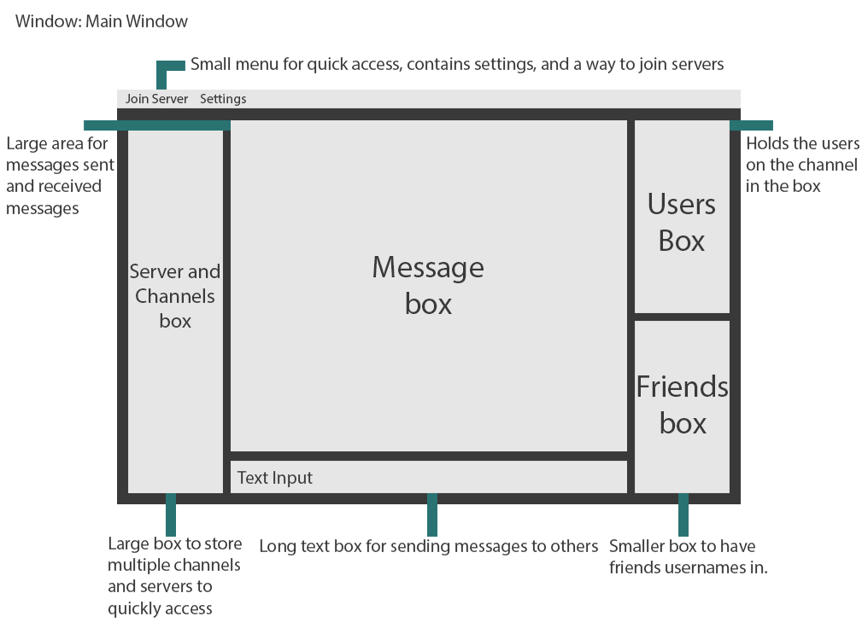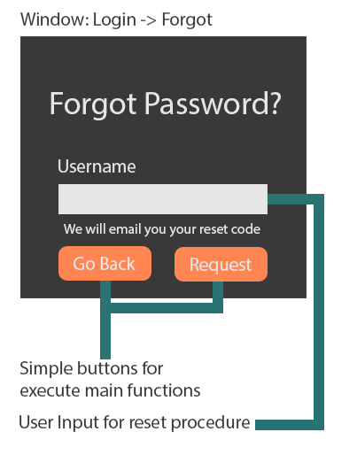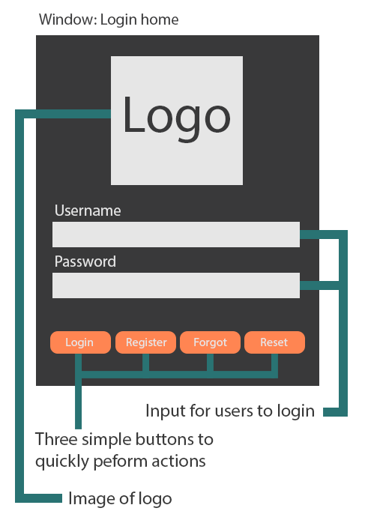

### 

### 

### Form objects and their states

Main Window:

This window where the user will be the most of the time. I wanted to make it easy to use because of this, I layed out the channels and servers box in a slimmer box so it doesn’t take as much room, but enough room to easily switch between each server and channel. The box on the right is for the users in the current channel, this is a smaller box than the server box because there needs to be enough room for the friends box without overcomplicating the UI and windows. The friends tab will hold less than users so it is smaller than that, however it will still be easy to use and easy to find friends through this box. The Message box is significantly larger as I want to display as much text possible on the screen, but without having multiple windows. The input box below is the smallest as you only need to write once and send, it isn’t storing anything, only if you are typing it will, but it will disappear when sent.

Settings Menu:

This menu will serve as the input for the colours and fonts for the main menu. It is a simple layout as it only has a few options, there are two columns, as there are multiple choices with each section. It has a descriptor above to help the user understand what it changes. The button saves the options to a file which is large and bright so it makes users remember to click to save. The font choice is large so you can easily read the text, this is applied to all of the pages bellow.

Login Home:

The home for the logo is the first window you see, it has a logo on the main window, because it makes it seems like a home page as websites normally have their logo featured in the center. There are two boxes for input to login, as pushing another button will make it take longer accessing the main window. The three buttons are so the user can login, or if they have forgotten or have a reset code, they open other windows to deal with these situations. These buttons are large and bright so it is easy for users to spot.

Forgot Page:

The second to last window is the forgot page, this page is where you input your username to get an email to reset your password. The fonts are large and easy to read as well as the composition being balanced. There is a box for the username as it is required for the server, without this you can’t reset the password. The box is big enough for a standard size username, as well as a description of what will happen when you click the reset button. They are also large and bright so it is easier to see and remember to click the request button.

Reset Page:

Finally this window has four inputs, one for the username, two for password and one for the code. There are two password inputs as the user could type incorrectly, and have to reset their password again. There are descriptors above each box to symbolize what each input needs. There are the two bright buttons again, to make them stand out.

All boxes will be holding strings as if it was another variable type it would not be compatible with the protocol, and the others are not suitable either, e.g. an integer can only allow you to send a number which will not be sufficient enough to send a message.

## Key variables, data structures and validation

### Login server

|  |  |  |
| --- | --- | --- |
| Name | Data type | Use |
| logger | Logging library class RootLogger | Is used to log actions on the server to a file, so you can see bugs and if an attacker was targeting the server. |
| data | Bytes | Stores users raw input from socket connection, to then be manipulated and evaluated in each sub for seperate reasons. |
| ip | String | Stores the IP of the person who has sent the input stored in the variable data. |
| username | String | The username of the account the client wants to login with. Used to get password from the database. |
| password | String, Bytes | The password the client inputted.It is then hashed to check against the hashed password in the database |
| email | String | Inputted by client, is added to the database when registering. The email is also used to get the email from the database to send the reset code to. |
| resetCode | String | A code which is sent to the user when they forget their email. It gets the raw Code and hashes it, but not for security, but to make it unique. |
| rawCode | String | A generate uuid to then be hashed to then used for resetCode. |
| timeStamp | String | A timestamp when a user connects to the server. Is used to add to the database to notify when the user was last logged in, in case an attacker successfully hacked an account. |
| CURSOR_UP_ONE | String | Used to go up a line in the terminal |
| ERASE_LINE | String | Used to erase a line in the terminal |
| conn | Sqlite3 library class Connection | To connect to the database |
| c | Sqlite3 library class Cursor | Execute SQL on the database |
| user_row | tuple | This holds the data taken from the database |
| sent_from | String | The email the server will send from |
| to | String | The users email you want to generate and send the reset code to |
| subject | String | The subject of the email |
| body | String | The body of the email |
| email_text | String | The email text as a whole |
| server | Smtplib library class SMTP_SSL | The way to communicate with the gmail server over SMTP |
| loginConf | Pathlib library class WindowsPath | A path to a file, is used to check if it exists, if not it creates it |
| loginServ | Socket library class socket | A socket which is used to communicate with the client |
| PORT | integer | The port number for the client program to communicate with |
| mailEmail | string | The email the server is sending from |
| MailPassword | string | The password of the email the server is emailing from |
| text | bytes | The received data from the client from the main thread |
| addr | tuple | The address the connection is coming from |
| fileDir | String | The directory of the users config to download to |
| sData | bytes | Receives data to concatenate into one file |
| fDownloadFile | Buffered Reader | Opens the file specified, writes text to the file |
| sRead | bytes | Read the data from the file to then send it to the client |
| fUploadFile | Buffered Reader | Opens the file you want to upload to the client |

### Client Form

|  |  |  |
| --- | --- | --- |
| Name | Data type | Use |
| freenode | Server (class) | To connect to a server for the client to use. |
| listenThread | Thread | This is used to create a thread to listen to the connections inbound from the server. |
| msgThread | Thread | This will be used to create a thread to send a message to a user or channel. |
| num | Integer | Used to check if the user is connected or not |
| PreviousTab | String | Check the name of the previous tab to save a file. |
| CurrentTab | String | Check the current tab to change the tab to. |
| msg | String | Stores the message from the message text box. |
| curLine | String | This is used to get the current line of the file. |
| writer | StreamWriter | Write logs to a file. |
| fileReader | String | Reads text from a file into this variable. |
| fR | String | Used to get text from a file. |
| myList | List | Used to load the text from the message received box. |

### Server Class

|  |  |  |
| --- | --- | --- |
| Name | Data type | Use |
| Instance | ircForm (Class) | To allow the thread to edit the main ircForm form. |
| servName | String | The user friendly name for the server |
| url | String | The url / ip to connect to the server |
| port | Integer | The port to connect to the server |
| username | String | What the client wants to be called on the server |
| socket | TcpClient() | How to connect to the server |
| socketStream | SslStream or NetworkStream | SslStream to connect using SSL encryption to get data from the server and to send it, NetworkStream is the same but unencrypted. |
| pingThread | Thread | Used to create a thread to reply to “PING” messages from the server. |
| generalThread | Thread | This thread will be multipurpose, if another operation needs to be on a thread I will use this for it. |
| message | Byte | Used to convert the message needing to be sent into bytes which is needed as you cannot send a string variable type over the internet. |
| fMessage | String | The message received and reused for the formatted message. |
| tab | String | Used to get current tab and to see whether to save a file or not. |
| pathAndPort | String Array | When the whole url is inputter it splits the url and path in two. |
| fileReader | String | Reads a file. |
| fU | String | Gets a specific section from a files text. |
| con | Boolean | Used to try and connect |
| count | Integer | Used to add seconds to between trying to connect |
| newPage | TabPage | Used to create a new tab on the GUI |
| c1 | String | Gets the first character of a string to check if it is a CTCP message. |
| c2 | String | Gets the last character of a string to check if it is a CTCP message. |
| usr | String | Used to store the username of the person who sent a message |
| b | boolean | Used to check if two boxes are colliding. |
| m | MatchCollection | Splits the raw received messages into manageable sections to search through. |

### Message Class

|  |  |  |
| --- | --- | --- |
| Name | Data type | Use |
| instance | ircForm (Class) | Used to add to the GUI |
| fN | String | The friendly name for the server to save files to |
| message | String | The message from the box to be parsed to send data to the server or used for the client |
| msgAry | String Array | The message variable but in an array to easily parse |
| stream | SslStream or NetworkStream | Used to send the data to the server |
| isTab | Boolean | Check if the message is to be sent to the current tab user or channel |
| tab | String | He name of the current tab |
| command | String | The possible command used to know what procedure to deal with that command |

### Settings Form

|  |  |  |
| --- | --- | --- |
| Name | Data type | Use |
| path | String | Where to save to file to |
| count | Integer | To check if each input is filled |
| txt | String | To get the text of the current control |
| temp | String | Replaces the spaces within the input with nothing |
| f | FileStream | Used to check if path exists |
| writer | StreamWriter | Write the configuration file |
| Text | String | Removes unnecessary characters |

### Login Form

|  |  |  |
| --- | --- | --- |
| Name | Data type | Use |
| checkConn | Boolean | Used to check for a connection to the login server |
| user | String | Stores the users username |
| pass | String | Stores the users password |
| concat | Byte | Used to join all of the data needed for the specific request together to be sent to the login server |
| returndata | String | Stores the received data from the server |

### Register Form

|  |  |  |
| --- | --- | --- |
| Name | Data type | Use |
| checkConn | Boolean | Used to check for a connection to the login server |
| email | String | Stores the email of the user |
| user | String | Stores the users potential username |
| pass | String | Stores the users password |
| concat | Byte | Used to join all of the data needed for the specific request together to be sent to the login server |
| returndata | String | Stores the received data from the server |

### Forgot Form

|  |  |  |
| --- | --- | --- |
| Name | Data type | Use |
| checkConn | Boolean | Used to check for a connection to the login server |
| concat | Byte | Used to join all of the data needed for the specific request together to be sent to the login server |
| returndata | String | Stores the received data from the server |

### Reset Form

|  |  |  |
| --- | --- | --- |
| Name | Data type | Use |
| checkConn | Boolean | Used to check for a connection to the login server |
| user | String | Stores the users username |
| pass | String | Stores the password |
| reset | String | Stores the reset code |
| concat | Byte | Used to join all of the data needed for the specific request together to be sent to the login server |
| returndata | String | Stores the received data from the server |

### Global Module

|  |  |  |
| --- | --- | --- |
| Name | Data type | Use |
| form | Form | Used to close and dispose of the form |
| s | String | Used to remove the hidden characters from the form |

### IRC Module

|  |  |  |
| --- | --- | --- |
| Name | Data type | Use |
| outstream | Byte | Used to send data to the IRC server. |
| c | Color | Set the colour of the text |
| writer | StreamWriter | Write logs |
| tab | String | Gets current tab |
| fileReader | String | Reads colours from file |
| settings | String Array | Rads all settings from file |
| setting | String Array | Gets a single setting from settingS |
| RGB | Integer Array | Sets the RGB value of the nickname colour |

### Login Module

|  |  |  |
| --- | --- | --- |
| Name | Data type | Use |
| clientSocket | TcpClient() | Connects to the login server |
| serverStream | NetworkStream | Sends and receives data to the login server |
| returndata | String | The formatted received messages |
| ip | Array | Gets the url and port of the server. |
| outStream | Byte | Gets rstring and turns it into bytes, used to send to the server too |
| inStream | Byte | Used to read the data received from the server |
| oIp | String | The original IP string |
| client | WebClient | Used to connect to the IP on port 80 |
| stream | Stream | Tests if connected |
| sha256 | SHA256 | Creates a SHA256 variable to be used to convert bytes into a hash |
| bytes | Byte | The bytes version of the password to be hashed |
| hash | Byte | The result of the SHA256 onto the password as bytes |
| sB | StringBuilder | Creates the hash into a string |

### Validation

To make the program as robust as possible each input needs to validated so it doesn’t cause breaks within the code, or that they are inputting the correct data. Below there are the different inputs with validation .

#### Buttons

These buttons are already robust as .NET already handles this, however it has to have something programmed for it to work.

Buttons in the menus are either user to open and close forms or to send data. It will gather the information from text boxes and send them off to the login server.

The buttons on the top bar of the client will either connect to a server, or disconnect from one, as well as opening the settings menu.

Button Lists are a grouping of buttons, these will serve no function currently, it will just store necessary information such as users, friends and servers. They will need functions in the future however this will be after the core of the program which will be built.

#### Text boxes

Text boxes allow a user to input whatever they want, they will have different functions for each one.

The menu text boxes are used to send the appropriate data for each section, they all use functions to send the data which parses these, if they are empty the client still sends the data as the server handles the data and sends back the appropriate reply to the client.

The client has multiple text boxes however the message send text box is the only box which allows the user to input as the others are for output of messages received and sent. The input message box should allow any text to be parsed through, however if the text starts with a slash and is a command the program will have to perform the specific task linked to that through the function which parses the data to it to complete the function successfully.

#### Tabs

The tabs are only used to load and unload users and text from the message box to talk to certain people. It isn’t coded within the tabs, instead the classes and the form itself load and unload certain files.

#### Images

There will only be a few images, one is a warning, one is a logo, and another is a icon. The images are displayed in certain areas. The first will be the main menu where it will first load the logo, and if the user enters incorrect credentials the image changes to an error image. The last image is a cog for the settings button on the client.

### Data files

Login Server:

* Login.conf : Stores the login credentials for the gmail account
* Server.db : The database containing users, passwords, emails and reset codes
* Server.log : The log of the actions made on the server
* Folder for user configurations as a backup : Holds the files backed up from the client program

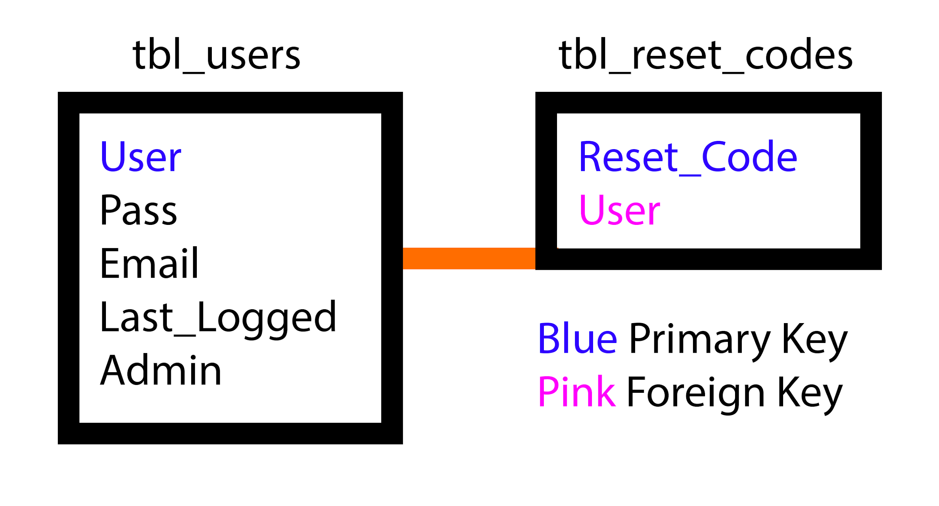

This is the entity relationship diagram for the servers database (server.db). It is a one to one relationship as a user can only have one reset code. User is primary key because it is a unique identifier, and the reset_code is the primary key for the reset code table. It has a foreign key linked to the user primary key on table users as each has its own reset code when generated in the forgot procedure.

Client Program:

* Font-colours.conf : Stores font choice and colours
* Servers-channels.conf : Stores servers and channels joined
* Multiple logs - Store what each channels received and sent messages are for backup

## Pseudocode

### Login server

#### Login procedure pseudocode

This code bellow handles the login requests to the server, checking the database that the credentials are correct and exist and then allowing them through if successful.

Justification:

As this server is for logging in, the server will need this feature as without it there will be no way of verifying the user is logged into the client correctly. It needs to hash the password as when registering the program hashes it. The server then compares the user password input to the hash for the user to see if it is correct allowing the user to use the client. If username doesn’t exist or password is incorrect it won’t allow the user to open up the client.

|  |
| --- |
| procedure login(clientsock, addr, timeStamp):  # Sets up the register connection  logger = logging.getLogger("Login")  clientsock.send("LOGIN\n".encode())  data = clientsock.recv(1024)  ip = addr[0]   # split so that "user password is the best password" becomes "user" "password is the best password"  username, password = data.decode().rstrip().split(" ", 1)  password = base64.b64encode(hashlib.sha256(password.encode('utf-8')).digest())    # Sets up the connection with the db  conn = sqlite3.connect('serverFiles/server.db')  conn.cursor().execute(  "CREATE TABLE IF NOT EXISTS tbl_users (user TEXT PRIMARY KEY, pass TEXT, email TEXT last_logged TEXT, "  "admin TEXT);")  c = conn.cursor()   # do a single query for all data relating to the user,  c.execute("SELECT * FROM tbl_users WHERE user = ? LIMIT 1", (username,))  user_row = c.fetchone()   # Checks if the pass matches the account, logs the result  if user_row is None or bcrypt.checkpw(password, user_row[1]) == False Then  clientsock.send("FAIL\n".encode())   # If doesn't exist, it adds it to the db  logger.info("FAIL, %s, User: %s" % (ip, username))   # if it successful you can enter  else  clientsock.send("PASS\n".encode())   c.execute("UPDATE tbl_users SET last_logged = ? WHERE user = ?", (timeStamp, username))  conn.commit()   # If doesn't exist, it adds it to the db  logger.info("PASS, %s, User: %s" % (ip, username))  End if  clientsock.close()  logger.info(repr(addr) + ": Login connection closed") |
|  |

#### 

#### Reset procedure pseudocode

This deals with resetting the passwords of users, it checks the database for a code and then checks if that code is linked to the user inputted allowing them to change their password if the code was correct and the user exists in the database.

Justification:

Without this the user will not be able to easily change their password which could leave them locked out of their account. It looks for the code and finds the username associated. If the username matches with the inputted, it allows the user to reset their password.

|  |
| --- |
| procedure reset(clientsock, addr):  # Sets up the register connection  logger = logging.getLogger("Reset")  clientsock.send("RESET\n".encode())  data = clientsock.recv(1024)  ip = addr[0]  username, resetCode, password = data.decode().rstrip().split(" ", 3)  password = bcrypt.hashpw(base64.b64encode(hashlib.sha256(password.encode('utf-8')).digest()), bcrypt.gensalt(14))   # Connects to the db  conn = sqlite3.connect('serverFiles/server.db')  conn.cursor().execute(  "CREATE TABLE IF NOT EXISTS tbl_users (user TEXT PRIMARY KEY, pass TEXT, email TEXT, last_logged TEXT, "  "admin TEXT);")   # Used to get the username  c = conn.cursor()  c.execute("SELECT * FROM tbl_users WHERE user = ? LIMIT 1", (username,))  row = c.fetchone()   # If doesn't exist, it adds it to the db  if row is None Then  clientsock.send("DENY\n".encode())  logger.info("NO SUCH USER %s %s" % (username, ip))   # If exists see if reset code is correct  else   # Connects to the db, creates table if not exist  conn = sqlite3.connect('serverFiles/server.db')  conn.cursor().execute("CREATE TABLE IF NOT EXISTS tbl_reset_codes (reset_code TEXT PRIMARY KEY, user TEXT, "  "FOREIGN KEY(user) REFERENCES tbl_users(user));")   # Connects to the table to see if there is already a code  c = conn.cursor()  c.execute("SELECT reset_code FROM tbl_reset_codes WHERE user = ?", (username,))  checkCode = str(c.fetchone()).strip("[('',)]")   # Checks if the user has a reset code  if checkCode is None Then  clientsock.send("DENY\n".encode())  logger.info("NO CODE FOR USER %s %s" % (username, ip))   # If the code is correct reset the password  elif checkCode == resetCode Then  c.execute("DELETE FROM tbl_reset_codes WHERE user = ?", (username,))  conn.commit()  c.execute("UPDATE tbl_users SET pass = ? WHERE user = ?", (password, username))  conn.commit()  clientsock.send("CHANGED\n".encode())  logger.info("CORRECT CODE FOR USER %s %s" % (username, ip))   # If incorrect, log and deny it  else  clientsock.send("DENY\n".encode())  logger.info("INCORRECT CODE FOR USER %s %s" % (username, ip))  End if  End if  clientsock.close()  logger.info(repr(addr) + ": Reset connection closed") |

#### 

#### Forgot procedure pseudocode

This procedure deals with creating and sending emails which contain a unique code for a user to user to reset their password in the reset menu, it adds the code to as separate table in the database.

Justification: The forgot procedure will generate a code so the user can change their password within the reset procedure otherwise there is no way of knowing that it is them or not when trying to change the password.

|  |
| --- |
| procedure forgot(clientsock, addr, mailEmail, mailPassword):  # Sets up the register connection  logger = logging.getLogger("Forgot")  clientsock.send("FORGOT\n".encode())  data = clientsock.recv(1024)  ip = addr[0]  username = data.decode().rstrip()   # Connects to the db  conn = sqlite3.connect('serverFiles/server.db')  conn.cursor().execute(  "CREATE TABLE IF NOT EXISTS tbl_users (user TEXT PRIMARY KEY, pass TEXT, email TEXT, last_logged TEXT, "  "admin TEXT);")   # Used to get the email for later  c = conn.cursor()  c.execute("SELECT * FROM tbl_users WHERE user = ? LIMIT 1", (username,))  row = c.fetchone()   # If doesn't exist, it adds it to the db  if row is None Then  clientsock.send("DENY\n".encode())  logger.info("NO SUCH USER %s %s" % (username, ip))   else  # Gets the users email  email = row[2]   # Connects to the db, creates table if not exist  conn = sqlite3.connect('serverFiles/server.db')  conn.cursor().execute("CREATE TABLE IF NOT EXISTS tbl_reset_codes (reset_code TEXT PRIMARY KEY, user TEXT, "  "FOREIGN KEY(user) REFERENCES tbl_users(user));")   # Connects to the table to see if there is already a code  c = conn.cursor()  c.execute("SELECT reset_code FROM tbl_reset_codes WHERE user = ? LIMIT 1", (username,))  checkCode = c.fetchone()   # Creates a randomly generated code and adds it to a global dictionary for later use  rawCode = uuid.uuid4().hex  resetCode = hashlib.sha256(rawCode.encode()).hexdigest()   # If there isn't a code for the user, add one  if checkCode is None Then  c.execute("INSERT INTO tbl_reset_codes(reset_code, user) VALUES(?, ?)", (resetCode, username))  conn.commit()   # Else delete the old code, and set the new one  else  c.execute("DELETE FROM tbl_reset_codes WHERE user = ?", (username,))  conn.commit()  c.execute("INSERT INTO tbl_reset_codes(reset_code, user) VALUES(?, ?)", (resetCode, username))  conn.commit()  End if  # Sets up email contents  sent_from = mailEmail  to = [email]  subject = 'IRC Reset Code'  body = 'Here is your reset code for user %s:\n%s' % (username, resetCode)   # Orders the strings to be sent  email_text = """From: %s\nTo: %s \nSubject: %s\n\n%s  """ % (sent_from, ", ".join(to), subject, body)   # Attempt to send the email  try:  # Sets up the connection and sends the email  server = smtplib.SMTP_SSL('smtp.gmail.com', 465)  server.ehlo()  server.login(mailEmail, mailPassword)  server.sendmail(sent_from, to, email_text)  server.close()   # If it was successful, these lines run  clientsock.send("SENT\n".encode())  logger.info("FORGOT SENT %s %s %s" % (ip, username, email))   # If fails, send back it failed.  except:  clientsock.send("FAIL\n".encode())  logger.error("FORGOT SENT FAIL %s %s %s" % (ip, username, email))  End try  End if  clientsock.close()  # print(colored(repr(addr) + ": Forgot connection closed", 'red'))  logger.info(repr(addr) + ": Forgot connection closed") |

#### 

#### Register procedure pseudocode

This adds the user to the database requiring the email, username username and password while checking if the username has been used before in the database.

Justification: Without the register form you would have to manually add the use to the database and then manually hash and store the password. And it would be more difficult to sign up, this procedure streamlines this as well as reducing the time to create a user.

|  |
| --- |
| procedure register(clientsock, addr, timeStamp):  # Sets up the register connection  logger = logging.getLogger("Register")  clientsock.send("REGISTER\n".encode())  data = clientsock.recv(1024)  username, email, password = data.decode().rstrip().split(" ", 2)  ip = addr[0]  password = bcrypt.hashpw(base64.b64encode(hashlib.sha256(password.encode('utf-8')).digest()), bcrypt.gensalt(14))  is_valid = validate_email(email)   # Connects to the db  conn = sqlite3.connect('serverFiles/server.db')  conn.cursor().execute("CREATE TABLE IF NOT EXISTS tbl_users (user TEXT PRIMARY KEY, pass TEXT, email TEXT, "  "last_logged TEXT, admin TEXT);")   # Sees if the user exists already in the database  c = conn.cursor()  c.execute("SELECT user FROM tbl_users WHERE user = ?", (username,)) # sees if user is already in db  checkUser = c.fetchone()  c.execute("SELECT email FROM tbl_users WHERE email = ?", (email,)) # sees if user is already in db  checkEmail = c.fetchone()   # If doesn't exist, it adds it to the db  if checkUser is None and checkEmail is None and is_valid is True Then  c.execute("INSERT INTO tbl_users(user, pass, email, last_logged, admin) VALUES(?, ?, ?, ?, 0)",  (username, password, email, timeStamp))  conn.commit()  clientsock.send("CREATED\n".encode())   # Logs to text file action  logger.info("CREATED %s FROM %s" % (username, ip))   # If user or email exists, return that it does, so user can think of a new one  elif checkUser is not None Then  logger.info("USER EXISTS %s FROM %s %s" % (username, ip, email))  clientsock.send("USER EXISTS\n".encode())  conn.commit()   elif is_valid is False Then  logger.info("EMAIL INVALID %s FROM %s %s" % (username, ip, email))  clientsock.send("EMAIL NOT VALID\n".encode())  conn.commit()   elif checkEmail is not None Then  logger.info("EMAIL EXIEMAIL EXISTS %s FROM %s %s" % (username, ip, email))  clientsock.send("EMAIL EXISTS\n".encode())  conn.commit()  End if   clientsock.close()  logger.info(repr(addr) + ": Register connection closed") |

#### 

#### Login server send procedure pseudocode

This sends adds file to the client containing their config files making it easy for them to get their settings from separate places. When logging in the client will download the configuration.

Justification: This will help the portability of the program as a user could log in in two locations and have the same configuration file, this will help with the usability of the program.

|  |
| --- |
| procedure send(clientsock, addr):  # Sets up the connection  logger = logging.getLogger("Send")  clientsock.send("SEND\n".encode())  data = clientsock.recv(1024)  username, password = data.decode().rstrip().split(" ", 1)  password = base64.b64encode(hashlib.sha256(password.encode('utf-8')).digest())  ip = addr[0]   # Connects to the db to be used to authenticate user  conn = sqlite3.connect('serverFiles/server.db')  conn.cursor().execute(  "CREATE TABLE IF NOT EXISTS tbl_users (user TEXT PRIMARY KEY, pass TEXT, email TEXT, last_logged TEXT, "  "admin TEXT);")  c = conn.cursor()   # do a single query for all data relating to the user,  c.execute("SELECT * FROM tbl_users WHERE user = ? LIMIT 1", (username,))  user_row = c.fetchone()   # If pass or username bad, return DENY  if user_row is None or bcrypt.checkpw(password, user_row[1]) == False Then  clientsock.send("DENY\n".encode())   # Logs to text file action  logger.info("DENY SEND %s %s" % (ip, username))   # Send the file to the client  else  # Logs to text file action  logger.info("ALLOW SEND %s %s" % (ip, username))   fileDir = str("Configs/%s.conf" % username)  with open(fileDir, "rb") as fUploadFile:  sRead = fUploadFile.read(1024)  while sRead:  clientsock.send(sRead)  sRead = fUploadFile.read(1024)  End if   clientsock.close()  logger.info(repr(addr) + " Send connection closed") |

#### Login server receive procedure pseudocode

This does the opposite to above, when leaving it downloads the configuration file back onto the server to send again in the future.

Justification:

This is the way the server updates its configuration file, without this r=the file stored in the server would be outdated or not exist meaning it will lose a feature.

|  |
| --- |
| procedure receive(clientsock, addr):  logger = logging.getLogger("Receive")  # Sets up the connection  clientsock.send("RECEIVE\n".encode())  data = clientsock.recv(1024)  username, password = data.decode().rstrip().split(" ", 1)  password = base64.b64encode(hashlib.sha256(password.encode('utf-8')).digest())  ip = addr[0]   # Connects to the db to be used to authenticate user  conn = sqlite3.connect('serverFiles/server.db')  conn.cursor().execute(  "CREATE TABLE IF NOT EXISTS tbl_users (user TEXT PRIMARY KEY, pass TEXT, email TEXT, last_logged TEXT, "  "admin TEXT);")  c = conn.cursor()   # do a single query for all data relating to the user,  c.execute("SELECT * FROM tbl_users WHERE user = ? LIMIT 1", (username,))  user_row = c.fetchone()   # If pass or username bad, return DENY  if user_row is None or bcrypt.checkpw(password, user_row[1]) == False Then  clientsock.send("DENY\n".encode())   # Logs to text file action  logger.info("DENY RECEIVE %s %s" % (ip, username))   # Connect to the client to give the data to store  else   logger.info("ALLOW RECEIVE %s %s" % (ip, username))  username = clientsock.recv(1024)  username = username.decode().rstrip()  fileDir = str("Configs/%s.conf" % username)  sData = loginServ.recv(1024)  fDownloadFile = open(fileDir, "wb")  while sData:  fDownloadFile.write(sData)  sData = loginServ.recv(1024)   # Logs to text file action  logger.info(repr(addr) + ": Send connection closed")  End If |

### Client Program

#### Login Form

This authenticates the client with the login server allowing them to get on, it gets all the data from the inputs and then sends them to the login server.

Justification: Without this form the user will not be able to login to the server in a user friendly way making it difficult for the user to use. There would not be a way for the user to login either without this with the client.

|  |
| --- |
| Procedure loginBtn_Click(sender As Object, e As EventArgs) Handles loginBtn.Click  // Check for connection  checkConn = CheckForConnection("http://" & GetLoginIp()(0))   // If there was a connection, send data to login server  If checkConn = True Then  // Declares varibles to be used to send login info after starting the login thread  user = userBox.Text  pass = passBox.Text  pass = GenSHA256SHash(pass) 'Hashes password so it adds more characters   // Creates the string to be sent to the server, and starts the connection  concat = ASCII.GetBytes(user & " " & pass)  returndata = Request("login", concat)   // If the connection failed display a message box and enable buttons  If returndata = "error" Then  MessageBox.Show("Error: Server side error", "Error", MessageBoxButtons.OK, MessageBoxIcon.Error)  Else  // Checks data to see if the server reply was positive  If returndata = "PASS" Then  ircForm.Show()   ElseIf returndata = "ADMIN" Then  ircForm.Show()    ElseIf returndata = "FAIL" Then  MessageBox.Show("Incorrect details", "Error", MessageBoxButtons.OK, MessageBoxIcon.Error)  End If    End If  Else  MessageBox.Show("Error: No connection to server" & vbNewLine & "Check if you are connected to the server, or if  the server is online", "Error", MessageBoxButtons.OK, MessageBoxIcon.Error)  End If End Procedure |

#### 

#### Register Form

This registers the user with the server allowing them to login, this also gets the three inputs, concatenate them into one byte string and sends them off.

Justification: Without this form the user will not be able to register to the server in a user friendly way making it difficult for the user to create an account. There would not be a way for the user to create an account either without this with the client otherwise they will need to know the commands and the ip.

|  |
| --- |
| Procedure regBtn_Click(sender As Object, e As EventArgs) Handles regBtn.Click  // check for connection  checkConn = CheckForConnection("http://" & GetLoginIp()(0))   // If there was a connection, send data to login server  If checkConn = True Then   // Declares varibles for sending for later, hashes password  email = emailBox.Text  user = userBox.Text  pass = passBox.Text  pass = GenSHA256SHash(pass) 'Hashes password so it adds more characters   // Creates the string to be sent to the server, and starts the connection  concat As Byte() = ASCII.GetBytes(user & " " & email & " " & pass)  returndata As String = Request("register", concat)   // If the connection failed display a message box and enable buttons  If returndata = "error" Then  // Enable buttons when finished  MessageBox.Show("Error: Server side error", "Error", MessageBoxButtons.OK, MessageBoxIcon.Error)  Else  // Checks data to see if the server reply was positive  If returndata = "CREATED" Then  msgbox("Created!")  ElseIf returndata = "USER EXISTS" Then  msgbox("User Exists.")  ElseIf returndata = "EMAIL EXISTS" Then  msgbox("Email Used.")  ElseIf returndata = "EMAIL NOT VALID" Then  msgbox("Email Invalid.")  End If  End If   Else  MessageBox.Show("Error: No connection to server", "Error", MessageBoxButtons.OK, MessageBoxIcon.Error)  End If End Procedure |

#### Forgot Form

When a user forgets their password they need to get a code to change their password, they do this by entering their email into the input box which sends the email address to the server which generates and sends the code to the user.

Justification: Without this form the user will not be able to send a forgot request to the server in a user friendly way making it difficult for the user to use. There would not be a way for the user to generate a code either without this with the client otherwise they will need to know the commands and the ip.

|  |
| --- |
| Procedure forgotBtn_Click(sender As Object, e As EventArgs) Handles forgotBtn.Click  // check for connection  checkConn = CheckForConnection("http://" & GetLoginIp()(0))   // If there was a connection, send data to login server  If checkConn = True Then  // Creates the string to be sent to the server, and starts the connection  concat = ASCII.GetBytes(userBox.Text)  returndata = Request("forgot", concat)   // If the connection failed display a message box and enable buttons  If returndata = "error" Then  MessageBox.Show("Error: Server side error", "Error", MessageBoxButtons.OK, MessageBoxIcon.Error)  Else  // Checks data to see if the server reply was positive  If returndata = "SENTT" Then  msgbox("Sent!")  ElseIf returndata = "FAILT" Then  msgbox(Couldn't send, try Again."  ElseIf returndata = "DENYT" Then  msgbox("No Such User.")  End If  End If  Else  MessageBox.Show("Error: No connection to server" & vbNewLine & "Passwords don't match", "Error",  MessageBoxButtons.OK, MessageBoxIcon.Error)  End If End Procedure |

#### 

#### Reset Form

This form deals with resetting the users password, it needs 4 inputs to send to the server to reset the password, including the reset code. It will search the code database and get the username of who it is linked to. When found it compares that to the username inputted to see if they match, if so they input their password twice for verification and then if they also match the password is hashed and stored in the database.

Justification: Without this it would be impossible to reset the password of the user, you could directly connect to the server however it would be more difficult to reset the password. It is more user friendly to have a form than use a command line interface.

|  |
| --- |
| Procedure resetBtn_Click(sender As Object, e As EventArgs) Handles resetBtn.Click  If pass1Box.Text = pass2Box.Text And pass1Box.Text <> "" Then  // check for connection  checkConn = CheckForConnection("http://" & GetLoginIp()(0))   If checkConn = True Then  // Declares varibles for sending for later, hashes password  user = userBox.Text  pass = pass1Box.Text  reset = resetBox.Text  pass = GenSHA256SHash(pass) // Hashes password so it adds more characters   // Creates the string to be sent to the server, and starts the connection  concat = ASCII.GetBytes(user & " " & reset & " " & pass)  returndata = Request("reset", concat)   // If the connection failed display a message box and enable buttons  If returndata = "error" Then  'Enable buttons when finished  EnableButtons(Me)  MessageBox.Show("Error: Server side error", "Error", MessageBoxButtons.OK, MessageBoxIcon.Error)  Else  // Checks data to see if the server reply was positive  If returndata = "CHANGED" Then  msgbox("Success!")  ElseIf returndata = "DENY" Then  msgbox("Failed!")  End If  End If  Else  MessageBox.Show("Error: No connection to server", "Error", MessageBoxButtons.OK, MessageBoxIcon.Error)  End If  Else  MessageBox.Show("Passwords don't match", "Error", MessageBoxButtons.OK, MessageBoxIcon.Error)  End If End Procedure |

#### 

#### Login Menu Module

This stores functions used over the login menus and the ones linked through buttons to it. Check for connection tests if the program can connect to the login servers ip which is in a file. If they can connect it will return true, if not false. GenSHA256Hash creates a hash which will be used to create a more complex password from the users password which may be not as good in plaintext. GetLoginIp gets the login ip from the ip file.

Justification: This module will contain modules which will be used across the initial menus. CheckForConnection is needed as without it there will be errors when attempting to connect to the server. GenSHA256Hash is needed to make the password be more complicated to make it more difficult to crack. Next is GetLoginIp this will be needed to get the ip of the server to test the connection and to send requests.

|  |
| --- |
| // Checks for connections  Function CheckForConnection(ip) As Boolean  Try // Try and connect to the ip  Using client = get()  Using stream = client.connect(ip) // Try connect to the ip  Return True 'If connected without error return true  End Using  End Using  Catch // If can't get a connection  Return False  End Try  End Function   'Generates a string from the hash  Function GenSHA256SHash(ByVal pass As String)  // Encodes the password, and convert to bytes  bytes = ASCII.GetBytes(pass)  // Computes the hash and stores it in the var  Dim hash As Byte() = sha256.ComputeHash(bytes)  sB = hash.toString()  Return sB  End Function   // Opens file to get ip  Function GetLoginIp()  Using sr As Reader = New Reader("ip")  oIp = RmHiddenChar(sr.ReadToEnd())  ip = oIp.Split(":")  Return ip  End Using  End Function |

#### 

#### Client Form

The client form will be used to start the connection to the server, and to create the listen thread as well, it will also have the GUI for the client which is the main part of the form.

Justification: Without starting the connection or starting the listen thread there would be no easy way to connect to the irc server, and would have no use except from logging in.

|  |
| --- |
| 'Start a listen thread Procedure StartListen(server)  // Create new thread which runs listen on the server inputted  listenThread = New Thread(Sub() server.listen(Me))  Makes it a background thread  listenThread.IsBackground = True  // Starts the thread  listenThread.Start() End Procedure   Procedure join()  // Connect to server with username in quotes  freenode.connect("EEEETesting")  // Start a listen thread for freenode  StartListen(freenode) End Procedure   Procedure disconnect()  // Disconnect from server  freenode.disconnect(Me)  listenThread.Abort() End Procedure |

#### 

#### Settings Form

This changes the colours within the form which is called when saving on the settings form and when opening the client form. It gets the settings and sets the colours for the background, foreground, text, nick text and the size of the text.

Justification: This will get colours from a file and sets colours in the form to the specific ones in the configuration file.

|  |
| --- |
| Procedure changeColours(instance As ircForm)  'opens up the file  Dim fileReader As String = ReadAllText("colours")   // Creates string arrays to store the values from above in  // Stores all settings  settings() = {}  // stores one setting  setting() = {}   // Splits the data in the file into different sections.  settings = fileReader.Split(" ")   For i = 0 To 5  // Change form background  If i = 1 Then  setting = settings(0).Split(",")  instance.BackColor = Color.FromArgb(setting(0), setting(1), setting(2))  setting = {}   // Change control Background  ElseIf i = 2 Then  setting = settings(1).Split(",")   For Each Control In Form  c.BackColor = Color.FromArgb(setting(0), setting(1), setting(2))  Next   setting = {}   // Change text Colour  ElseIf i = 3 Then  setting = settings(2).Split(",")   For Each Control In Form  c.ForeColor = Color.FromArgb(setting(0), setting(1), setting(2))  Next   setting = {}   // Change nick Colour  ElseIf i = 4 Then  setting = settings(3).Split(",")   For Each Control In Form  setNickColour(setting)  Next   // Change font Size  Else  For Each Control In Form  fnt = Font("Font Name", settings(4))  Form.Font = fnt  Next  End If  Next  End Procedure |

#### Server Class

Adjust send box adjusts the size of the message box compared to the username label so they are both visible.

Justification: The usability will be better due to the username correctly fitting in the form without it being covered up by a text box.

|  |
| --- |
| // Adjusts send box Procedure AdjustSendBox()  // Used to check bounds are not intersecting  Dim b As Boolean = True   While b = True  // When still intersecting  b = form.box.IntersectsWith(form.lbl)  If b = False Then // If not intersecting, success and leave look  Exit While  Else  // Gets current position of the text box and adds one to x axis  box.Location = New Point(box.Location.X + 1, box.Location.Y)  // Reduces size of the box  box.Width = box.Width - 1  End If  End While End Procedure |

This sets up the connection to the server, depending if the port is ssl or not, if ssl create a ssl stream, if not make it a normal stream.

Justification: This will encrypt the data meaning that the user will be more secure than using a different non-ssl port as man in the middle attacks will be hindered.

|  |
| --- |
| Procedure SetupConn()  // Creates new socket  socket = New TcpClient()  // Connect to the url and port  socket.Connect(url, port)   // Check if it is ssl  If port = 6697 Then  socketStream.AuthenticateAsClient(url)  Else  // Use unencrypted connection  socketStream = socket.GetStream()  End If End Procedure |

This disconnects the user from the server and kills the thread listening to the server.

Justification: This is more so a usability feature as the user doesn’t need to disconnect but if they want to as they are leaving home they can disconnect, or just close the client.

|  |
| --- |
| 'Disconnect from server  Procedure Disconnect(instance As ircForm)  // send quit message  SendData("QUIT Bye!", socketStream)  // Kill thread  form.KillListen()   // Close and dispose networking vars  socket.Close()  socket.Dispose()  socketStream.Close()  socketStream.Dispose()  End Sub |

This is ran on another thread to constantly take in and parse data sent from the server to the client to correctly deal with it.

Justification: Without this messages will no be displayed, and wouldn’t be displayed correctly as well as the messages being displayed in the correct text.

|  |
| --- |
| Procedure Listen(instance As ircForm)  // Starts listening for data  While 1  // Get incoming data  socketStream.Read(message)   // Turn to string and remove null characters  fMessage = Encoding.ASCII(message)   If fMessage = Nothing Then  MsgBox(fMessage)   // If the response was PING  ElseIf fMessage.Substring(0, 4) = "PING" Then  // Start pong thread  pingThread = New Thread(AddressOf Pong)  Else  // Regex captured string into seperate groups  For Each Section in fMessage  // Define easy to read vars  fMessage = m.section  usr = m.section   If m.section.Length = 3 Then  // That it sent the names of users due to the 353 code  If m.section = "353" Then   chan = m.Groups(5).Value.Remove(0, 1)  path = "temp/" & chan & "Names"  If tab = chan Then  fR = ReadAllText(path)   // Add to users box  chanUsers = RmHiddenChar(fR).split(" ")  For i = 0 To chanUsers.length() - 1  form.Items.Add(chanUsers(i))  Next  Else  Using writer to path   writer.WriteLine(fMessage)  End Using  End If  End If   // If the response is a channel  If m.section.StartsWith("#") Then   // And that tab is currently open  If tab = m.section Then  // Print username  usrColour(m.Groups.Value, instance)  // Add message  form.AppendText(fMessage)  Else  // Save to file  logFile(m.section & " | " & fMessage  End If  Else  // If the message is from a user  If tab = usr Then  // Print the username  usrColour(usr, instance)  // Add to textbox  form.AppendText(fMessage)  Else  // Save the message  logFile(usr & " | " & fMessage  End If  End If  End If  Next  End If  // Clears the aray  Array.Clear(message)  End While  End Procedure |

#### 

#### Message Class

MsgCommand sends messages to a specific user which will create a new tab to speak to the other user over.

AddFriend adds a user inputted into a box to be stored and looked at to know the nicknames you trust.

JoinChan makes your client join a new channel, and leavChan makes your client leave the specified channel.

Justification: Without this class, there would be no way of messaging the irc server, as well as the commands being created within this class which will remove vital functions such as joining a channel and messaging users directly.

|  |
| --- |
| Procedure MsgCommand(msg As String)  // Create var for formatted text to be put into  concat = ""  If msg <> "" Then  // Concats string into correct format  concat = "PRIVMSG " & msg & " :" & msg  // Send message to user on server, and flushes stream  SendData(concat, stream)   'Append to box  ColourChange("Msg to: " & msg, "usr", instance)  Form.AppendText(" | " & msg)  End If  End Procedure    Procedure AddFriend()  // Adds user to list  If msg <> "" Or msg = Nothing Then  Form.Items.Add(msg)  WriteAllText("configs/" & fN & "Friends", msg & " ", True)  End If  End Procedure    Procedure joinChan()  SendData("JOIN " & msgAry(1), stream)  End Procedure    Procedure leaveChan()  SendData("PART " & msgAry(1), stream)  End Procedure |

#### IRC Module

This module contains two procedures which will be used for the classes, it will save the text received from the server into a file where the user can see the messages received and will be used to load previous messages. SendData sends a specific string to the server sent from the user.

Justification: Without logging the file there is no way of storing old messages and loading them into the client. SendData is used to send data to the client, this will be needed as without this it would add more lines making it more inefficient.

|  |
| --- |
| // Saves to appropriate file  Procedure logFile(text, file)  Using writer open ("logs/" & file & ".txt", True)  writer.WriteLine(text)  End Using  End Sub   // Send the data to the server correctly  Procedure SendData(message)  // Sends the server the text  socketStream.Write(message, server)  // Flushes the socket stream  socketStream.Flush()  End Sub |

#### Global Module

This will be used over the whole project, where it will get rid of newlines which should format the data correctly.

Justification: This function is used across the program and to save lines, also reducing the size of the compiled program.

|  |
| --- |
| // Removes hidden characters from string and returns  Function RmHiddenChar(s As String)  s = s.Replace(\n, "")  Return s  End Function |

## Test strategy for development.

While developing I will be testing my program, I will be testing for bugs and errors to fix, the boxes below are what I will be testing.

#### Login window

|  |  |  |  |  |  |
| --- | --- | --- | --- | --- | --- |
| Test no. | Criteria | Data type | User input | Expected outcome | Actual outcome |
| 1.1.1 | Check if logging in with registered username and password works | Valid string | “Ethan”  “Test” | Message box or form opens |  |
| 1.1.2 | Test if sending incorrect username and correct password doesn’t work | Valid String, Invalid String | “Ethan”  “test” | Message appears that username or password is wrong |  |
| 1.1.3 | Test if sending incorrect password and correct username doesn’t work | Valid String, Invalid String | “ethan”  “Test” | Message appears that username or password is wrong |  |
| 1.1.4 | Test if no username or password works | Nothing | “” “” | Message appears that username or password is wrong |  |
| 1.2.2 | Check if clicking register opens the register form | An action not a data type | Click on register button | Register form opens |  |
| 1.2.3 | Check if clicking forgot opens the forgot form | An action not a data type | Click on forgot button | Forgot form opens |  |
| 1.2.4 | Check if clicking reset opens the reset form | An action not a data type | Click on reset button | Reset form opens |  |
| 1.2.5 | Check if clicking login sends data to the server using a valid | Valid String, Valid String | “Ethan”  “Test”  Click on login button | Logs into server and shows textbox or form |  |

#### Register window

|  |  |  |  |  |  |
| --- | --- | --- | --- | --- | --- |
| Test no. | Criteria | Data type | User input | Expected outcome | Actual outcome |
| 2.1.1 | Using a valid email, a valid username and a valid password into the boxes. | Valid string, Valid string, Valid string | (I will delete the Ethan user and recreate it)  “Ethan”,  “Test”,  “71830@student.varndean.ac.uk” | Creates account and displays success message |  |
| 2.1.2 | Using a invalid email valid username and valid password | Invalid String, Valid String, Valid String | “Hello”,  “Not.at.email”,  “Password” | Gives error and no account created |  |
| 2.1.3 | Using valid email valid username and a password with a range of char | Valid String, Valid String, Extreme String | “Username”,  “)(He110wOr!d)(”  “realEmail@ahhhhh.com” | Creates account and displays success message |  |
| 2.1.4 | Using a already used email | Extreme String, Valid String, Extreme String | “Username”,  “Ahhhhhh”,  “71830@student.varndean.ac.uk” | Gives error and no account created |  |
| 2.2.1 | Test if back button works | An action not a data type | Click back button | Goes back to first form |  |
| 2.2.2 | Test if register button works with valid strings. | Valid String, Valid String, Valid String,  An action not a data type | “Ethan”,  “Test”,  “71830@student.varndean.ac.uk”  Click register button. | Creates account and displays success message |  |

#### Forgot window

|  |  |  |  |  |  |
| --- | --- | --- | --- | --- | --- |
| Test no. | Criteria | Data type | User input | Expected outcome | Actual outcome |
| 3.1.1 | Enter valid username | Valid string | “Ethan” | Sends an email to the user and gives an success message |  |
| 3.1.2 | Enter email instead of text | Invalid string | “71830@student.varndean.ac.uk” | Give error to user |  |
| 3.1.3 | Enter username who is not used | Extreme invalid string | “aaaaa” | Give error to user |  |
| 3.2.1 | Check if back button works | An action not a data type | Click back button | Goes to main menu form |  |
| 3.2.2 | Check if send button works | Valid string  An action not a data type | “Ethan”  Click send button | Sends and email to the user |  |

#### Reset window

|  |  |  |  |  |  |
| --- | --- | --- | --- | --- | --- |
| Test no. | Criteria | Data type | User input | Expected outcome | Actual outcome |
| 4.1.1 | Input valid into boxes | Valid strings | “Ethan”, “Testt”,  “Testt”,  Valid code | Changes the password of the account and displays success message |  |
| 4.1.2 | Input all valid except from code | Valid string, Valid string, Valid string,  Invalid string | “Ethan”, “Testt”,  Invalid code | Shows error and nothing is changed |  |
| 4.1.3 | Input all valid except from passwords being different | Valid string, Valid string,  Invalid String,  Invalid String,  Valid string, | “Ethan”, “Testt”,  “Test”,  Valid code | Shows error and nothing is changed |  |
| 4.2.1 | Check if back button works | An action not a data type | Click back button | Go back to main menu |  |
| 4.2.2 | Check if reset button works | Valid string  An action not a data type | “Ethan”, “Testt”,  “Testt”,  Valid code  Click reset button | Changes the password of the account and displays success message |  |

#### Client window

|  |  |  |  |  |  |
| --- | --- | --- | --- | --- | --- |
| Test no. | Criteria | Data type | User input | Expected outcome | Actual outcome |
| 5.1.1 | Click join connects to freenode server | An action not a data type | Clicking join freenode button | Connects to freenode server |  |
| 5.1.2 | Click disconnect to freenode server | An action not a data type | Clicking disconnect button after connecting to the server | Disconnects from freenode server |  |
| 5.1.3 | Clicking settings icon opens settings | An action not a data type | Clicking setting icon | Opens up settings tab |  |
| 5.2.1.1 | Message command works | Valid String | “/msg user hello” | Sends a message to a user |  |
| 5.2.1.2 | Message command without arguments gives warning | Extreme string | “/msg” | Doesn’t send anyone a message and warning given |  |
| 5.2.2.1 | Join command works | Valid String | “/join #channelNameTest” | Joins a channel |  |
| 5.2.2.2 | Join command without arguments gives warning | Extreme string | “/join” | Doesn’t Join a channel and warning given |  |
| 5.2.3.1 | Leave command works | Valid String | “/leave #channelNameTest” | Leaves a channel |  |
| 5.2.3.2 | Leave command without arguments gives warning | Extreme string | “/leave” | Doesn’t leave a channel and warning given |  |
| 5.2.4.1 | Add command works | Valid String | “/add hello” | Adds user to list box |  |
| 5.2.4.2 | Add command without arguments gives warning | Extreme string | “/add” | Doesn’t add a user to the box and returns warning |  |
| 5.2.5 | Message without any commands | Valid String | “hello” | Sends message to the channel or user they are currently on through tabs |  |
| 5.3.1 | Displays text from server | Action not data type | Logging in on menu | Displays text send from server into a text box |  |
| 5.3.2 | Displays usernames and errors in different colours | Valid string | “/msg realperson hi”  “/msg fakeperson hi” | Shows username in colour and shows error in colour |  |
| 5.4 | Change colours of form on load | Action not data type | Logging in on menu | Colours of form are different to default |  |
| 5.5 | Switching tabs works | Valid string  Action not data type | “/join #channel”  Click on tab which is labeled channel | Tabs change as well as text and names |  |
| 5.4.1 | Server list box holds items successfully | Action not data type | Clicking join freenode | Shows “Freenode” in the server box |  |
| 5.4.2.1 | Users box store items | Valid string  Action not data type | “/join #channel”  Click on tab which is labeled channel | Users from channel stored in user list box |  |
| 5.4.2.2 | Switching tabs changes or removes items | Valid string  Action not data type | “/join #channel”  Click on tab which is labeled channel | When switching tabs text changes |  |
| 5.4.3 | Friends box added items successfully | Action not data type | Logging in on menu | When loading the form the colours change to the specific theme set in a file |  |

#### Settings window

|  |  |  |  |  |  |
| --- | --- | --- | --- | --- | --- |
| Test no. | Criteria | Data type | User input | Expected outcome | Actual outcome |
| 6.1.1 | Input correct data types | Valid string | “255,255,255”  “0,0,0”  “255,255,255”  “0,0,0”  “10” | It saves successfully into a file and changes the colour of the form. |  |
| 6.1.2 | Input text instead of numbers | Invalid string | “Hi”  “Hi”  “Hi”  “Hi”  “Hi” | Doesn’t save and shows error popup |  |
| 6.2 | Check if button works | Valid strings,  An action not a data type | “255,255,255”  “0,0,0”  “255,255,255”  “0,0,0”  “10”  Click save button | Saves the data into a file and changes form colour. |  |
| 6.3.1 | Check if saves to a settings file | Valid string * 5  Action, opens file | “255,255,255”  “0,0,0”  “255,255,255”  “0,0,0”  “10”  Open file | Settings stored in the file |  |
| 6.3.2 | Check if settings load into form | Valid string * 5  Action not a data type | “255,255,255”  “0,0,0”  “255,255,255”  “0,0,0”  “10”  Exit settings to see form. | Form changed colour |  |

#### Login server

|  |  |  |  |  |  |
| --- | --- | --- | --- | --- | --- |
| Test no. | Criteria | Data type | User input | Expected outcome | Actual outcome |
| 7.1 | Test if computer can connect, receive data | Valid string | Send data to socket, such as hello world | To receive the message and print if it was successful |  |
| 7.2 | Send data | Valid string | n/a | I will connect to the socket from terminal, and see when I connect it sends data. |  |
| 7.3 | Test if database has correct tables in it | n/a | n/a | Create the database successfully with the tables inside |  |
| 7.4.1 | Register account, and add the username, email and password to the users table | Valid string | Hello email@email.com password | The username, email and password added to the database |  |
| 7.4.2 | Check if email is valid | Invalid string | Hello aaaa password | Denies the account creation |  |
| 7.4.3 | Make a password longer than 72. | (Hopefully valid) Extreme string | Hello email@email.com (73 char random password) | Adds account to the database successfully |  |
| 7.5.1 | Receive a file | Valid string | RECEIVE  Username Password  File contents | Gets the text from a file, and sends it to the client successfully |  |
| 7.5.2 | Send a file | Valid string | SEND  Username Password | A file from the client has been downloaded onto the server |  |
| 7.6.1 | Generate code and add it to the database | Valid string | FORGOT  Username | The code is in the database in the reset_code table. |  |
| 7.6.2 | Send email to users email | Valid string | FORGOT Username | Look at emails to see if the code was sent |  |
| 7.6.3 | Deny non-existent user | Invalid string | FORGOT IncorrectName | Don’t generate and send email |  |
| 7.7.1 | Successfully login user | Valid string | LOGIN  Username Password | Server sends “ALLOW” to the user |  |
| 7.7.2 | Deny user if password or username is wrong | Invalid string | LOGIN  User  FakePass  LOGIN  FakeUser  Pass | Send “DENY” to the user |  |
| 7.8.1 | Change password for the user | Valid string | RESET Username ResetCode NewPass | The hash has changed in the database |  |
| 7.8.2 | Deny invalid reset code | Invalid strong | RESET User fake Pass | Don’t change password |  |
| 7.8.3 | Deny invalid username or password | Invalid strong | RESET User code Fake  RESET Fake code Pass | Don’t change password |  |
| 7.9 | Accept multiple connections at once | n/a | n/a | Multiple clients communicating to one server |  |

## Post development test strategy.

After development I will be testing my program for errors to conclude the programming and to see if I met the criteria as well as it works as intended.

#### Login window

|  |  |  |  |  |  |
| --- | --- | --- | --- | --- | --- |
| Test no. | Criteria | Data type | User input | Expected outcome | Actual outcome |
| 1.1.1 | Check if logging in with registered username and password works | Valid string | “Ethan”  “Test” | Message box or form opens |  |
| 1.1.2 | Test if sending incorrect username and correct password doesn’t work | Valid String, Invalid String | “Ethan”  “test” | Message appears that username or password is wrong |  |
| 1.1.3 | Test if sending incorrect password and correct username doesn’t work | Valid String, Invalid String | “ethan”  “Test” | Message appears that username or password is wrong |  |
| 1.1.4 | Test if no username or password works | Nothing | “” “” | Message appears that username or password is wrong |  |
| 1.2.2 | Check if clicking register opens the register form | An action not a data type | Click on register button | Register form opens |  |
| 1.2.3 | Check if clicking forgot opens the forgot form | An action not a data type | Click on forgot button | Forgot form opens |  |
| 1.2.4 | Check if clicking reset opens the reset form | An action not a data type | Click on reset button | Reset form opens |  |
| 1.2.5 | Check if clicking login sends data to the server using a valid | Valid String, Valid String | “Ethan”  “Test”  Click on login button | Logs into server and shows textbox or form |  |

#### Register window

|  |  |  |  |  |  |
| --- | --- | --- | --- | --- | --- |
| Test no. | Criteria | Data type | User input | Expected outcome | Actual outcome |
| 2.1.1 | Using a valid email, a valid username and a valid password into the boxes. | Valid string, Valid string, Valid string | (I will delete the Ethan user and recreate it)  “Ethan”,  “Test”,  “71830@student.varndean.ac.uk” | Creates account and displays success message |  |
| 2.1.2 | Using a invalid email valid username and valid password | Invalid String, Valid String, Valid String | “Hello”,  “Not.at.email”,  “Password” | Gives error and no account created |  |
| 2.1.3 | Using valid email valid username and a password with a range of char | Valid String, Valid String, Extreme String | “Username”,  “)(He110wOr!d)(”  “realEmail@ahhhhh.com” | Creates account and displays success message |  |
| 2.1.4 | Using a already used e | Extreme String, Valid String, Extreme String | “Ethan”,  “Ahhhhhh”,  “realEmail@ahhhhh.com” | Gives error and no account created |  |
| 2.2.1 | Test if back button works | An action not a data type | Click back button | Goes back to first form |  |
| 2.2.2 | Test if register button works with valid strings. | Valid String, Valid String, Valid String,  An action not a data type | “Ethan”,  “Test”,  “71830@student.varndean.ac.uk”  Click register button. | Creates account and displays success message |  |

|  |  |
| --- | --- |
| Using a used email | Gives error no account created |

#### Forgot window

|  |  |  |  |  |  |
| --- | --- | --- | --- | --- | --- |
| Test no. | Criteria | Data type | User input | Expected outcome | Actual outcome |
| 3.1.1 | Enter valid username | Valid string | “Ethan” | Sends an email to the user and gives an success message |  |
| 3.1.2 | Enter email instead of text | Invalid string | “71830@student.varndean.ac.uk” | Give error to user |  |
| 3.1.3 | Enter username who is not used | Extreme invalid string | “aaaaa” | Give error to user |  |
| 3.2.1 | Check if back button works | An action not a data type | Click back button | Goes to main menu form |  |
| 3.2.2 | Check if send button works | Valid string  An action not a data type | “Ethan”  Click send button | Sends and email to the user |  |

#### Reset window

|  |  |  |  |  |  |
| --- | --- | --- | --- | --- | --- |
| Test no. | Criteria | Data type | User input | Expected outcome | Actual outcome |
| 4.1.1 | Input valid into boxes | Valid strings | “Ethan”, “Testt”,  “Testt”,  Valid code | Changes the password of the account and displays success message |  |
| 4.1.2 | Input all valid except from code | Valid string, Valid string, Valid string,  Invalid string | “Ethan”, “Testt”,  Invalid code | Shows error and nothing is changed |  |
| 4.1.3 | Input all valid except from passwords being different | Valid string, Valid string,  Invalid String,  Invalid String,  Valid string, | “Ethan”, “Testt”,  “Test”,  Valid code | Shows error and nothing is changed |  |
| 4.2.1 | Check if back button works | An action not a data type | Click back button | Go back to main menu |  |
| 4.2.2 | Check if reset button works | Valid string  An action not a data type | “Ethan”, “Testt”,  “Testt”,  Valid code  Click reset button | Changes the password of the account and displays success message |  |

#### Client window

|  |  |  |  |  |  |
| --- | --- | --- | --- | --- | --- |
| Test no. | Criteria | Data type | User input | Expected outcome | Actual outcome |
| 5.1.1 | Click join connects to freenode server | An action not a data type | Clicking join freenode button | Connects to freenode server |  |
| 5.1.2 | Click disconnect to freenode server | An action not a data type | Clicking disconnect button after connecting to the server | Disconnects from freenode server |  |
| 5.1.3 | Clicking settings icon opens settings | An action not a data type | Clicking setting icon | Opens up settings tab |  |
| 5.2.1.1 | Message command works | Valid String | “/msg user hello” | Sends a message to a user |  |
| 5.2.1.2 | Message command without arguments gives warning | Extreme string | “/msg” | Doesn’t send anyone a message and warning given |  |
| 5.2.2.1 | Join command works | Valid String | “/join #channelNameTest” | Joins a channel |  |
| 5.2.2.2 | Join command without arguments gives warning | Extreme string | “/join” | Doesn’t Join a channel and warning given |  |
| 5.2.3.1 | Leave command works | Valid String | “/leave #channelNameTest” | Leaves a channel |  |
| 5.2.3.2 | Leave command without arguments gives warning | Extreme string | “/leave” | Doesn’t leave a channel and warning given |  |
| 5.2.4.1 | Add command works | Valid String | “/add hello” | Adds user to list box |  |
| 5.2.4.2 | Add command without arguments gives warning | Extreme string | “/add” | Doesn’t add a user to the box and returns warning |  |
| 5.2.5 | Message without any commands | Valid String | “hello” | Sends message to the channel or user they are currently on through tabs |  |
| 5.3.1 | Displays text from server | Action not data type | Logging in on menu | Displays text send from server into a text box |  |
| 5.3.2 | Displays usernames and errors in different colours | Valid string | “/msg realperson hi”  “/msg fakeperson hi” | Shows username in colour and shows error in colour |  |
| 5.4 | Change colours of form on load | Action not data type | Logging in on menu | Colours of form are different to default |  |
| 5.5 | Switching tabs works | Valid string  Action not data type | “/join #channel”  Click on tab which is labeled channel | Tabs change as well as text and names |  |
| 5.4.1 | Server list box holds items successfully | Action not data type | Clicking join freenode | Shows “Freenode” in the server box |  |
| 5.4.2.1 | Users box store items | Valid string  Action not data type | “/join #channel”  Click on tab which is labeled channel | Users from channel stored in user list box |  |
| 5.4.2.2 | Switching tabs changes or removes items | Valid string  Action not data type | “/join #channel”  Click on tab which is labeled channel | When switching tabs text changes |  |
| 5.4.3 | Friends box added items successfully | Action not data type | Logging in on menu | When loading the form the colours change to the specific theme set in a file |  |

#### Settings window

|  |  |  |  |  |  |
| --- | --- | --- | --- | --- | --- |
| Test no. | Criteria | Data type | User input | Expected outcome | Actual outcome |
| 6.1.1 | Input correct data types | Valid string | “255,255,255”  “0,0,0”  “255,255,255”  “0,0,0”  “10” | It saves successfully into a file and changes the colour of the form. |  |
| 6.1.2 | Input text instead of numbers | Invalid string | “Hi”  “Hi”  “Hi”  “Hi”  “Hi” | Doesn’t save and shows error popup |  |
| 6.2 | Check if button works | Valid strings,  An action not a data type | “255,255,255”  “0,0,0”  “255,255,255”  “0,0,0”  “10”  Click save button | Saves the data into a file and changes form colour. |  |
| 6.3.1 | Check if saves to a settings file | Valid string * 5  Action, opens file | “255,255,255”  “0,0,0”  “255,255,255”  “0,0,0”  “10”  Open file | Settings stored in the file |  |
| 6.3.2 | Check if settings load into form | Valid string * 5  Action not a data type | “255,255,255”  “0,0,0”  “255,255,255”  “0,0,0”  “10”  Exit settings to see form. | Form changed colour |  |

#### Login server

|  |  |  |  |  |  |
| --- | --- | --- | --- | --- | --- |
| Test no. | Criteria | Data type | User input | Expected outcome | Actual outcome |
| 7.1 | Test if computer can connect, receive data | Valid string | Send data to socket, such as hello world | To receive the message and print if it was successful |  |
| 7.2 | Send data | Valid string | n/a | I will connect to the socket from terminal, and see when I connect it sends data. |  |
| 7.3 | Test if database has correct tables in it | n/a | n/a | Create the database successfully with the tables inside |  |
| 7.4.1 | Register account, and add the username, email and password to the users table | Valid string | Hello email@email.com password | The username, email and password added to the database |  |
| 7.4.2 | Check if email is valid | Invalid string | Hello aaaa password | Denies the account creation |  |
| 7.4.3 | Make a password longer than 72. | (Hopefully valid) Extreme string | Hello email@email.com (73 char random password) | Adds account to the database successfully |  |
| 7.5.1 | Receive a file | Valid string | RECEIVE  Username Password  File contents | Gets the text from a file, and sends it to the client successfully |  |
| 7.5.2 | Send a file | Valid string | SEND  Username Password | A file from the client has been downloaded onto the server |  |
| 7.6.1 | Send email to users email | Valid string | FORGOT Username | Look at emails to see if the code was sent |  |
| 7.6.2 | Deny non-existent user | Invalid string | FORGOT IncorrectName | Don’t generate and send email |  |
| 7.7.1 | Successfully login user | Valid string | LOGIN  Username Password | Server sends “ALLOW” to the user |  |
| 7.7.2 | Deny user if password or username is wrong | Invalid string | LOGIN  User  FakePass  LOGIN  FakeUser  Pass | Send “DENY” to the user |  |
| 7.8.1 | Change password for the user | Valid string | RESET Username ResetCode NewPass | The hash has changed in the database |  |
| 7.8.2 | Deny invalid reset code | Invalid strong | RESET User fake Pass | Don’t change password |  |
| 7.9 | Accept multiple connections at once | n/a | n/a | Multiple clients communicating to one server |  |

# Development

## Login Server Iterations

### First Iteration

I first started by importing several libraries which I know I will be using for the project. I initialize the colorama so it is used correctly for the program and print ascii art of the servers name. I create a host and port variable to be used to set the port the server will be listening on, and the host is where it will be accessed from, ‘’ means to run it on the local area network so I can access it via the other machines on my network. I use a try except statement to attempt to bind the program to the port. If there is already something running using that port it will cause an error so that is why I needed the try except statement.

In the try statement I bind to the port, but if not it prints the error and then quits the program when the user presses enter. Once connected successfully the program then listens on that thread and allows a stack of 10 users connected at once, however I will be using threading which expands this even more.

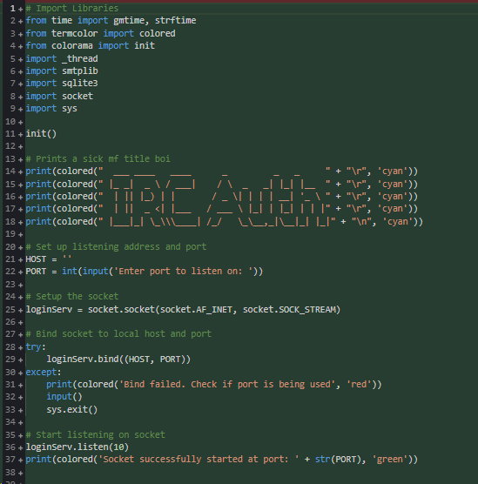

As I am using threading I have to repeat a lot of code throughout the program. I first create a variable to open the log file so I can append actions that happened on the server to the file to then find if a certain ip is suspicious and block them on the firewall. I first want to send “LOGIN” to the client connected. I then ask for some data from the client to then send.

I first get the ip of the user to use for later and then splits the data received into two variables, the user and password of the client who wants to sign in. I then connect to the database and create a table if not already made. I then fetch the password from the user inputted if they exist, and then check if the password is incorrect or the user doesn’t exist.

If doesn’t exist or bad password the client is sent a fail response otherwise, if the user is an admin it will respond with “ADMIN” else it will respond “PASS”. Ater this the connection will close.

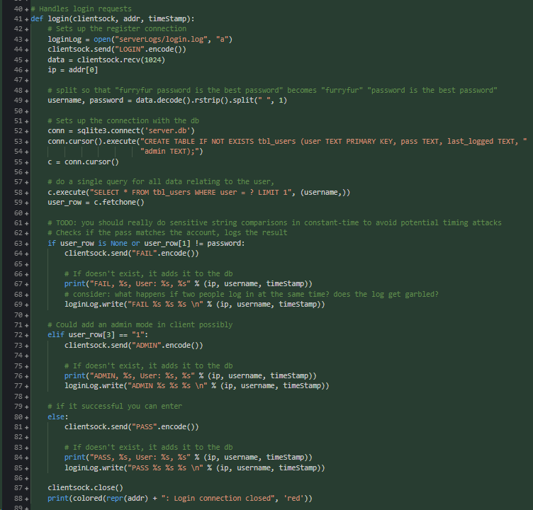

This procedure creates a new user for the database so you can login into the server. First it sends “REGISTER” to the client and then checks if the user exists with the data received from the client. If no user it adds it to the database else it sends back “EXISTS” for the client to notify the user of it. 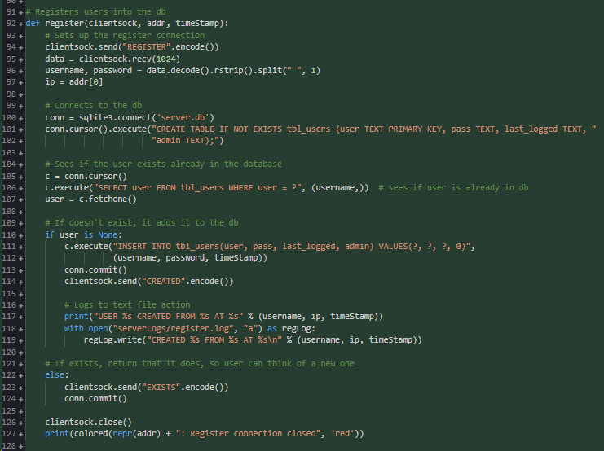

This procedure sends data to the client from the config file stored on the server. It requires the user to login first within the command itself, if successful, it sends the data to the client reading the bytes from the users config file, then closes the connection.

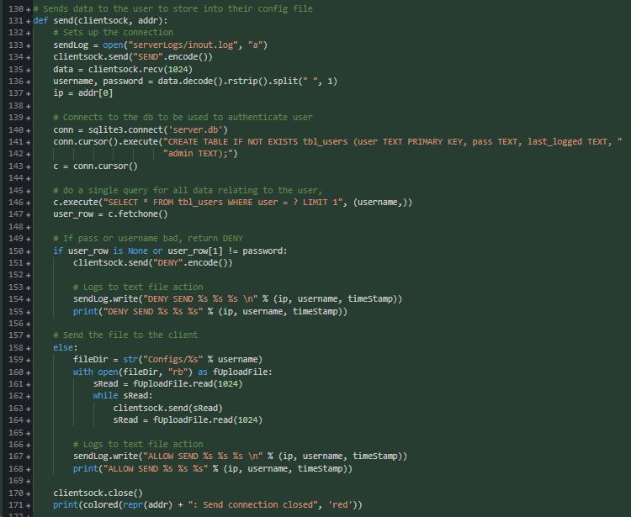

This is the opposite of above as it gets a files contents and then sends it to the client to save on their side, it requires their username and password to sign in which keeps the security high, it has to connect to the users sending port for it to send the file contents to the login server.

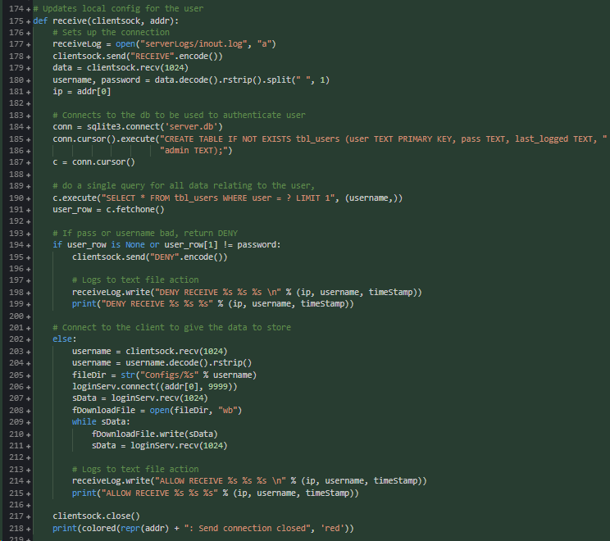

I created two place holders for the other procedures I will be making later, and finally making a while loop which repeats forever, if the data is one of the commands listed it then in the if or elif statements it will create a new thread to deal with that client connected. If the command is not recognised it responds command unknown and closes the socket.

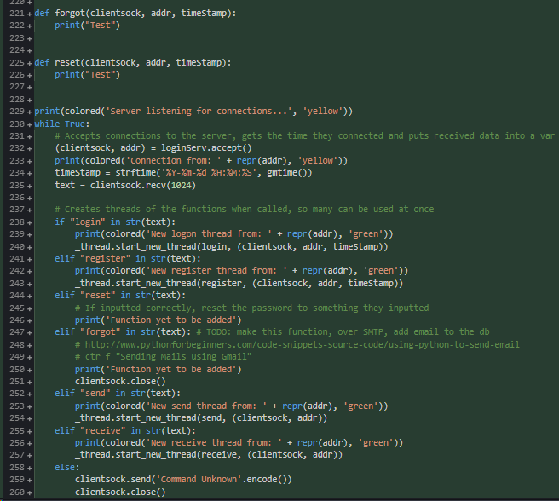

I have made a temporary file to test out the receive function for later, this is a temporary way of testing it works correctly.

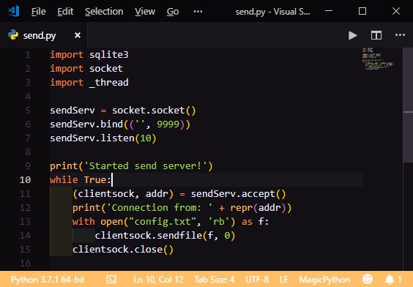

#### Testing

|  |  |  |  |  |  |
| --- | --- | --- | --- | --- | --- |
| Test no. | Criteria | Data type | User input | Expected outcome | Actual outcome |
| 7.1 | Test if computer can connect, receive data | Valid string | Send data to socket, such as hello world | To receive the message and print if it was successful | Connected successfully. |
| 7.2 | Send data | Valid string | n/a | I will connect to the socket from terminal, and see when I connect it sends data. | Server sent data. |
| 7.3 | Test if database has correct tables in it | n/a | n/a | Create the database successfully with the tables inside | So far tables were created successfully. |
| 7.4.1 | Register account, and add the username, email and password to the users table | Valid string | REGISTER Hello email@email.com password | The username, email and password added to the database | The username, email and password added to the database |
| 7.4.2 | Check if email is valid | Invalid string | Howdy aaaa password | Denies the account creation | Not working due to no email being implemented yet |
| 7.4.3 | Make a password longer than 72. | (Hopefully valid) Extreme string | REGISTER Hello email@email.com (73 char random password) | Adds account to the database successfully | Adds account to the database successfully |
| 7.5.1 | Receive a file client side | Valid string | SEND  Username Password  File contents | A file from the client has been downloaded onto the server | Did not work |
| 7.5.2 | Send a file from the client | Valid string | RECEIVE  Username Password | Gets the text from a file, and sends it to the client successfully | A file from the client has been downloaded onto the server |
| 7.6.1 | Generate code and add it to the database | Valid string | FORGOT  Username | The code is in the database in the reset_code table. | n/a |
| 7.6.2 | Send email to users email | Valid string | FORGOT Username | Look at emails to see if the code was sent | n/a |
| 7.6.3 | Deny non-existent user | Invalid string | FORGOT IncorrectName | Don’t generate and send email | n/a |
| 7.7.1 | Successfully login user | Valid string | LOGIN  Username Password | Server sends “ALLOW” to the user | Server sends “ALLOW” to the user |
| 7.7.2 | Deny user if password or username is wrong | Invalid string | LOGIN  User  FakePass  LOGIN  FakeUser  Pass | Send “DENY” to the user | Send “DENY” to the user |
| 7.8.1 | Change password for the user | Valid string | RESET Username ResetCode NewPass | The hash has changed in the database | n/a |
| 7.8.2 | Deny invalid reset code | Invalid strong | RESET User fake Pass | Don’t change password | n/a |
| 7.8.3 | Deny invalid username or password | Invalid strong | RESET User code Fake  RESET Fake code Pass | Don’t change password | n/a |
| 7.9 | Accept multiple connections at once | n/a | n/a | Multiple clients communicating to one server | Multiple clients communicating to one server |

7.4.2: The server successfully made an account, however I have not implemented emails yet so this would of not worked

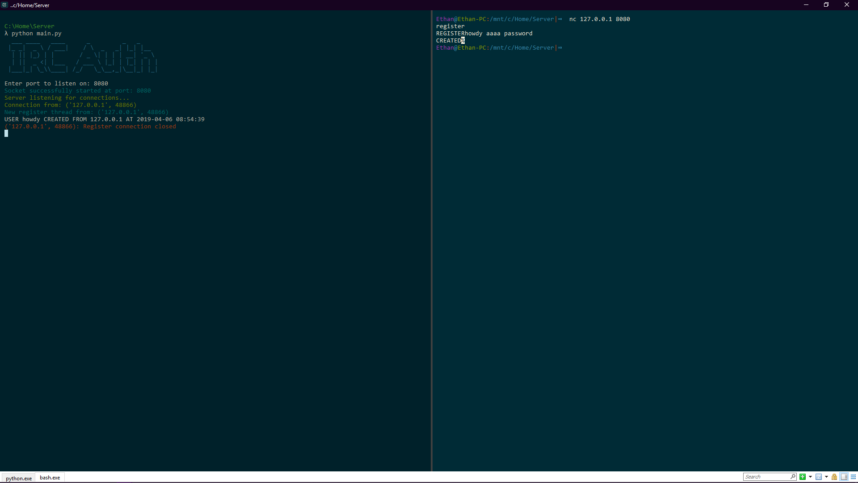

7.5.1: The server did not respond to my send server so it did not work as intended

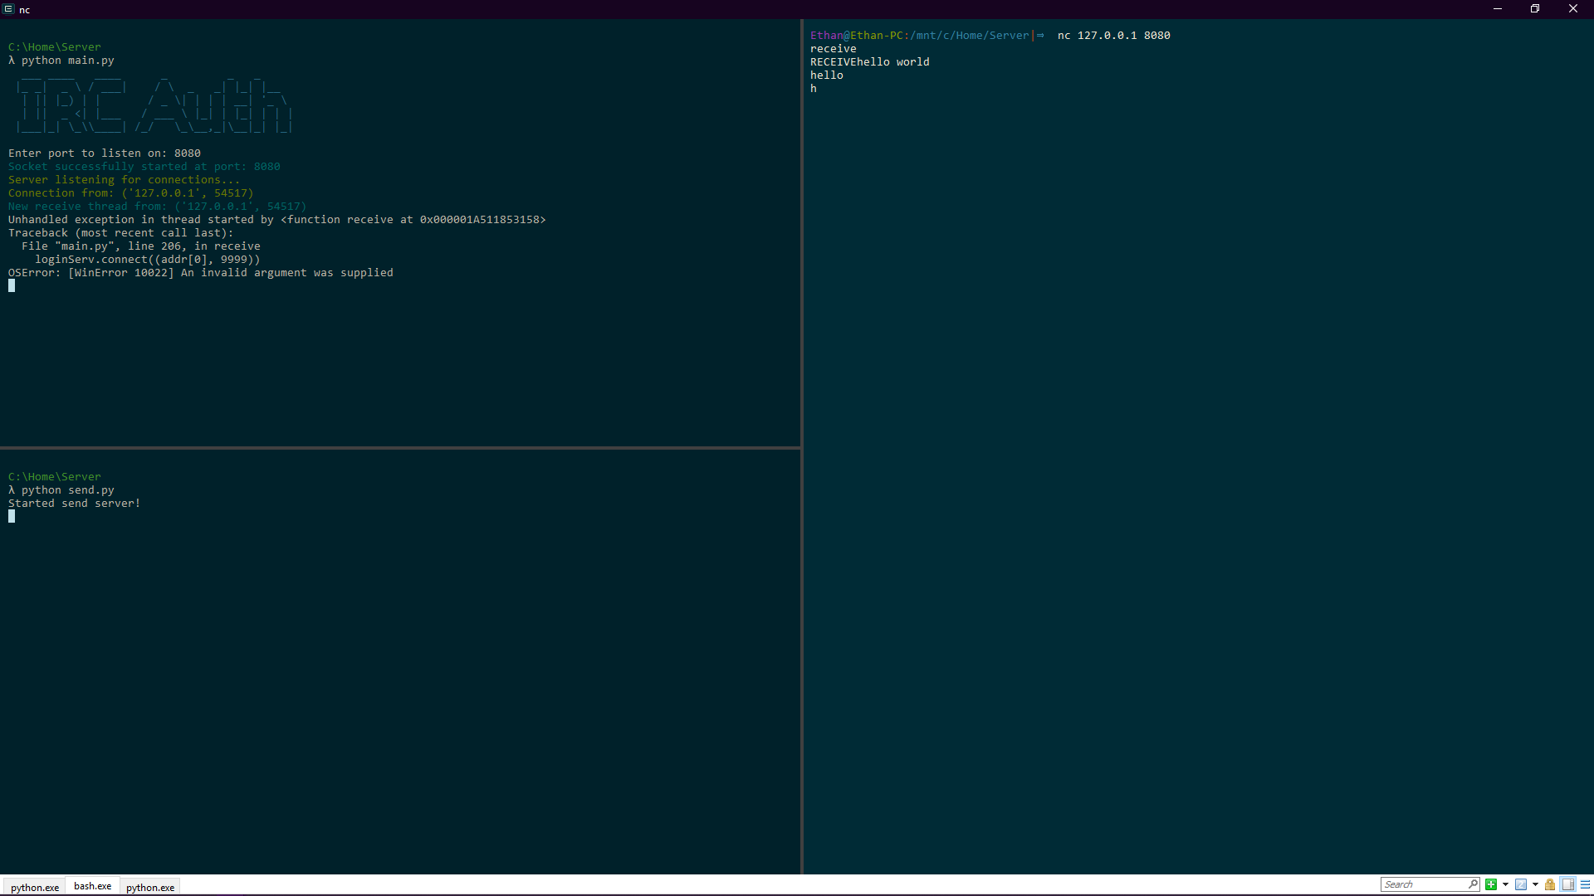

#### Review

What has been done:

I have created a login procedure to deal with clients logging in, a register procedure to create accounts, a receive procedure for the server to receive files to the server, and send to send files to the client.

How it meets the success criteria:

2.1.2.1 , 2.2.3 and 2.1.2.2

2.1.2.1: The login server adds new users to the database when registering

2.2.3: Wrong username or password inputted creates error

2.1.2.2: Doesn’t create duplicate users

Changes in the design:

I have had to create a test file to send the file to the receive procedure to test if it worked, and threading is slightly different to what I thought.

Summary of the prototype:

The server can create and login users to the server, as well as send files and will have the receive procedure fixed by the end.

### Second Iteration

This sub checks if the user exists firstly, then if the user does, it gets the email of the user. Afterwards it creates the reset code table if doesn’t exist. It checks if the user already has a code or not, if they already have, it deletes the record. Both branches then add the reset code to the table. Before the if statement I generate a uuid4 code and then hash the uuid., this is the reset code.

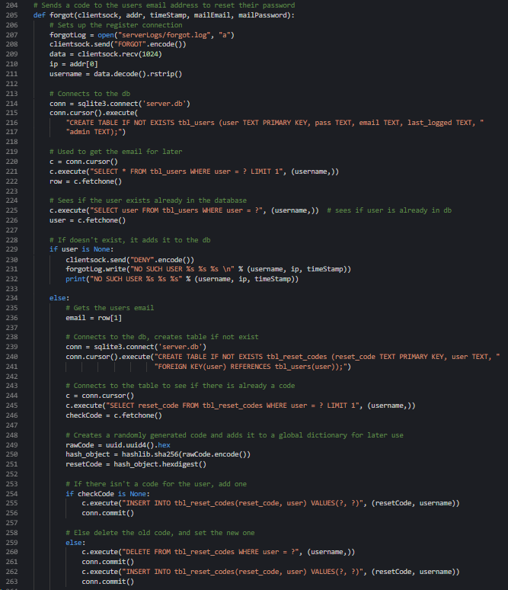

I then set the variables for the email which is needed to be sent. The sent_from is mailEmail to use to send the email to the users email. To is the users email, the subject is the subject of the email, and the body will contain the reset code.

Email_test concatenates it and then uses a try catch statement. If it works, it sets the email server as smtp.gmail.com and then intilises the connection to the server, logs into the email and then sends the email and closes the connection.

After this it closes the connection if successful and sends “SENT”, if not it sends “FAIL”

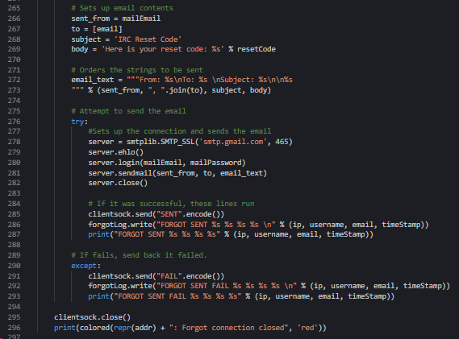

I need to get the gmail username and password so the server can use it to send the email to the client, so I added a variable for this too.

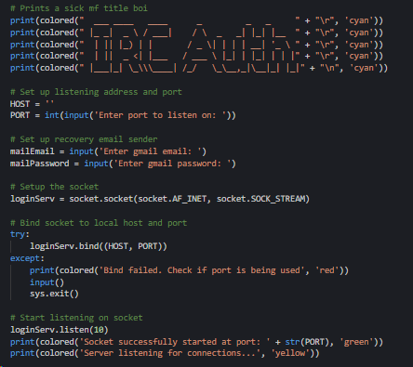

#### Testing

|  |  |  |  |  |  |
| --- | --- | --- | --- | --- | --- |
| Test no. | Criteria | Data type | User input | Expected outcome | Actual outcome |
| 7.4.2 | Check if email is valid | Invalid string | Howdy aaaa password | Denies the account creation | Not working due to it not being implemented yet |
| 7.5.1 | Receive a file | Valid string | SEND  Username Password  File contents | Gets the text from a file, and sends it to the client successfully | Still doesn’t work as not coded the fix yet |
| 7.6.1 | Generate code and add it to the database | Valid string | FORGOT  Username | The code is in the database in the reset_code table. | The code is in the database in the reset_code table. |
| 7.6.2 | Send email to users email | Valid string | FORGOT Username | Look at emails to see if the code was sent | Email received with code |
| 7.6.3 | Deny non-existent user | Invalid string | FORGOT IncorrectName | Don’t generate and send email | Denied the username |
| 7.8.1 | Change password for the user | Valid string | RESET Username ResetCode NewPass | The hash has changed in the database | n/a |
| 7.8.2 | Deny invalid reset code | Invalid strong | RESET User fake Pass | Don’t change password | n/a |
| 7.8.3 | Deny invalid username or password | Invalid strong | RESET User code Fake  RESET Fake code Pass | Don’t change password | n/a |

7.4.2: I have not implemented email checking just yet so it doesn’t work for this iteration yet

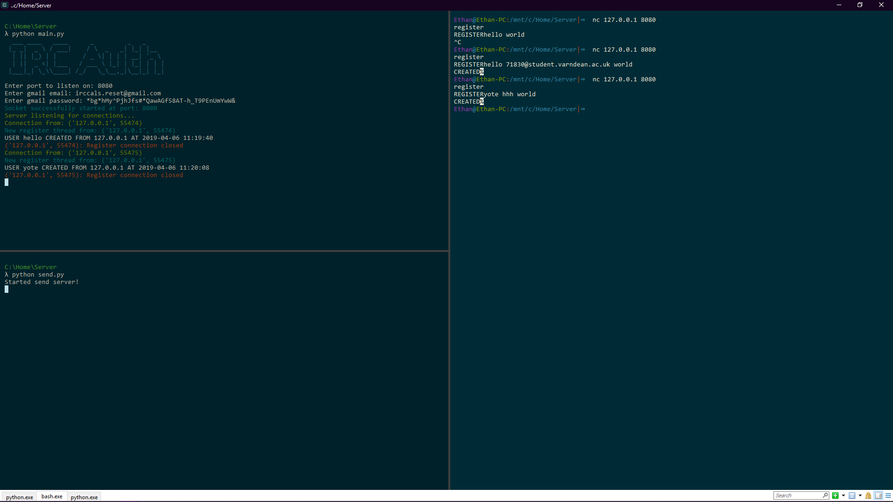

#### Review

What has been done:

Added the forgot procedure to reset passwords via email which has been successful but I need to validate the email.

How it meets the success criteria:

2.5.2.1 and 2.5.2.2

2.5.2.1: Didn’t allow invalid usernames in when requesting a reset code

2.5.2.2: Successfully sent a request code to user

Changes in the design:

I had to create and format an email to send it off to the server.

Summary of the prototype:

Added forgot procedure

### Third Iteration

I imported new libraries for new functions for the server. I now use the logging library to easily log the events on the server and then also prints it to the screen too. I create a handler to then log it. I also format the log to get the time, name, level of log and message such as “PASS”. Next is cursor_up_one, which goes up one line in the console and erase_line erases that line.

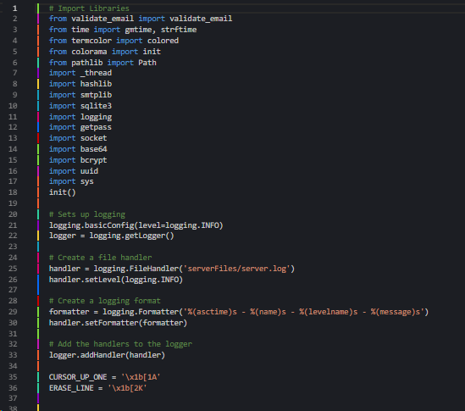

I now hash the password using bcrypt which means the password is now no longer stored on the server, but the bcrypt hash is stored it on the server. I also update the time the user logged in on the table. And added logging too.

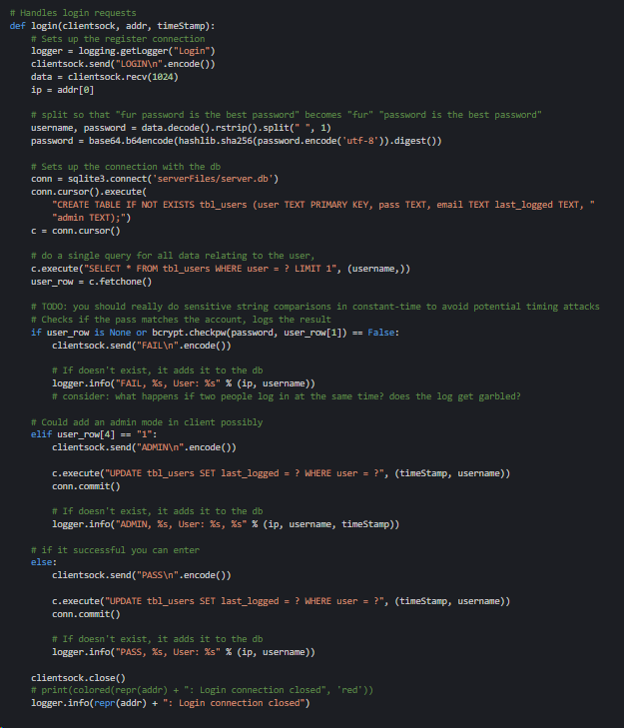

I now generate the hash from the password, and then check if the email is valid or not. If invalid it doesn’t create the new account and added logging too. This is the end of the updates for this section.

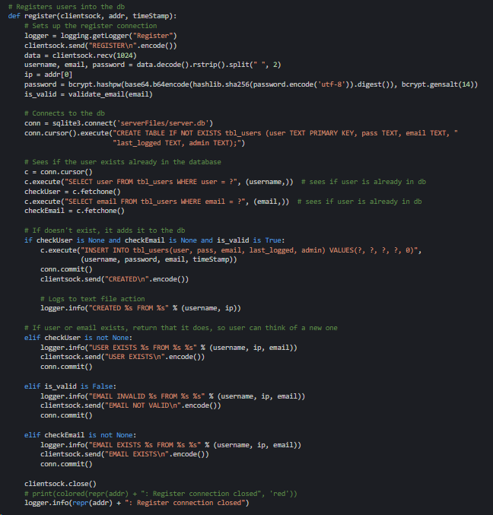

Next I added the bcrypt hash to send and added the email to the sql table creator as well as adding logging to the procedure.

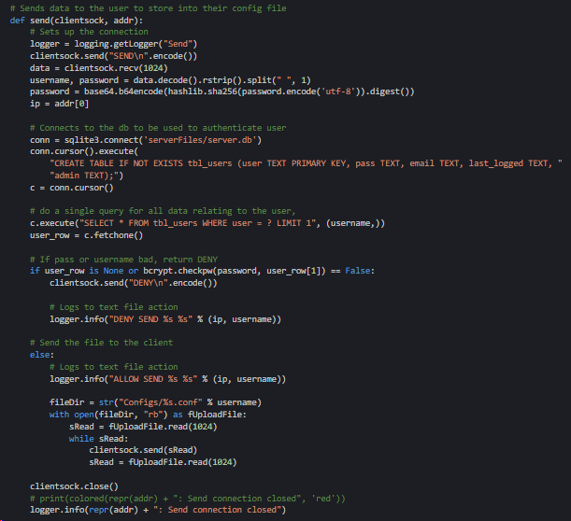

And the same from above for this section too to keep it secure and consistent between procedures.

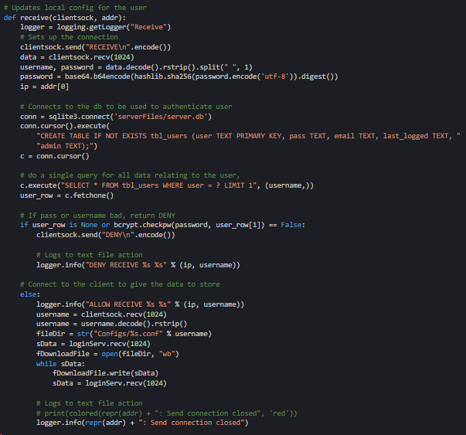

I added logging too to the forgot procedure as well to know when someone is trying to reset a password on the account.

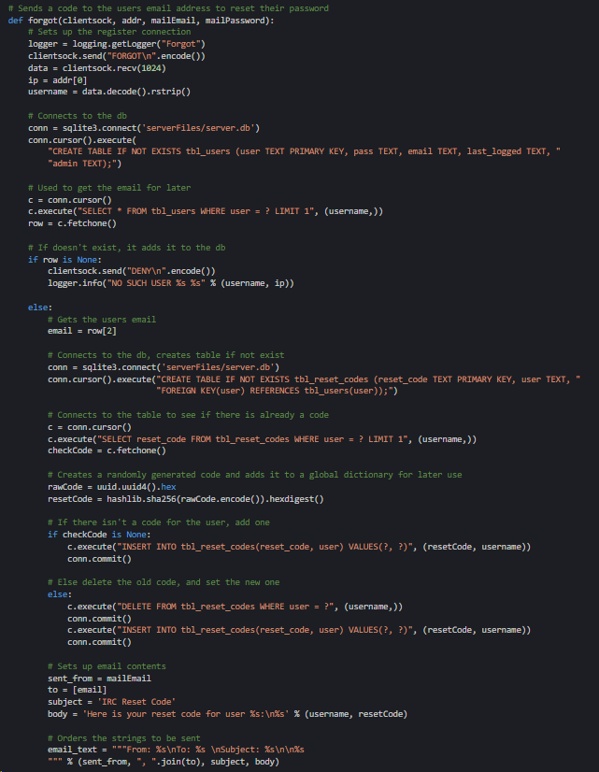

Lastly I created the reset form, it gets the code and find the user paired with that code. If the code matches the username it will reset the password, if they don’t match or the code doesn’t have a username linked it doesn’t reset the password. The password is hashed and then stored into the server replacing the current stored hash for that account.

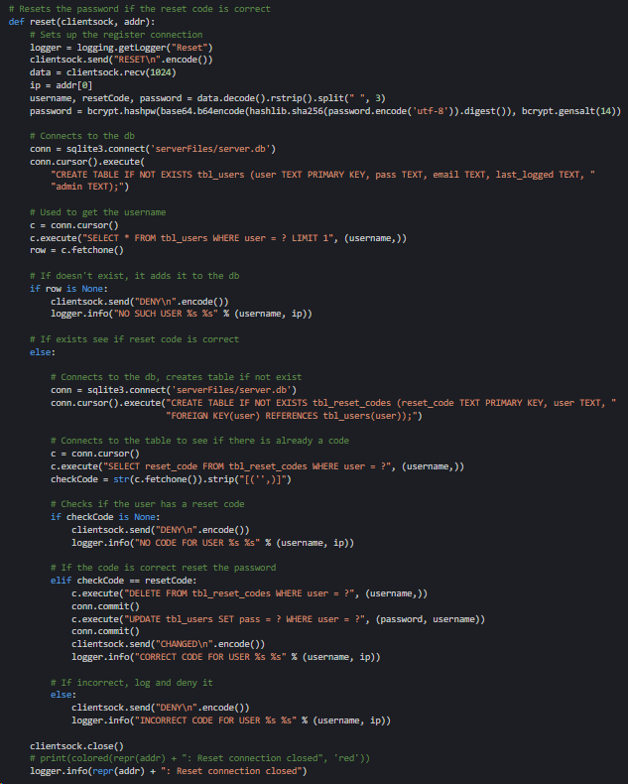

It opens up a file called login.conf to check if it exists, and if so it opens it and reads the text into the contents variable. It stores the port, email and email password. If the file doesn’t exists it asks for an input for it to start.

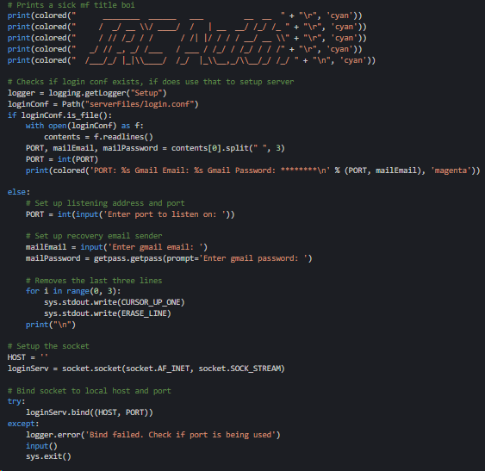

I now log just before the new thread, I added a “GET” request if a browser visits that site, the browser displays “IRC Auth!” and the server logs the event to the file.

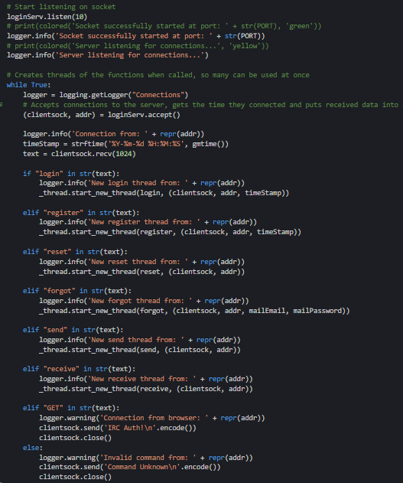

Lastly I fixed the send procedure which now, when tested using the send.py file using an account called hello, it sends the file contents to the server and the server overwrites the content in the file with the received data.

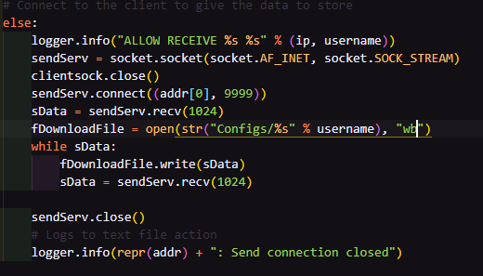

I wanted to redirect the client away from the server to the ip of the server instead so I send the file after giving a http response back to the browser.

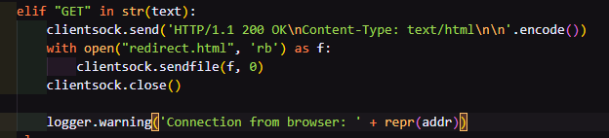

The website redirects the browser back to the port 80 where a website could be hosted if I might add if I have the time.

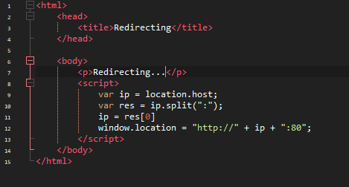

#### Testing

|  |  |  |  |  |  |
| --- | --- | --- | --- | --- | --- |
| Test no. | Criteria | Data type | User input | Expected outcome | Actual outcome |
| 7.4.2 | Check if email is valid | Invalid string | Howdy aaaa password | Denies the account creation | Denies the account creation |
| 7.5.1 | Receive a file to the client | Valid string | SEND  Username Password  File contents | A file from the client has been downloaded onto the server | A file from the client has been downloaded onto the server |
| 7.8.1 | Change password for the user | Valid string | RESET Username ResetCode NewPass | The hash has changed in the database | The hash has changed in the database |
| 7.8.2 | Deny invalid reset code | Invalid strong | RESET User fake Pass | Don’t change password | Don’t change password |
| 7.8.3 | Deny invalid username or password | Invalid strong | RESET User code Fake  RESET Fake code Pass | Don’t change password | Don’t change password |

#### Review

What has been done:

Fixed bugs, added new method of logging, hashes passwords and deals with a stray browser navigating to the login port.

How it meets the success criteria:

2.5.3 , 2.4.3 and 2.4.2

2.5.3: Don’t allow invalid reset codes to change password of a user, or username is incorrect

2.4.3: Doesn’t reset the password when given incorrect code and credentials

2.4.2: Resets the password when given correct code with username and other inputs filled correctly

Changes in the design:

Having to change the hashing algorithm from SHA256 to bcrypt as well as dealing with GET requests from browsers.

Summary of the prototype:

Fixed bugs, hashes passwords, logging changed and handles GET requests

## Explaining IRC

IRC stands for Internet Relay Chat

IRC is essentially the predecessor to applications such as discord or slack, it is a application protocol used to communicate to others which allows different clients to connect and not just one, discord and slack only allow their clients to use their servers, but IRC will let any. This can be a security problem however only for the unsecured clients.

IRC has two methods of communicating with others, the first is direct to a user, so it’s only you and the other talking to each other over the server.

The other are channels which allow you and several others to talk in one place, like a group chat.

IRC has commands, such as “/join” which will allow you to join a server, or “/leave” which will make you leave one. There are lots of commands which take programming on client side which I will have to code in the future as there are many, I will be sticking with: /join, /leave, /msg and /add. /add is my own command which will add a user to the sticky list of usernames in the bottom left so you can remember who you can trust on IRC.

IRC also has standard ports of SSL and not encrypted ports. The standard encrypted port for IRC uses port 6697, other ports are usually unencrypted, so I will make the client automatically connect over SSL on this port.

Servers will occasionally send a “PING” message on its own to the client, the client needs to respond with “PONG” otherwise the server will assume the client has lost connection or disconnected from the server.

## IRC Client Iterations

### First iteration: Login Main Menu

I first created the form in visual studio, I will be coding the project in vb.NET so I created a winforms vb.NET program because of this. I created this from my original form design, and downloaded fonts to use for the form.

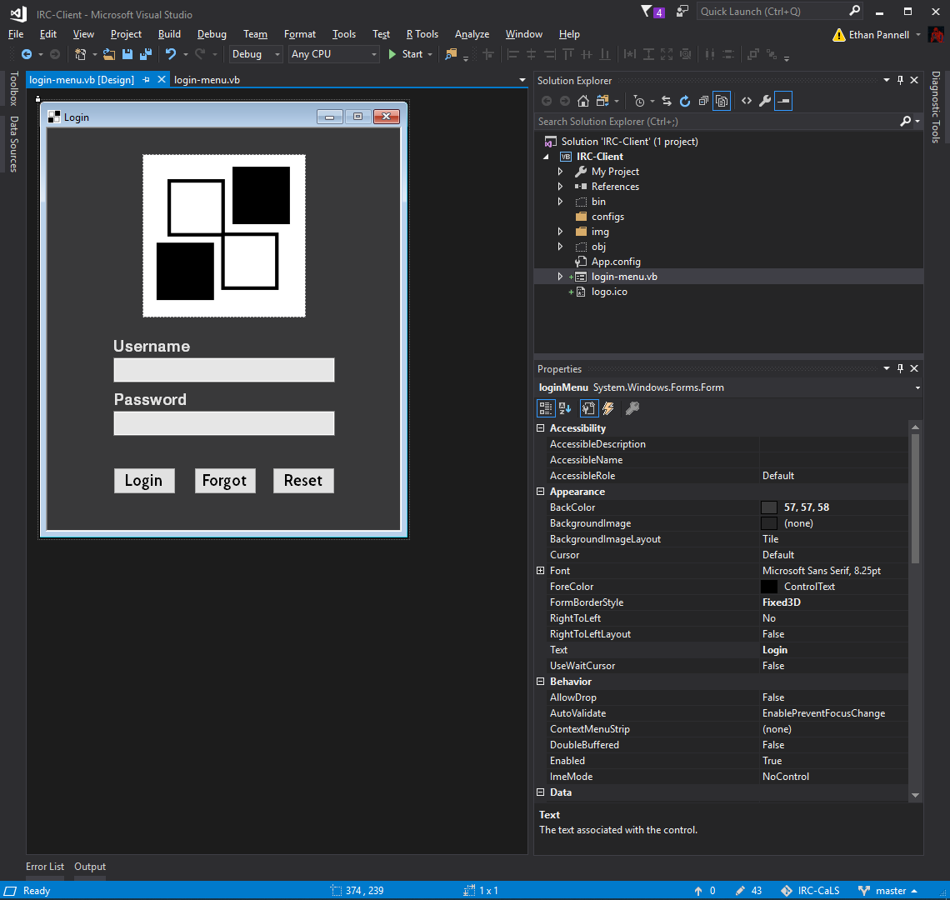

I ran the program and it compiled successfully. It displays all elements well

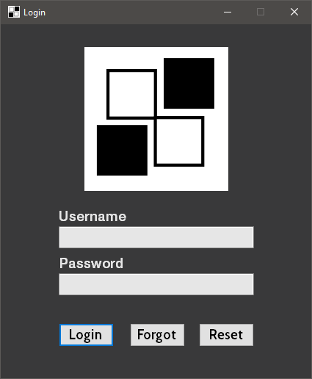

I started up my python server, and manually added a new user, the password was hashed as I will be hashing it client side and server side for added complexity.

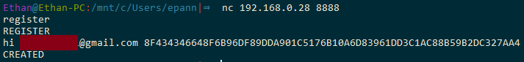

I first looked at some example code (<http://vb.net-informations.com/communications/vb.net_socket_programming.htm>) about how to connect to a server with sockets in vb.net, and got a grasp of the sockets library and imported it into the code.

I created two variables, clientSocket as a socket so I can receive data, and severStream which gets the data from the socket, and sends the data. I need these variables as they allow me to connect to the servers on the internet or in my local connections.

I then set the clientSocket to connect to my localhost port of 8888 as I will be running my server there, this was added as this is where my login server will be running temporarily, as I will be installing it to my raspberry pi.

I then set serverstream to get the datastream from the tcp connection.

As sending over sockets only allows bytes I create a new variable which could convert and hold the variable, I made a variable called outStream as this will contain the data which I will be sending through the serverStream variable.

I then write, which essentially means send, the data to the server and flush the serverstream of data.

Instream is the variable where the data received from the server is added to.

serverStream.read is the opposite of write, it read the data received into a variable.

I check if the response is correct, then if it was the expected result, send the username and password which is yet to be written. Then create a message box if the data is sent.

In whole, this piece of code connects to the server, sends “login” and expects a result, if it is the correct result send the username and password over.

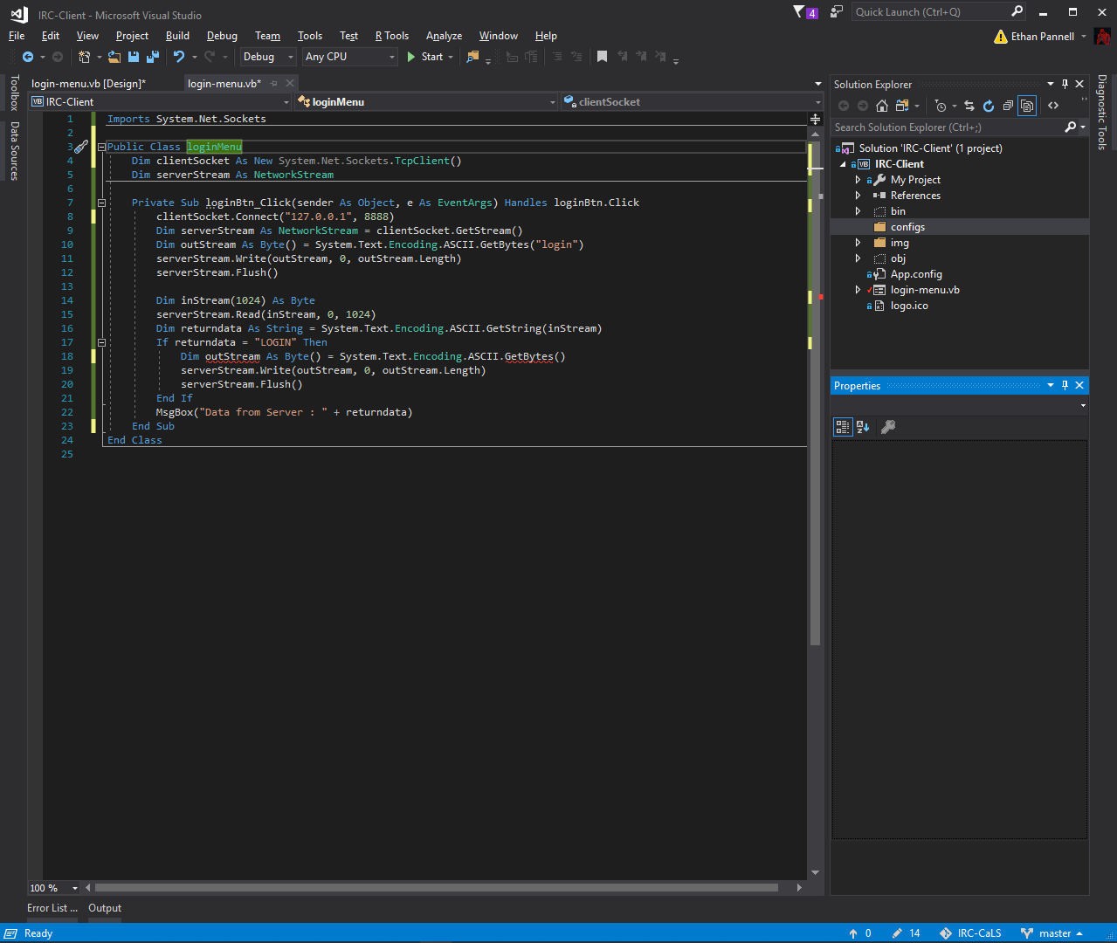

I then added three new variables, user, pass and concat. User is for the username, pass is for the password and concat will turn the string into the correctly formatted string. I then added a new function called GenerateSHA512

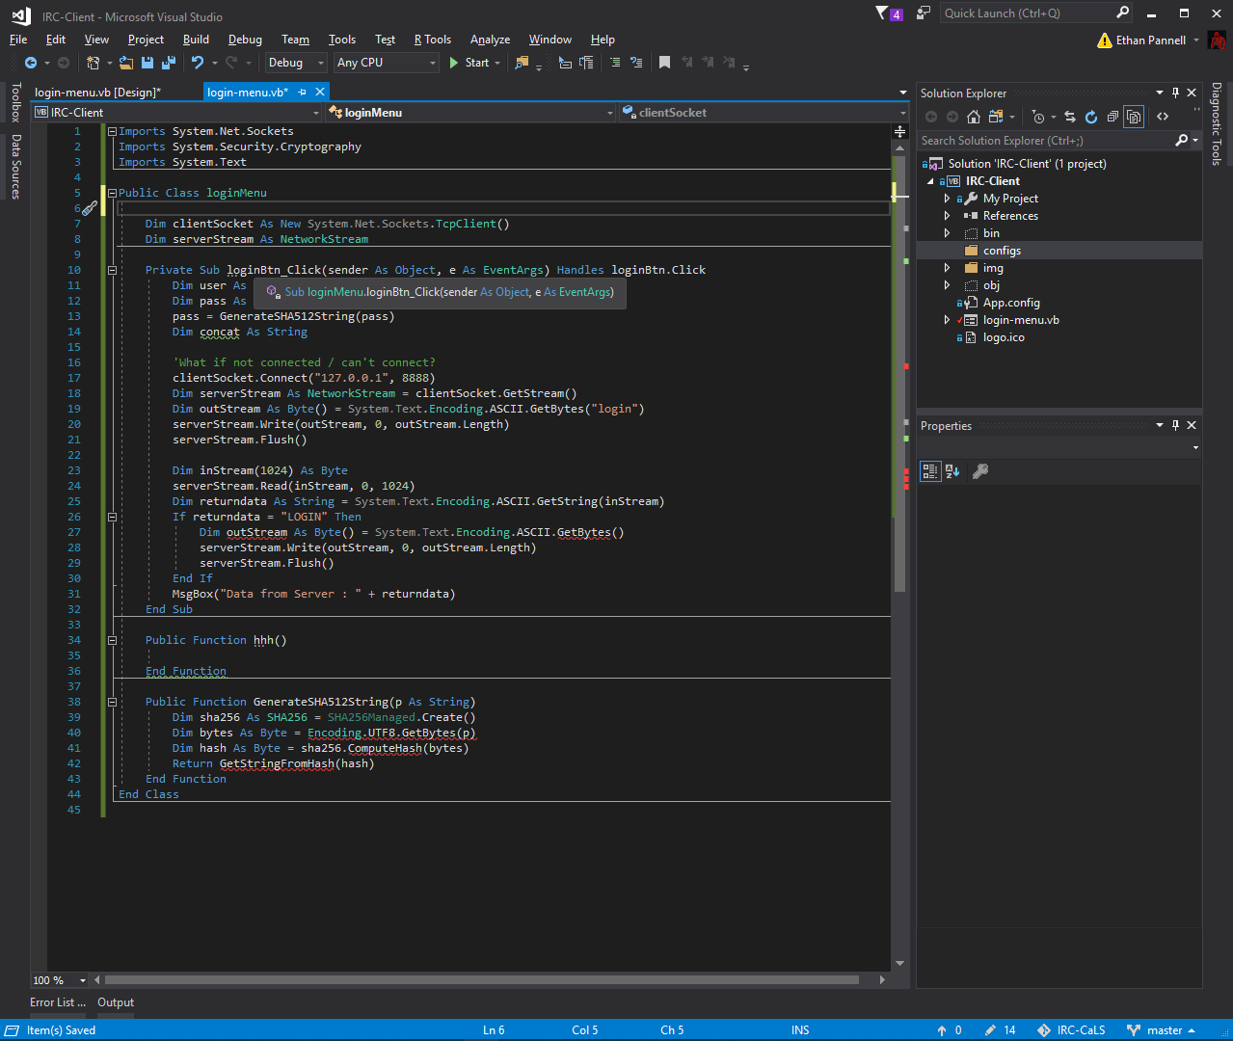

I then added debug boxes to test if I have connected to the server correctly, using the same strings I used for the server, and tested if the server responds correctly. And so far it did and created a new thread on the server however the code didn’t respond to the LOGIN response causing an error on the server side, however the server will still run.

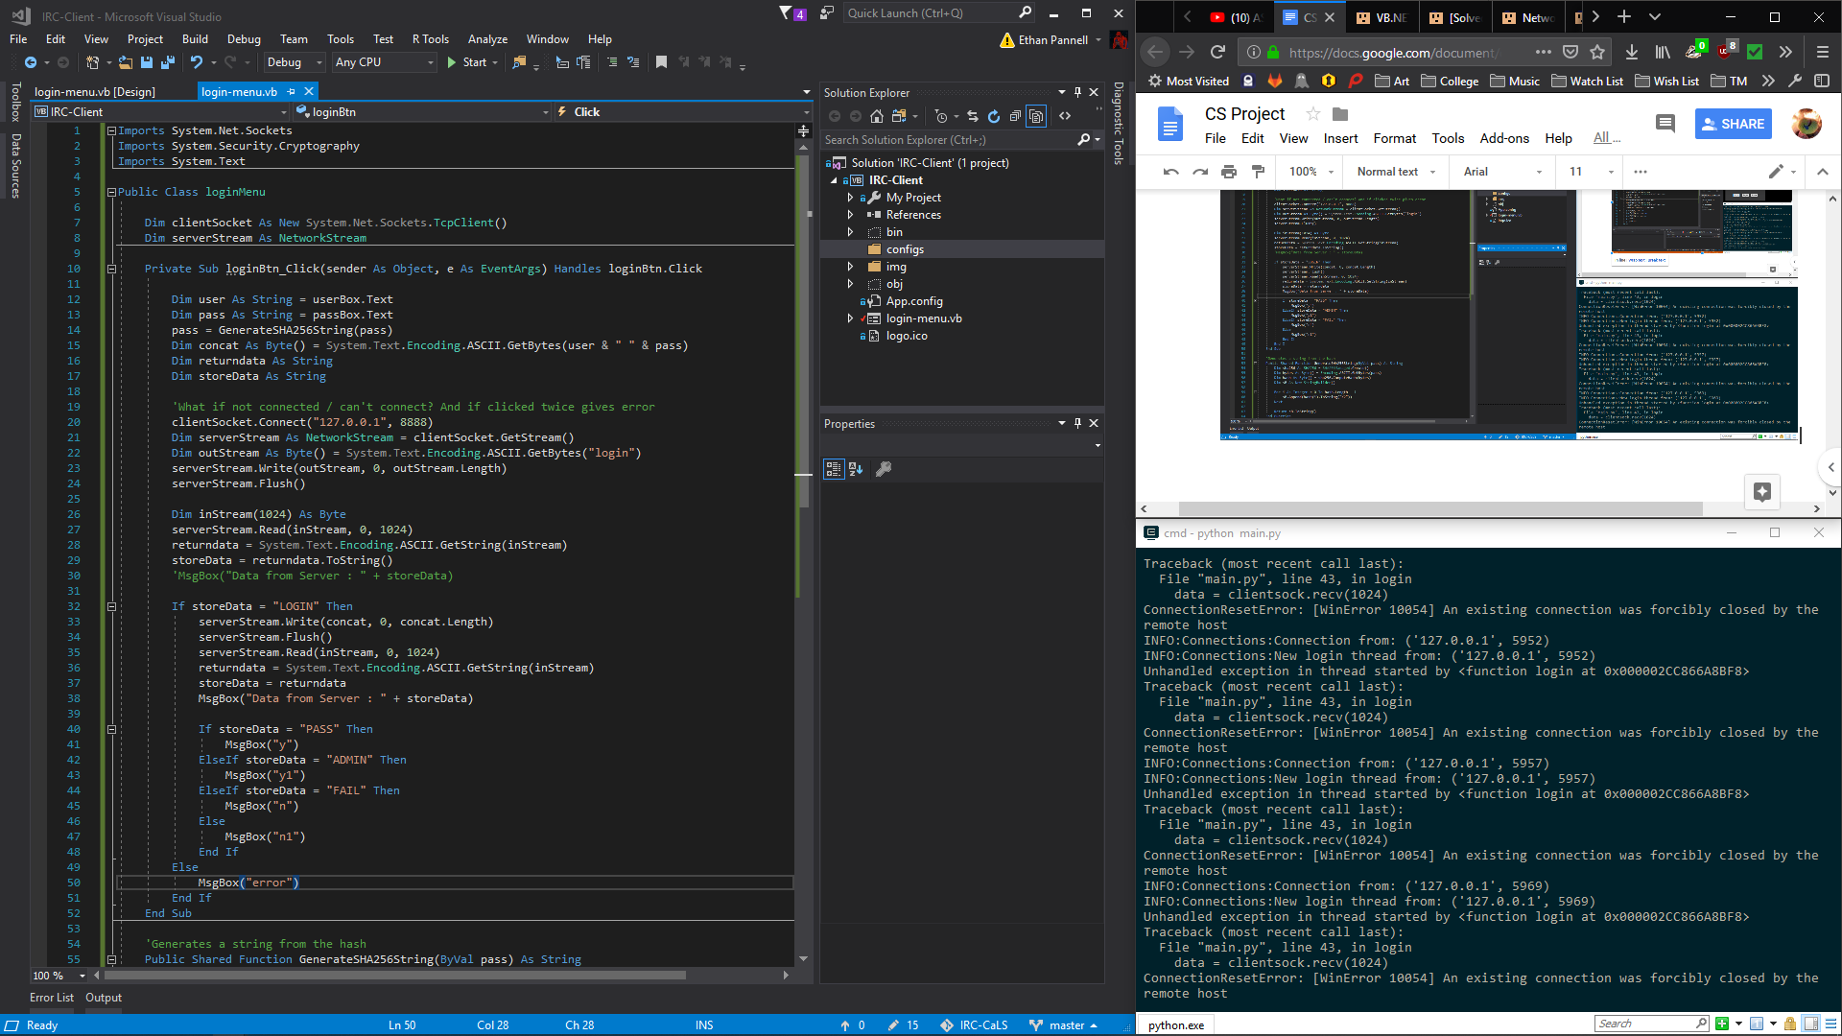

I had to change and fix the hash generator, as it wasn’t correctly outputting the hash, as well as I used a hash which is too lengthy for the database and for sending. SHA256 creates a smaller length of hash making it not take as much storage.

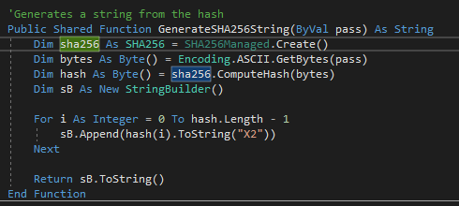

I added a text box to temporarily debug the code to see the response from the server

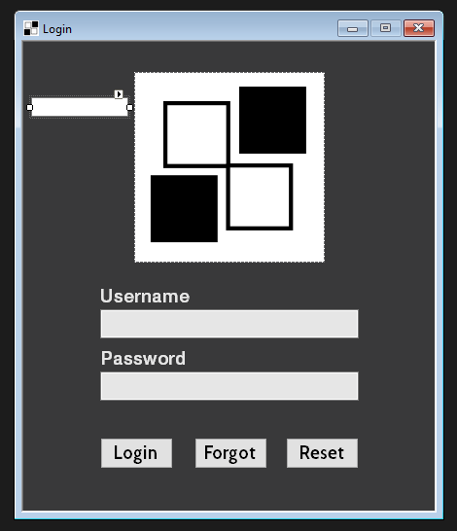

This returns the data sent to the client into the debug box for later



I ran the code and put in a username and password to test if it was still connecting. It still does but was still not sending the data correctly.

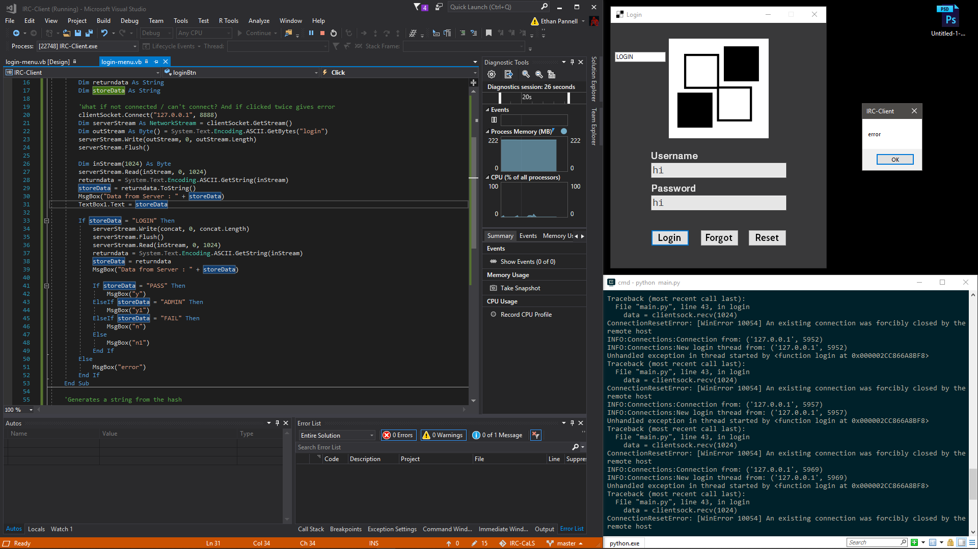

After copying and pasting the “LOGIN” text, I discovered there was a newline which could of been my issue

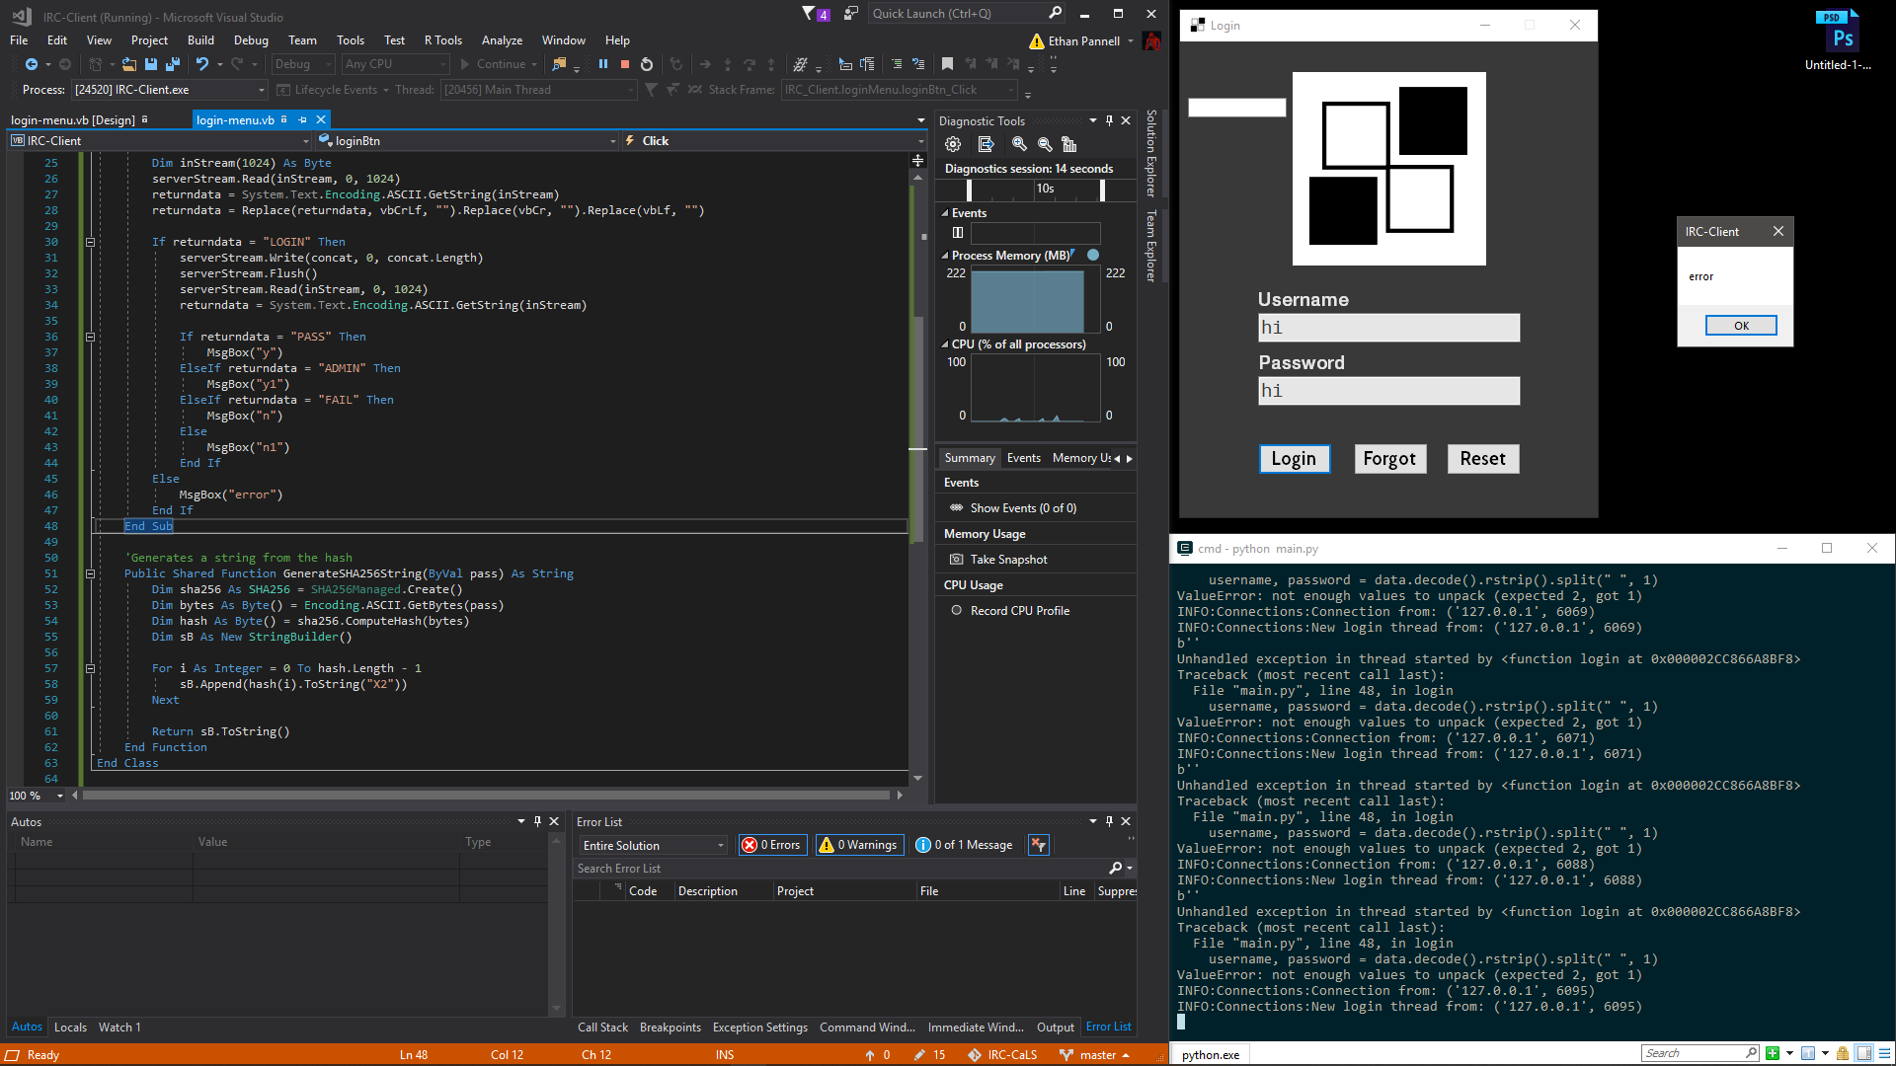

I proceed to add comments to my code so I could read it more easily to find issues for the future.

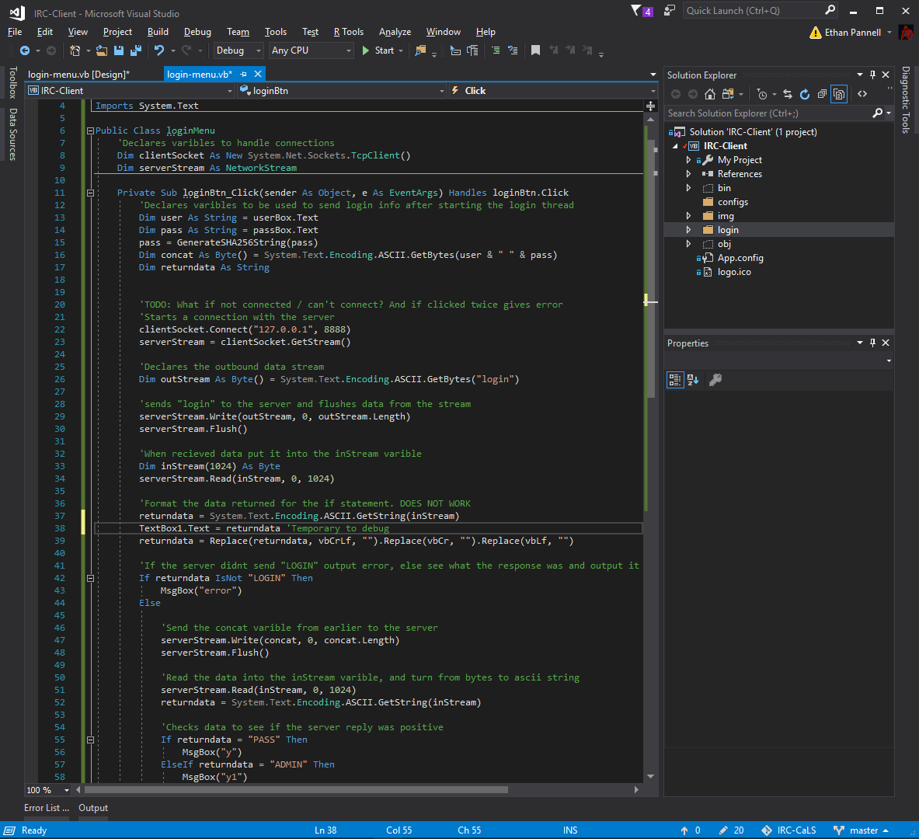

I debugged a line and found that the return data included hundreds of null characters, I had forgotten about this aspect because of the amount of bits I specified in the text.

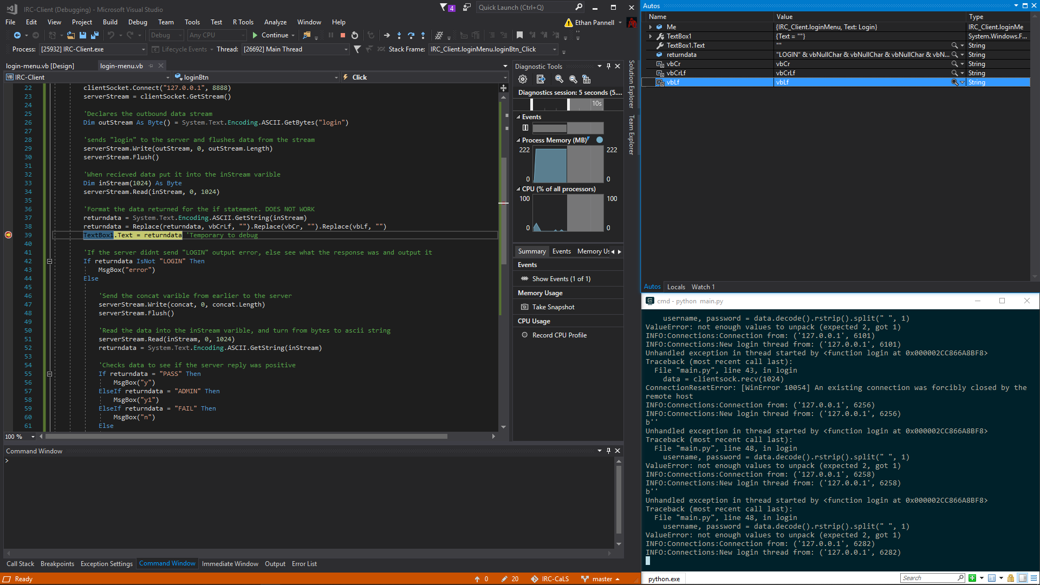

I tested it to see if it removed the null characters and it was successful.

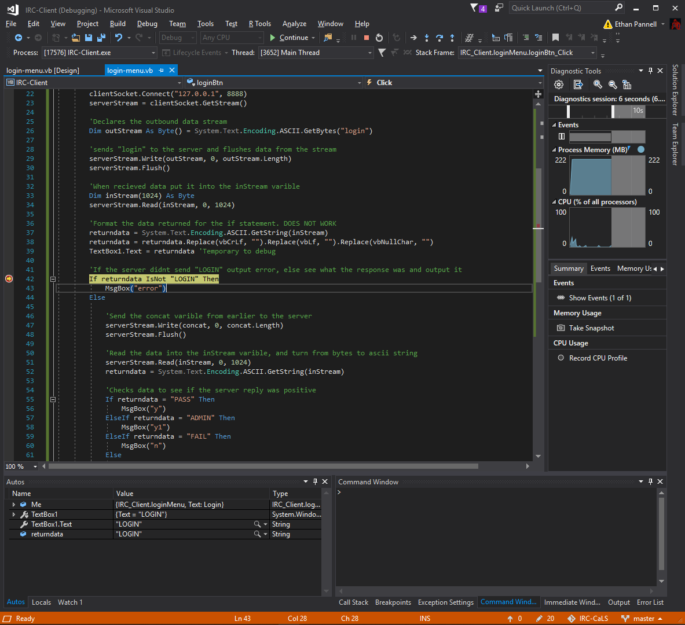

I tested it with the program and it responded n1! This means that it was successful as it communicated with the server and got a response after sending the usernames.

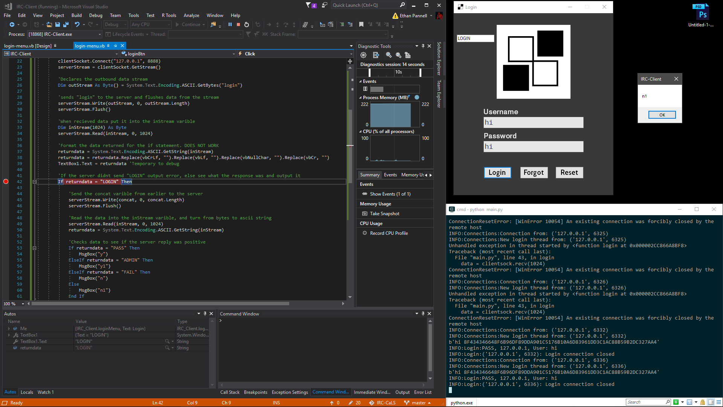

This is the line which fixed the issue, it replaces all the hidden characters which users cannot see usually.

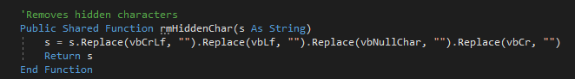

After the server communication, I want to close the connection and stream as I do not need it anymore, only until I need to retype the password or username because of an error. I close the stream to stop the data coming through then close the connection as a whole

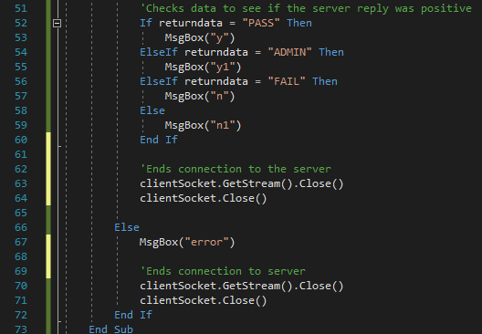

However this caused an error making me unable to connect to the server twice.

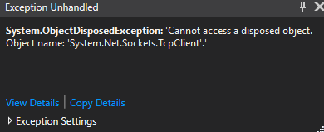

I then tired again by moving the clientSocket.connect() out of the sub into onload, it fixed the connection issue to the server, but the stream was not connected as it was disposed.

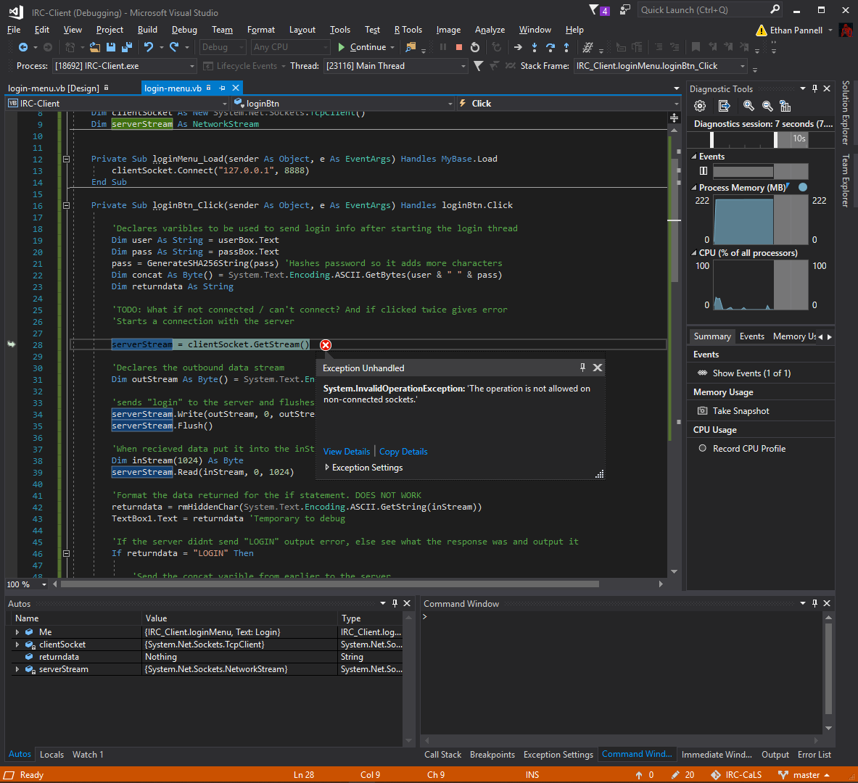

I moved the clientsocket and server stream variables into the sub so every time it is clicked it creates and disconnects from the server, rather than connecting once when the form is created.

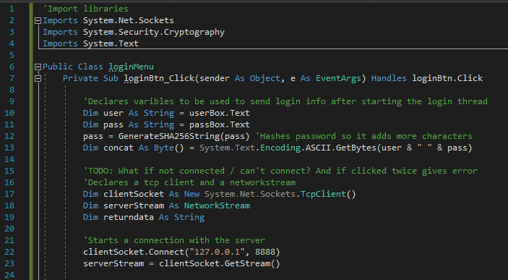

I created a new file for all of the functions and subs I will be using for the other menus. I created a rmHiddenChar sub parse the string to remove unnecessary characters. The other sub is to test connection with the internet and if there is a connection is returns true.

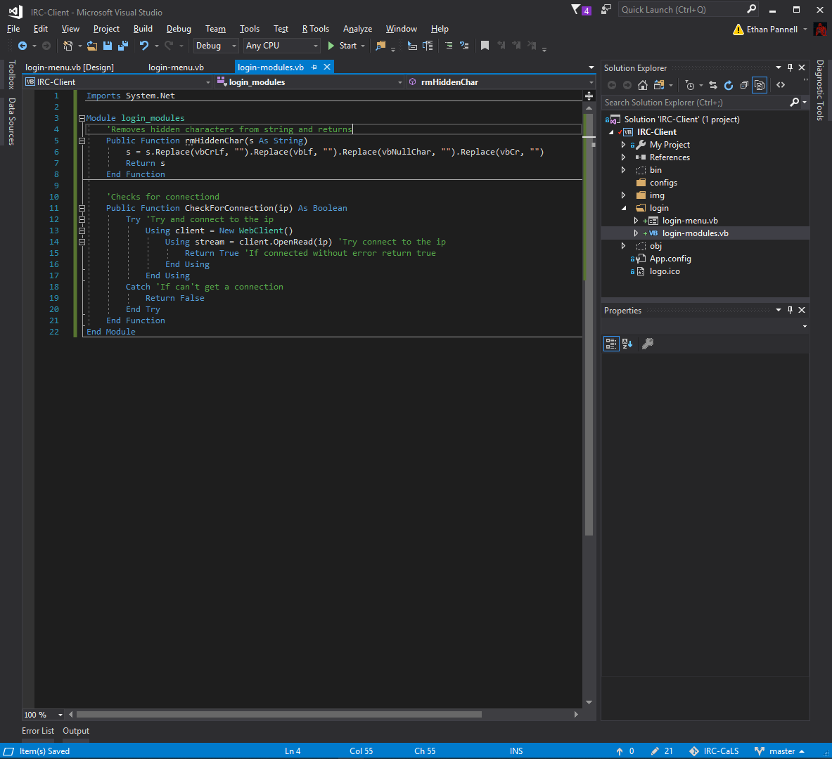

I then removed the debug line

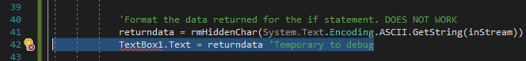

And added the ip of my computer, to test connection with it, and

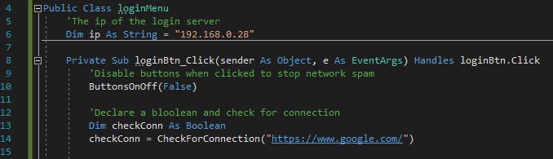

I tried to test the connection through my CheckForConnection function, however it didn’t seem like I could connect to the ip. I fixed this by changing it to google to check if I am online, however this is temporary.

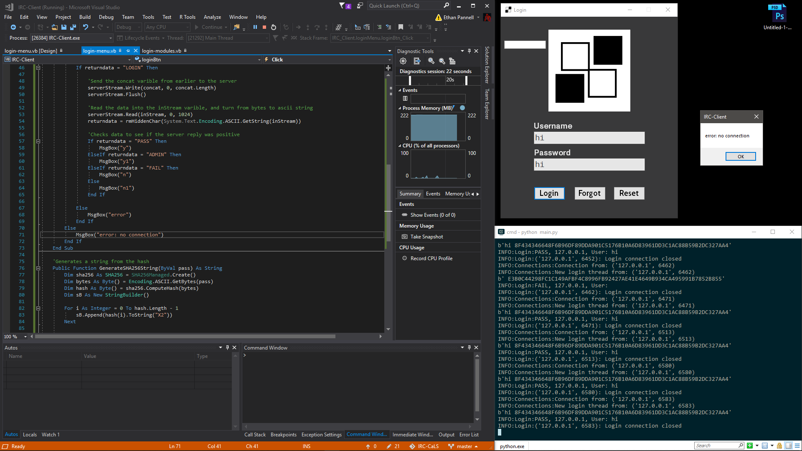

I took away the debug box as there is now no use for it

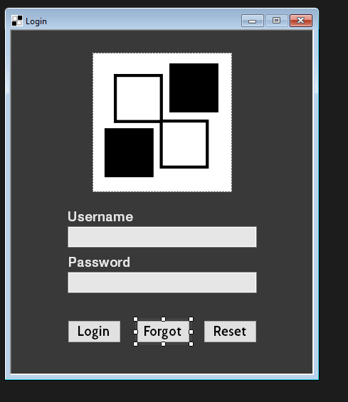

I created a module file so I could call the procedures and functions which are needed across the project for the future.This will allow me to save the amount of lines and efficiency of the program.

I also moved over the function which removes the hidden characters, I also moved the hashing function too and finally the check for connections function, I added them to this as it can be applied to each form which reduces lines and RAM usage. 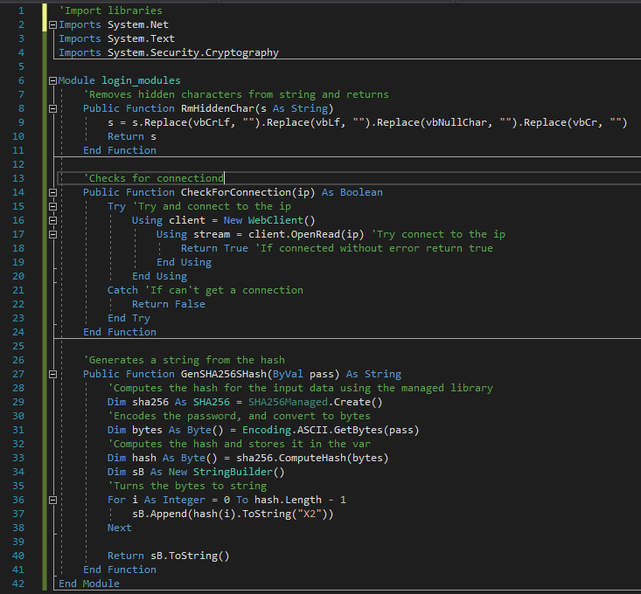

I forgot to create a button for registering to the server, so I created a new button for this issue.

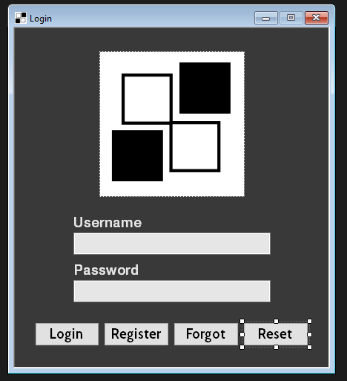

I wanted the program to be easily navigated without the use of a mouse, so I added tab indexes to each element making it easier for the user to switch between elements of the program.

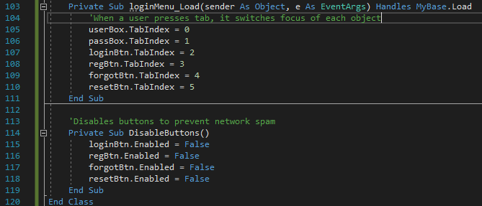

I spotted a potential bug, so I created this earlier as I did not want someone to spam click the button which would essentially DoS my raspberry pi. I created this method so once I get a response it will enable the buttons.

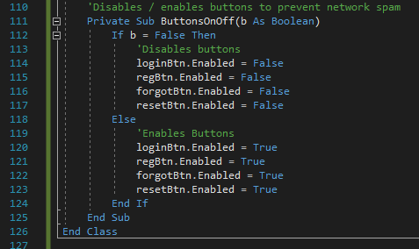

I added the line to when you first send the response which will disable the buttons.



If there was an error or a successful response it will re enable the buttons.

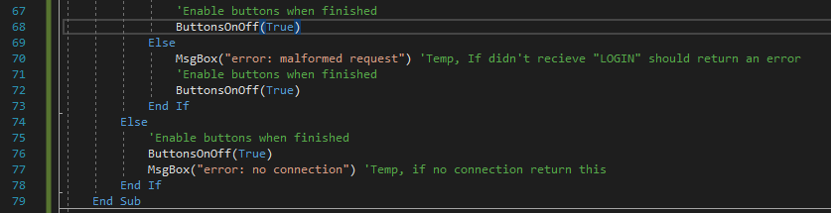

I was trying to get rid of a ding sound whenever I pressed enter on a text box, I tried this on one button. It performs a click on the button.

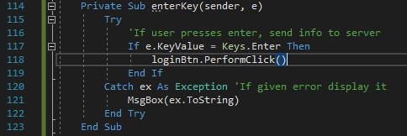

I then applied it on the boxes to see if it worked, but didn’t unfortunately.

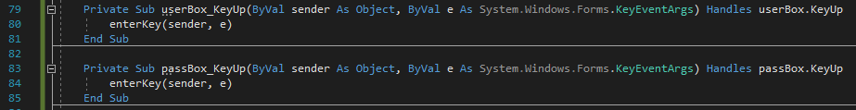

I tried adding a handled line however was not working

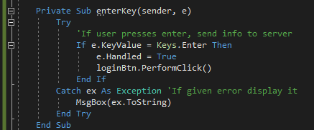

I then attempted to also do it after calling the enterKey sub but didn’t work either

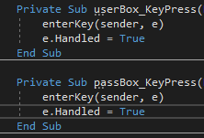

I decided to try and fix it later, however I found out it was due to my enter button trying to make new line, not because of the button as it isn’t a multiline box.

I then made a new for the register and make a sub which handled the register button which opened up the form

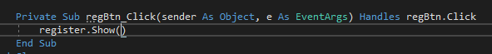

I designed the form like this, as it only needed these three text elements to successfully register a new user from it needing these sections.

#### Testing

|  |  |  |  |  |  |
| --- | --- | --- | --- | --- | --- |
| Test no. | Criteria | Data type | User input | Expected outcome | Actual outcome |
| 1.1.1 | Check if logging in with registered username and password works | Valid string | “Ethan”  “Test” | Message box or form opens | Message box or form opens |
| 1.1.2 | Test if sending incorrect username and correct password doesn’t work | Valid String, Invalid String | “Ethan”  “test” | Message appears that username or password is wrong | Message appears that username or password is wrong, but uses a message box |
| 1.1.3 | Test if sending incorrect password and correct username doesn’t work | Valid String, Invalid String | “ethan”  “Test” | Message appears that username or password is wrong | Message appears that username or password is wrong, but uses a message box |
| 1.1.4 | Test if no username or password works | Nothing | “” “” | Message appears that username or password is wrong | Message appears that username or password is wrong, but uses a message box |
| 1.2.2 | Check if clicking register opens the register form | An action not a data type | Click on register button | Register form opens | Doesn’t work |
| 1.2.3 | Check if clicking forgot opens the forgot form | An action not a data type | Click on forgot button | Forgot form opens | Doesn’t work |
| 1.2.4 | Check if clicking register opens the resetform | An action not a data type | Click on register button | Register form opens | Doesn’t work |
| 1.2.5 | Check if clicking login sends data to the server using a valid | Valid String, Valid String | “Ethan”  “Test”  Click on login button | Logs into server and shows textbox or form | Logs into server and shows textbox or form, but uses a message box |

#### Review

What has been done:

I have created the form and added elements which are needed for the future such as buttons to open the register form and other forms. I also added the functionality of logging in to the the server to open the next menu. I also handle the errors however I use message boxes currently which is not the way I want to handle it.

How it meets the success criteria:

This reaches 2.2.2 due to it successfully sending a login request and receiving the data sent from the server, so far and 2.5.1 if the server works correctly which it does in this context post-development of the login server. It has hit ¼ of 1.2 as the login button works correctly. I have also hit 1.1 as the login form opens up first.

Changes in the design:

Having to add functions for the buttons as well as having to enable and disable the buttons due to it being easily spammable by a user.

Summary of the prototype:

Created the login form and successfully logged in and semi-handled the errors but have not created the forms for the other buttons.

### Second iteration: Register Menu

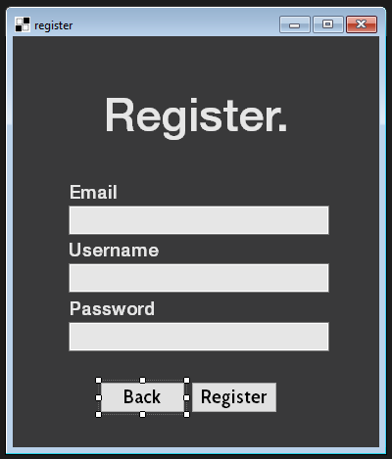

When the register form opens it will hide the original menu.

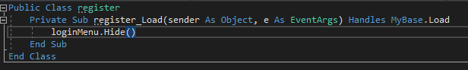

I added this to my modules file, so the IP variable is easy to get, and without it accidently getting overwritten so the users can connect successfully.

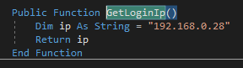

I then found out that I made my code more efficient by creating the response to be all capitals, so my client would send “login” the server would send “LOGIN” and from there I send the details and the server then cuts the connection as intended. This enables me to dynamically send data correctly reducing the lines, as it allows me to put the request type such as “register” and put the other details in without having to copy the code for each form.

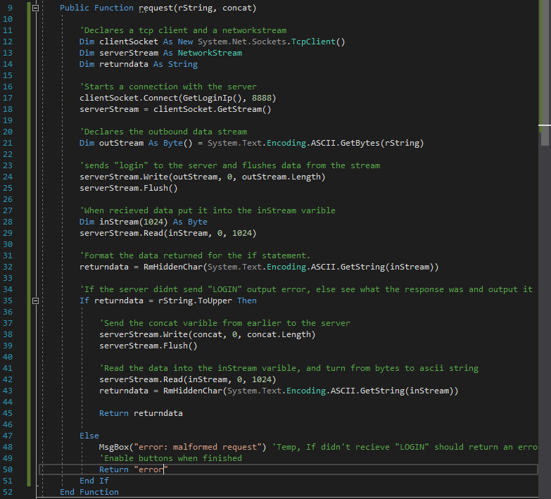

I added the function on the register code for a test, and copied the rest of the other code from the first and adjusted it. I made a concat variable which is the data which will be putting in the form, and the request type will be hardcoded into the return data variable which holds the return function to be used.

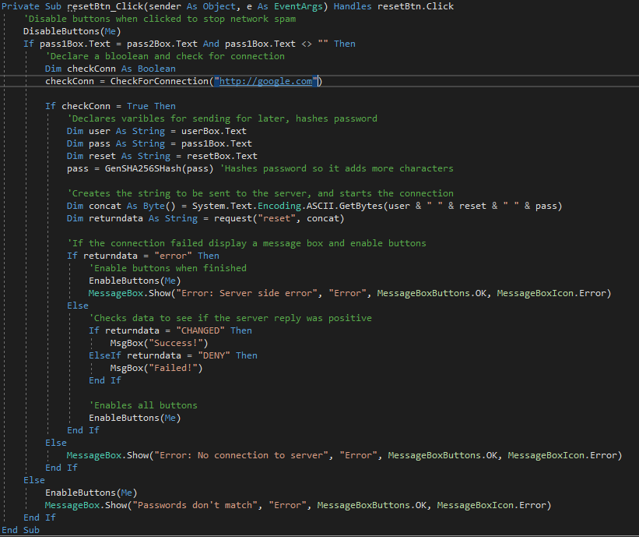

I then adjusted the login button too with the same fix, which will make the code way more efficient which is great because it will take up less storage.

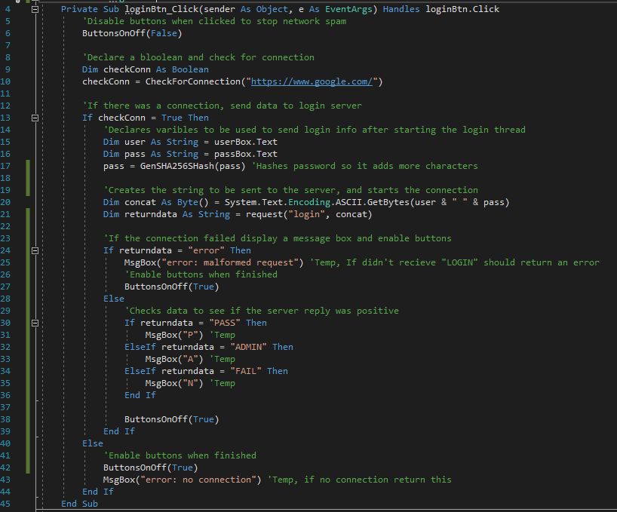

I then tested the register form with what I have created, and it work with significantly less lines, and I can apply this to the other forms which are needed to be made as well.

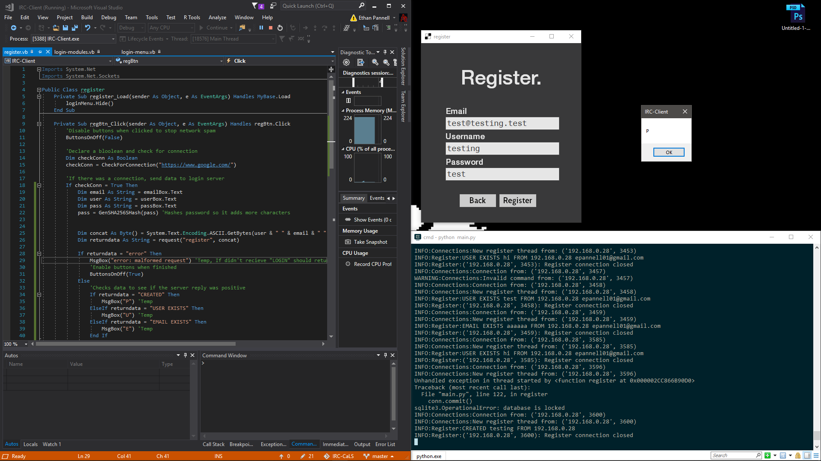

I added the tab index to the register load sub which will make it easier for users to interact with the program.

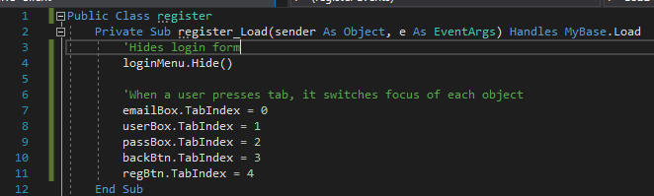

I then copied the buttons and enter key sub to the register form. As it is needed to stop spam to the server.

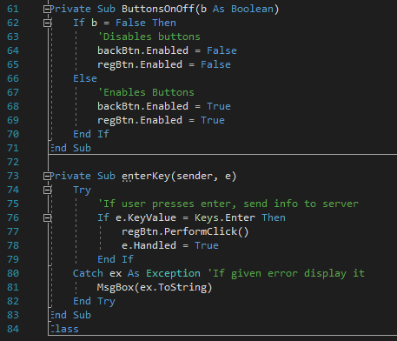

I then copied the enter key sub Initiator to each buttons, however this takes up more lines than I thought so I need to adjust this to be more efficient later however i’m not too sure how.

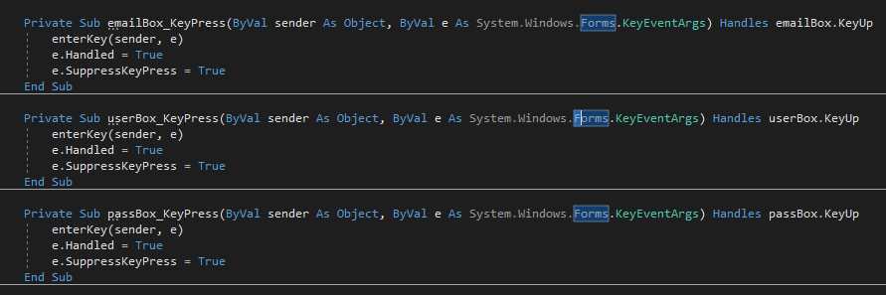

I tested an invalid email as I wanted to test if it was correctly handled, however it was not correctly handled client side, so I added a new error handler so I know if it was working correctly

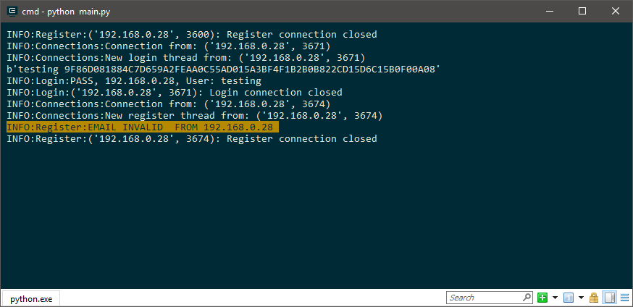

This is the new error handler which solved the issue, due to me not looking for the right string in the python file.

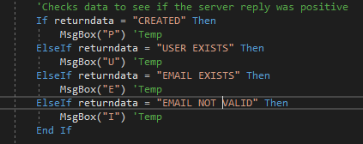

I downloaded Raspbian Lite which is the linux operating system I am using for my raspberry pi. I then wrote the image to my SD card.

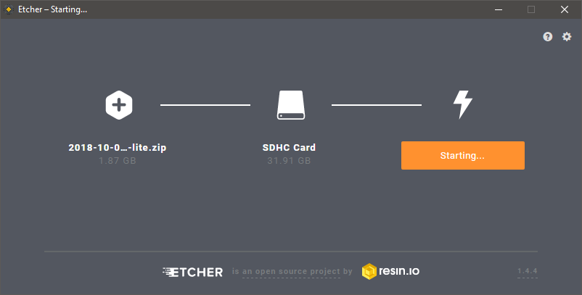

I then installed python3, pip and the libraries. I downloaded the login server directory onto my pi, and downloaded drivers for my display

I had to change some of the code, specifically that the path variable didn’t work with the open function as it didn’t work as intended at first.

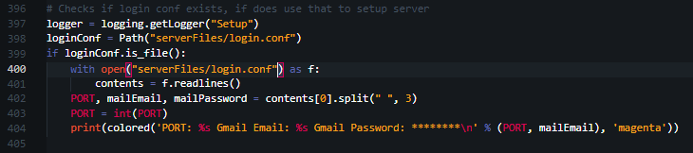

I then uploaded it to my private git repository and then pulled it to my raspberry pi and started it, and it worked.

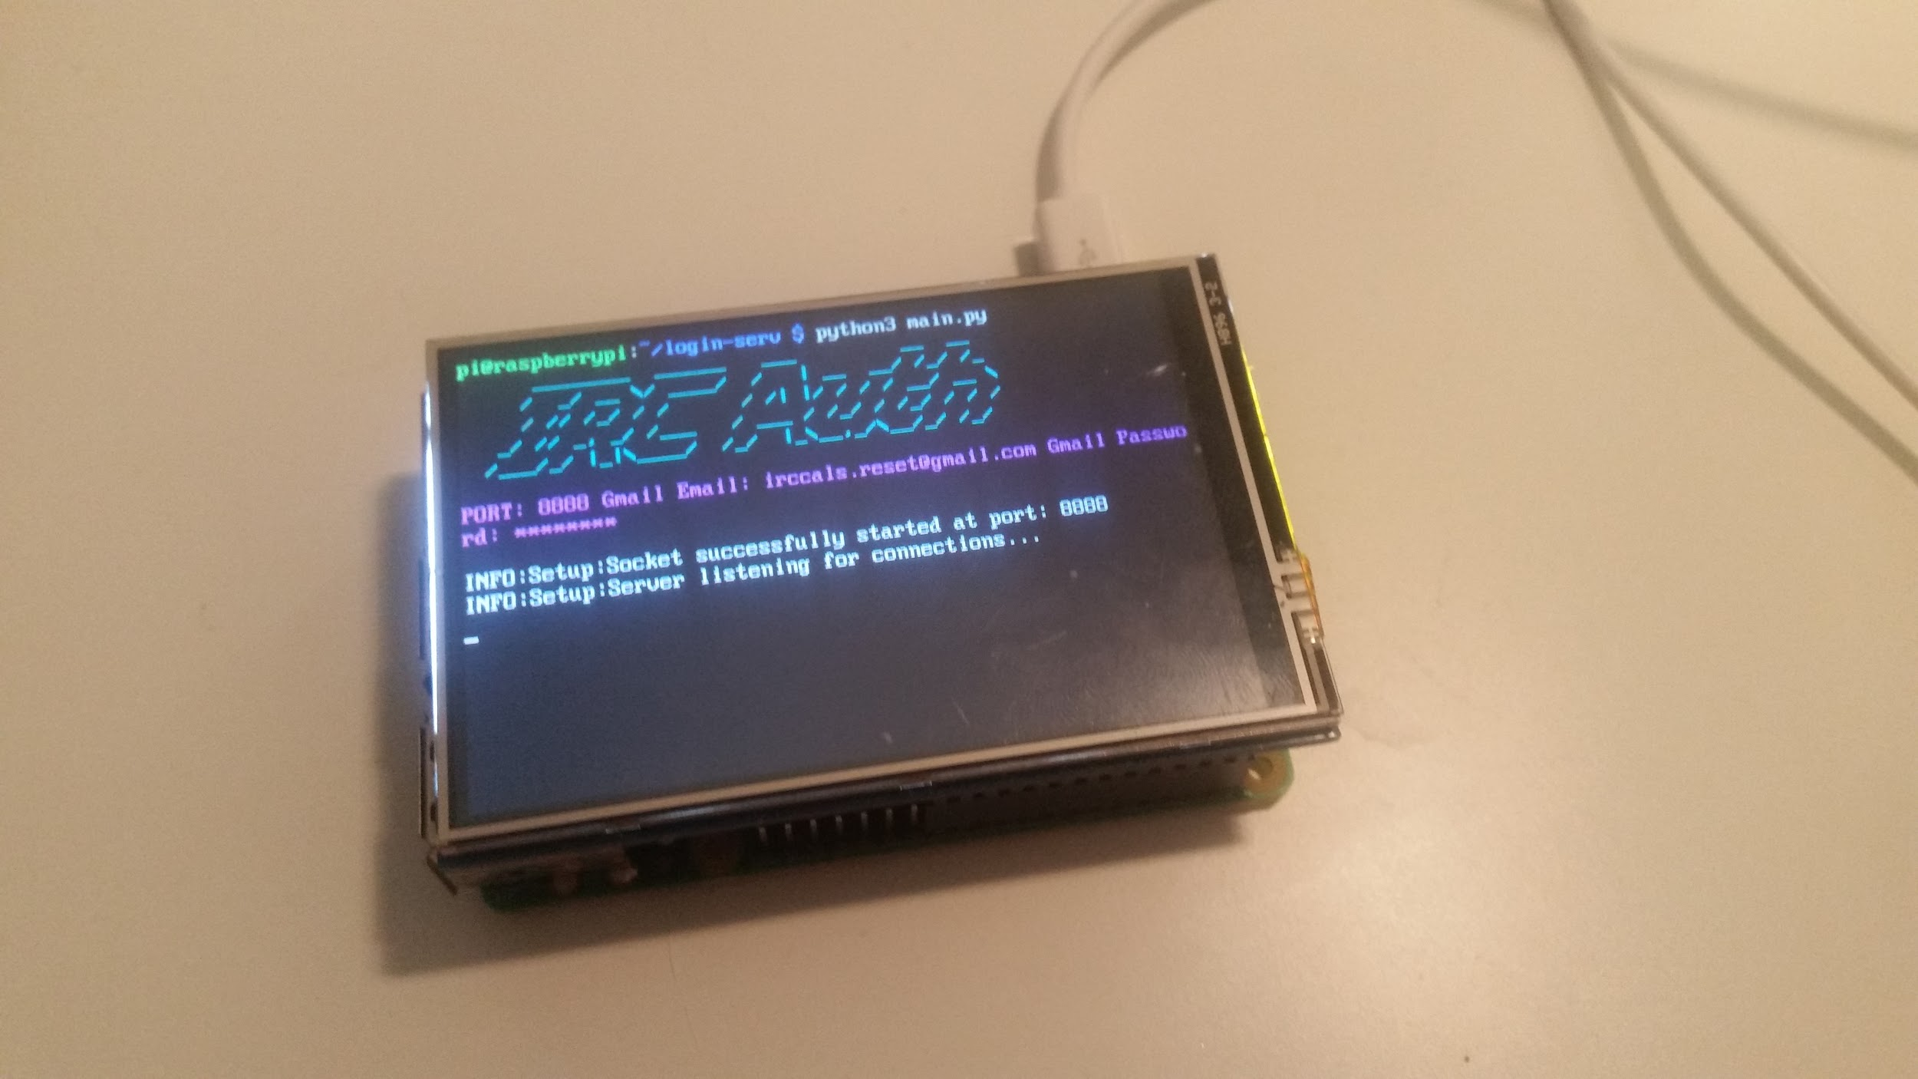

I went through the buttons on the menu form and made it so it opens up each of the forms correctly.



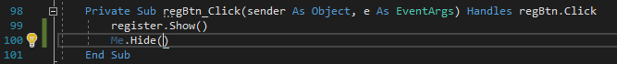

#### Testing

Login window

|  |  |  |  |  |  |
| --- | --- | --- | --- | --- | --- |
| Test no. | Criteria | Data type | User input | Expected outcome | Actual outcome |
| 1.1.2 | Test if sending incorrect username and correct password doesn’t work | Valid String, Invalid String | “Ethan”  “test” | Message appears that username or password is wrong | Message appears that username or password is wrong, but uses a message box |
| 1.1.3 | Test if sending incorrect password and correct username doesn’t work | Valid String, Invalid String | “ethan”  “Test” | Message appears that username or password is wrong | Message appears that username or password is wrong, but uses a message box |
| 1.1.4 | Test if no username or password works | Nothing | “” “” | Message appears that username or password is wrong | Message appears that username or password is wrong, but uses a message box |
| 1.2.2 | Check if clicking register opens the register form | An action not a data type | Click on register button | Register form opens | Register form opens |
| 1.2.3 | Check if clicking forgot opens the forgot form | An action not a data type | Click on forgot button | Forgot form opens | Nothing |
| 1.2.4 | Check if clicking register opens the resetform | An action not a data type | Click on register button | Register form opens | Doesn’t work |
| 1.2.5 | Check if clicking login sends data to the server using a valid | Valid String, Valid String | “Ethan”  “Test”  Click on login button | Logs into server and shows textbox or form | Logs into server and shows textbox or form, but uses a message box |

Register window

|  |  |  |  |  |  |
| --- | --- | --- | --- | --- | --- |
| Test no. | Criteria | Data type | User input | Expected outcome | Actual outcome |
| 2.1.1 | Using a valid email, a valid username and a valid password into the boxes. | Valid string, Valid string, Valid string | (I will delete the Ethan user and recreate it)  “Ethan”,  “Test”,  “71830@student.varndean.ac.uk” | Creates account and displays success message | Creates account and displays success message, uses message box currently |
| 2.1.2 | Using a invalid email valid username and valid password | Invalid String, Valid String, Valid String | “Hello”,  “Not.at.email”,  “Password” | Gives error and no account created | Gives error incorrectly and no account created |
| 2.1.3 | Using valid email valid username and a password with a range of char | Valid String, Valid String, Extreme String | “Username”,  “)(He110wOr!d)(”  “realEmail@ahhhhh.com” | Creates account and displays success message | Creates account and displays success message, uses message box currently |
| 2.1.4 | Using a already used username | Extreme String, Valid String, Extreme String | “Ethan”,  “Ahhhhhh”,  “realEmail@ahhhhh.com” | Gives error and no account created | Gives error incorrectly and no account created |
| 2.2.1 | Test if back button works | An action not a data type | Click back button | Goes back to first form | Goes back to first form |
| 2.2.2 | Test if register button works with valid strings. | Valid String, Valid String, Valid String,  An action not a data type | “Ethan”,  “Test”,  “71830@student.varndean.ac.uk”  Click register button. | Creates account and displays success message | Creates account and displays success message, uses message box currently |

#### Review

What has been done:

I have added the register form button to open the register form, and successfully create an account by sending the right data to the server and then parses the response from it, however only uses message boxes for warnings.

How it meets the success criteria:

It hits points: 2.1.1 , 2.1.2.1 , 2.1.2.2 and ½ of 1.2 done as the forgot form now opens up on the form correctly.

2.1.1: As the server is functioning it will respond with “Used” to the client for it to then parse and see if it was successful of account curation.

2.1.2.1: I programmed it so it can send and receive register commands over the connection successfully to create new accounts.

2.1.2.2: This is part of this criteria as it sends the password to the server and hashes it, but it is sent from the client reaching the other half of the criteria

Changes in the design:

I had to create a new function called “Request” which is used for reusability to send out requests to the server and get the response

Summary of the prototype:

Added the register form and created a Login module file to hold the functions used between forms and files.

### Third iteration: Forgot Menu

I then started development on the forgot password form, this is how I had designed it.

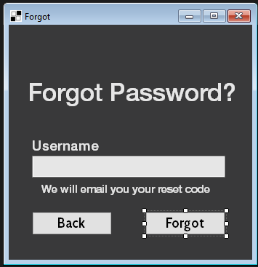

I added the default code used repeatedly from above such as the handles, sending and receiving data and the button and enter subs used for each form but all slightly adjusted. I want to now try and reduce the code because of the amount of lines the buttons disable and enable uses.

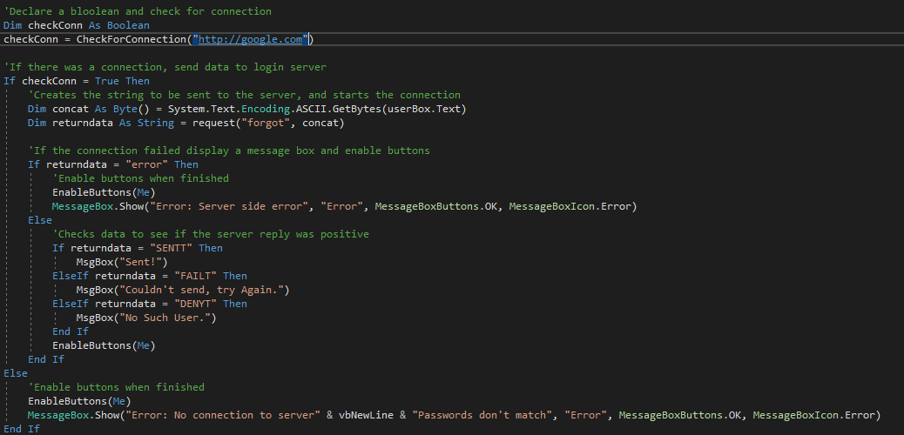

I first tried to make it so I could disable all buttons on the form as I can then make it so it blocks all buttons on each form without having to adapt it to each form. I looped through each control on the form and disable them as a test.

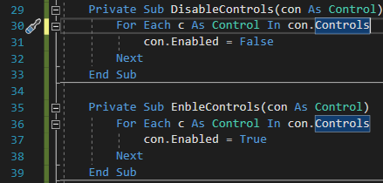

It worked however it disabled everything which is expected, so I will have to try and adapt my code to disable all buttons instead.

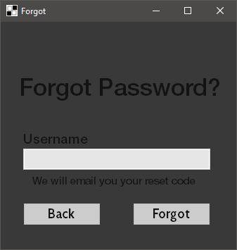

I then tried to find out how it was blocking the elements using the loop to filter the locked elements.

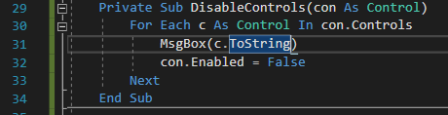

I found out the type of data it was as a string to see if I could find the text in the loop and only disable those however this was not working

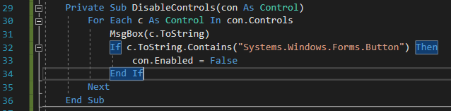

I realized that I spelt the string wrong, so I corrected it.





However still didn’t work after fixing that.

I tried just button to see if that worked, but didn’t work either.



I found that you can find the type of element it is, through “TypeOf”, so I tried to see if it was a button or not, and if so it would disable it, I am confident this will work so I added it to the modules.

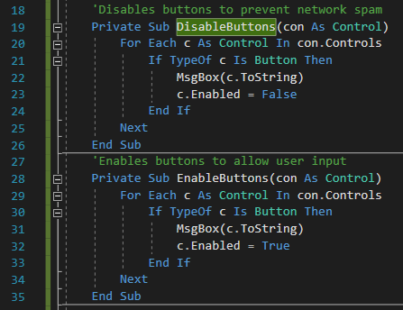

I added the disable and enable functions to each form I have coded so far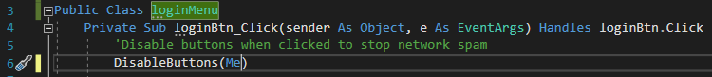

Another example, I will be mostly using this by default for the next forms for the login menu.

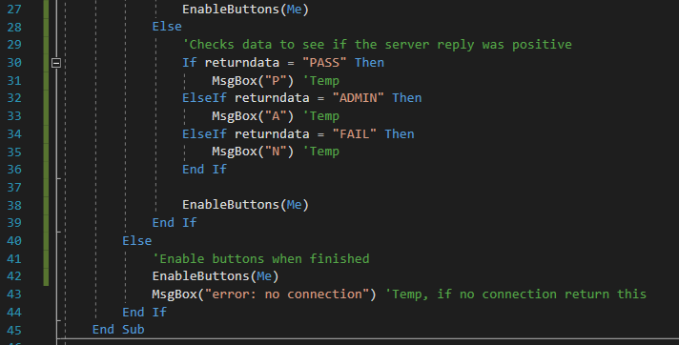

It successfully disabled the buttons. The fonts are different as it is running on a different computer.

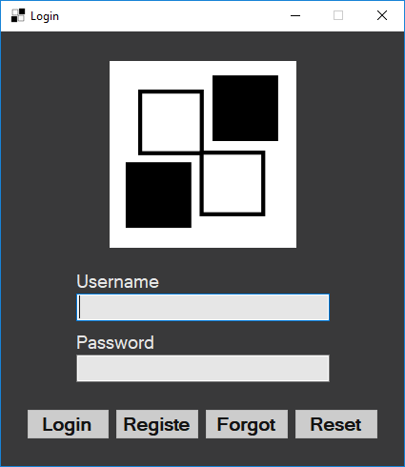

#### Testing

Login menu

|  |  |  |  |  |  |
| --- | --- | --- | --- | --- | --- |
| Test no. | Criteria | Data type | User input | Expected outcome | Actual outcome |
| 1.2.2 | Check if clicking forgot opens the forgot form | An action not a data type | Click on forgot button | forgot form opens | forgot form opens |

Forgot window

|  |  |  |  |  |  |
| --- | --- | --- | --- | --- | --- |
| Test no. | Criteria | Data type | User input | Expected outcome | Actual outcome |
| 3.1.1 | Enter valid username | Valid string | “Ethan” | Sends an email to the user and gives an success message | Sends an email to the user but incorrectly displays message |
| 3.1.2 | Enter email instead of text | Invalid string | “71830@student.varndean.ac.uk” | Give error to user | Give error to user, but incorrectly |
| 3.1.3 | Enter username who is not used | Extreme invalid string | “aaaaa” | Give error to user | Give error to user, but incorrectly |
| 3.2.1 | Check if back button works | An action not a data type | Click back button | Goes to main menu form | Goes to main menu form |
| 3.2.2 | Check if send button works | Valid string  An action not a data type | “Ethan”  Click send button | Sends and email to the user | Sends and email to the user |

#### Review

What has been done:

Created the

How it meets the success criteria:

2.3.1, 2.3.2 and ¾ of 1.1 due to adding the forgot form to the login menu.

2.3.1: It now sends a request from the client to the server for the forgot procedure on the server to generate, send and store the code used reset the users password.

2.3.2: Due to the server working when sending a username which is not used I will display a message box with the error, I want to change it so it shows it on the form however I shall do this in the future.

Changes in the design:

Changed the button locking mechanism as I wanted to make the code reusable for each form to be easily used saving the total data used.

Summary of the prototype:

Added the forgot form and changed the button mechanism for the forms.

### Fourth iteration: Reset Menu

I then designed the reset form, where users can input the code they received from the user, and reset their password with a validation check to see if it was the same password, as well as their username so they know what users password needs to be reset.

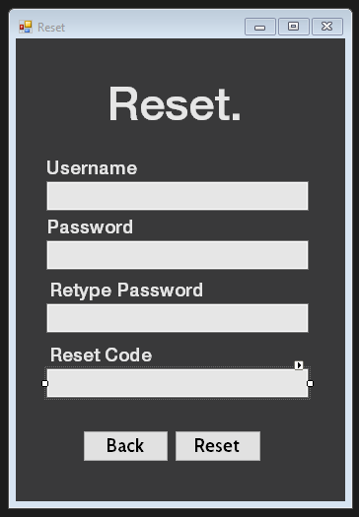

I added the main code to the button sub, which will enable to to communicate to the server to request a password reset. It’s essentially the same as the others but uses different error handlers to and sends different data.

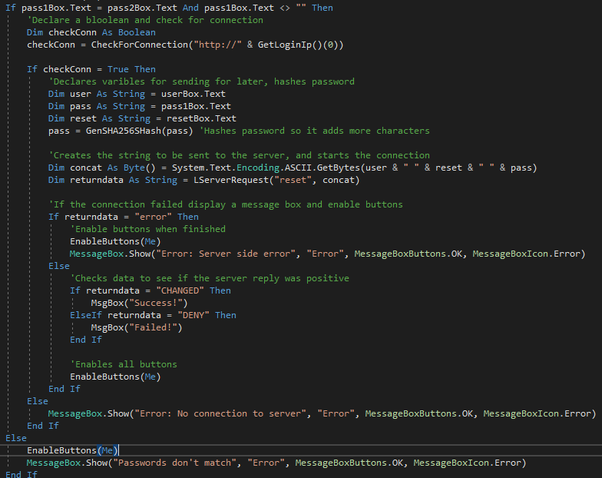

I ran the code to see if there were errors, and there were. I added a breakpoint to find the error

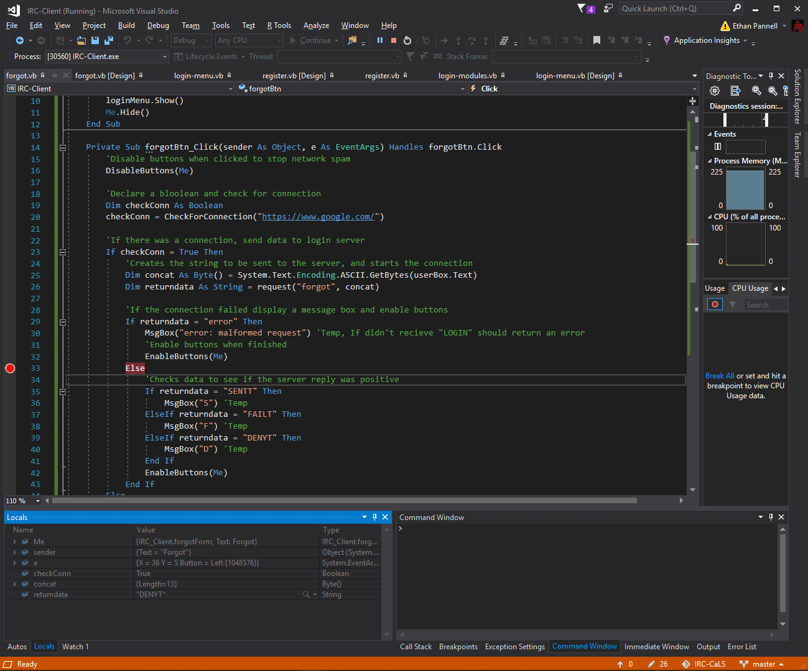

Server sends extra T which doesn’t get correctly evaluated, so I adjusted the code on my client, as there was no extra T on the server.

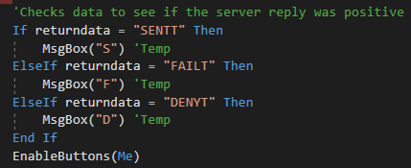

I tried to remove the ding using this method it worked well so I added the code to stop the ding into the username textbox as it will frustrate the users.

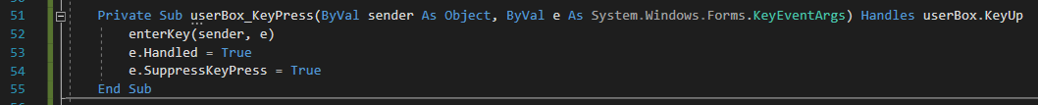

I then added the register button to open the register form and close the menu on the menu form. I also coded the tab index so I and others can quickly navigate from each element on the form by using the tab key which helps the usability for the user.

I copied the standard form code from my other forms, and adjusted it so it deals with the different data in the correct way without causing errors. It is from line 45 to line 53.

This code only needed to look for two responses.

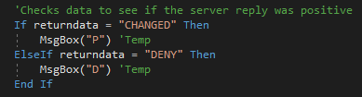

It needed to check if the passwords were the same as they might make another mistake when making the password. It was put above check for connections if statement.



I then tested it using the name hi, password hi and a code I received from the email I used to get the forgot password from earlier.

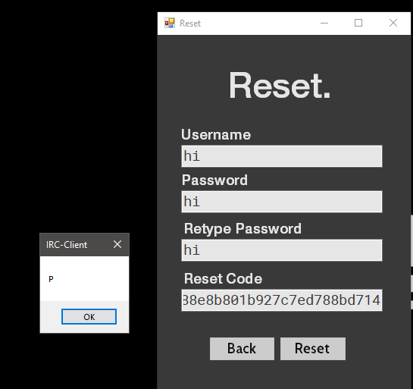

It can now fully communicate with the server, now it is time to remove place holders and show errors successfully

I replaced the pop up text boxes with text which changes the titles text to the output of an error from the server, I repeat this for each form except the main menu where I wil do something different.

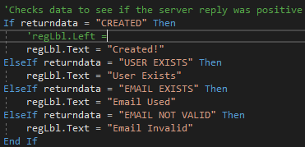

Unfortunately I didn’t take in account that the text will not be in the center where I originally put the text.

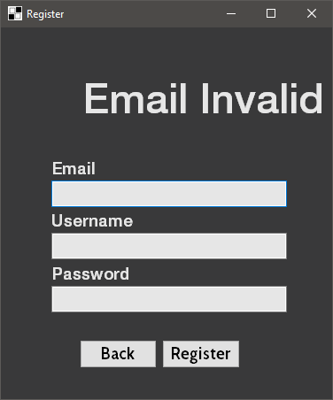

I changed the position of the text for each error or success, each had a different value to change, for the one above it was 45

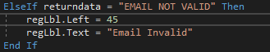

The result was this

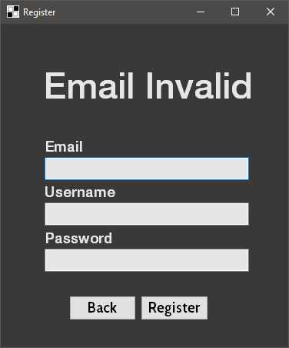

I repeat this process for the other forms except the login page

I set it so when there is an error given, a photo appears which will notify the user instead of using additional space for text.

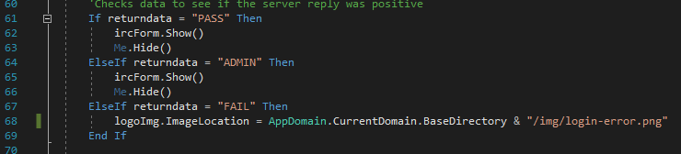

When loading a form the menu image is switched back the the original basic logo.

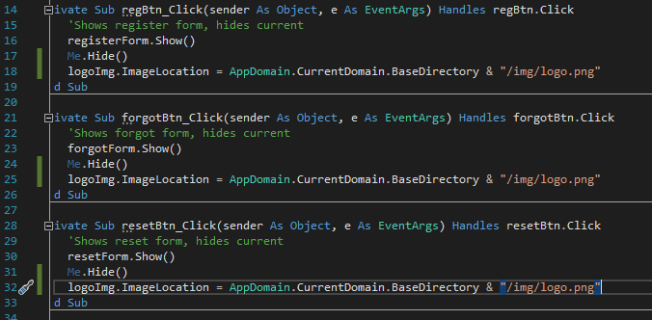

I added a debug key to quickly enter the irc form without having to log in, when I press the volume down button it will open the irc form.

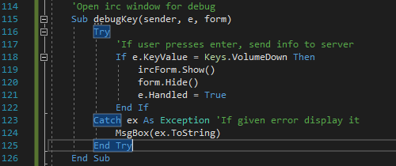

I added it to both the boxes on the irc form code.

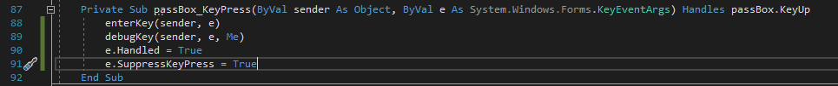

I found if I tried to see if the login server was online, and it was, my function would not work. This issue was that my pi didn’t have a web server installed. I then installed apache2 which is a commonly used web server, to accept and reply to the connects, as well as have a website on it will the executable to communicate with it. I will create the website at the end of the project as an additional piece of work, as it needs to be clean and not show the default web page.



On my Raspberry Pi I ran:

Sudo apt update && sudo apt upgrade && sudo apt install apache2

I will add a website to this later as it would just show the default debian webpage.

I changed the method of getting the IP as it will not be effective for the user to not be able to put the ip in of their server or another persons server.

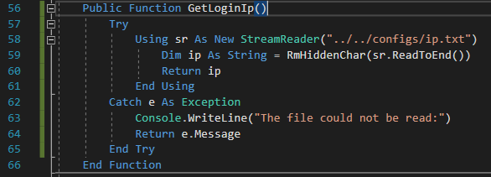

I made a file called ip.txt and put it in a config folder where the user can edit it.

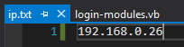

I switched the method of getting the image to have the image be put into the resources area, as the path when compiling is not there, and I want to manage the amount of hassle the user needs to deal with. I applied it to the images on the login form.



I added resources which I will use for the project, the cog I found from the internet and adapted it into an icon, the other two I quickly made in photoshop.

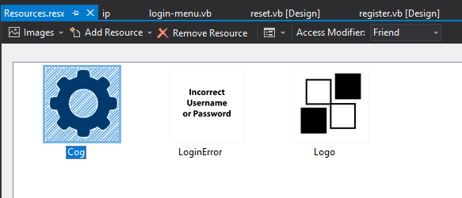

I added the ip as a resource too on the files tab this removed a few lines

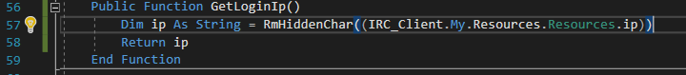

I discovered that I can make a sub which can handle each box with the ding sound remover which reduces the amount of lines of code which is good.

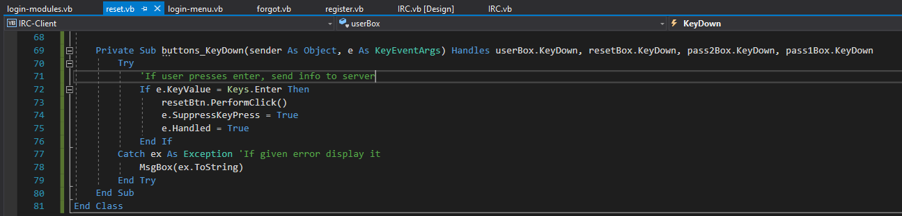

I started up the program and realised it used a significantly large amount of RAM space which I want to avoid. This is due to winforms taking up a lot of RAM which I did not realise was a down side of the project type I made in visual studio.

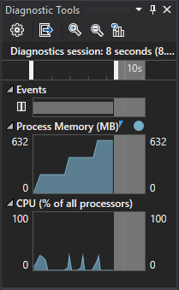

I made a simple procedure which frees up this RAM, to remove the unnecessary RAM data you have to clear the garbage in the program, you can do this by using “GC.Collect()” the GC means garbage collector, and the .collect() will collect and dispose of that data. The lines before are to close and dispose of forms which are no longer needed. This will be called whenever a form is closed

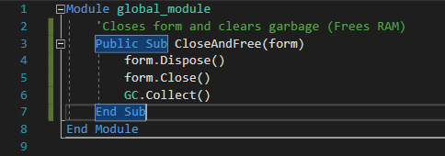

The results were good, the ram heightened when I opened up a new form, and went back down when I closed it which means it went well

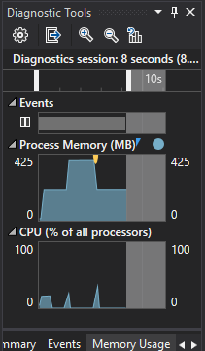

I made another sub to reduce the lines more to open up the login menu on each form correctly, I applied it to wherever the login menu needs to be opened.

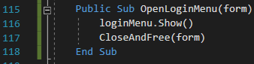

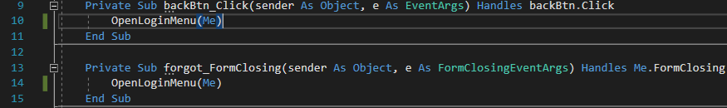

I had some issues where I could not write back to the IP due to the resources not recreating it in the debug folder creating errors, I reverted back to writing to the file instead.

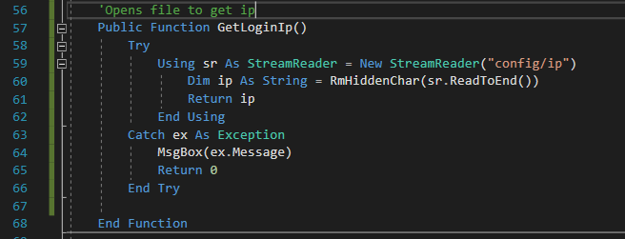

I then created a symbolic link between the config colder and the debug config due to it not copying the file when debugging, so I can edit one file and it will be used by the program without having to copy and change it every time.

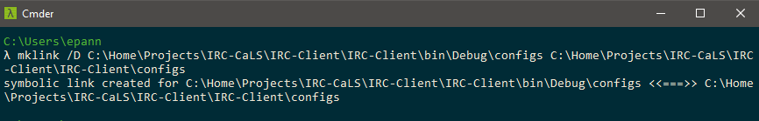

I have decided to use classes for the irc part, as in the future I will be adding the functionality of adding more servers which will be its own class and adding more functions to the messages too.

Login menu using lots of RAM when clicking buttons to connect to the server and it failing to connect.

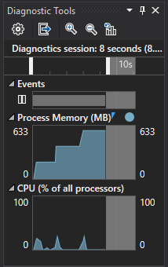

I added the GC.Collect function to where the buttons are clicked, so it removes the garbage collected, which will free the RAM.

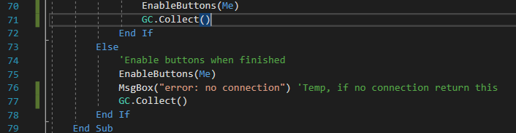

The result of the testing, it spikes briefly then goes back down.

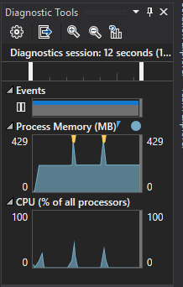

#### Testing

Login window

|  |  |  |  |  |  |
| --- | --- | --- | --- | --- | --- |
| Test no. | Criteria | Data type | User input | Expected outcome | Actual outcome |
| 1.1.2 | Test if sending incorrect username and correct password doesn’t work | Valid String, Invalid String | “Ethan”  “test” | Message appears that username or password is wrong | Message appears that username or password is wrong |
| 1.1.3 | Test if sending incorrect password and correct username doesn’t work | Valid String, Invalid String | “ethan”  “Test” | Message appears that username or password is wrong | Message appears that username or password is wrong |
| 1.1.4 | Test if no username or password works | Nothing | “” “” | Message appears that username or password is wrong | Message appears that username or password is wrong |
| 1.2.4 | Check if clicking reset opens the reset form | An action not a data type | Click on reset button | Reset form opens | Reset form opens |

Register window

|  |  |  |  |  |  |
| --- | --- | --- | --- | --- | --- |
| Test no. | Criteria | Data type | User input | Expected outcome | Actual outcome |
| 2.1.1 | Using a valid email, a valid username and a valid password into the boxes. | Valid string, Valid string, Valid string | (I will delete the Ethan user and recreate it)  “Ethan”,  “Test”,  “71830@student.varndean.ac.uk” | Creates account and displays success message | Creates account and displays success message |
| 2.1.2 | Using a invalid email valid username and valid password | Invalid String, Valid String, Valid String | “Hello”,  “Not.at.email”,  “Password” | Gives error and no account created | Gives error and no account created |
| 2.1.3 | Using valid email valid username and a password with a range of char | Valid String, Valid String, Extreme String | “Username”,  “)(He110wOr!d)(”  “realEmail@ahhhhh.com” | Creates account and displays success message | Creates account and displays success message |
| 2.1.4 | Using a already used username | Extreme String, Valid String, Extreme String | “Ethan”,  “Ahhhhhh”,  “realEmail@ahhhhh.com” | Gives error and no account created | Gives error and no account created |
| 2.2.2 | Test if register button works with valid strings. | Valid String, Valid String, Valid String,  An action not a data type | “Ethan”,  “Test”,  “71830@student.varndean.ac.uk”  Click register button. | Creates account and displays success message | Creates account and displays success message |

Forgot window

|  |  |  |  |  |  |
| --- | --- | --- | --- | --- | --- |
| Test no. | Criteria | Data type | User input | Expected outcome | Actual outcome |
| 3.1.1 | Enter valid username | Valid string | “Ethan” | Sends an email to the user and gives an success message | Sends an email to the user and gives an success message |
| 3.1.2 | Enter email instead of text | Invalid string | “71830@student.varndean.ac.uk” | Give error to user | Give error to user |
| 3.1.3 | Enter username who is not used | Extreme invalid string | “aaaaa” | Give error to user | Give error to user |

Reset window

|  |  |  |  |  |  |
| --- | --- | --- | --- | --- | --- |
| Test no. | Criteria | Data type | User input | Expected outcome | Actual outcome |
| 4.1.1 | Input valid into boxes | Valid strings | “Ethan”, “Testt”,  “Testt”,  Valid code | Changes the password of the account and displays success message | Changes the password of the account and displays success message |
| 4.1.2 | Input all valid except from code | Valid string, Valid string, Valid string,  Invalid string | “Ethan”, “Testt”,  Invalid code | Shows error and nothing is changed | Shows error and nothing is changed |
| 4.1.3 | Input all valid except from passwords being different | Valid string, Valid string,  Invalid String,  Invalid String,  Valid string, | “Ethan”, “Testt”,  “Test”,  Valid code | Shows error and nothing is changed | Shows error and nothing is changed |
| 4.2.2 | Check if reset button works | Valid string  An action not a data type | “Ethan”, “Testt”,  “Testt”,  Valid code  Click reset button | Changes the password of the account and displays success message | Changes the password of the account and displays success message |

#### Review

What has been done:

Added error messages to each form to fix all of the orange tests from earlier, added the login form to the reset button to open the reset form as well as successfully sending and resetting the password on a user's account

How it meets the success criteria:

2.4.2 2.4.3 and finished 1.2 buttons

2.4.2: It resets the password correctly when the data is sent over to the server successfully with a valid code.

2.4.3: Doesn’t reset the code if incorrect which is good for security of the accounts.

So far:

It has hit these points: 1.1 , 1.2 , 2.1.1 , 2.1.2.1 , 2.2.1 , 2.2.2 , 2.2.3 , 2.3.1 , 2.3.2 , 2.4.2 , 2.4.3 , 2.5.1 and 2.5.2

1.1: Login form opens first

1.2: Buttons successfully open each form

2.1.1: More of a server test but cif a client sends a username already used it will deny the new account creation

2.1.2.1: The login server adds new users to the database successfully through communicating with the server.

2.2.1: If the username is missing the alert is successfully shown on the form

2.2.2: Logs the user into the server if the username and password were correct

2.2.3: If was an incorrect username or password the user is not allowed in to the client

2.3.1: If the client requests a recovery, the email is sent to the user if the user exists

2.3.2: If the client requests a recovery and the username is wrong nothing is sent

2.4.2: Resets the password if the user inputs the correct inputs such as code and username

2.4.3: Doesn’t reset if the code was wrong but everything else was correct

2.5.1: Doesn’t reset if the inputs were wrong

2.5.2: Don’t allow invalid usernames in when requesting a reset code

Changes in the design:

Changed from message boxes to changing the titles of each section to show the received data from the server.

Summary of the prototype:

Login menu, register menu, forgot menu and reset menu completed with errors successfully parsed and displayed. All of this is on the assumption that the user has successfully installed the login server and set it up correctly.

### Fifth iteration: Client Stage One

I designed the form like the design section from earlier. To the left is a tree box which allows to have a main text with dropdowns.The center has three text boxes the top for announcements, the middle for messages and the bottom for sending message. The placeholder text box where the users name will be. The right side are list boxes where usernames and friends will be.

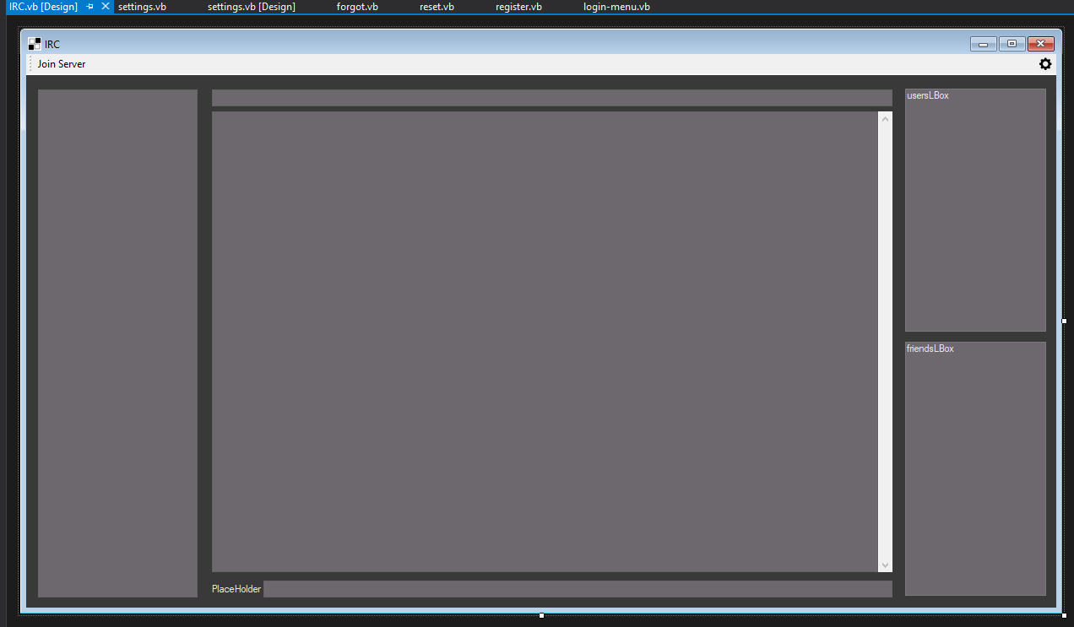

I added the ding removal code to the text box I will be typing in (I also added it to all other text boxes on forms), as well as adding support for opening the settings form as well as closing the application as a whole.

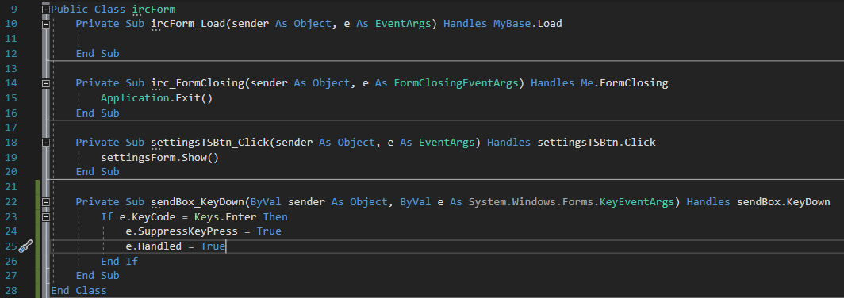

I created three files for the irc client, they are classes. These will most likely be the classes I need for the program.

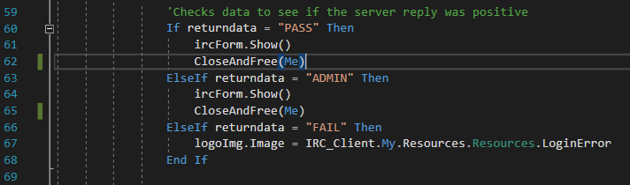

I noticed that I forgot to add the port to the url which I coded into the function by splitting the url by the colon.

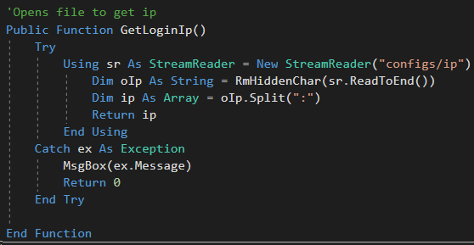

I changed the way of checking the connection, by creating the link while using check the connection.



The format in use ip:port

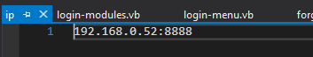

I setup the server class, the irc client needs to connect, disconnect, join channels,leave channels and listen to the data coming through the connection.

Init is gets the data needed for the server url and the user friendly name for the server;

Connect procedure will setup the connection between the client and server;

Disconnect will correctly disconnect from the IRC server;

Listen will parse the data coming through the connection and handle it;

Join will allow users to join channels where multiple people will be able to talk to each other;

And Leave will allow the user to leave the channel.

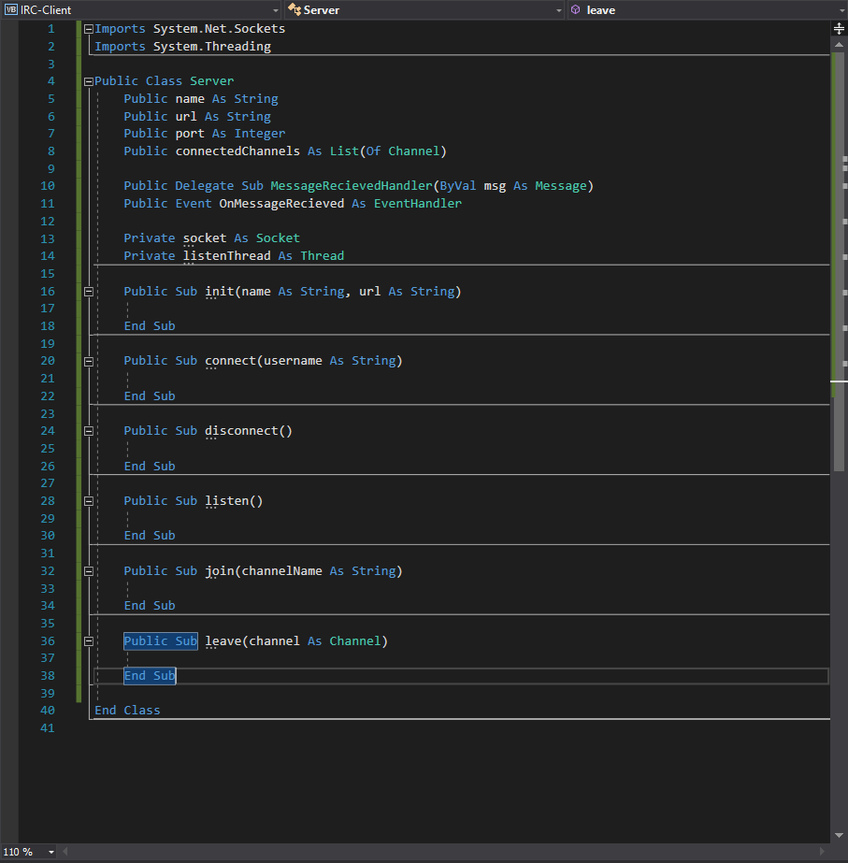

I added message and outstream variables to use to store the message from the data received and out stream for the outbound data which will be sent for connections. Public sub new is the init function from earlier, as I want it to run when I create the class. It sets the variables within the class which the other subs will need to function.

I will be following the IRC protocol specified by this website: <https://tools.ietf.org/html/rfc2812> which will allow me to make my program communicate with the server successfully.

Connect sub connects via the socket to the server on the first line of the connect sub, then the stream is created to get the data received and to send data. The username is then set as the placeholder. The nickname and user details are sent. It needs to send this data to successfully start the data transfer between the server and client due to the protocol specified for this to start.

Lastly a thread is created for the listen function to run in the background to constantly get the data from the server without interrupting the other processes if the program such as running the GUI.

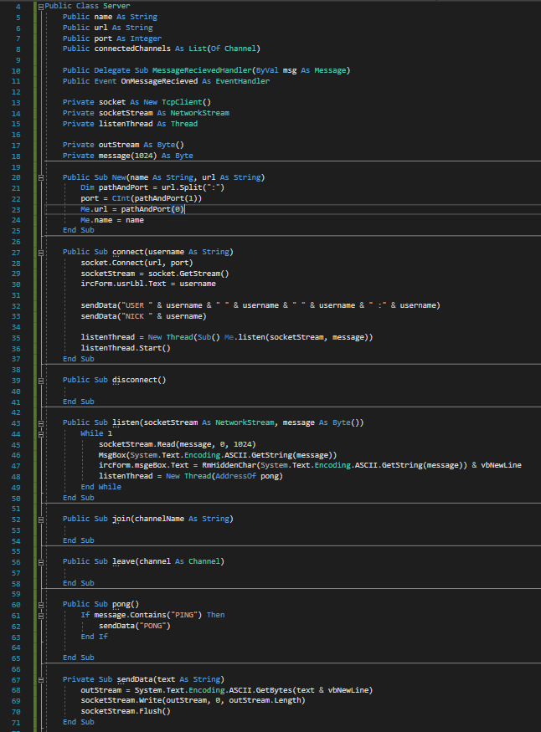

This sub sends data to the server by converting the string to bytes to then sends the data and flushes the stream.



Pong function will be ran when the server sends “PING”, sending “PONG” from the user side. This function is needed as it how the server tracks if a user is still connected. If no reply it assumes you have disconnected and doesn’t send any data to you and disconnects you from the server. 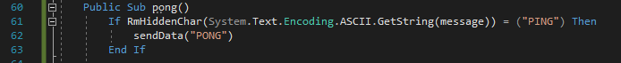

The listen sub reads the data from the server into the message, and then removes the characters not needed. That text is then written to the message text box, the listen thread is created as a temporary fix to the connection.

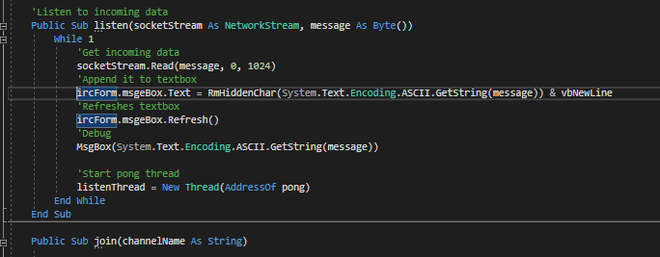

When I ran the program, I received data however the form was not showing the text in the box, to fix this I looked online to find a solution, <https://stackoverflow.com/questions/8498937/updating-ui-from-another-thread> which I then looked at <https://stackoverflow.com/questions/17334425/vb-net-delegates-and-invoke-can-somebody-explain-these-to-me> to get more infomation about the invoke fuction

I added the code to append the received text to the UI, as this is a main function of the program.

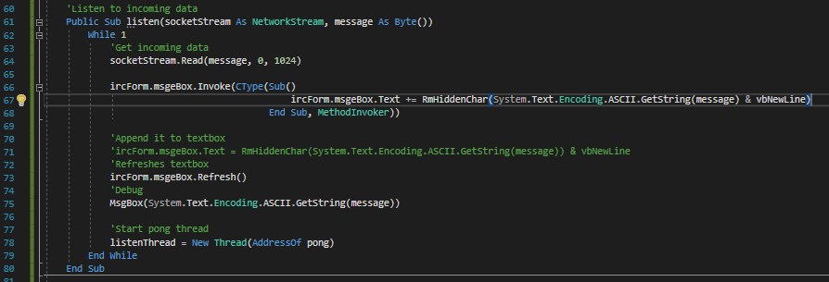

I tired to add the text to the form however it was giving me an error basically saying the window is not there, I will find the cause and fic this.

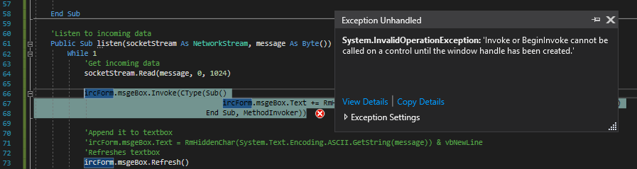

I first replaced the thread to a normal sub to see if the text was added that way.

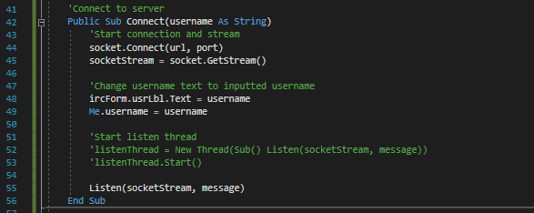

I changed the listen thread to send the data when listening so it initiates the connection then, and made a while loop to continuously read the data from the server and outputs it to the message box. Finally a new thread is created to keep the connection going through starting a pong thread every loop which currently is inefficient.

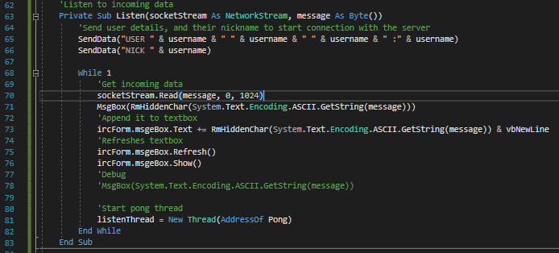

This successfully added the text however the UI was unresponsive due to the while 1 loop taking up all of the programs CPU time.

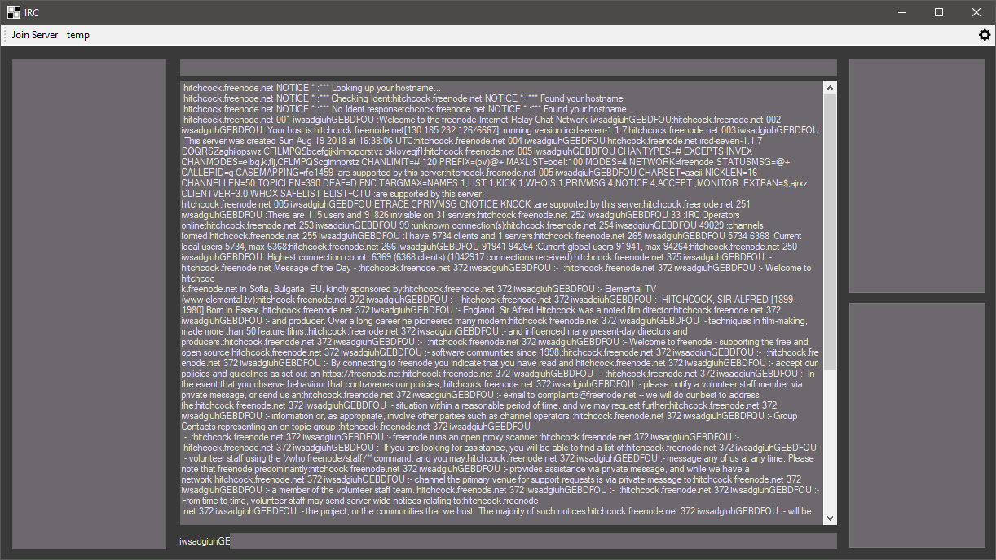

I reverted it back to the new thread and it doesn’t work with this either.



When I created a message box it displayed both windows at once, however the one in the background was not working, so I theorise it was writing to an invisible form.

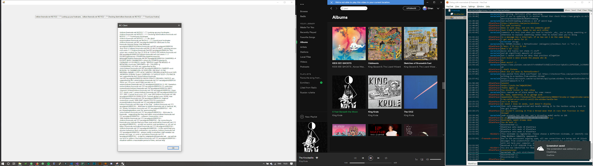

I added a few extra lines to the listen function which should show the window which it could be writing to. It adds the msgebox to the invisible form and then updates and show the form and textbox if not was showing.

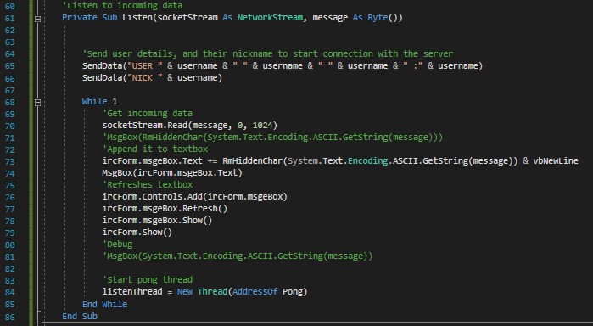

This was the result of the test and I was correct that there was a hidden form which is the problem behind this.

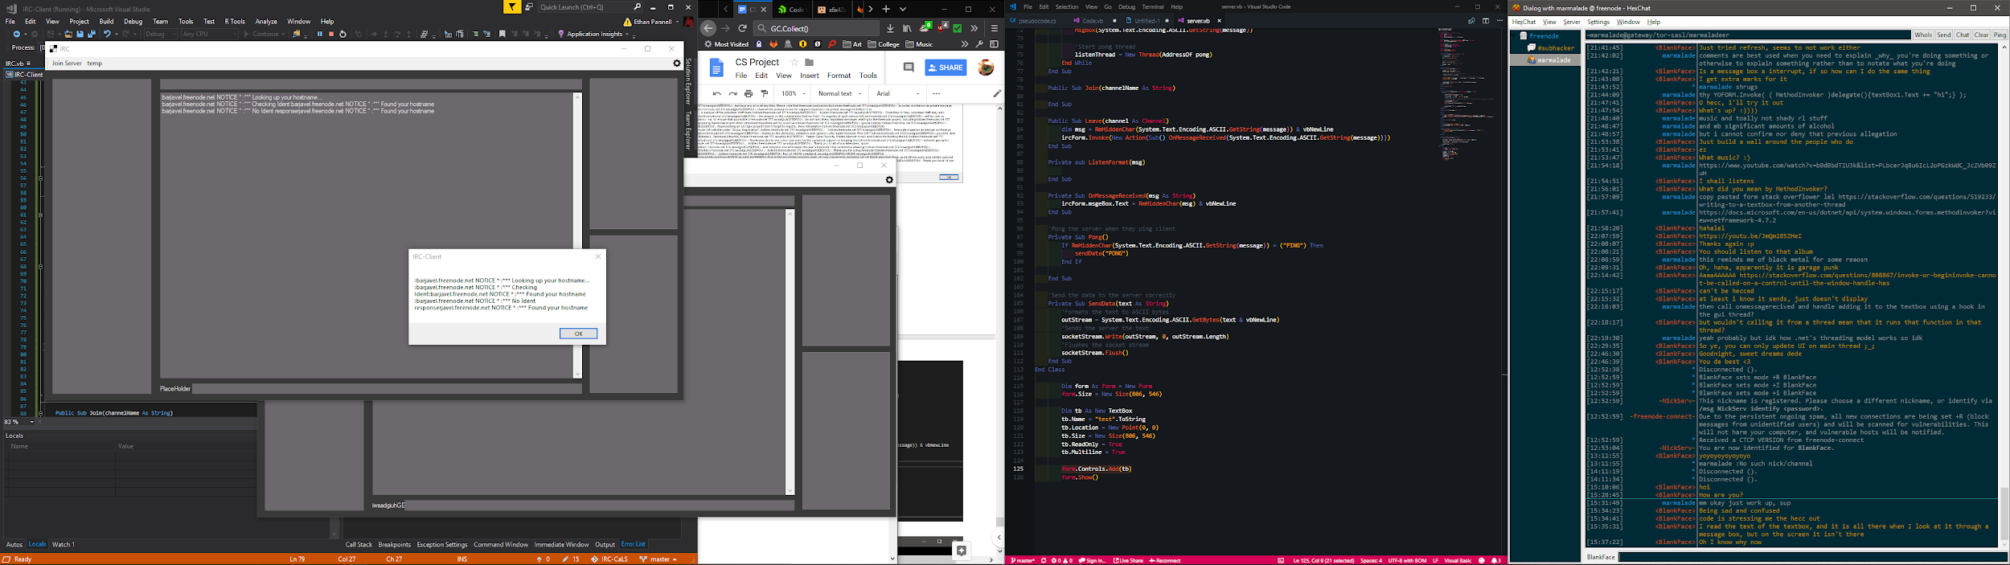

vb.NET threading creates a new instance of everything called. This is not very useful for me currently, in fact it has stalled the project by quite a lot as it has been troublesome to fix.

I had an idea where the data received could be saved into a text file and then incrementally read by the main thread, however there is a large issue, is that it could not be updated enough and that it will take up more processing power which is not wanted due to it looping more than just the one listen thread loop.

I moved back the user and nick send data to the connect sub at the top.

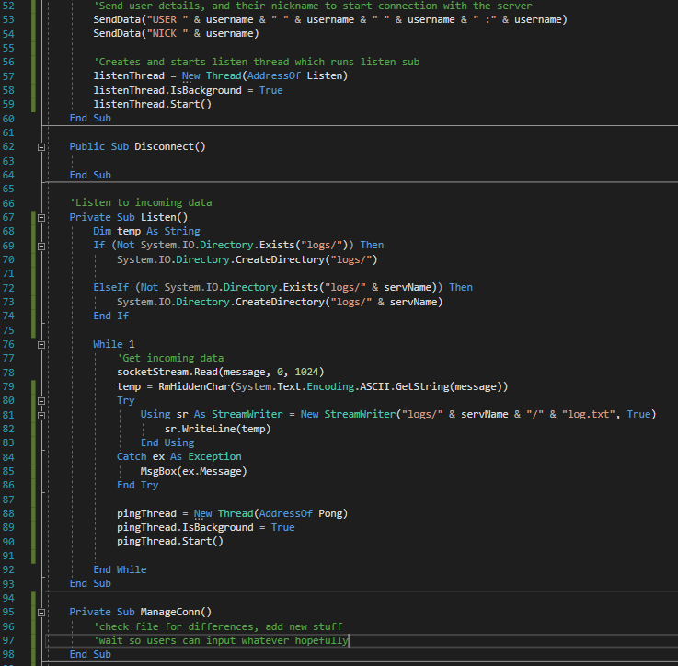

I tried creating the thread via the form instead of the class however the same result happened.

I then tried using the form as a inputted value so I can try and directly edit that form instead.

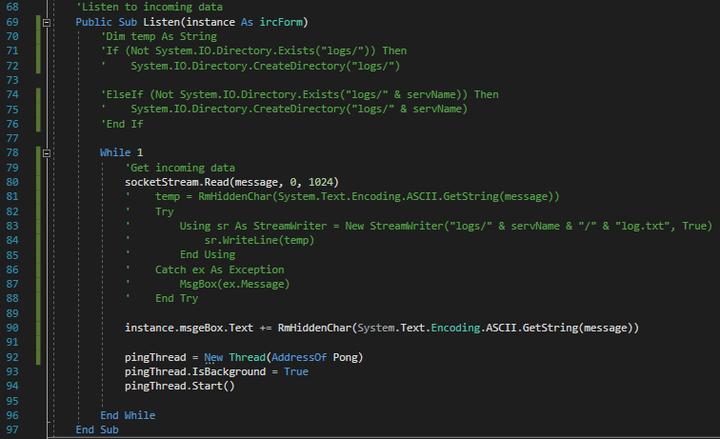

I then make the thread in the ircForm file itself as I need to reference the form which called it.

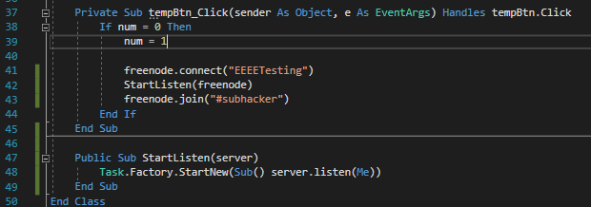

But it didn’t seem to work either which was unfortunate as it seemed logical to reference the main form to then edit the text. I cannot edit the main GUI.

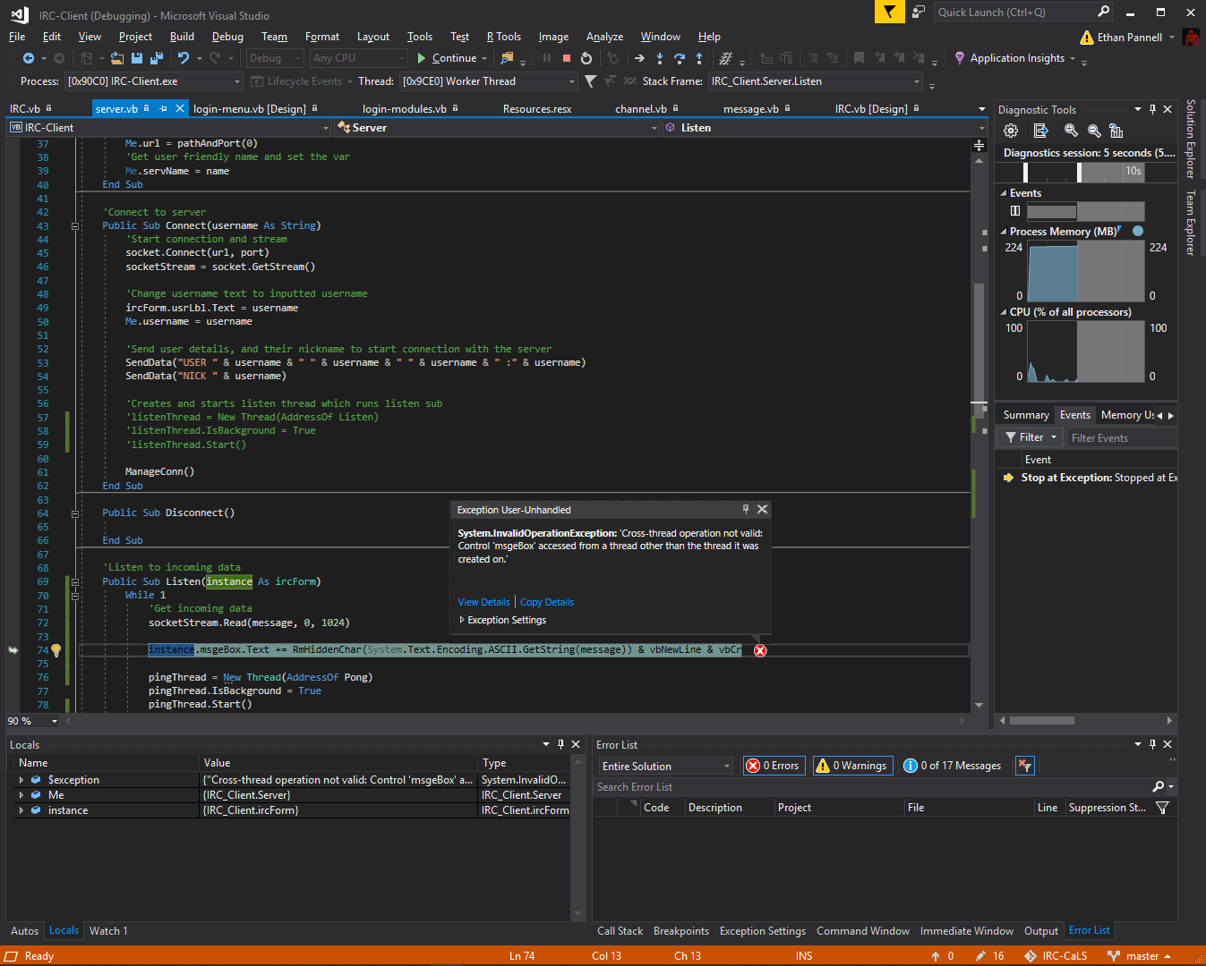

I found a fix due to searching for C# solutions as vb.NET is similar to C# this link is: <https://www.programering.com/a/MDM4cDNwATM.html> this took me longer than expected and I will have to find the right method of using threading in the future as this could be a possible flaw in the future.



The fix worked successfully, however the formatting of the text isn’t so I now need to fix that next.

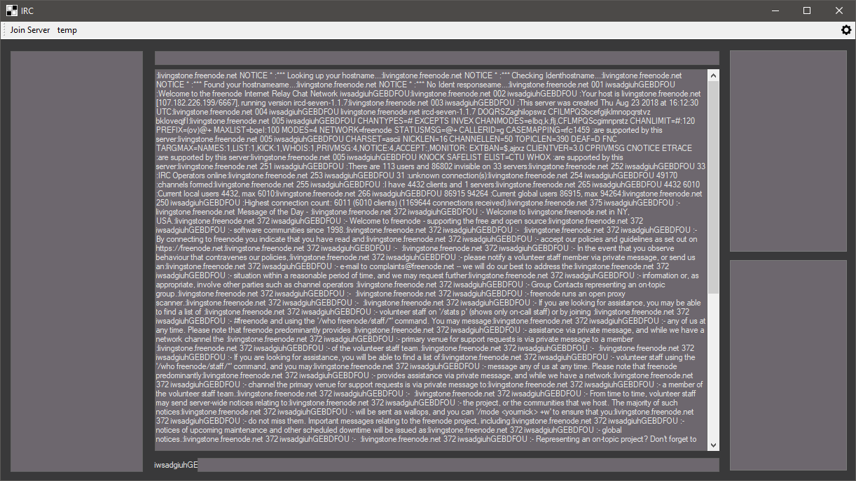

#### Testing

Client window

|  |  |  |  |  |  |
| --- | --- | --- | --- | --- | --- |
| Test no. | Criteria | Data type | User input | Expected outcome | Actual outcome |
| 5.1.1 | Click join connects to freenode server | An action not a data type | Clicking join freenode button | Connects to freenode server | Connects to freenode server |
| 5.1.2 | Click disconnect to freenode server | An action not a data type | Clicking disconnect button after connecting to the server | Disconnects from freenode server | Nothing |
| 5.1.3 | Clicking settings icon opens settings | An action not a data type | Clicking setting icon | Opens up settings tab | Nothing |
| 5.2.1.1 | Message command works | Valid String | “/msg user hello” | Sends a message to a user | No |
| 5.2.1.2 | Message command without arguments gives warning | Extreme string | “/msg” | Doesn’t send anyone a message and warning given | No |
| 5.2.2.1 | Join command works | Valid String | “/join #channelNameTest” | Joins a channel | No |
| 5.2.2.2 | Join command without arguments gives warning | Extreme string | “/join” | Doesn’t Join a channel and warning given | No |
| 5.2.3.1 | Leave command works | Valid String | “/leave #channelNameTest” | Leaves a channel | No |
| 5.2.3.2 | Leave command without arguments gives warning | Extreme string | “/leave” | Doesn’t leave a channel and warning given | No |
| 5.2.4.1 | Add command works | Valid String | “/add hello” | Adds user to list box | No |
| 5.2.4.2 | Add command without arguments gives warning | Extreme string | “/add” | Doesn’t add a user to the box and returns warning | No |
| 5.2.5 | Message without any commands | Valid String | “hello” | Sends message to the channel or user they are currently on through tabs | No |
| 5.3.1 | Displays text from server | Action not data type | Logging in on menu | Displays text send from server into a text box | Yes but incorrectly |
| 5.3.2 | Displays usernames and errors in different colours | Valid string | “/msg realperson hi”  “/msg fakeperson hi” | Shows username in colour and shows error in colour | No |
| 5.4 | Change colours of form on load | Action not data type | Logging in on menu | Colours of form are different to default | No |
| 5.5 | Switching tabs works | Valid string  Action not data type | “/join #channel”  Click on tab which is labeled channel | Tabs change as well as text and names | No |
| 5.4.1 | Server list box holds items successfully | Action not data type | Clicking join freenode | Shows “Freenode” in the server box | No |
| 5.4.2.1 | Users box store items | Valid string  Action not data type | “/join #channel”  Click on tab which is labeled channel | Users from channel stored in user list box | No |
| 5.4.2.2 | Switching tabs changes or removes items | Valid string  Action not data type | “/join #channel”  Click on tab which is labeled channel | When switching tabs text changes | No |
| 5.4.3 | Friends box added items successfully | Action not data type | Logging in on menu | Stores the users into the friend box successfully | No |

#### Review

What has been done:

Created the IRC client form, the server class and successfully connect to the server through the server form.

How it meets the success criteria:

3.2 , 3.5.2 and 3.7.2 are met.

3.2: Successfully received a message from the IRC server.

3.5.2: Connect to the server IRC successfully

3.7.2: Send messages to users directly.

Changes in the design:

Having to add a debug line to the server to not check for illegal threads in the server

Summary of the prototype:

I have added the irc client form to the code and created a server class to communicate with a irc server specified hard coded within the program.

### Sixth iteration: Client Stage Two

I wanted to fix the username first as it is seemed an easy fix. I will overlap the input box over the label where the user name will be. The loop will check if the bounds of the username and the text box are colliding, meaning it will resize to the correct size showing all characters.

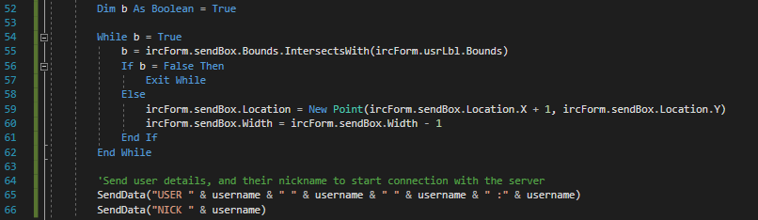

The text box has been elongated to cover the label there before.

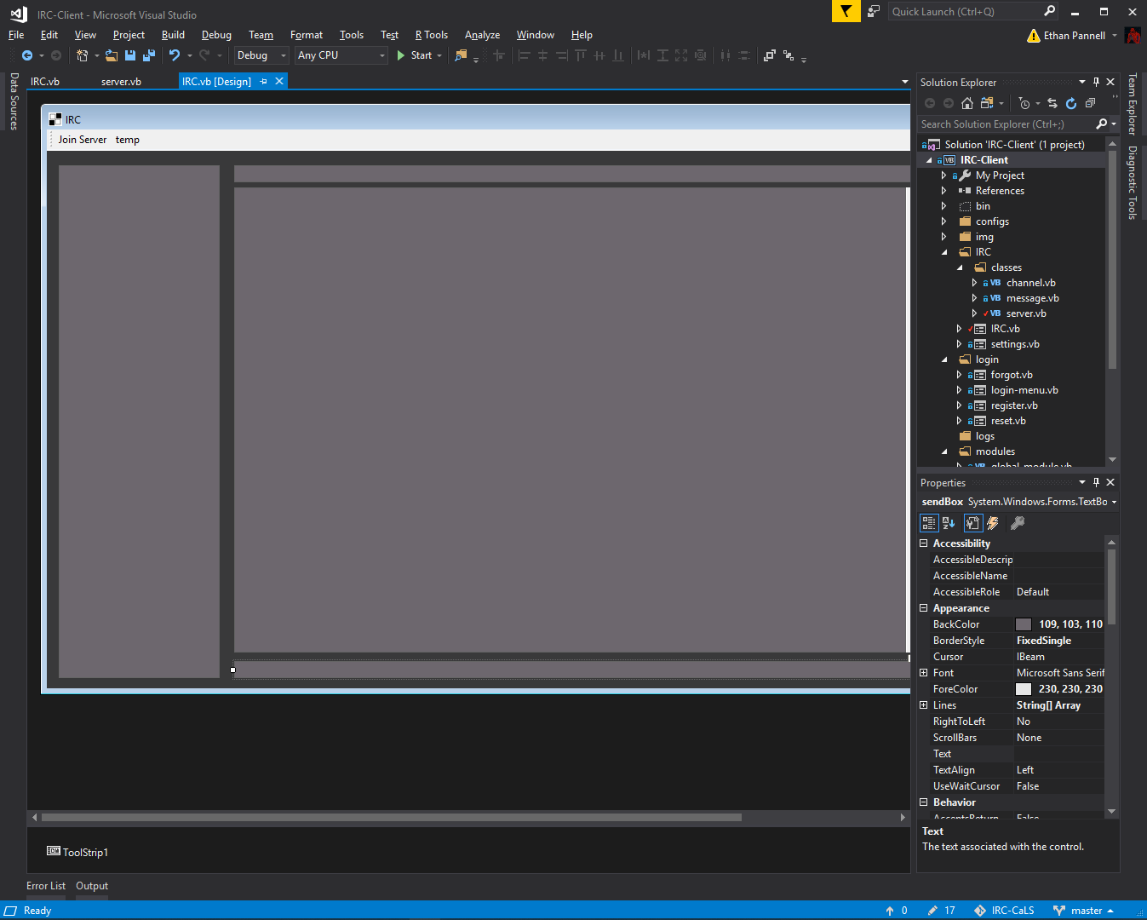

When running the text was successfully displayed from the whole username being shown.

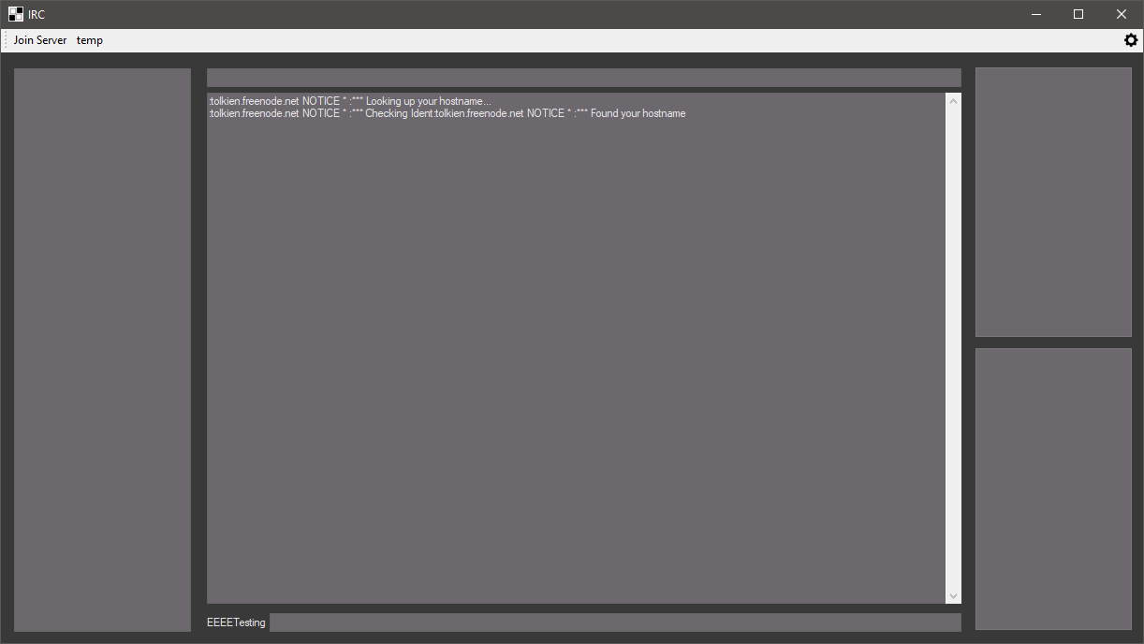

When I close the program it doesn’t fully close due to the thread in the background still running, so I will call this after connecting to the server. It sets the thread as a background worker so when I close the application all threads will end too.

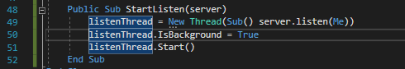

The two screenshots below are used to connect to the server, however typically port 6697 on irc servers use ssl, so the socketStream will set its variable type when the data is added due to the variables being different. If 6697 the connection will be encrypted else it will not be, I am planning to make a menu for this in the future to allow users to choose and save connection types.

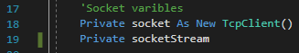

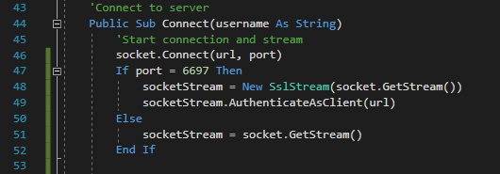

I changed the port to 6697 so the connection is encrypted.



I tested the connection and the code worked first time, the data transmission is now end-to-end encrypted.

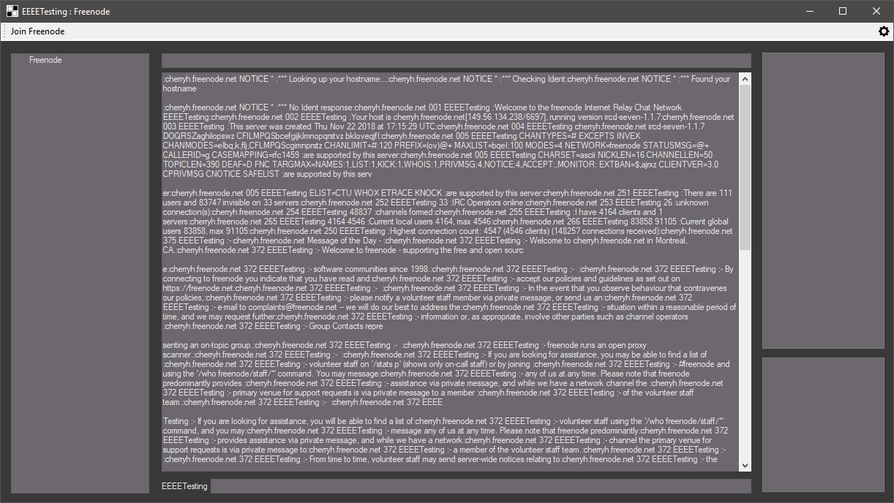

I edited the listen thread so it looks for the ping string within the first four characters of the received text which will then create a new thread, instead of creating and killing the thread every loop which is an inefficient use of the processor time so I put a if statement to deal with it instead. If it isn’t a ping message it will be an actual message from the user where is will then parse the text however it is currently adding it to the textbox without parsing. Lastly it clears the message variable due to it holding data which it doesn’t need any more once per loop otherwise it would keep printing the same thing.

I added a vbnewline twice and a carriage return to see how the text is structured when sent to the client, however this may not be correct as I have realised I have used the RmHiddenChar which would remove the formatting of the text.

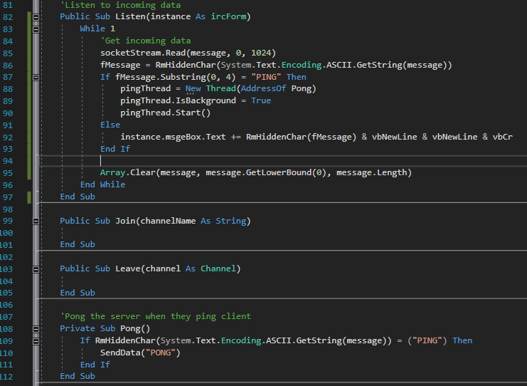

As you can see the formatting of the text is incorrect however it does break the text into the chunks sent to the client

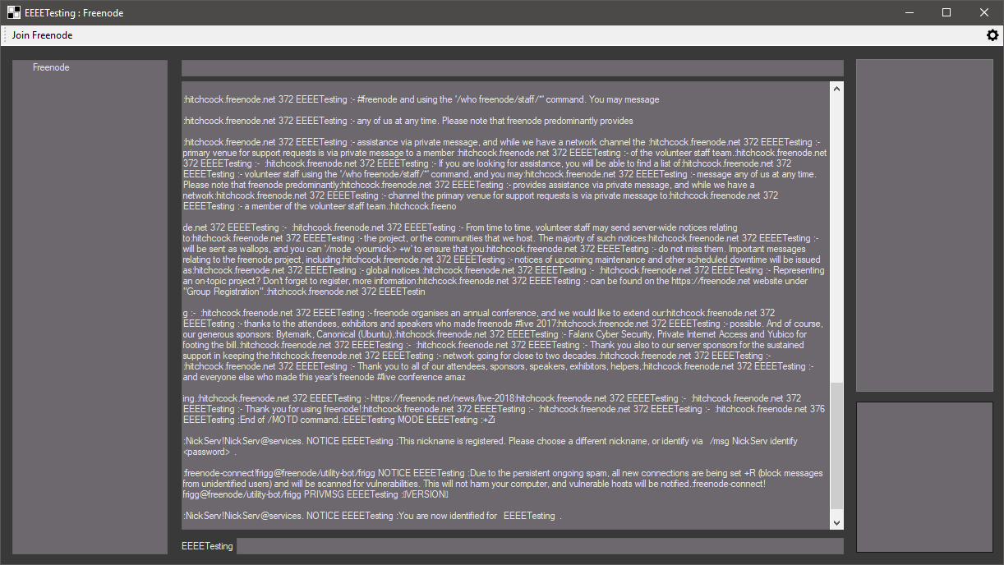

I remove the function I mentioned before and then appended the data without formatting it instead. The first message sent has no formatting however the other text does have formatting.

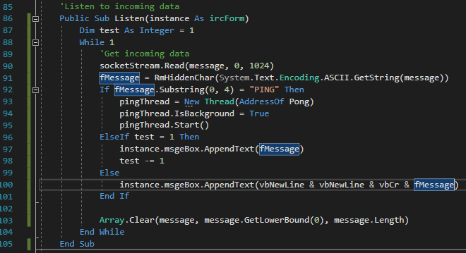

As the pong doesn’t need to check if the text contains PING it will send the data straight away and then ends.

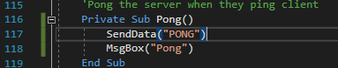

The PONG works well, however the formatting hasn’t changed much on the user side as it still has unexpected hand brakes.

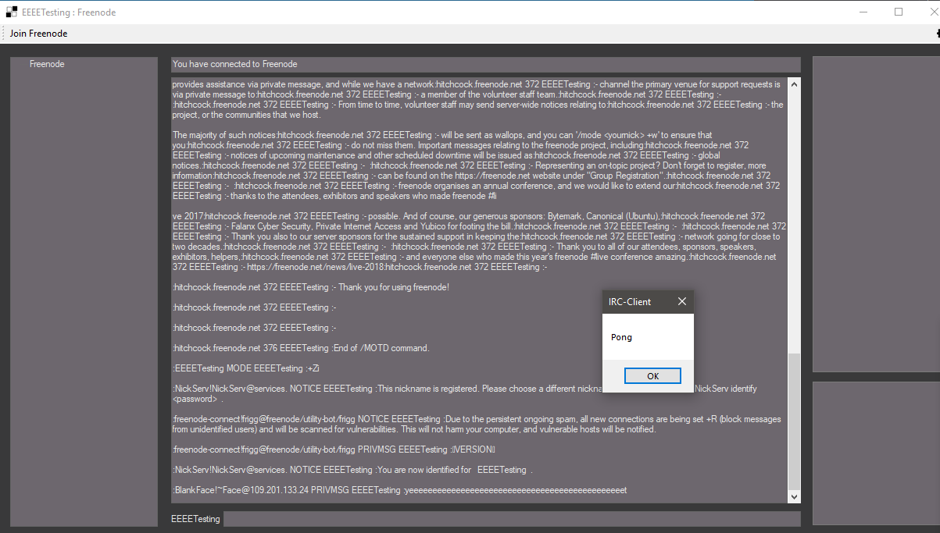

To be sure that the thread dies, I kill it using the code on line 118 which aborts the thread.

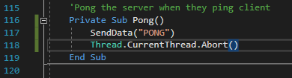

Disconnect sends “QUIT Bye!” to the server which the server will then kill the connection between the client and server, “Bye!” will just say that the client left to the channels with the message “Bye!”

I want to remove the unnecessary data the client doesn’t need to see from the message as it will help the user read the text, it splits the text by the colons, where the second colon is the message is. Sent user gets the username by selecting the text between the ! and : which is where the username of the sent user is.

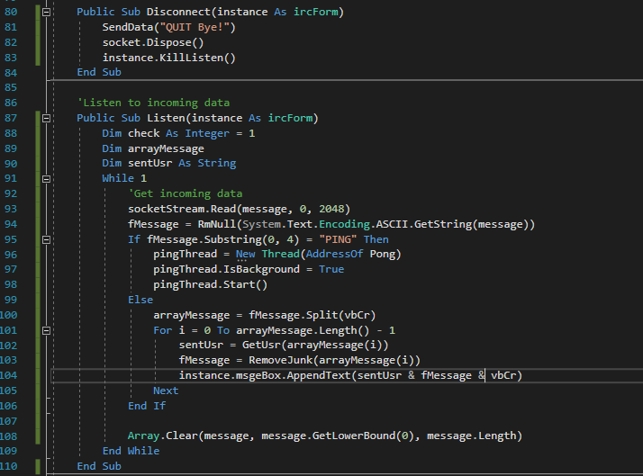

Remove junk gets rid of the not user friendly text, as the text received is in a format of “!username@host.com:person and/or command:message” It discards the first half and then gets the message from the text and returns it.

RmNull removes all the null bytes from the text.

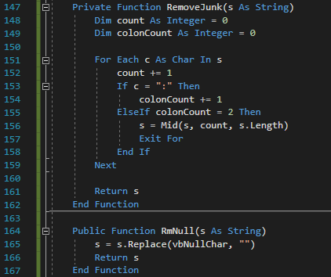

The result of the testing was good however there are occasional errors of text

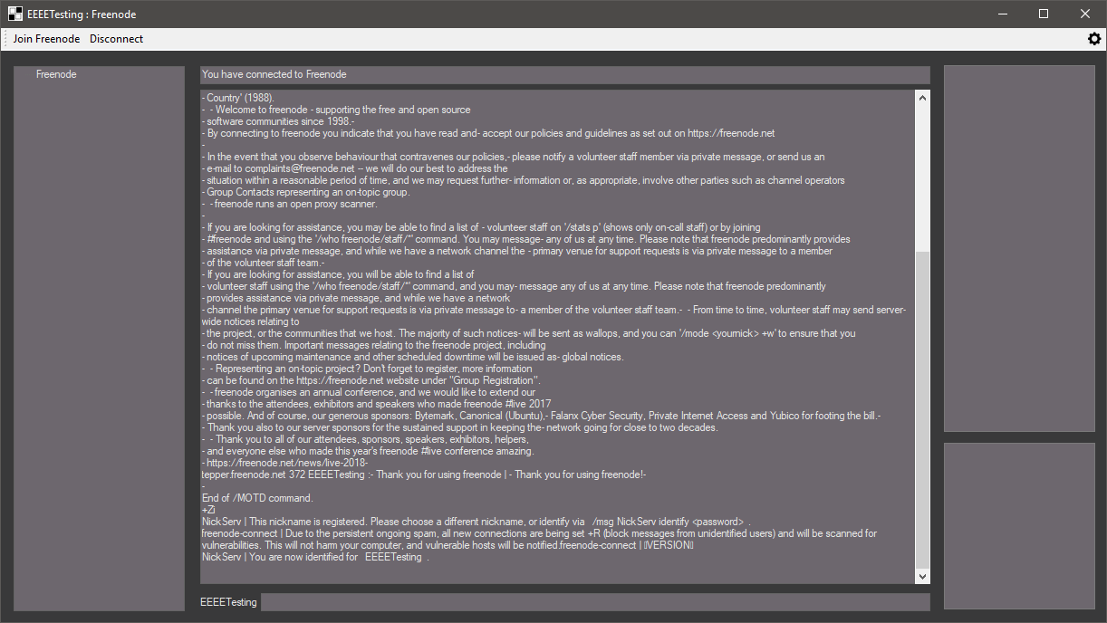

A message got through from the client on the right to the user on the right, but now I have to correctly format that text once more with colours and tabs for separate tabs.

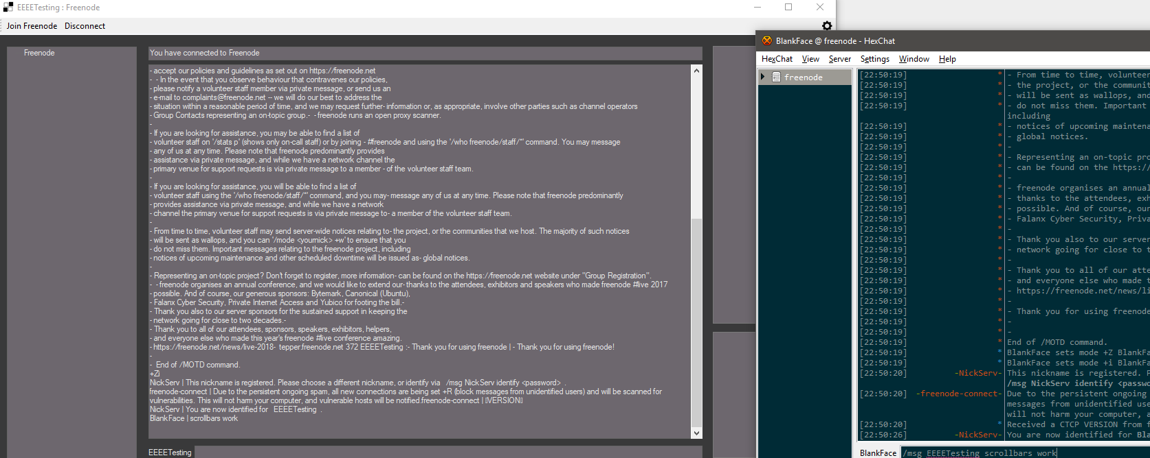

This splits the strings by carriage return line feeds where it will then add a newline then adds the username and removes the junk data to then add it to the textbox.

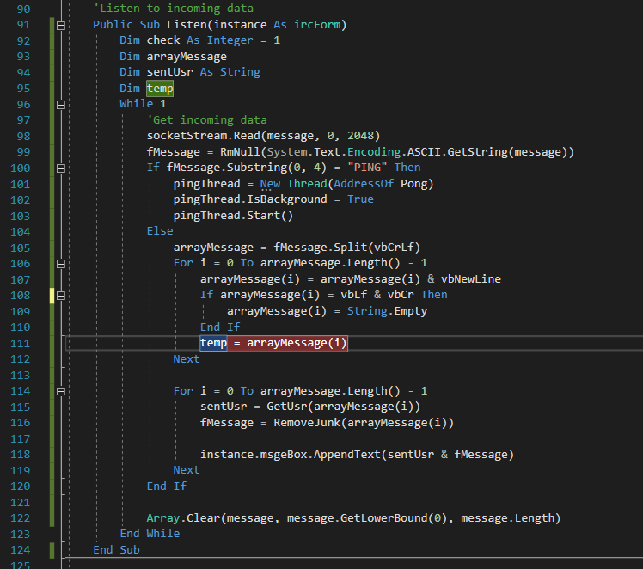

This fixed the text formatting however the last two messages were not correctly formatted which I will have to edit to deal with this.

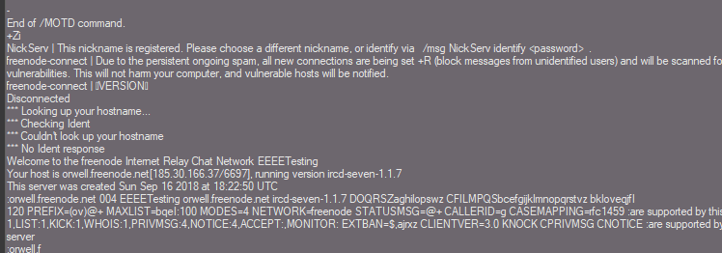

The connect procedure in summary now sets the username to the label underneath the input text box. It then adjusts so the text shows the whole username through the while loop. The title of the program is then changed to the username and server name of the client. I then add a key to the tree view so it adds the servers name to the view. If it is already there that means I have previously connected so it means there could be issues connecting because you cannot leave and join instantly. It will try every few seconds to connect counting up until it eventually connects. If it isn’t on the tree view it will connect as normal. Afterwards it calls the setupConn sub then identifies with the server logging in with a hard coded username and password for now.

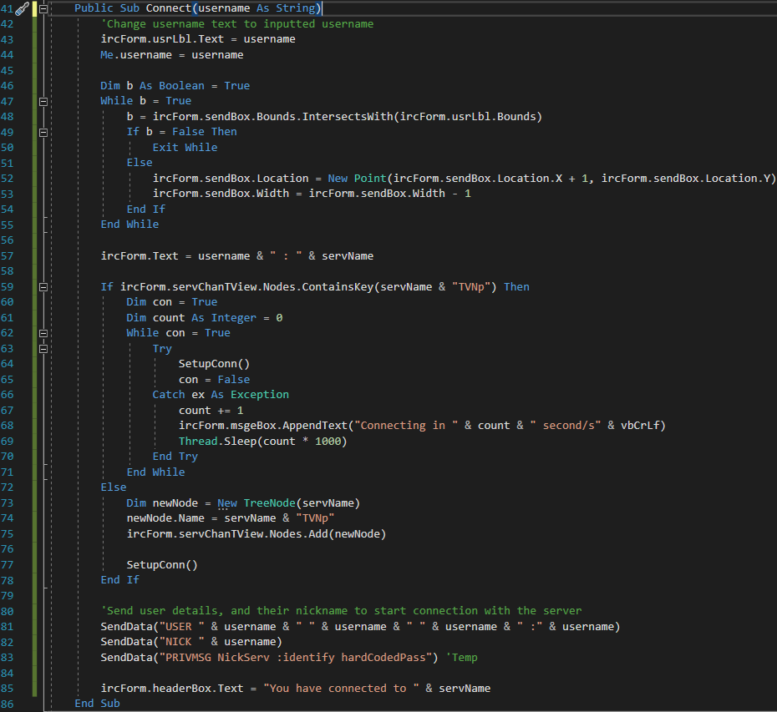

SetupConn chooses what connection method to use, and only accepts certain protocol types which are secure meaning that the transmission is more secure than someone using not one of the protocol type permitted bellow. It then authenticates with the server after getting the ssl stream. The other connection method does not use this and connects with just plain text.

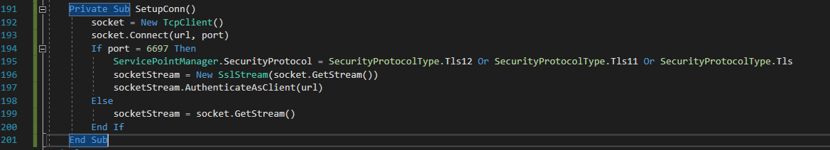

A user could try and send a message when not connected, due to me making it so a user can only connect when disconnected, and disconnect when connected it can remove errors however this didn’t affect sending messages, so I made it so when entering the message it checks if you are connected, if so it will send the message which is its own class.

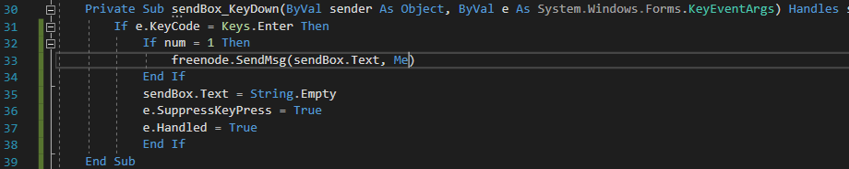



I made a message command which sends messages to a user, if they type “/msg username message” it will sent the text “message” to the user “username” which, the protocol specifies putting PRIVMSG at the beginning of the message so the server knows what to do with that data. The client then adds the text to the received/sent message box.

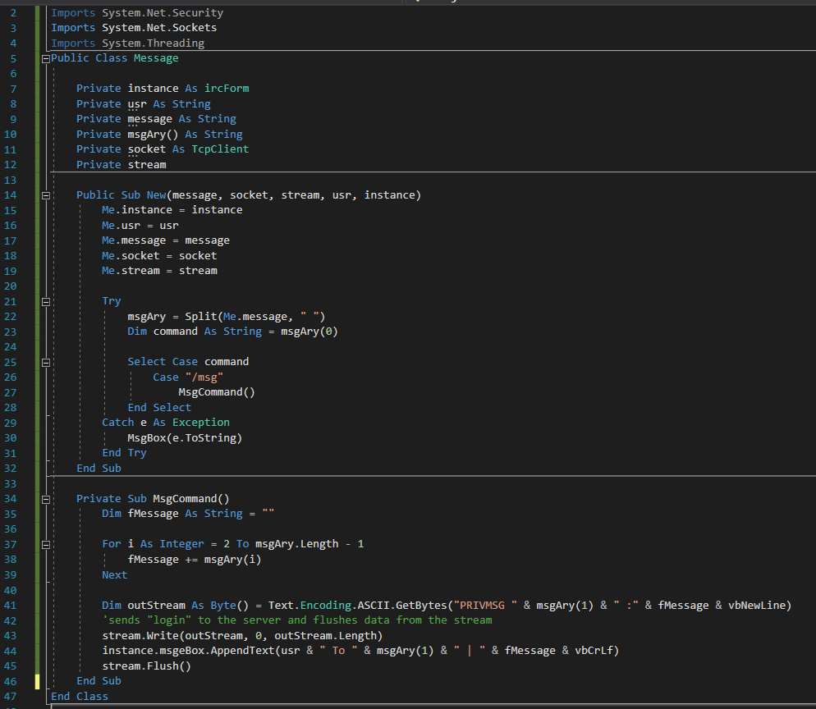

I typed the message I wanted to send into the box using the text box and it successfully sent to the user I wanted to send to.

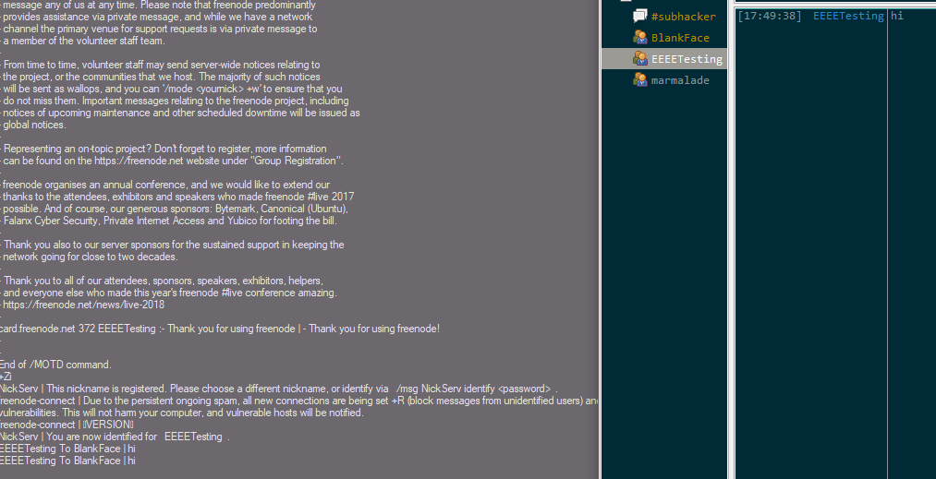

I removed the unnecessary variables from the program freeing space. I also added connectedChannels where the usernames of the users will be stored. I also commented all of the code

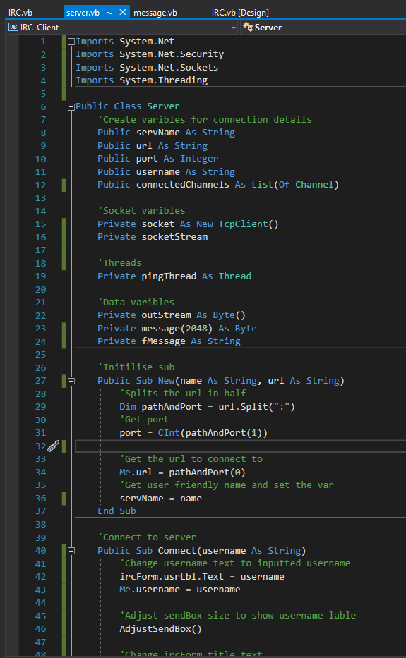

Here is another example of the commenting

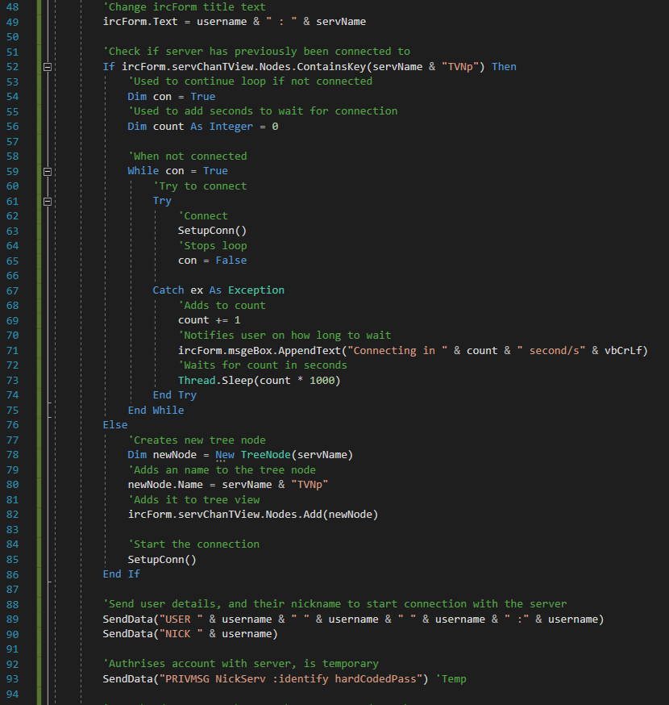

I turned the adjusting of the textbox into a sub where it can be called for the future for several servers

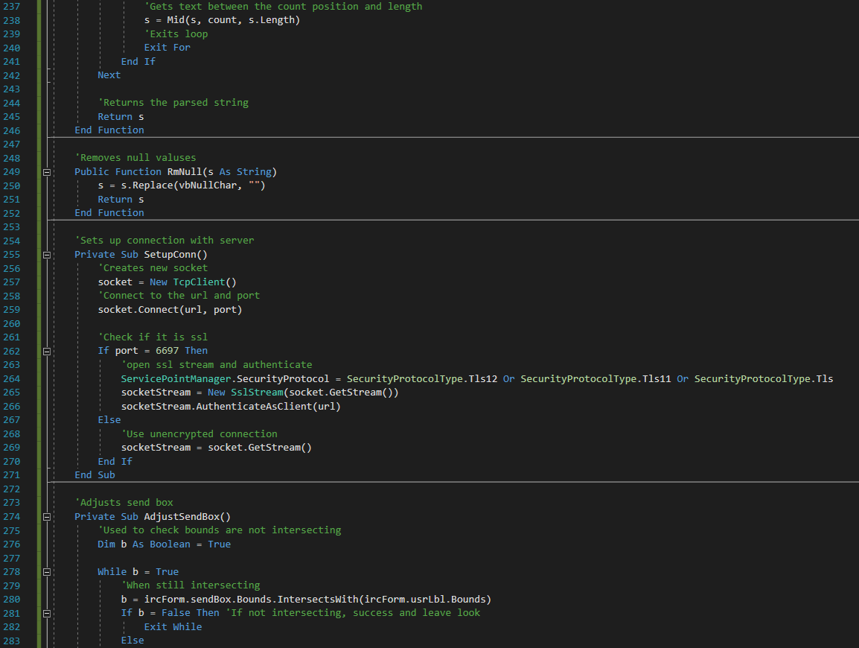

I also commented on the ircForm too so I could understand it better, bellow is an example

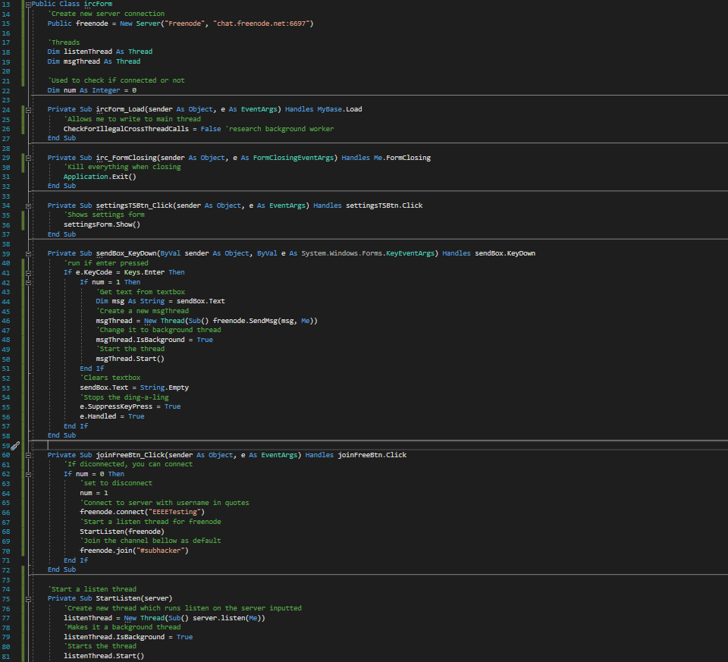

#### Testing

Client window

|  |  |  |  |  |  |
| --- | --- | --- | --- | --- | --- |
| Test no. | Criteria | Data type | User input | Expected outcome | Actual outcome |
| 5.1.2 | Click disconnect to freenode server | An action not a data type | Clicking disconnect button after connecting to the server | Disconnects from freenode server | Disconnects from the server theoretically but not implemented correctly. |
| 5.1.3 | Clicking settings icon opens settings | An action not a data type | Clicking setting icon | Opens up settings tab | Nothing |
| 5.2.1.1 | Message command works | Valid String | “/msg user hello” | Sends a message to a user | Sends a message to a user |
| 5.2.1.2 | Message command without arguments gives warning | Extreme string | “/msg” | Doesn’t send anyone a message and warning given | Doesn’t send message but doesn’t display anything |
| 5.2.2.1 | Join command works | Valid String | “/join #channelNameTest” | Joins a channel | Nothing |
| 5.2.2.2 | Join command without arguments gives warning | Extreme string | “/join” | Doesn’t Join a channel and warning given | Nothing |
| 5.2.3.1 | Leave command works | Valid String | “/leave #channelNameTest” | Leaves a channel | Nothing |
| 5.2.3.2 | Leave command without arguments gives warning | Extreme string | “/leave” | Doesn’t leave a channel and warning given | Nothing |
| 5.2.4.1 | Add command works | Valid String | “/add hello” | Adds user to list box | Nothing |
| 5.2.4.2 | Add command without arguments gives warning | Extreme string | “/add” | Doesn’t add a user to the box and returns warning | Nothing |
| 5.2.5 | Message without any commands | Valid String | “hello” | Sends message to the channel or user they are currently on through tabs | Nothing |
| 5.3.1 | Displays text from server | Action not data type | Logging in on menu | Displays text send from server into a text box | Yes |
| 5.3.2 | Displays usernames and errors in different colours | Valid string | “/msg realperson hi”  “/msg fakeperson hi” | Shows username in colour and shows error in colour | Nothing |
| 5.4 | Change colours of form on load | Action not data type | Logging in on menu | Colours of form are different to default | Nothing |
| 5.5 | Switching tabs works | Valid string  Action not data type | “/join #channel”  Click on tab which is labeled channel | Tabs change as well as text and names | Nothing |
| 5.4.1 | Server list box holds items successfully | Action not data type | Clicking join freenode | Shows “Freenode” in the server box | Nothing |
| 5.4.2.1 | Users box store items | Valid string  Action not data type | “/join #channel”  Click on tab which is labeled channel | Users from channel stored in user list box | Nothing |
| 5.4.2.2 | Switching tabs changes or removes items | Valid string  Action not data type | “/join #channel”  Click on tab which is labeled channel | When switching tabs text changes | Nothing |
| 5.4.3 | Friends box added items successfully | Action not data type | Logging in on menu | Stores the users into the friend box successfully | Nothing |

#### Review

What has been done:

Text is displayed well, started the message command, setup encrypted communications, and added disconnect function.

How it meets the success criteria:

3.5.1 , 3.7.1 , 3.7.2

3.5.1: The client now operates over SSL/TLS if the port is the default port used to communicate with it.

3.7.1: Display messages received from the server successfully, I have sort of done this so far however I still need to create tabs to split the messages from the user to my client.

3.7.2: I can now send messages to users directly and they receive them however I need to add tabs for this to be viable for the future.

Changes in the design:

Setup connection sub to use the most recent / secure versions of SSL/TLS

Summary of the prototype:

Changed the way the client displays text, and started to add a message command so I can message users from the client, and setup connecting over SSL/TLS to the IRC server and added a disconnect function.

### Seventh iteration: Client Stage Three

I started editing the message class so users can send have several functions which the class could check for and then send. I moved over the message command for now so the user can still save messages.

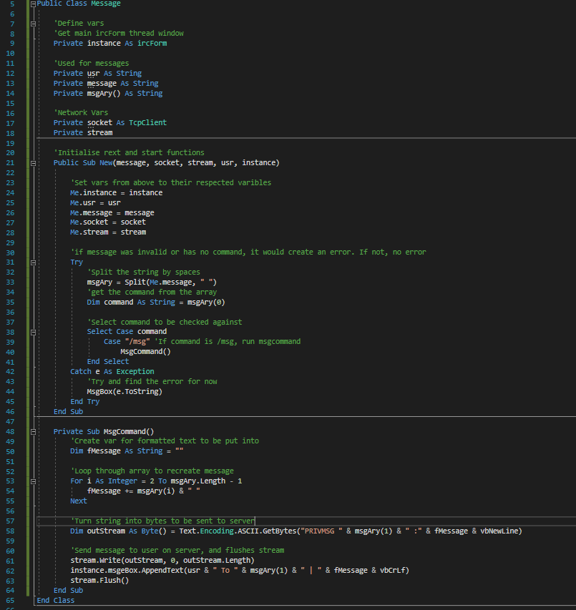

As sometimes the server would send data which was empty the listen function would break, I want to fix this error in the future however currently I will get other things working first, if there is an error the client will disconnect and then set the disconnect state in ircForm so the user can’t disconnect again when not connected.

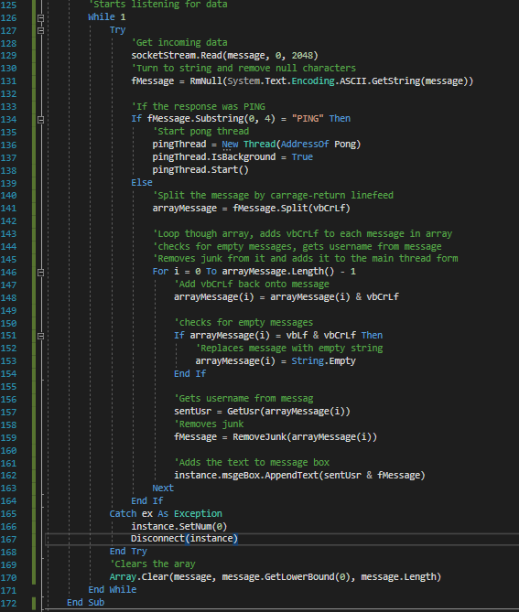

Sets the value of num securely.

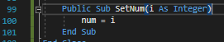

I am uploading this to gitlab in a private repo so I can look at the code everywhere, however I forgot to screenshot at this point when I had a lot of progress however this will show the development of the code within the day. Green is an added line, and red is a removed line, this application I am using is gitkraken to see the code.

I first edited the message class which now imports the server so it has access to the join and leave procedures which will allow me to leave a channel or join a channel so the message thread can make the client join a new server without having to reference all of the. I also added it into the reference for the class initiser. I then made the command variable to contain lowered text so it can easily be compared. I also added the two new commands for joining and leaving servers.

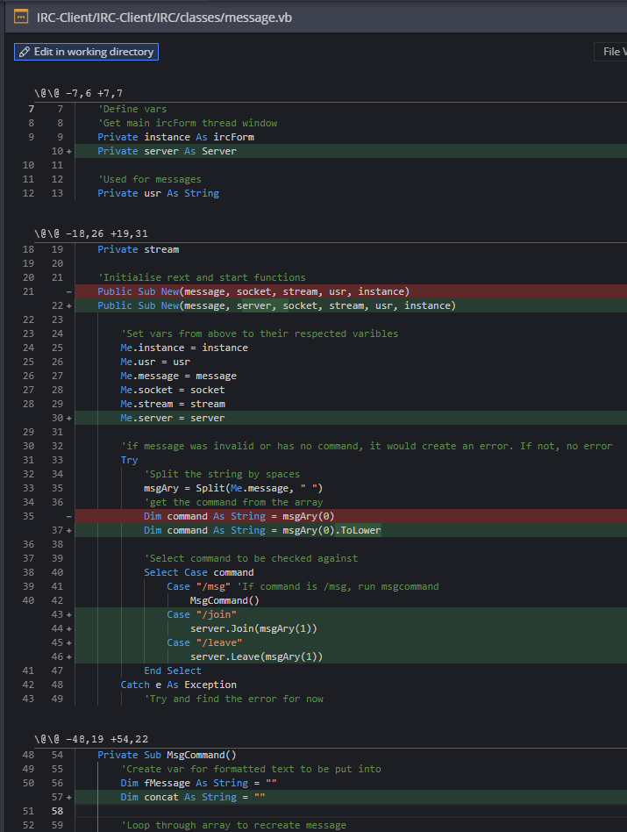

I added the concat variable to the send message procedure, it is where all of the data the user wants to send goes to to be then sent off, it then uses the SendData variable to reuse the code from earlier. I then changed the formatting of the text outputted from the client.

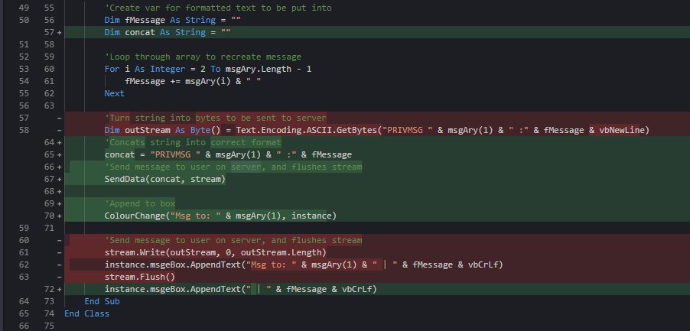

Now editing the server class, I imported regular expressions which can be used to format and get sections of text from the variable such as getting the username and message from the text received from the user. I added a general thread so I can start a thread for multiple things if needed. I changed the tree view into a listbox as it suited it better than the other.

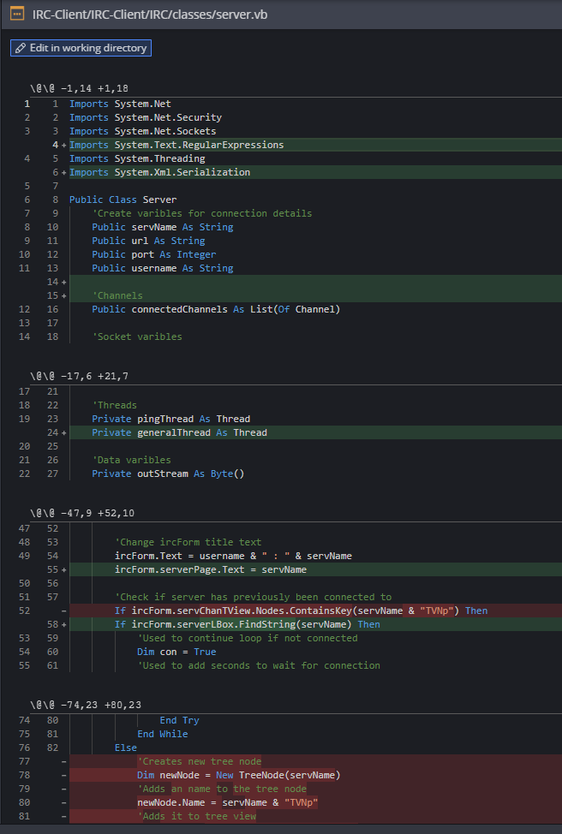

I begin the update on the box, add the item then end the update and select the box, however when testing this does not work. I now have to send the socket stream to send data to the server due to it being in a separate file all classes can access. I add this to disconnect too, and I now kill the thread after sending the data to then append the disconnected text to the message box.

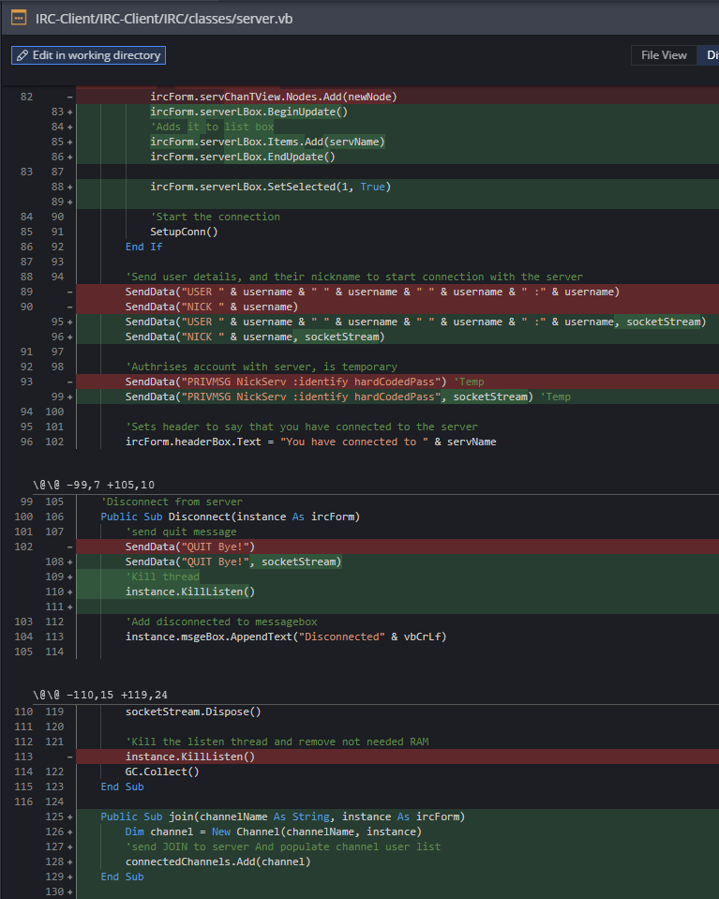

SentUsr was giving me errors so I removed the variable type so it is dynamic, and I won’t have to figure out what type of data it is. If the message array contains a message it will continue with executing the program. The message is then formatted and checked if the message only contains certain characters to then continue with executing the program, it then gets the user from the message and then formats the users text.

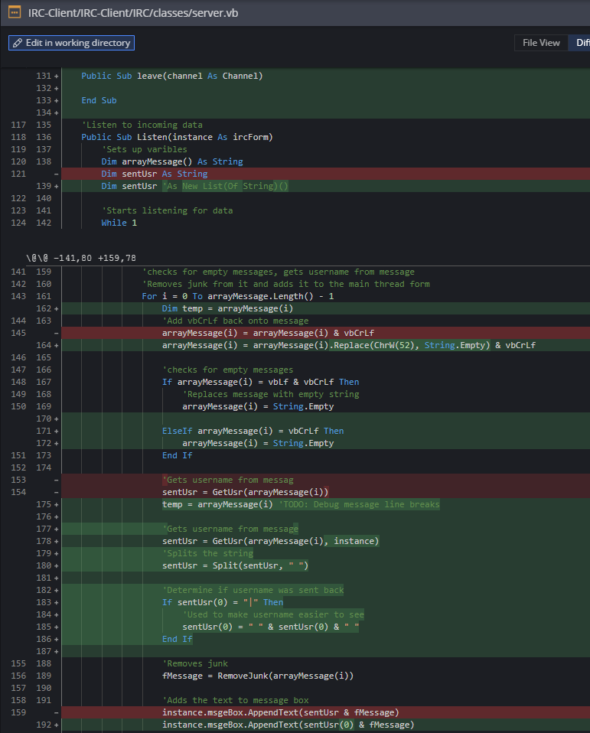

I then added the server to be included when creating a message class in the sendmsg procedure which will mean sending a message will no longer cause an error. Get user will now use regex to get the username from the text as it is easier than splitting it. I will possibly change the whole of the listen sub to also change to this later as it will be more efficient.

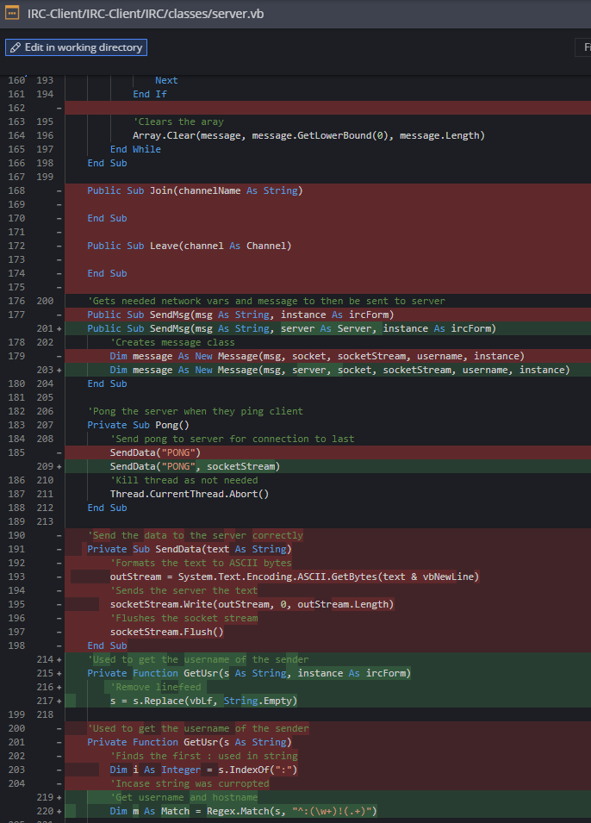

I made a new sub which you will see later, which changes the colour of the text for the usernames so it is easier for users to see who is messaging them. It then adds the message after the username in the default text colour.

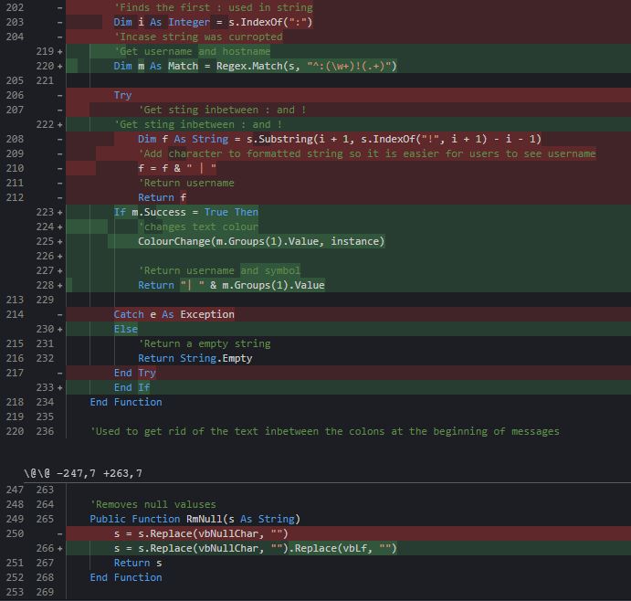

Now editing the IRC client code, I commented out freenode.join as I have not coded this part fully yet but calling it would cause errors for the program. I changed the threads to create a new message to include the server variable freenode which is now needed to run the function for the procedures within it. Set num will let me securely change the number for the irc client from another thread or class.

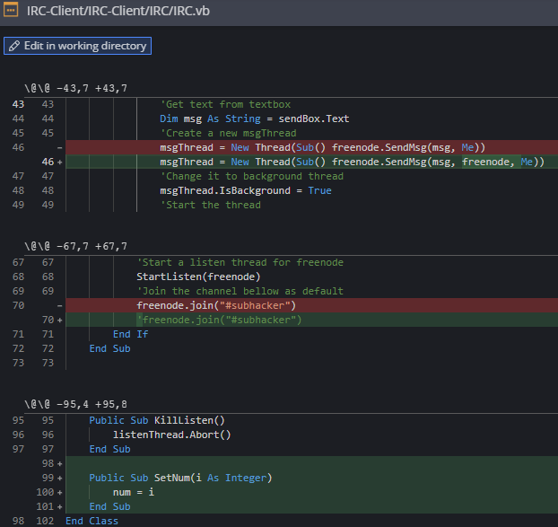

I made an IRC module file to contain subs which are needed for the classes and the irc form. SendData is needed for each class so they can easily send data without having to write out those three lines, excluding the comments, every time. Change colour lets the text inputted become a different colour within the with statement, after that the colour is reset back to the normal colour.

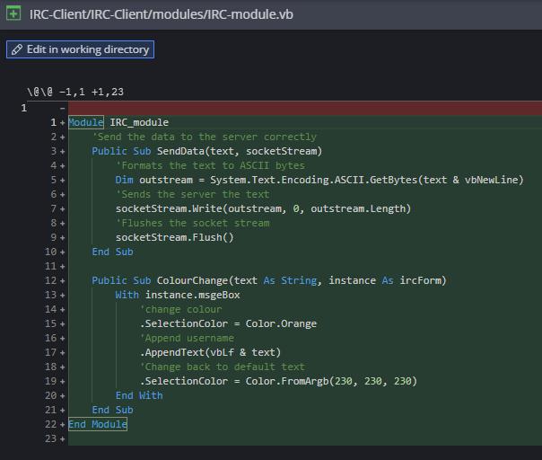

Going back to the message class, I now append the text without the vbCrLf as it would add another line after it which would look bad and out of place.

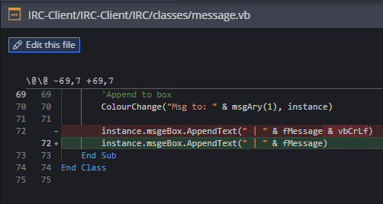

Now on the server class in the listen thread, I now use regex to get the different sections of text from the data received which includes the username, hostname, command sent, the user who sent it and the message itself. I have changed so the username isn’t found in another procedure but in the same procedure. I also easily get the message too which removed a lot of unnecessary lines.If there is no username, and a message is sent it is directly from the server so no username is added, the code at the bottom fixes this.

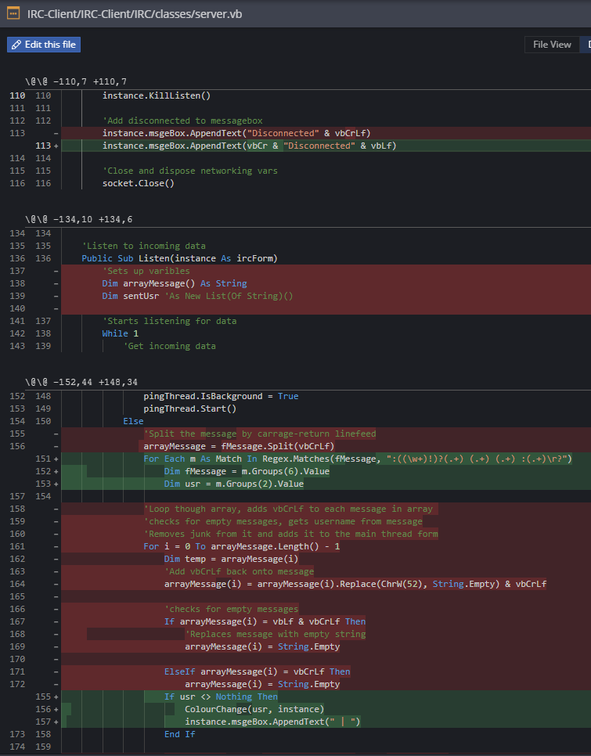

I kept getting strange characters in my program occasionally, appearing at the left and right of a message, I researched it and it turns out to be a CTCP which is a Client-to-client protocol, as I don’t need this in my client I will notify the user that someone sent a request however not respond to it, I may make it a feature in the future but I am unfamiliar with CTCP. The other code checks for a username, and if not it sends the text normally.

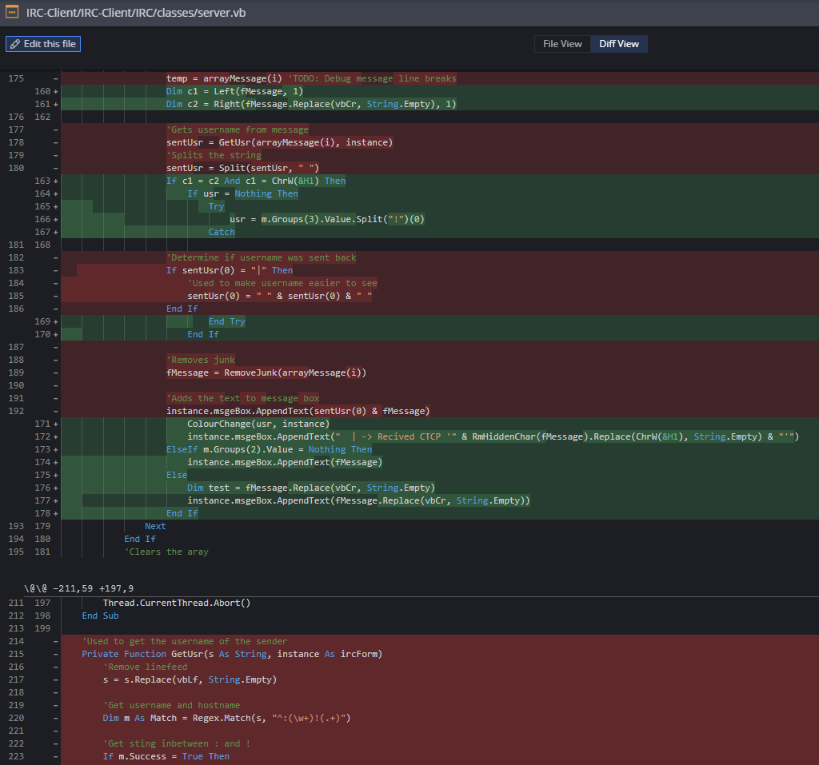

I removed this code as there was no use for it anymore especially as I can now format the text using regex which is much simpler than having to code lots of functions to parse the data received.

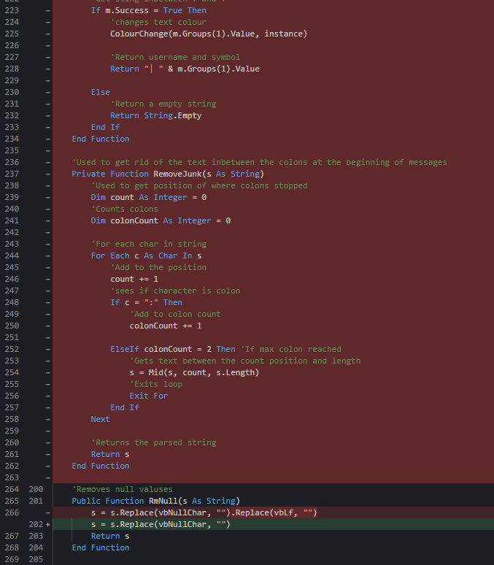

#### Testing

Client window

|  |  |  |  |  |  |
| --- | --- | --- | --- | --- | --- |
| Test no. | Criteria | Data type | User input | Expected outcome | Actual outcome |
| 5.1.2 | Click disconnect to freenode server | An action not a data type | Clicking disconnect button after connecting to the server | Disconnects from freenode server | Disconnects from the server theoretically but not implemented correctly. |
| 5.1.3 | Clicking settings icon opens settings | An action not a data type | Clicking setting icon | Opens up settings tab | Nothing |
| 5.2.1.2 | Message command without arguments gives warning | Extreme string | “/msg” | Doesn’t send anyone a message and warning given | Doesn’t send message but doesn’t display anything |
| 5.2.2.1 | Join command works | Valid String | “/join #channelNameTest” | Joins a channel | Nothing |
| 5.2.2.2 | Join command without arguments gives warning | Extreme string | “/join” | Doesn’t Join a channel and warning given | Nothing |
| 5.2.3.1 | Leave command works | Valid String | “/leave #channelNameTest” | Leaves a channel | Nothing |
| 5.2.3.2 | Leave command without arguments gives warning | Extreme string | “/leave” | Doesn’t leave a channel and warning given | Nothing |
| 5.2.4.1 | Add command works | Valid String | “/add hello” | Adds user to list box | Nothing |
| 5.2.4.2 | Add command without arguments gives warning | Extreme string | “/add” | Doesn’t add a user to the box and returns warning | Nothing |
| 5.2.5 | Message without any commands | Valid String | “hello” | Sends message to the channel or user they are currently on through tabs | Doesn’t send but doesn’t warn |
| 5.3.2 | Displays usernames and errors in different colours | Valid string | “/msg realperson hi”  “/msg fakeperson hi” | Shows username in colour and shows error in colour | Username displays well but errors not showing. |
| 5.4 | Change colours of form on load | Action not data type | Logging in on menu | Colours of form are different to default | Nothing |
| 5.5 | Switching tabs works | Valid string  Action not data type | “/join #channel”  Click on tab which is labeled channel | Tabs change as well as text and names | Nothing |
| 5.4.1 | Server list box holds items successfully | Action not data type | Clicking join freenode | Shows “Freenode” in the server box | Nothing |
| 5.4.2.1 | Users box store items | Valid string  Action not data type | “/join #channel”  Click on tab which is labeled channel | Users from channel stored in user list box | Nothing |
| 5.4.2.2 | Switching tabs changes or removes items | Valid string  Action not data type | “/join #channel”  Click on tab which is labeled channel | When switching tabs text changes | Nothing |
| 5.4.3 | Friends box added items successfully | Action not data type | Logging in on menu | Stores the users into the friend box successfully | Nothing |

#### Review

What has been done:

Message Class was added to the code to handle sending messages to the server and adding the text sent to the message box. I used regex to get the username from the message received and I will be using this to parse each section of the message received to handle them more easily instead of making several functions to find the text I need

How it meets the success criteria:

This section was more so for fixing the program and making it run more efficiently and uses less lines due to classes being used.

Changes in the design:

I added regex on username and turned SendData sub into a new module file as well as adding colour change in there too as the message class will use it too.

Summary of the prototype:

Fixed issues previously and implemented better ways of dealing with the data as well as making a message class which will be used to send messages and deal with commands used by the user.

### Eighth iteration: Client Stage Four

I have now added tabs to the program as each channel and person should have their text split between the different tabs so it is easier to manage and respond to messages.

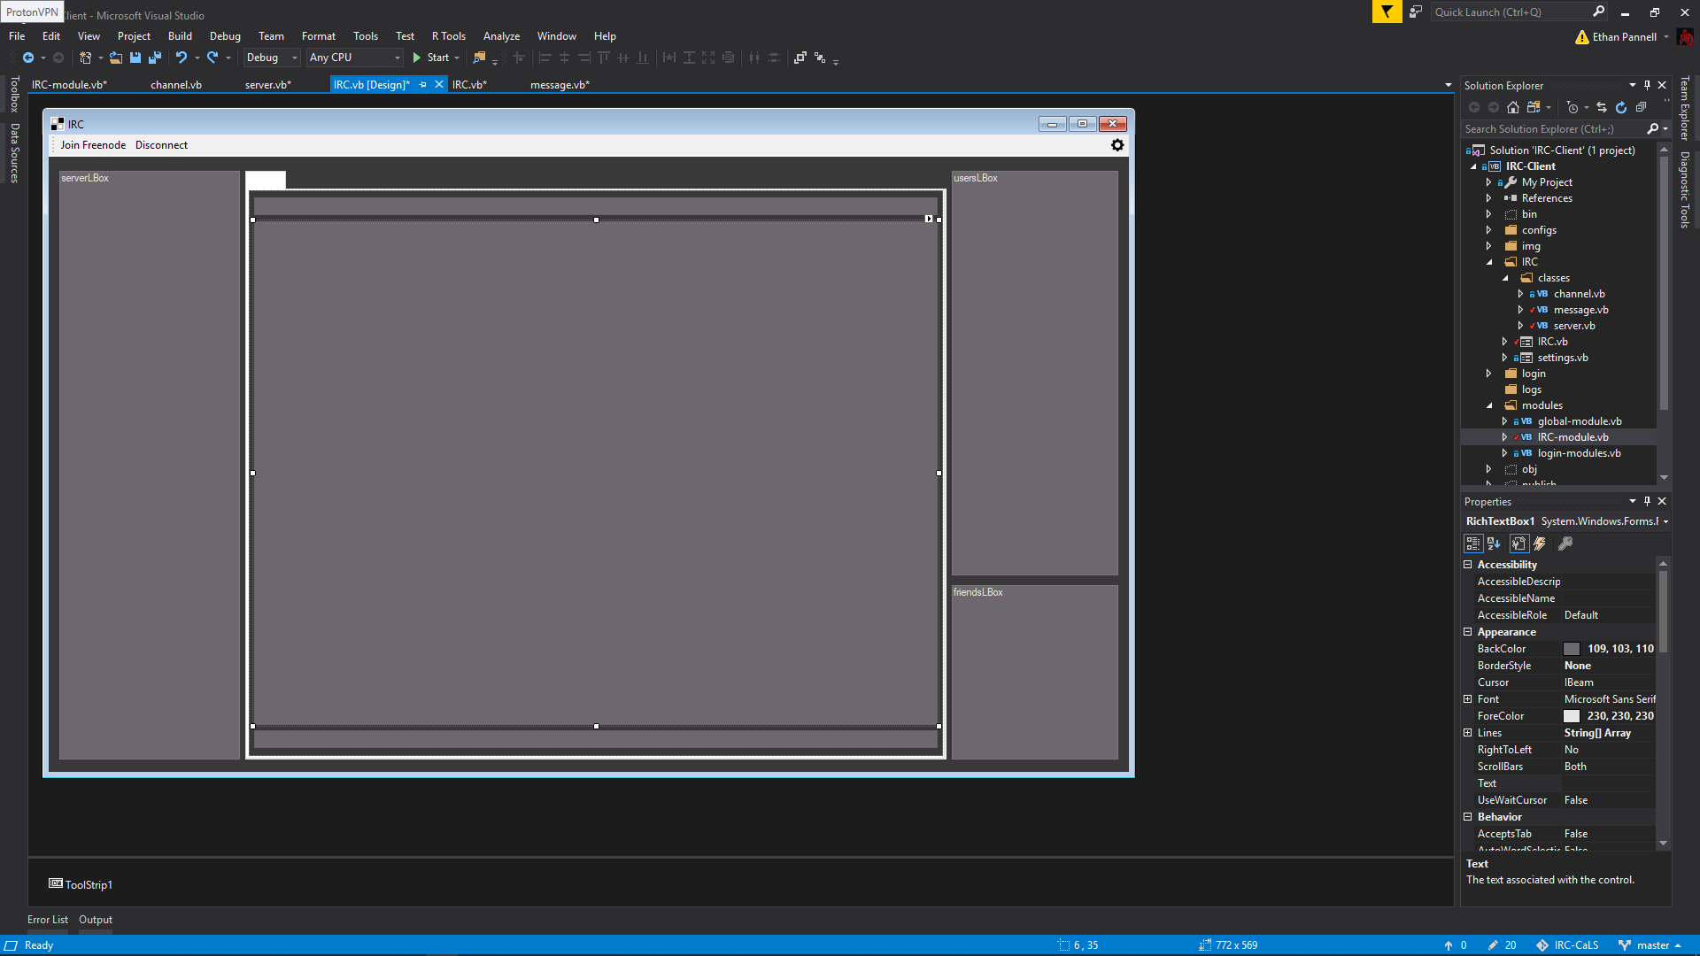

This is a regex which will match a select string and split it into groups which can be called for by the program. Regex uses brackets to split the text into groups. The regex bellow splits up the text into several groups, the first is the username with an exclamation mark which I do not need, however group two gets the username itself, the next gets the host name, group for gets the command, group 5 gets the receiver which is my username and group 6 gets the message. Group 1 and group 6 are not needed however they have to be in separate groups otherwise the regex won’t work as well and I have to parse it again in the program.

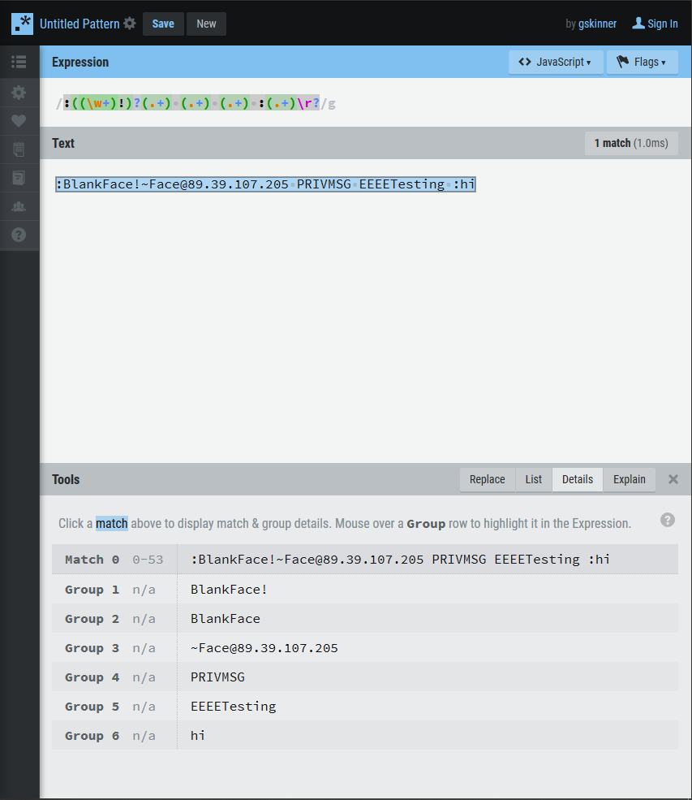

This is what the client looks like when connecting. There is an line break after nickserv message which notifies i’m using a registered nick, however after that the text is formatted correctly.

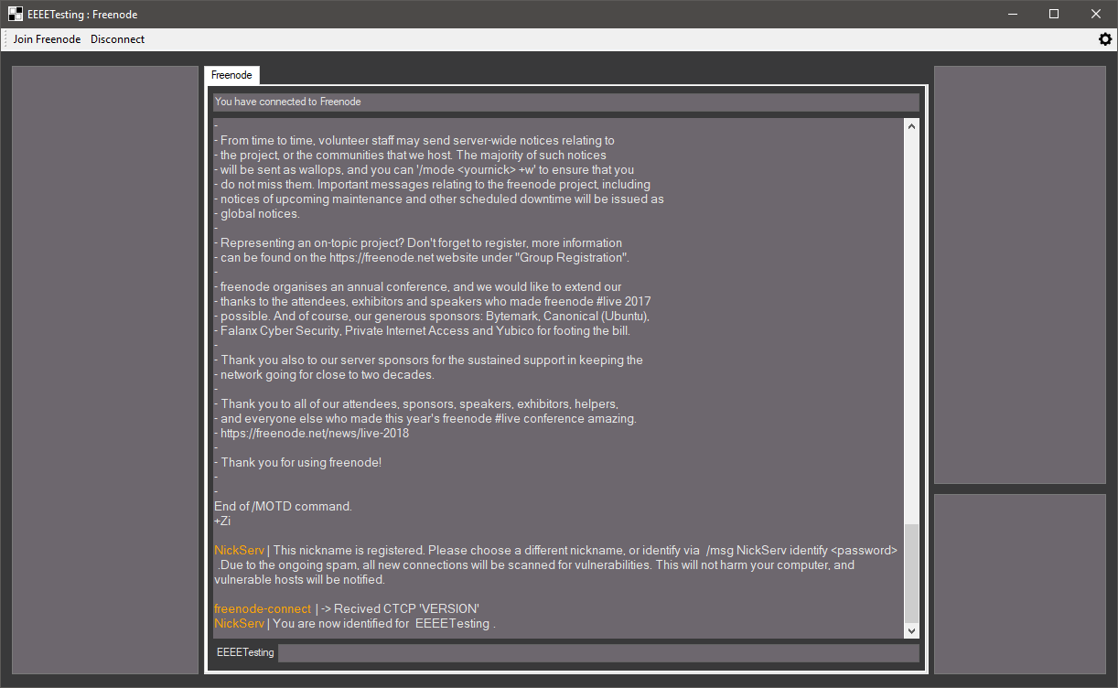

I simplified the code down and now I can add a friend into the friend box, and get the message from the text box I want to send and send it as a whole due to me having to reconstruct the text from it being split.

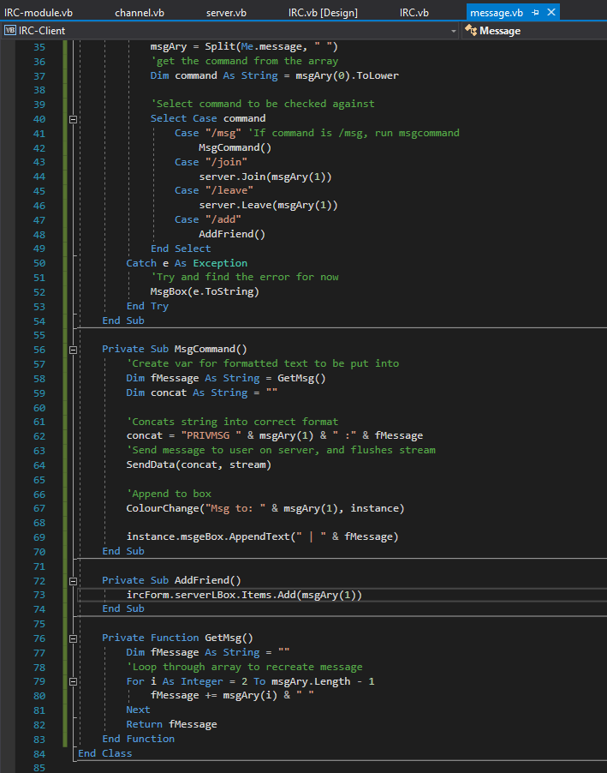

The text I wanted to add to the LBox was not appearing which was strange so I want to fix this later

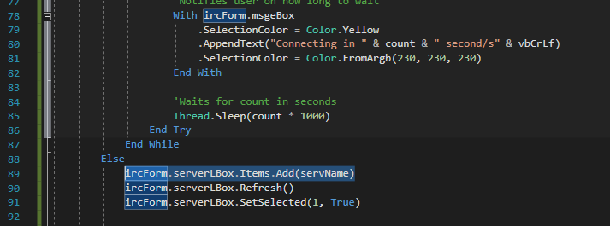

I added to the disconnect sub to send the quit data, kill the listen thread and then add a red box made of hashtags with disconnect inside of it in white. It then closes and disposes the stream and socket. Afterwards it collects all of the necessary data and removes it from RAM.

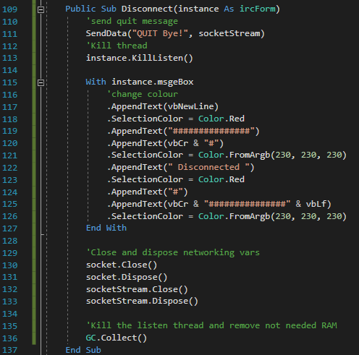

I made a if statement in the msg command sub which then checks if the get msg changed the text to “No text to send” and then relays it back to the user,

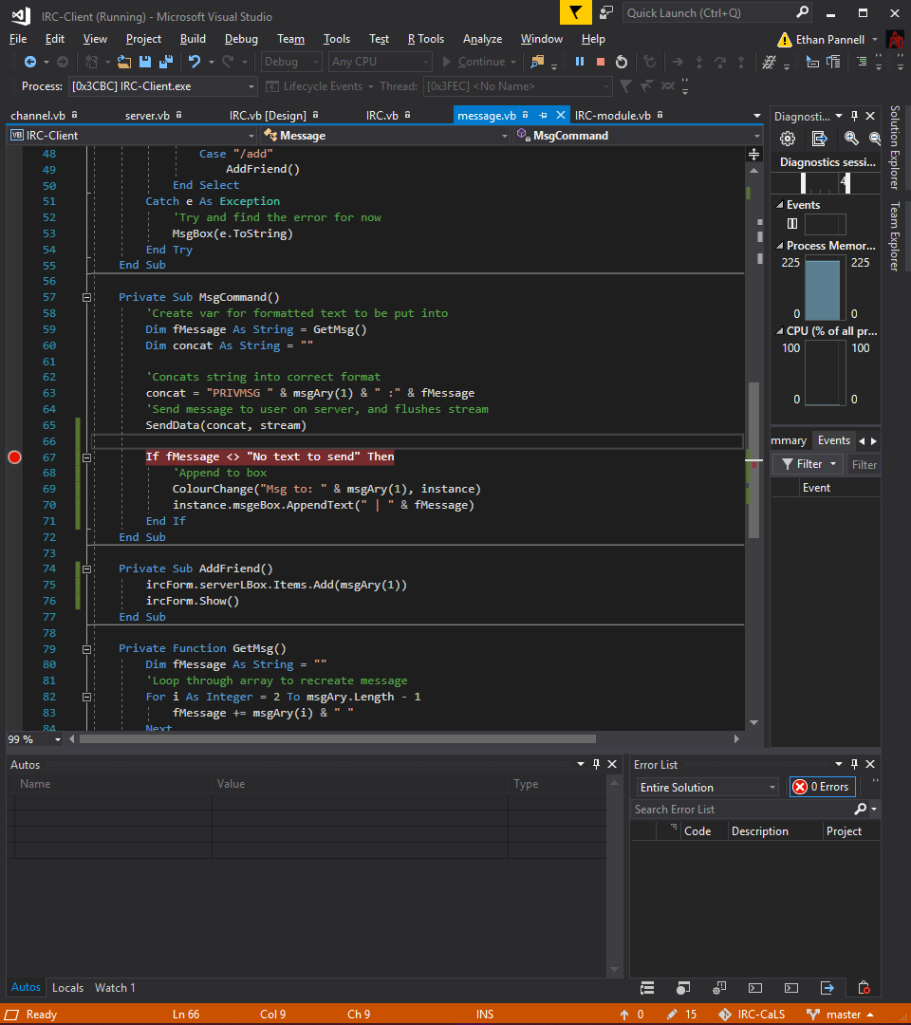

It now adds the no text to send at the end of the message.

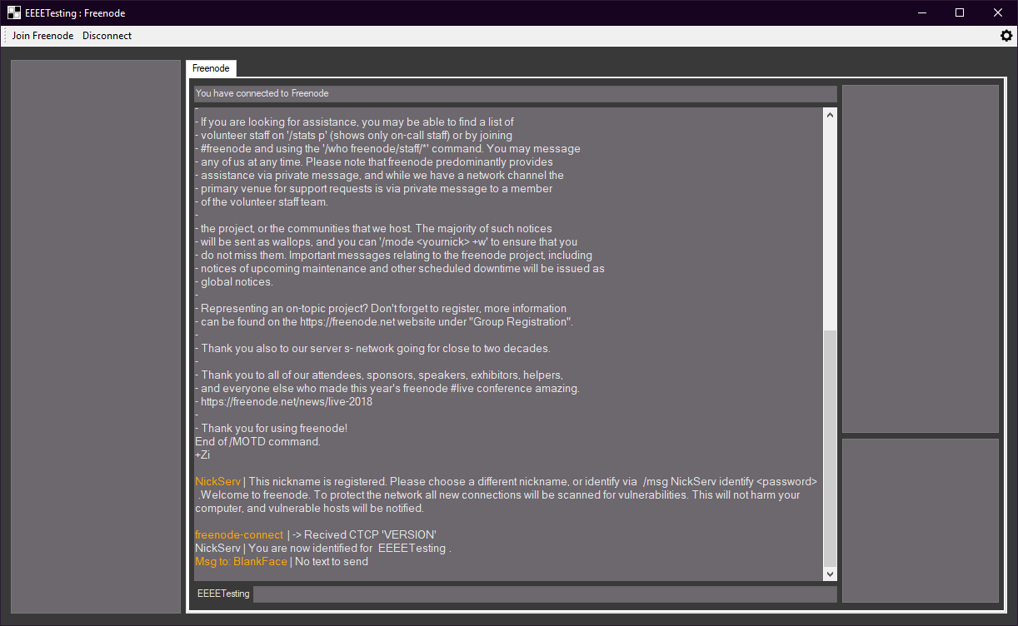

I noticed when quickly testing the reset button it didn't handle all of the errors, so I quickly fixed this with message boxes which shows the errors.

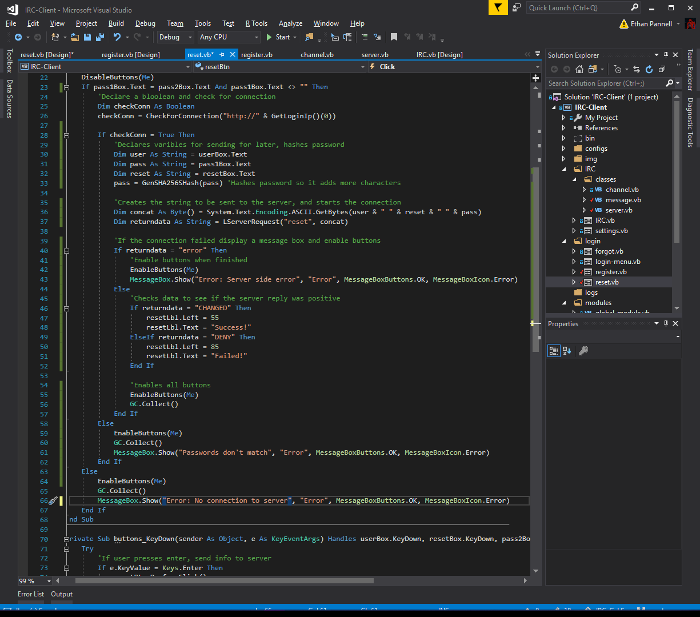

I changed the colour sub so for later a user can enter a name of a colour to change the text colour of it, or to dynamically change the colour within the program.

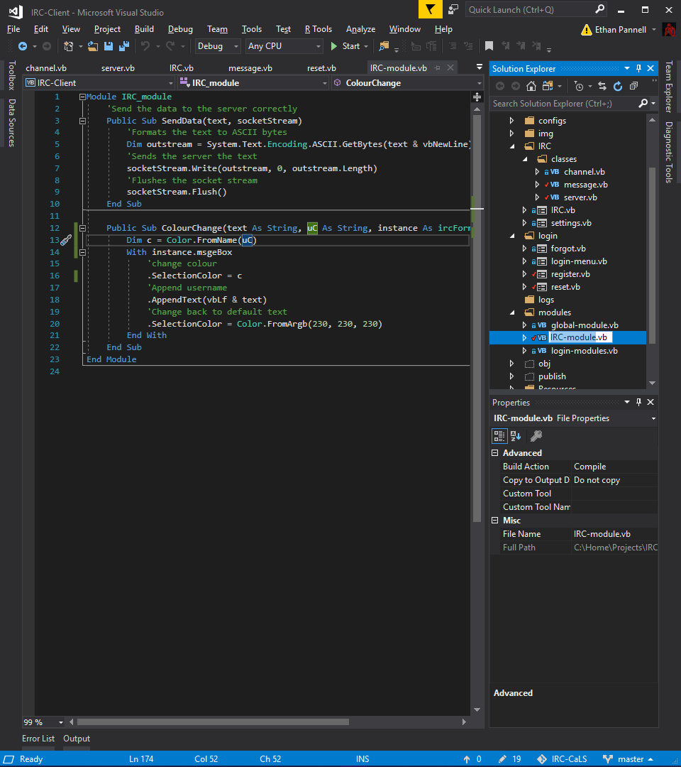

The result of above.

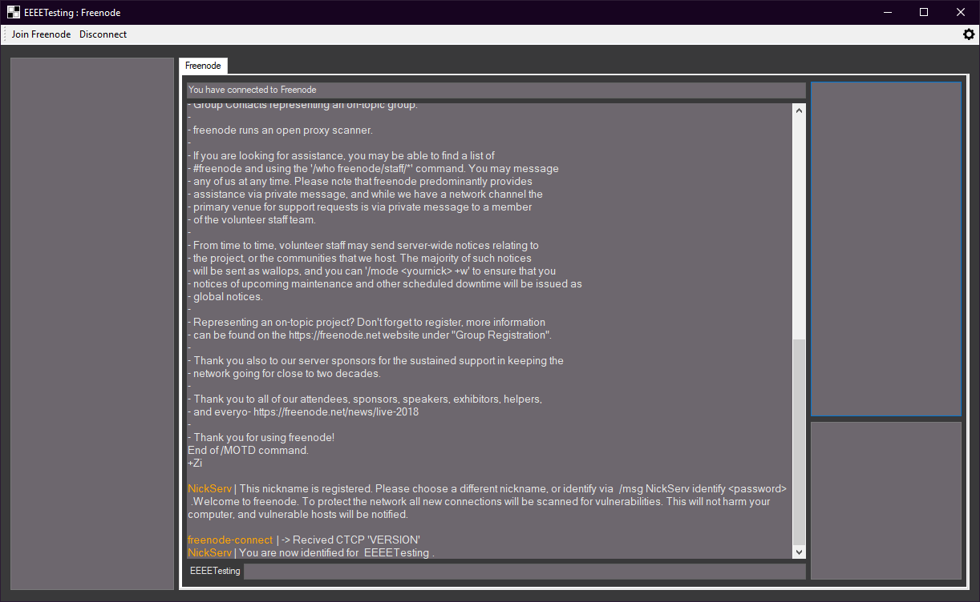

I had to change every colour change call to include orange as the text for now



And if there is an error message or a notification from the server text will be appended with the colour pink to stand out from the rest of the text.

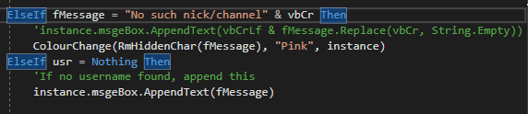

Now when trying to message a person who is not online it will append this to the text.

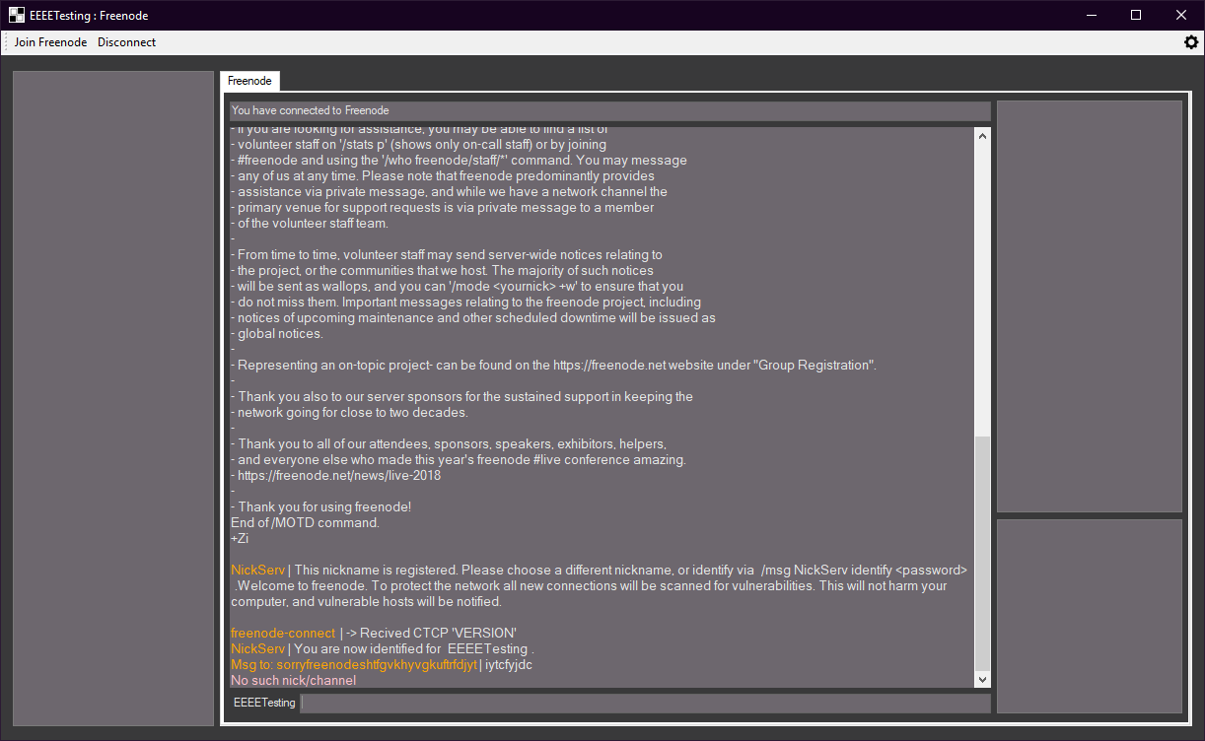

#### Testing

Client window

|  |  |  |  |  |  |
| --- | --- | --- | --- | --- | --- |
| Test no. | Criteria | Data type | User input | Expected outcome | Actual outcome |
| 5.1.2 | Click disconnect to freenode server | An action not a data type | Clicking disconnect button after connecting to the server | Disconnects from freenode server | Disconnects from the server theoretically but not implemented correctly. |
| 5.1.3 | Clicking settings icon opens settings | An action not a data type | Clicking setting icon | Opens up settings tab | Nothing |
| 5.2.1.2 | Message command without arguments gives warning | Extreme string | “/msg” | Doesn’t send anyone a message and warning given | Doesn’t send message but doesn’t display anything |
| 5.2.2.1 | Join command works | Valid String | “/join #channelNameTest” | Joins a channel | Nothing |
| 5.2.2.2 | Join command without arguments gives warning | Extreme string | “/join” | Doesn’t Join a channel and warning given | Nothing |
| 5.2.3.1 | Leave command works | Valid String | “/leave #channelNameTest” | Leaves a channel | Nothing |
| 5.2.3.2 | Leave command without arguments gives warning | Extreme string | “/leave” | Doesn’t leave a channel and warning given | Nothing |
| 5.2.4.1 | Add command works | Valid String | “/add hello” | Adds user to list box | Nothing |
| 5.2.4.2 | Add command without arguments gives warning | Extreme string | “/add” | Doesn’t add a user to the box and returns warning | Nothing |
| 5.2.5 | Message without any commands | Valid String | “hello” | Sends message to the channel or user they are currently on through tabs | Doesn’t send but doesn’t warn |
| 5.3.2 | Displays usernames and errors in different colours | Valid string | “/msg realperson hi”  “/msg fakeperson hi” | Shows username in colour and shows error in colour | Displays correctly |
| 5.4 | Change colours of form on load | Action not data type | Logging in on menu | Colours of form are different to default | Nothing |
| 5.5 | Switching tabs works | Valid string  Action not data type | “/join #channel”  Click on tab which is labeled channel | Tabs change as well as text and names | Nothing |
| 5.4.1 | Server list box holds items successfully | Action not data type | Clicking join freenode | Shows “Freenode” in the server box | Nothing |
| 5.4.2.1 | Users box store items | Valid string  Action not data type | “/join #channel”  Click on tab which is labeled channel | Users from channel stored in user list box | Nothing |
| 5.4.2.2 | Switching tabs changes or removes items | Valid string  Action not data type | “/join #channel”  Click on tab which is labeled channel | When switching tabs text changes | Nothing |
| 5.4.3 | Friends box added items successfully | Action not data type | Logging in on menu | When loading the form the colours change to the specific theme set in a file | Stores the users into the friend box successfully |

#### Review

What has been done:

Handled message errors, and most importantly changed the way it gets the data from the messages, it now uses regex to get the data from the messages received and now the colours can be changed more easily too to colours other than orange

How it meets the success criteria:

Adds apon already met criterias from previous iterations.

Changes in the design:

I changed the listen function to use regex to get sections of the messages so I can easily parse it to get different sections of the data to then use for specific functions if a certain string is sent.

Summary of the prototype:

Changed the way the listen function worked to use regex, handles errors from message and changes colours easily.

### Ninth iteration: Client Stage Five

I changed the join channel to be used in the message class itself so it doesn’t need to call back to the server as there is no difference between calling the sub within the server class to calling the one within the message class. I can now also add a friend into the bottom right box so I can remember who I can trust on this server to talk to

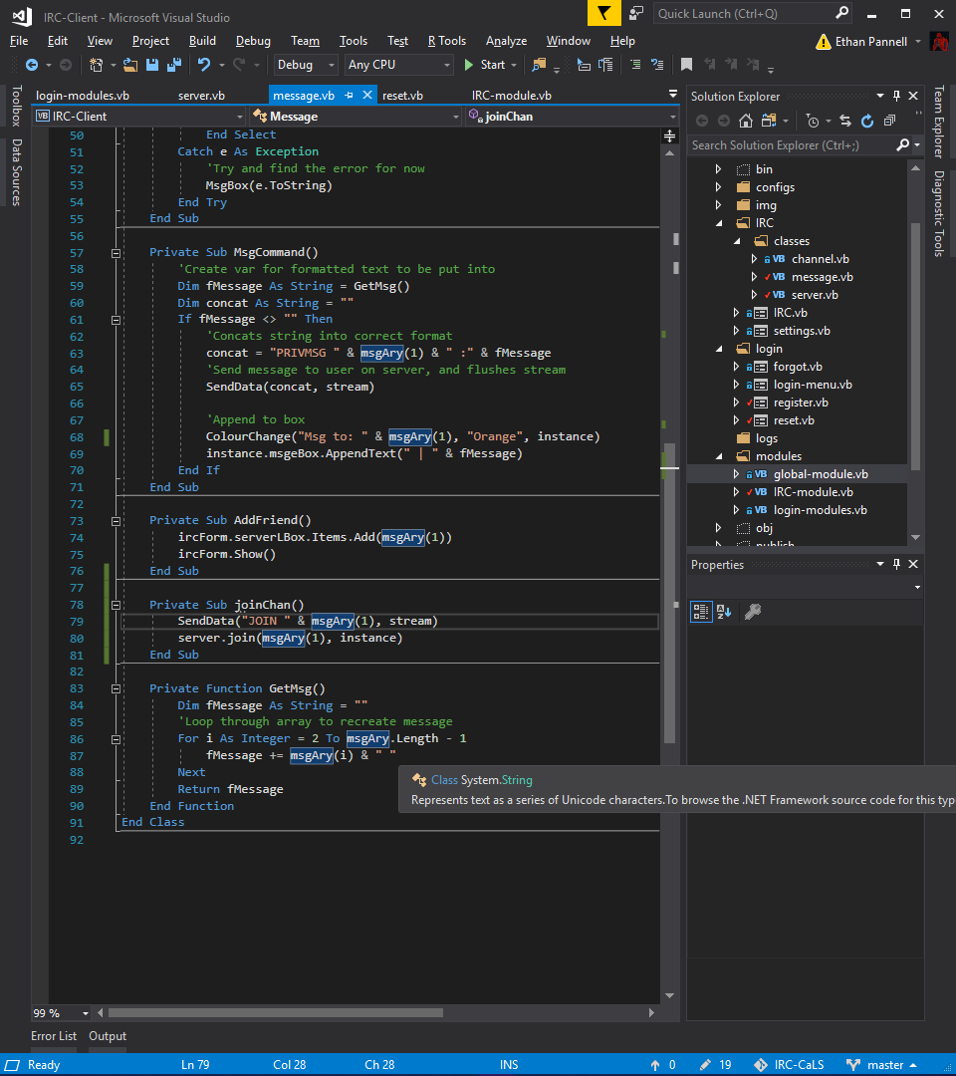

When running the join command the format of the text looks like this, so I might have to adjust my regex to see if it still works as intended.

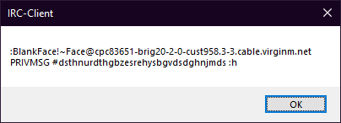

When testing the regex still works, and group 5 is the receiver of the message which is the channel, this is very useful as I can use in the future to split my text into different tabs.

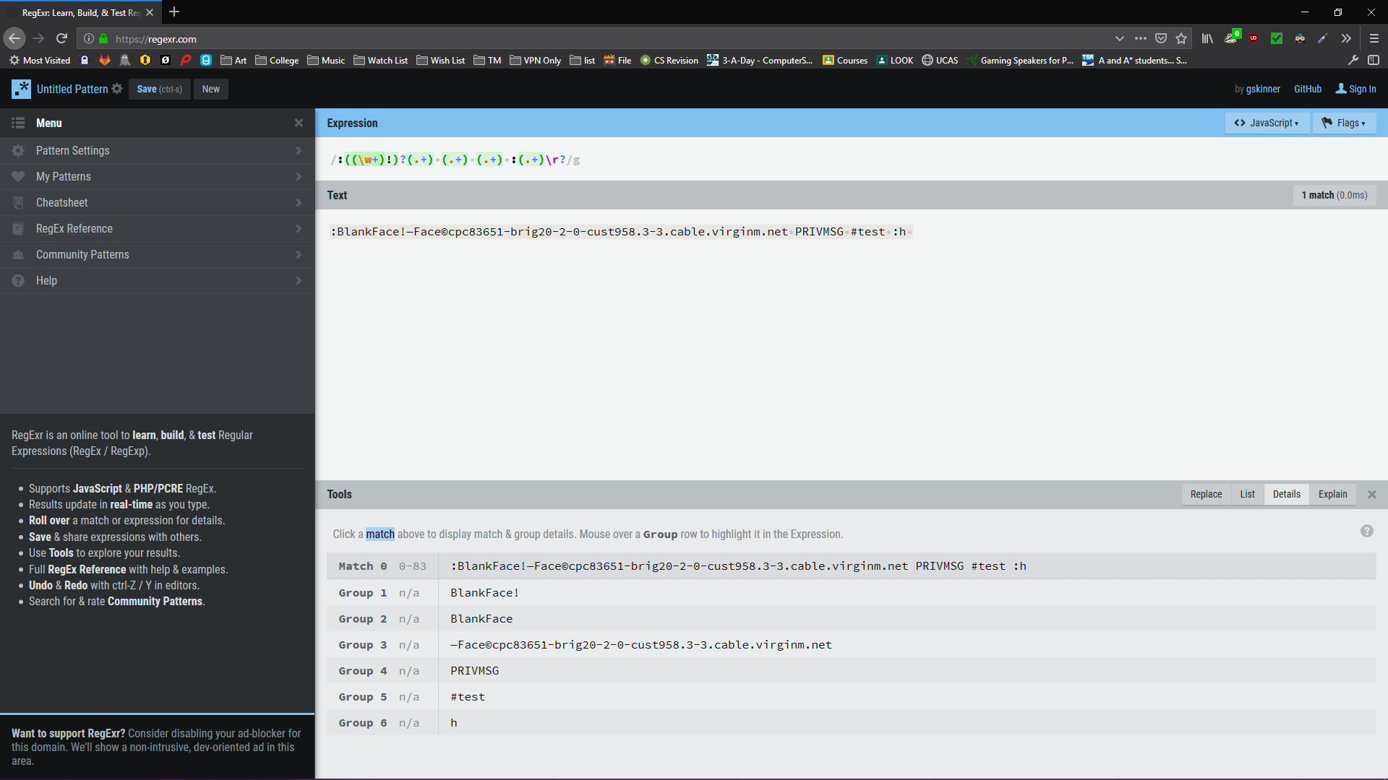

I joined a channel, which has no visual indicators yet, and I could successfully send messages to the using /msg #test hi after using /join #test.

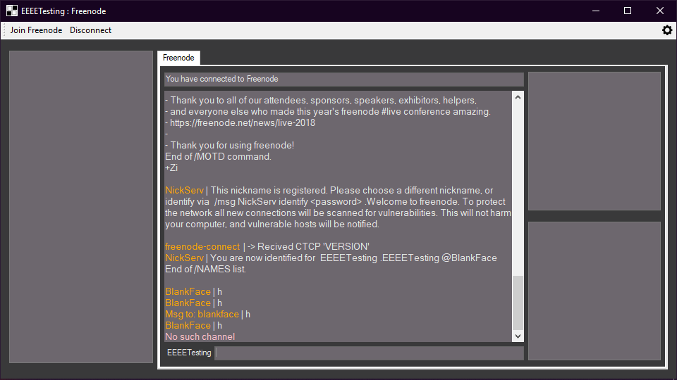

I then tested the add command and it added the text to the boxes correctly which means I can proceed with the next part of the program.

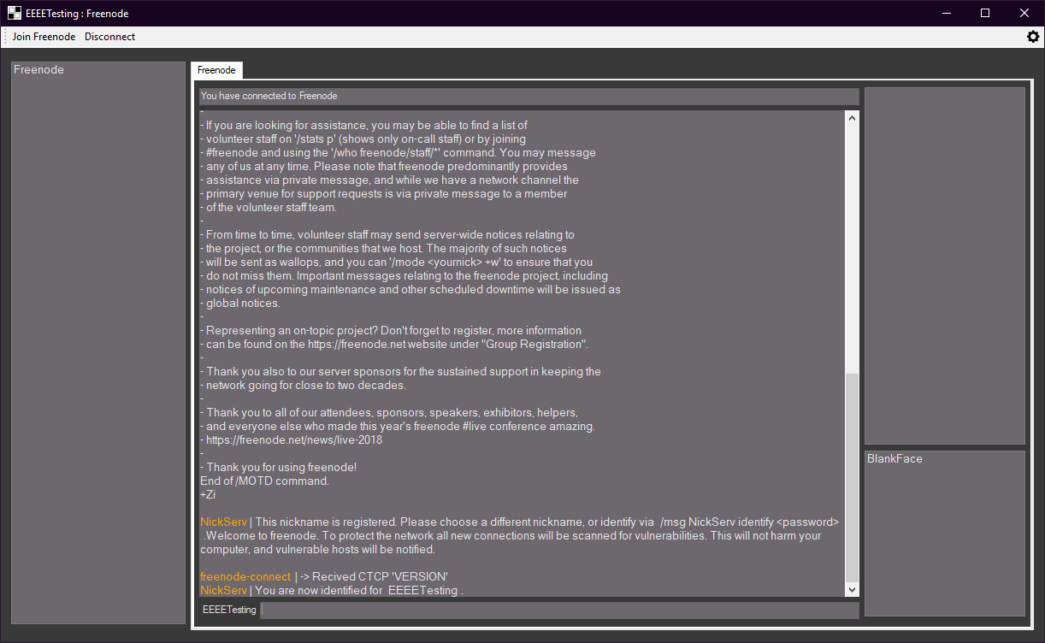

If an error or a notification from the server is given to the user such as end of names list, or no such nick, the text will be pink and then be appended to the message received / sent box.

If the second value of the split text is 353, this means the received data are the nicknames of the channel you have just joined. From there it splits the text by the spaces and adds each one to the nick box for later.

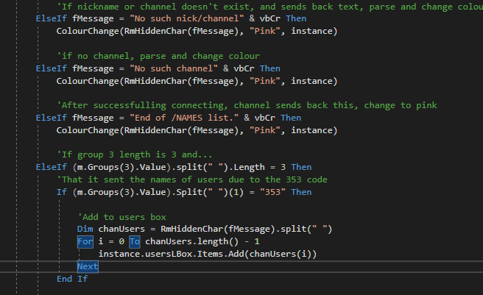

I joined a channel and the names were added successfully without errors, however in the future when I switch tabs it needs to change.

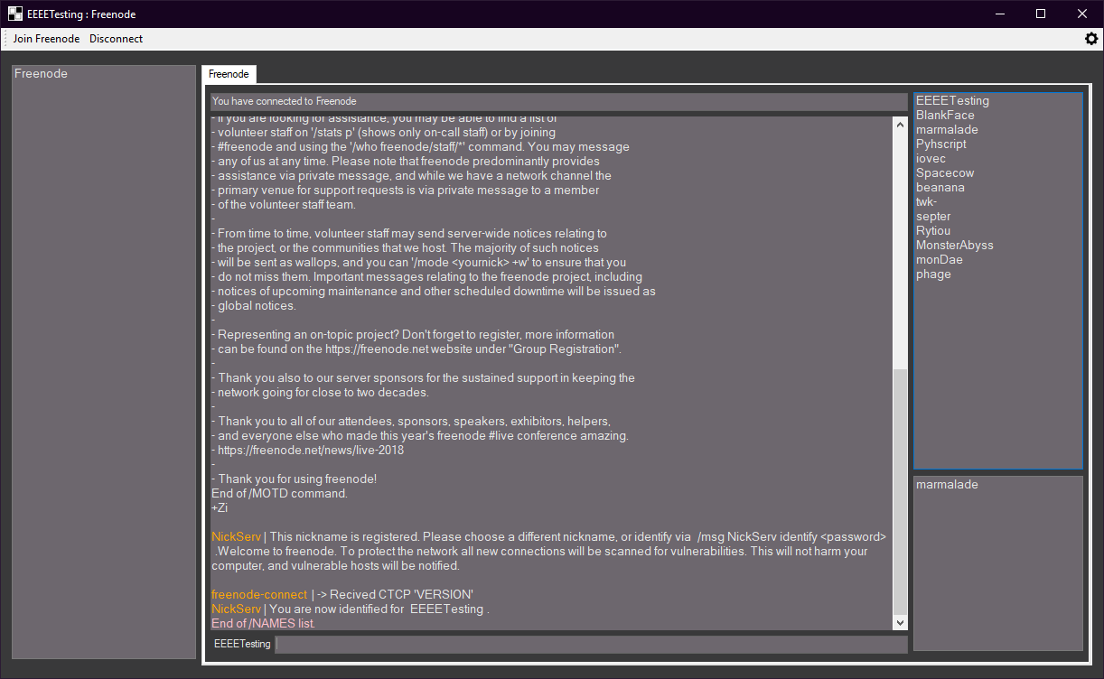

As the command could have no other data in it accept from the initial message command. I dealt with this by checking if there was any other data in the array, if there is data add the data to the boxes.

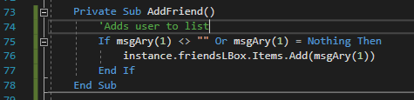

I needed to get the friendly name of the server into the message class so I added it as a requirement for the message class, and then added serverName as the friendly server string variable.



I then set the variable as fN standing for friendly name.

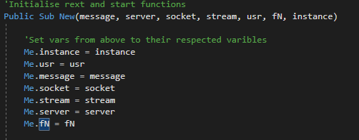

In the add friend command I now write the user text received into a file which will be read when connecting to a server, and add spaces to split each username.

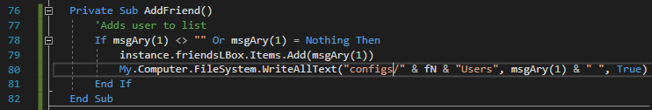

I then connect to the server and read all the text within the file then get all text excluding the last character from the file which removes the stray space. From there I split the text and either iterate through the list if there are multiple friends. If only one, don’t iterate and just add it to the box.

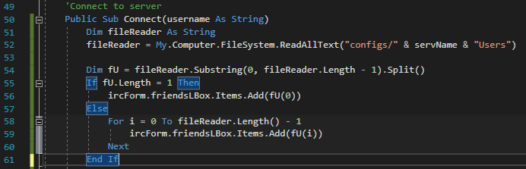

I added text to the user file to see if it is read correctly first time joining

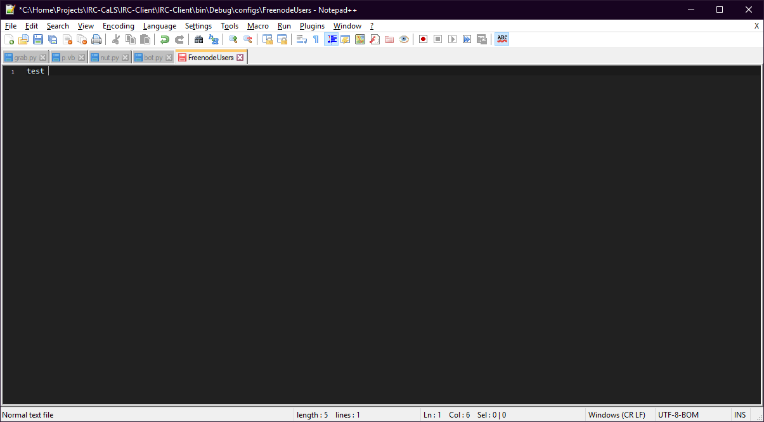

It added successfully when connecting to the server.

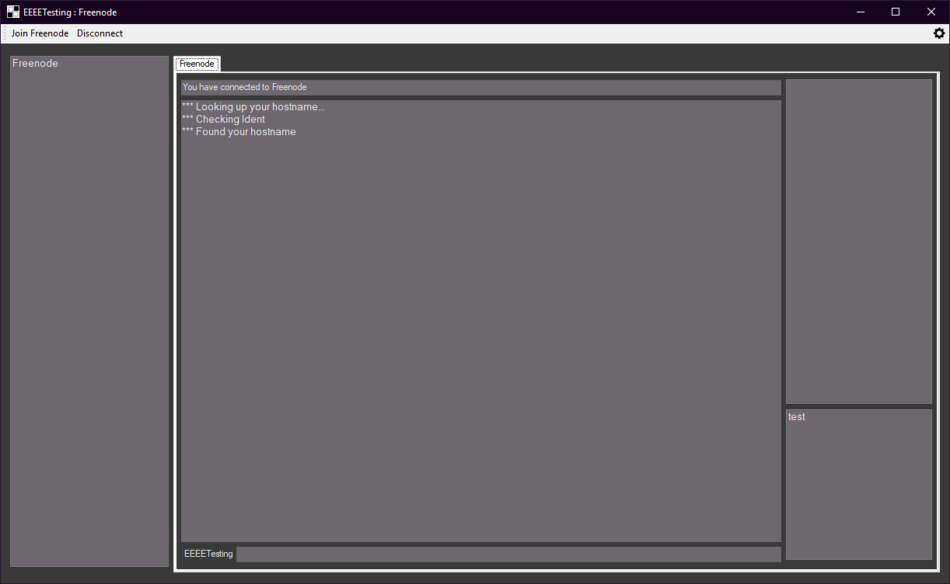

#### Testing

Client window

|  |  |  |  |  |  |
| --- | --- | --- | --- | --- | --- |
| Test no. | Criteria | Data type | User input | Expected outcome | Actual outcome |
| 5.1.2 | Click disconnect to freenode server | An action not a data type | Clicking disconnect button after connecting to the server | Disconnects from freenode server | Disconnects from the server theoretically but not implemented correctly. |
| 5.1.3 | Clicking settings icon opens settings | An action not a data type | Clicking setting icon | Opens up settings tab | Nothing |
| 5.2.1.2 | Message command without arguments gives warning | Extreme string | “/msg” | Doesn’t send anyone a message and warning given | Shows error and doesn't send message |
| 5.2.2.1 | Join command works | Valid String | “/join #channelNameTest” | Joins a channel | Joins but not correctly |
| 5.2.2.2 | Join command without arguments gives warning | Extreme string | “/join” | Doesn’t Join a channel and warning given | Shows error and doesn’t join |
| 5.2.3.1 | Leave command works | Valid String | “/leave #channelNameTest” | Leaves a channel | Nothing |
| 5.2.3.2 | Leave command without arguments gives warning | Extreme string | “/leave” | Doesn’t leave a channel and warning given | Nothing |
| 5.2.4.1 | Add command works | Valid String | “/add hello” | Adds user to list box | Adds user to list box |
| 5.2.4.2 | Add command without arguments gives warning | Extreme string | “/add” | Doesn’t add a user to the box and returns warning | Doesn’t add a user to the box |
| 5.2.5 | Message without any commands | Valid String | “hello” | Sends message to the channel or user they are currently on through tabs | Doesn’t send but doesn’t warn |
| 5.4 | Change colours of form on load | Action not data type | Logging in on menu | Colours of form are different to default | Nothing |
| 5.5 | Switching tabs works | Valid string  Action not data type | “/join #channel”  Click on tab which is labeled channel | Tabs change as well as text and names | Nothing |
| 5.4.1 | Server list box holds items successfully | Action not data type | Clicking join freenode | Shows “Freenode” in the server box | Shows “Freenode” in the server box |
| 5.4.2.1 | Users box store items | Valid string  Action not data type | “/join #channel”  Click on tab which is labeled channel | Users from channel stored in user list box | Yes but not implemented correctly |
| 5.4.2.2 | Switching tabs changes or removes items | Valid string  Action not data type | “/join #channel”  Click on tab which is labeled channel | When switching tabs text changes | Nothing |
| 5.4.3 | Friends box added items successfully | Action not data type | Logging in on menu | Stores the users into the friend box successfully | Stores the users into the friend box successfully |

#### Review

What has been done:

Errors from the server are now handled, you can now add a user to the friends / favourites tab, users are displayed when joining a channel, and can join channels too, however no tabs currently.

How it meets the success criteria:

3.7.4 , 3.4.3 , 3.4.2 and 3.4.1

3.7.4: Can now join channels but no tabs

3.4.3: Can add people to the friends box using the add command

3.4.2: Displays channels and servers

3.4.1: Displays usernames and server name in boxes

Changes in the design:

When connecting you need to load the users into the box.

Summary of the prototype:

Handled errors, add friend command added and can join channels but no tabs.

### Tenth iteration: Client Stage Six

I wanted to move on to adding tabs for channels and

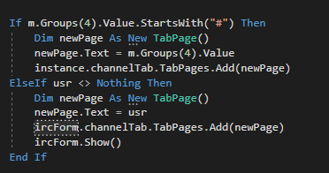

After looking over several stackoverflow pages I found this function which I adapted to my needs, as I could not add a new tab due to the GUI being on another thread, and adding a new object isn’t allowed even with my other method.



This worked as when I got a message from NickServ when joining a new tab appeared.

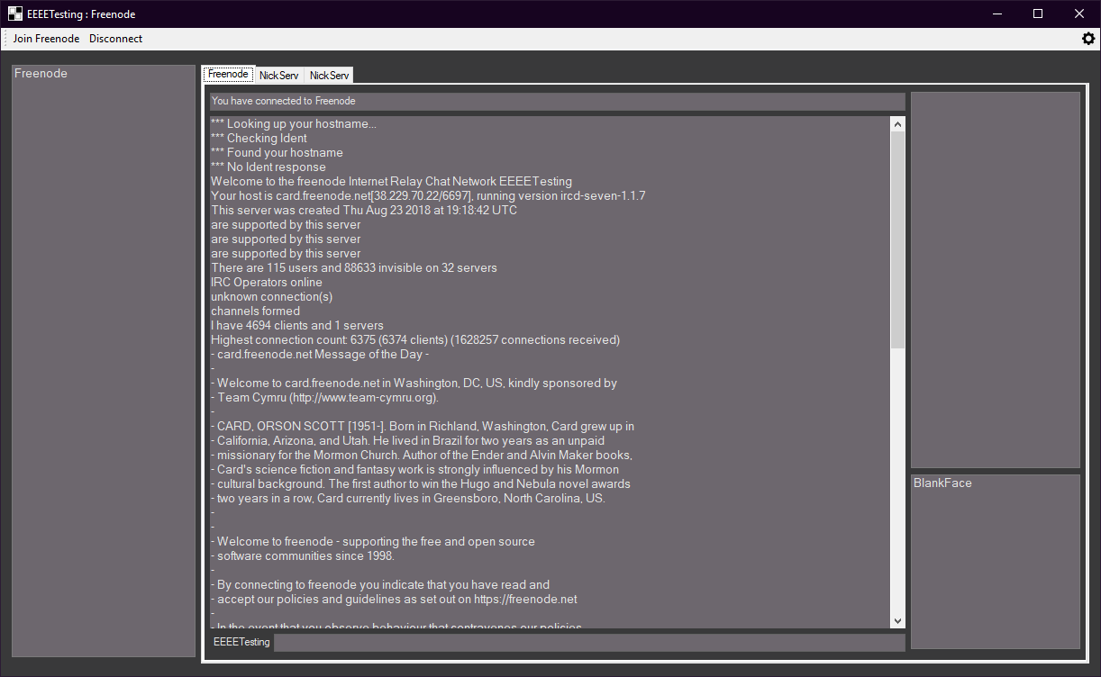

I then added the snipping above so both of the options of tabs, it gets the name of the user or channel and sets it as the name of that tab as well as adding “Tab” to the end of the name for consistency. I set the text as the channel or user name so it is easy for the users to use.

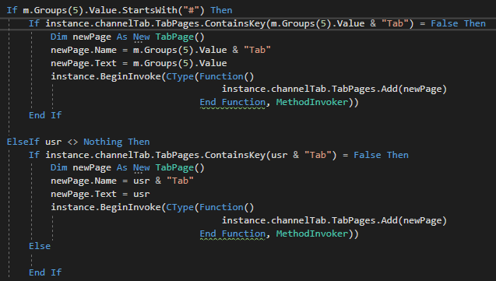

I joined a channel and it created a new tab which is what I wanted to do.

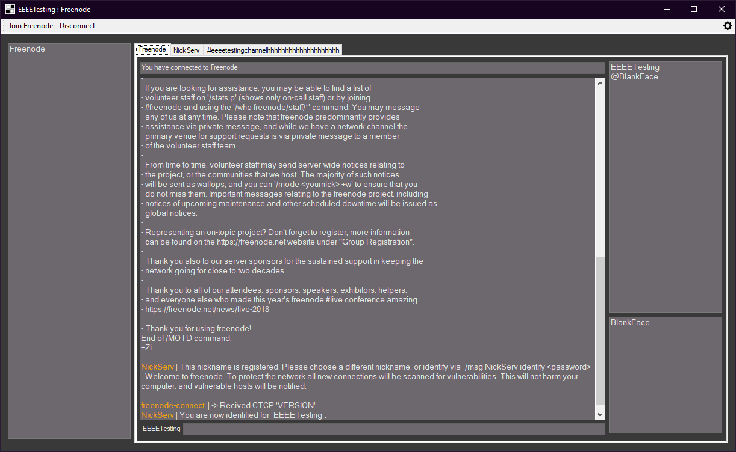

Unfortunately when I switch tab everything of the tab before goes, originally I thought I created a new instance of the original however I thought of a work around just in case this would of happened, I will explain this later.

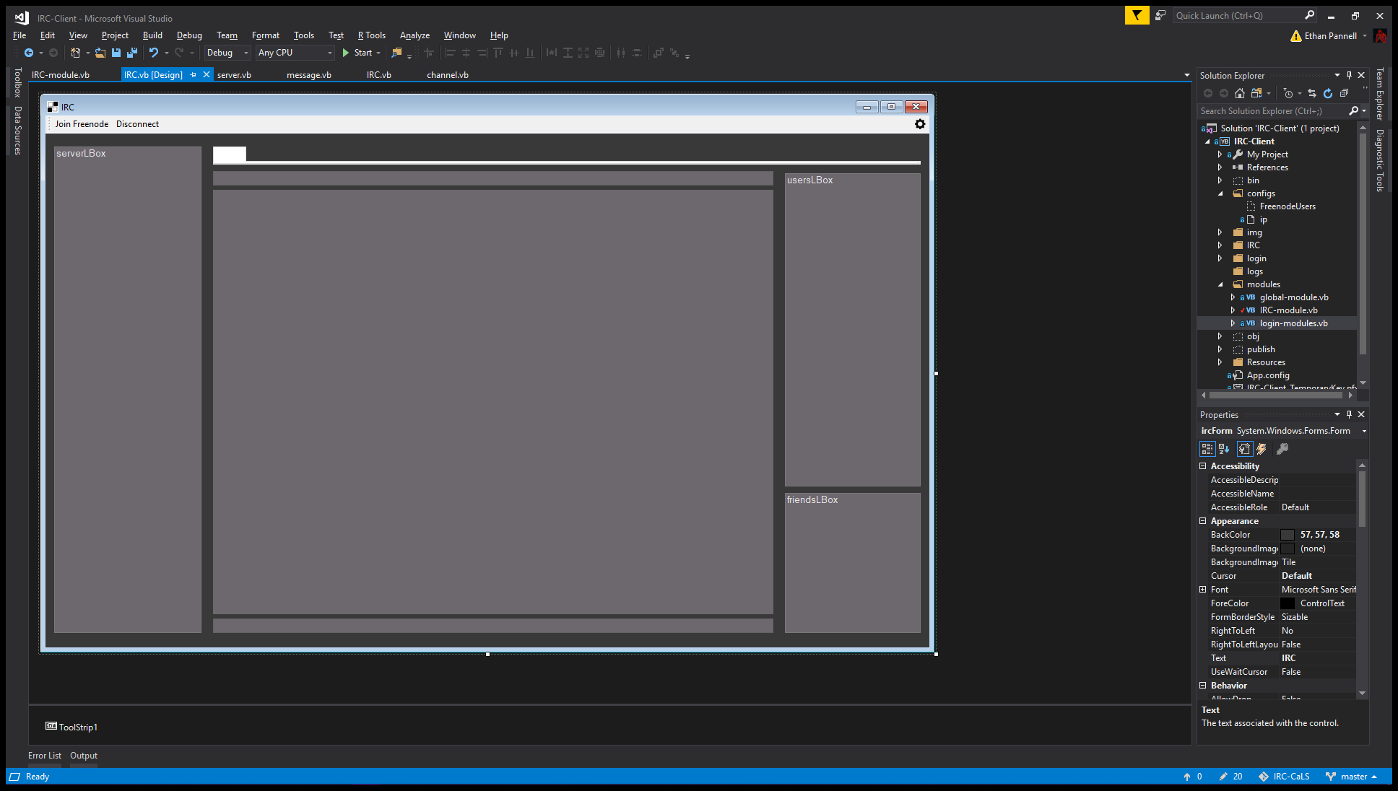

First I made a sub to do this instead as I am repeating the code in both options of tab, I need to send over the username, the tab and the form I want to add it to.

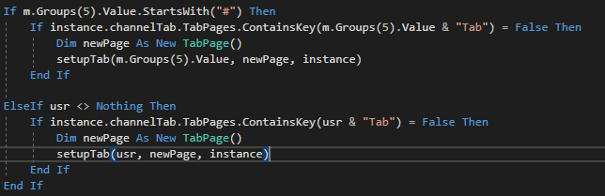

This is identical to the code from earlier however the variables mandre l slightly different but properly named. The thing which I dd and redd is the background to be the same grey and reds the background for now just incase it amndreddsccedently shows amndreddsccedently small part of it.

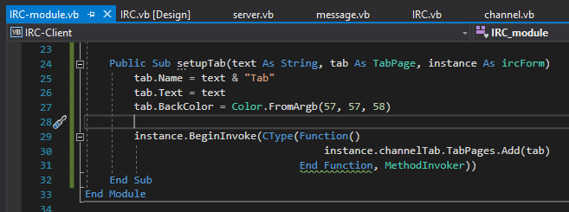

I want to see if I have already connected to the server due to the server timing you out if you connect too fast after disconnecting. Originally the code did not work due to me checking the ircForm class instead of the actual instance itself.



If not I add to the server list box with the connected server in the box.

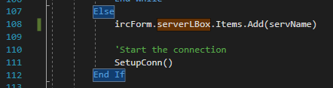

The first step of getting the tabs to work is that I need to save the text from the box into a file. When a tab is changed, the text from the message box is saved into a file with the name of that tab as the file name. It then removes the text from the textbox.

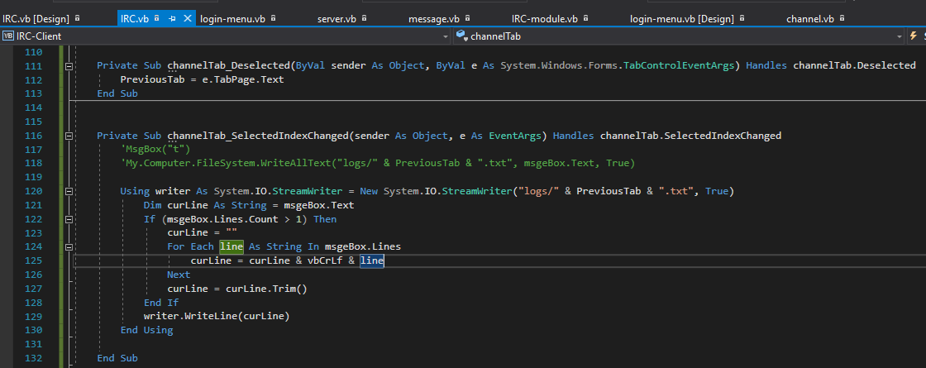

When running, and after I switched over, the text successfully got saved into a new file.

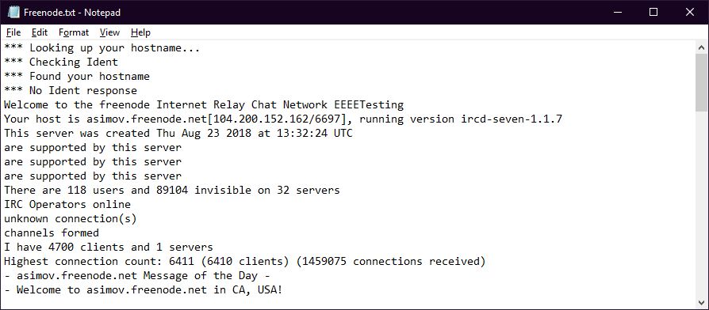

After saving the file and clearing the box, the previous messages of that chat is loaded into the box. If there is no file, it will write “The start of a new chat” as filler for the tab to then remove errors the next time switching tab.

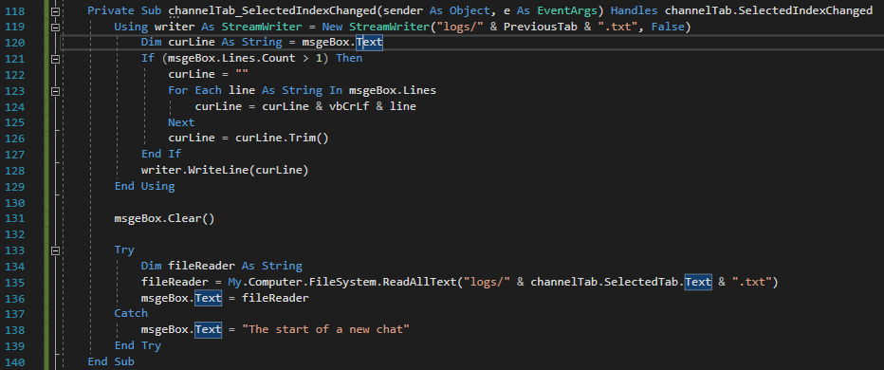

When I switched tab the text from the file was loaded into the box which was intended for the code to do.

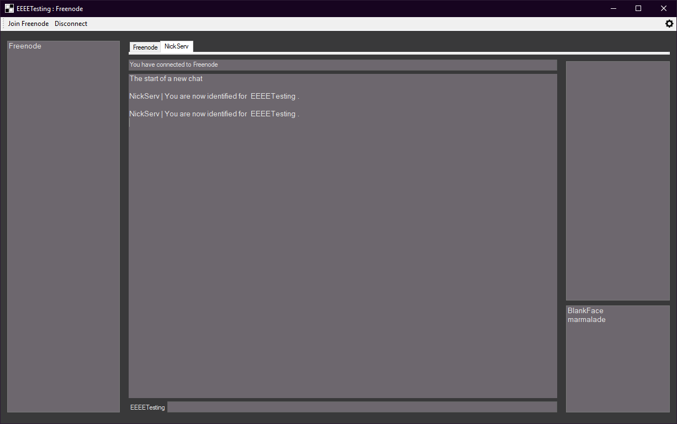

There are still a few issues, text will still be appended to the text box even if the message is from someone else. Bellow is the checklist of what needs to happen when I switch tabs.

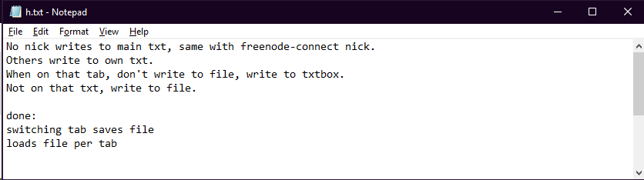

This was more simple to implement than I thought, I checked if the tab currently on is the name sent, if so it is written to the textbox, and when tabs switch it is saved, else it is written to the correct file. I repeat this for the channel too.

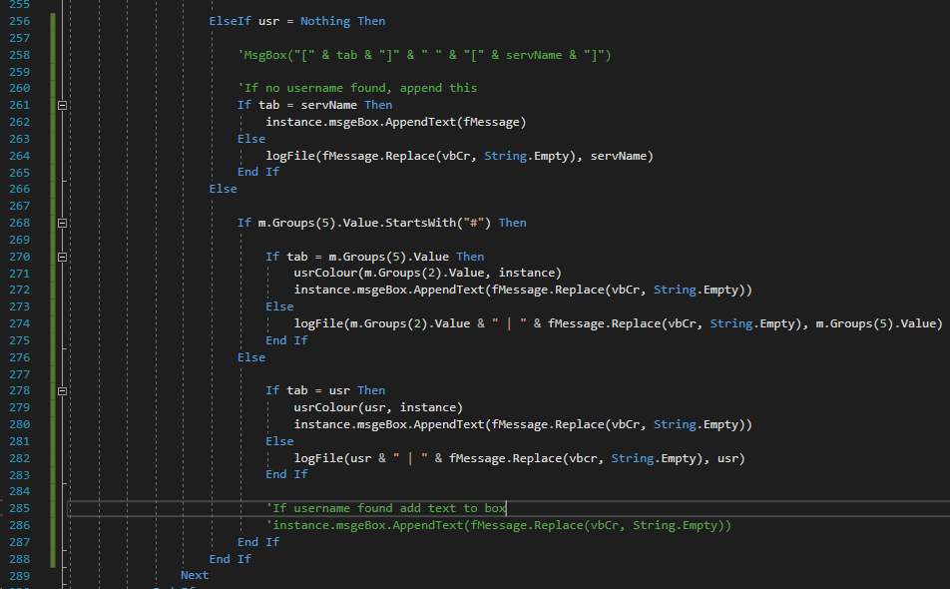

The logfile sub gets the text and filename as a string to be used to save a file. This sub was created as both options of tab use the same code. GetTab gets the current tab being used and returns it, which will be put into a variable.

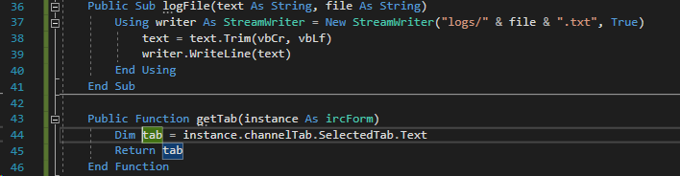

As the coloured text is seperate from the standard text, it needs to also be saved to the file if the current tab isn’t the main. It saves it into the main text file, if on the main tab it will append it correctly.

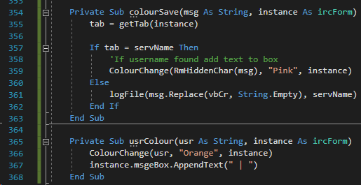

The application of the sub from above.

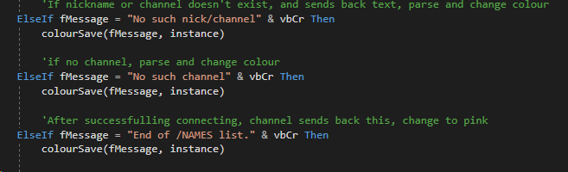

When writing to the textbox there is a newline at the end of the text, this code bellow removes this from the text making it look cleaner.

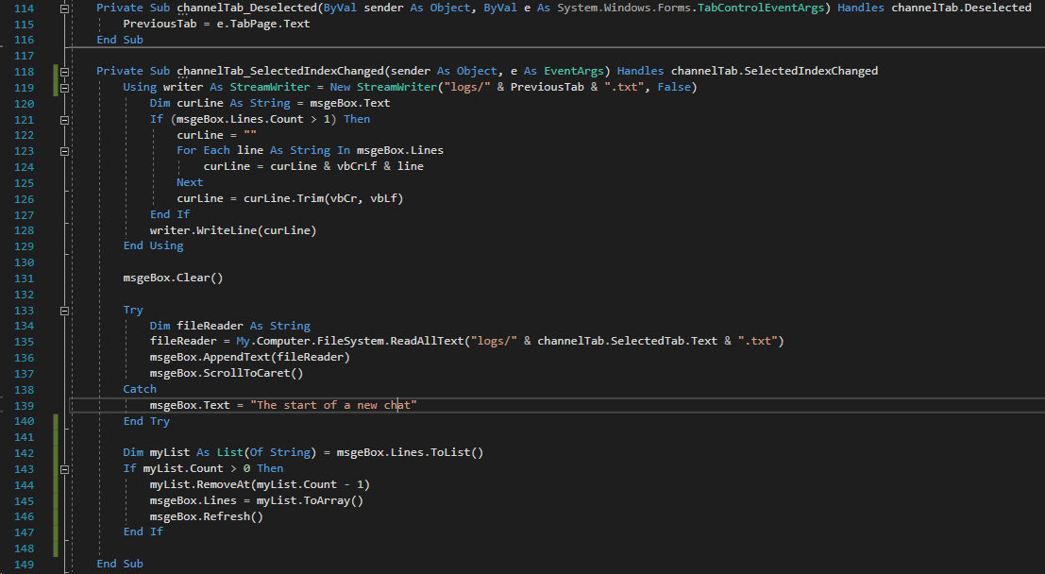

When sending a message, I want to save the amount of lines and subs used, so I repurposed the MsgCommand to send messages to either the tab or the user specified. I used the IsTab variable as a boolean to check if the message command was either used by “/msg” or was text directly entered into the textbox without a command. The code for when the user sends “/msg” is the same, but when the IsTab is true, it gets the text of the tab and uses it as the receiver of the message. The appended message is also different as it only appends the clients username to the textbox instead of “Msg to”.

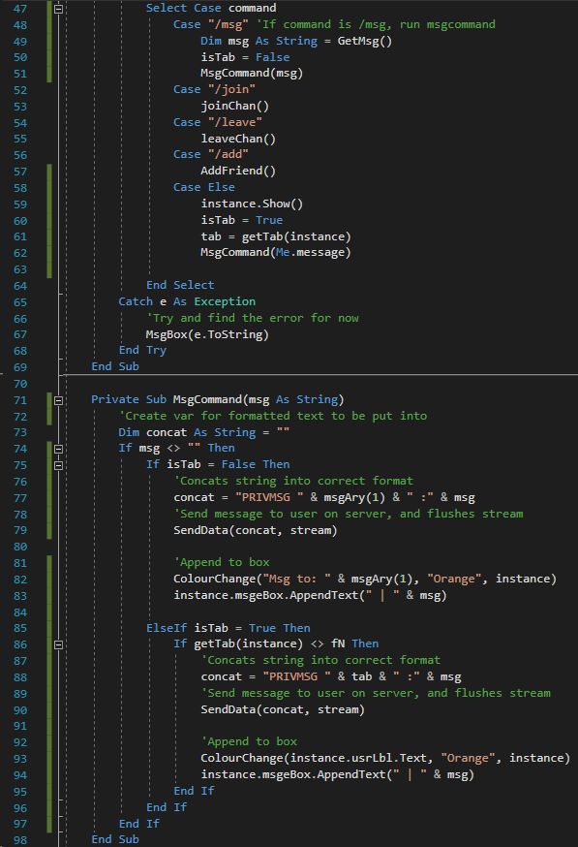

When leaving I now have to change the tab so the text is saves, and then remove the tab from the list. Other than that it sends PART to notify the server that we don’t want messages from that channel and for the user to not be listed within the channel.

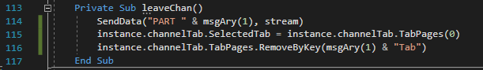

I then added comments to all of the code which would take up too much space to screenshot and paste them here.

#### Testing

|  |  |  |  |  |  |
| --- | --- | --- | --- | --- | --- |
| Test no. | Criteria | Data type | User input | Expected outcome | Actual outcome |
| 5.1.2 | Click disconnect to freenode server | An action not a data type | Clicking disconnect button after connecting to the server | Disconnects from freenode server | Disconnects from the server theoretically but not implemented correctly. |
| 5.1.3 | Clicking settings icon opens settings | An action not a data type | Clicking setting icon | Opens up settings tab | Nothing |
| 5.2.2.1 | Join command works | Valid String | “/join #channelNameTest” | Joins a channel | Joins but not correctly |
| 5.2.3.1 | Leave command works | Valid String | “/leave #channelNameTest” | Leaves a channel | Nothing |
| 5.2.3.2 | Leave command without arguments gives warning | Extreme string | “/leave” | Doesn’t leave a channel and warning given | Nothing |
| 5.2.4.2 | Add command without arguments gives warning | Extreme string | “/add” | Doesn’t add a user to the box and returns warning | Doesn’t add a user to the box |
| 5.4 | Change colours of form on load | Action not data type | Logging in on menu | Colours of form are different to default | Nothing |
| 5.5 | Switching tabs works | Valid string  Action not data type | “/join #channel”  Click on tab which is labeled channel | Tabs change as well as text and names | Yes but not implemented correctly |
| 5.4.2.1 | Users box store items | Valid string  Action not data type | “/join #channel”  Click on tab which is labeled channel | Users from channel stored in user list box | Yes but not implemented correctly |
| 5.4.2.2 | Switching tabs changes or removes items | Valid string  Action not data type | “/join #channel”  Click on tab which is labeled channel | When switching tabs text changes | Removes text but not users |

#### Review

What has been done:

Create tabs however not finished through saving of files and loading of them, added a disconnect function and added more functions to the message class.

How it meets the success criteria:

3.8.1: switching tabs changes the text

3.6: Logs the contents of messages into a file

Changes in the design:

Have the client save the logs due to it being needed for switching of tabs.

Summary of the prototype:

Can now switch tabs but not implemented fully

### Eleventh iteration: Settings and Client Finish up

I then started to work on one of the last features of the program is that the user can change the colours of the client and the font size of the text. Bellow is the design of the form.

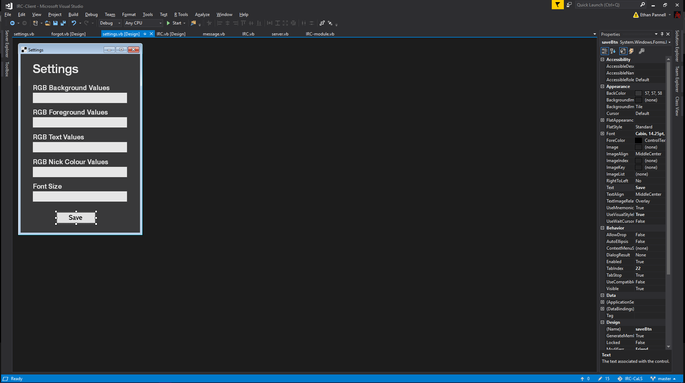

I started by creating the variables for the form. The first is for the foreground, which is the background of the elements of the form which are not the form itself, as the colours needed are in RGB which are split by commas. I will split them and then use those values for the colours. The font colour is also in the same format. Font size will be an integer to resize it.

The for loops are to split each of the text inputted into separate values to be used for later to change the text colour.

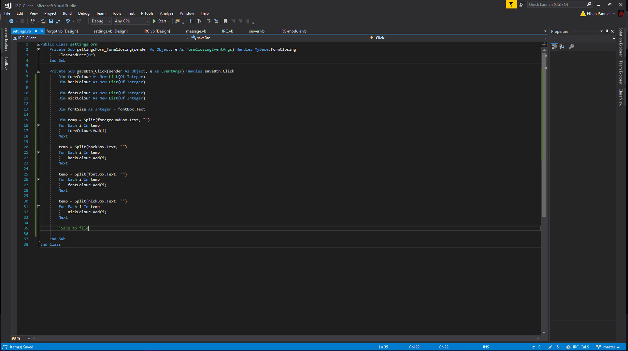

I scraped the previous code as it would be more efficient by just putting it into a large for loop reusing the same variable and resetting it when it gets the next setting, I will do this after this screenshot.

As I don’t want the software to be frustrating for the user, I will save the settings into a file to be accessed from later to then load into the client to be seen.

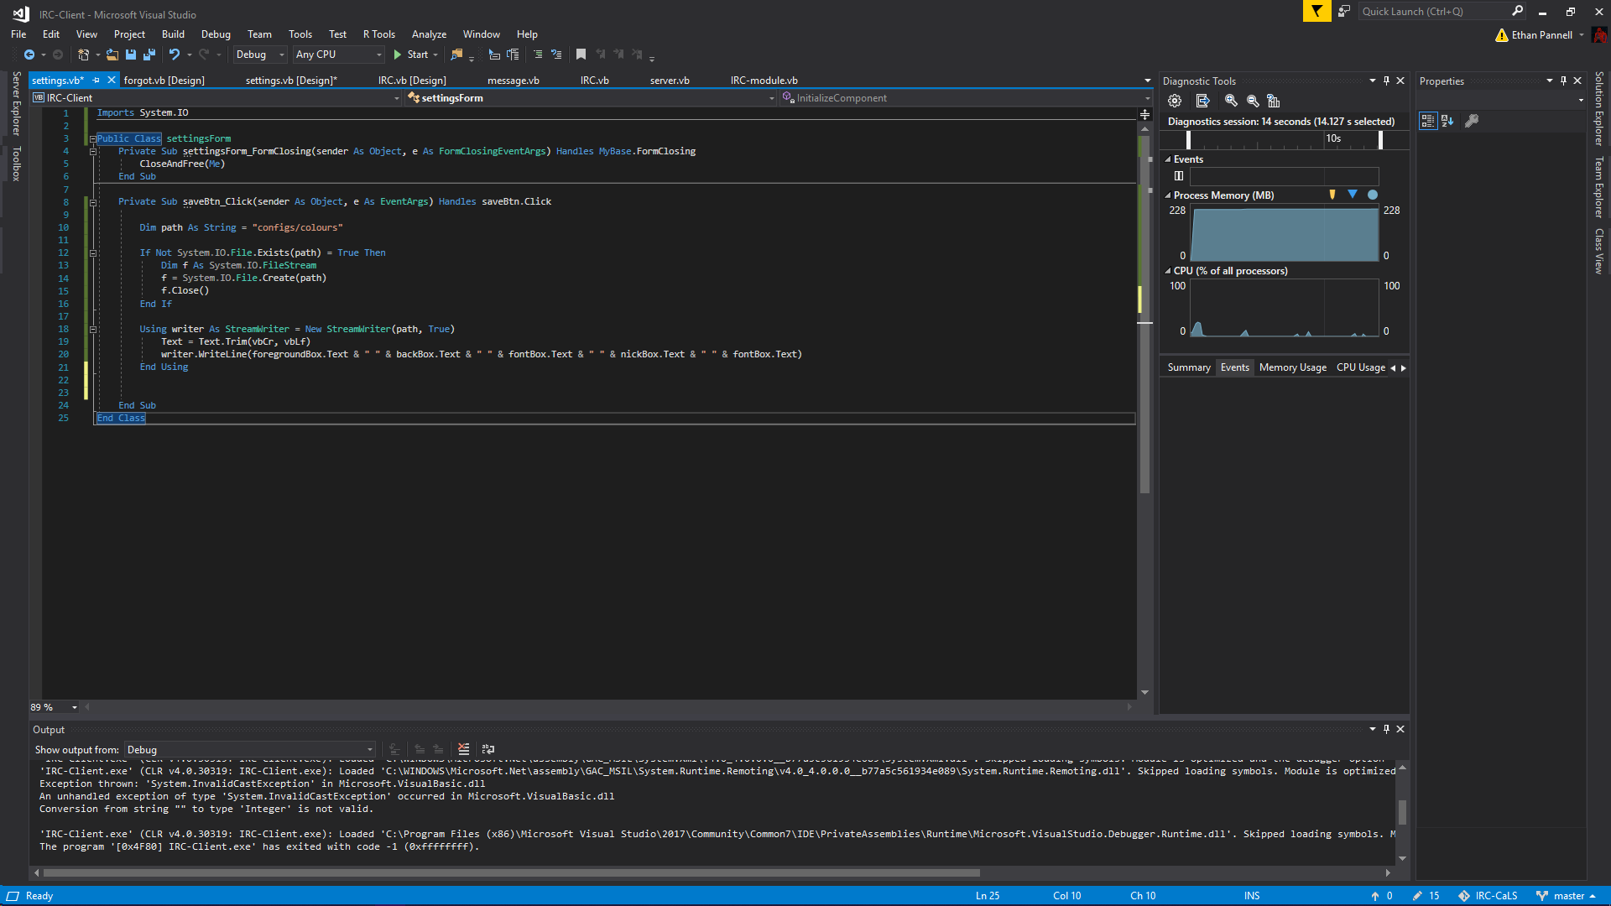

I then need to count if each section is filled otherwise it will cause errors, so I count the filled out forms, if all are filled it is then written to a file, if not it will cause an error for the user to fill them all out.

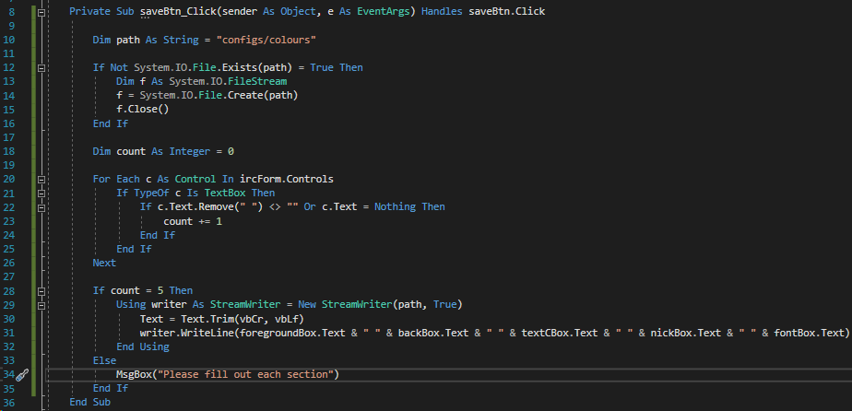

I then made a sub as I will be loading it in from several places. It gets the text saved and then loops through the whole array. The first three are for the background defined earlier, the next else if statement does the control background, which I said was the foreground earlier, the comments say what each section is used for.

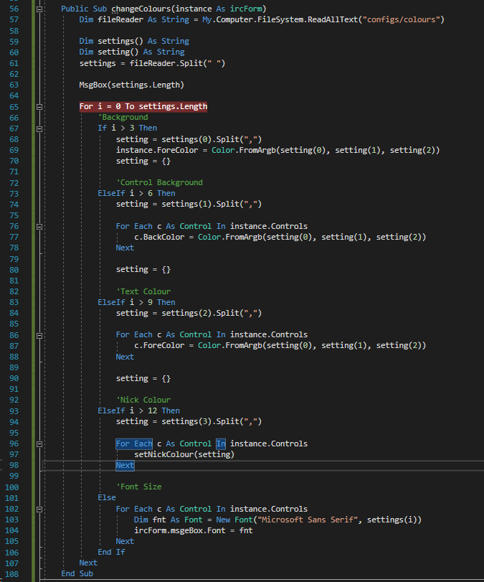

I will now set nick colour so when the user sends a message their nickname is a different colour

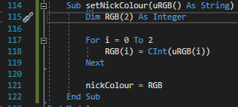

This just returns the nickname colour.

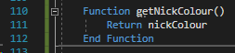

After saving it then loads the colours using the sub earlier into the form once entering the values in the settings window.

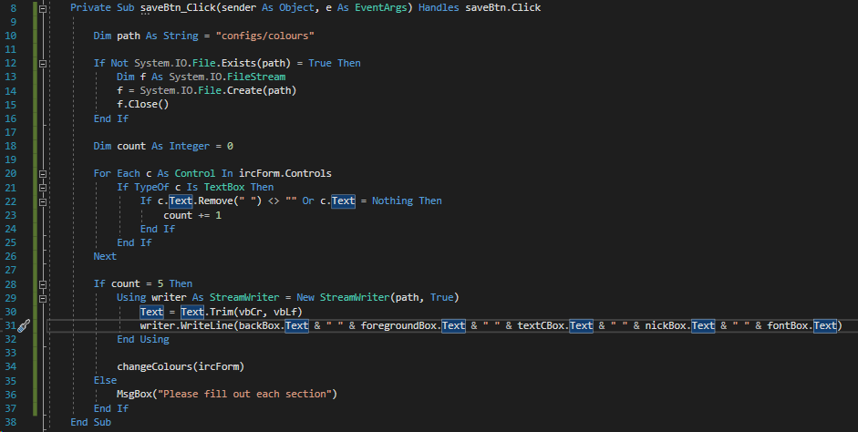

I now set the colour to be the nick set colour, however if the text is usr, it will set c as the colour for the text. If not it will do what it done before.

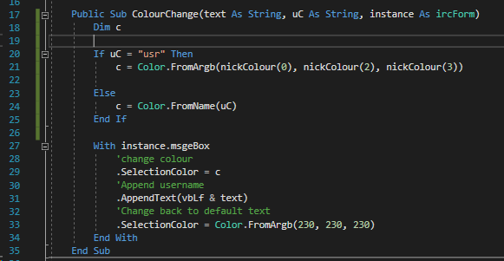

I changed the appropriate lines to show these colours

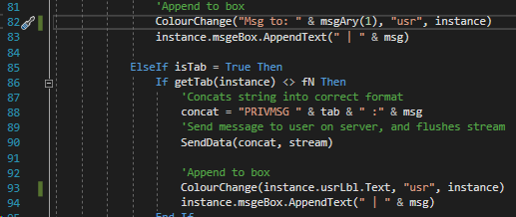

I now reset after each else if as it appended every time looping through the first three colours

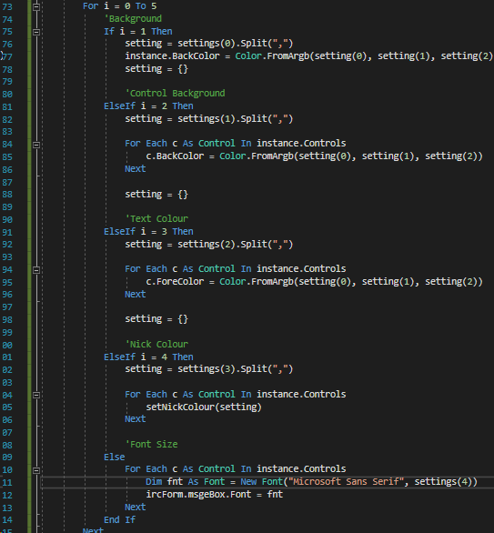

I added the colours to the setting for a test

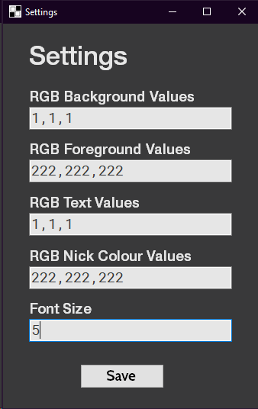

My first error was that the font size box was counting the value stored within as in integer but not a string.

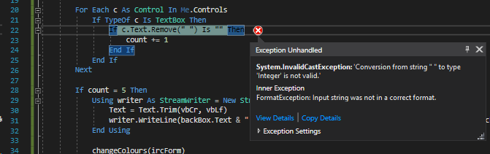

I now just check if it is not equal to “” instead as it shouldn’t have an issue due to the last trying to remove a string from a integer.

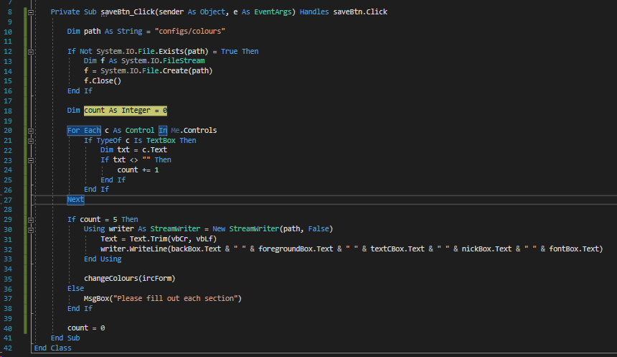

The method before worked however I came into a new error, where on the colourChange didn’t change the colour of the text, however I realised I skipped from 0 to 2 which is the whole array itself meaning nickColour(3) would not work due to it not existing.

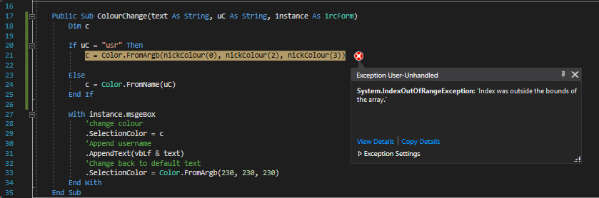

I fixed it by simply changing the numbers in the nickColour array.

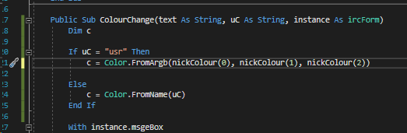

After inputting the same colours again the form colours changed on the form successfully which

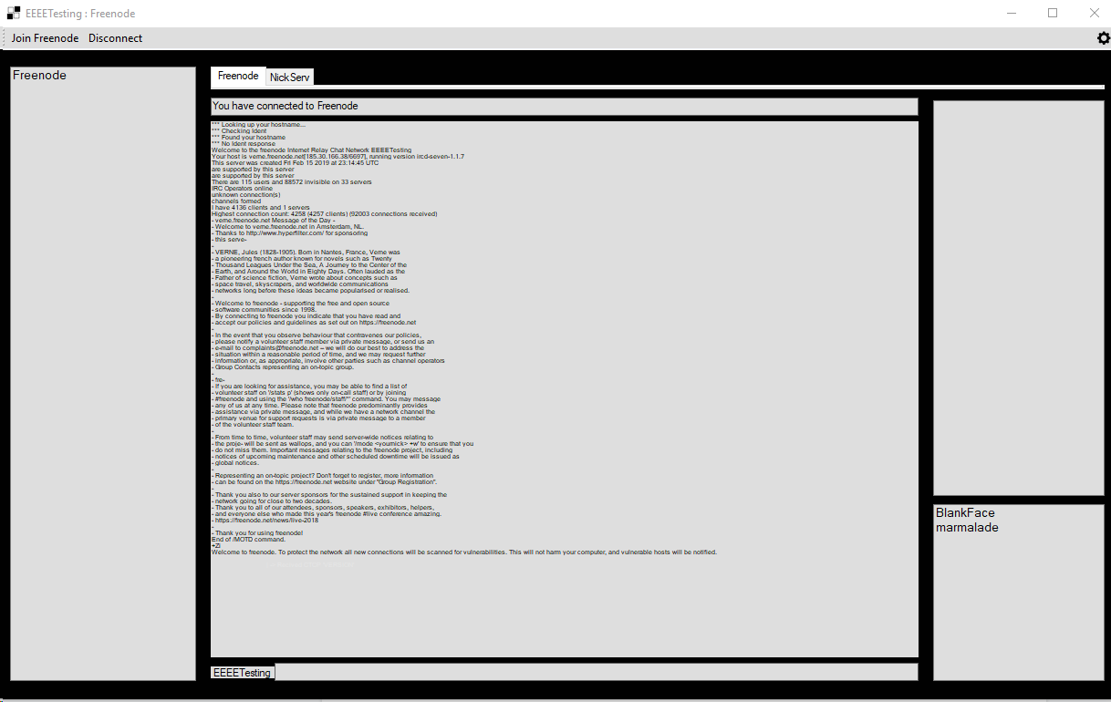

This code checks if the box named fontBox is a number by checking if the upper is equal to the lower of the text in fontBox, as if it is a number it would not change.

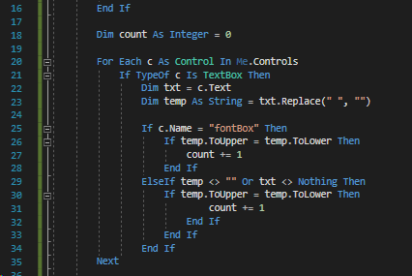

I changed the colour again, closed and opened up the program and the colours changed successfully.

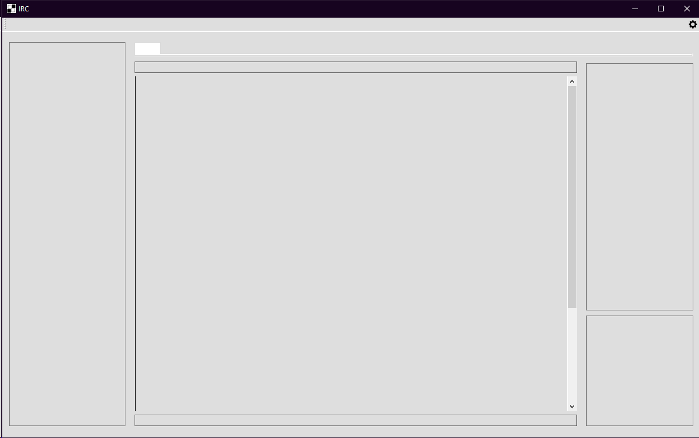

I added a tab index so users can tab to navigate between each element on the form without having to click.

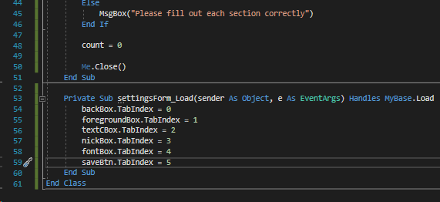

If there was no colour in the file, the default colour of orange will be selected

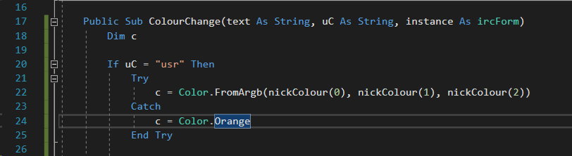

If the file is not found it will just keep the defaults

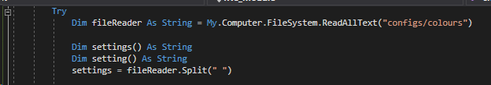

There is no need to put anything in the catch statement as the default colours will show first before switching the scheme.

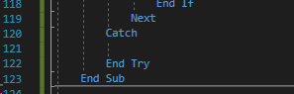

Connecting to a channel will get the names of the users on a channel, however when switching it keeps those names in that section which is a problem. I will write the names into a file to keep hold of the names in a new folder.

If the current tab is the channel name, it will read the file into the listbox for names, otherwise it will write the names into a file instead which solves the problem.

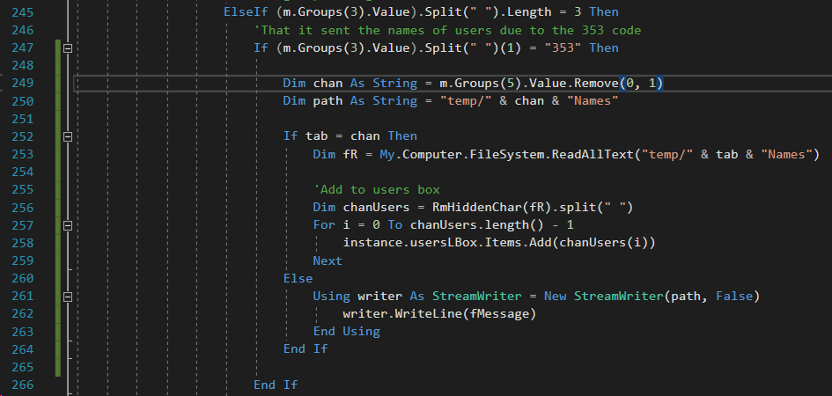

When switching tab it needs to load the file into the list box, so on the ircForm it will do this automatically. It splits the text into a list and iterates over that list while adding it into the box. The try catch is used to see if there is a file for it, if not it will not load.

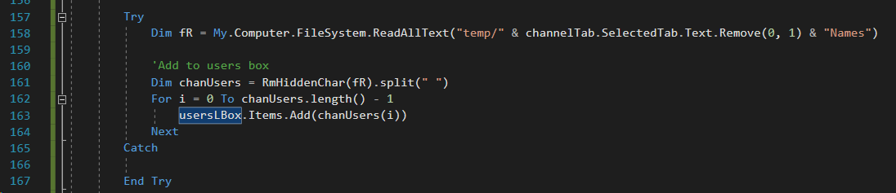

It when switching a tab the user box is cleared.

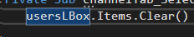

And finally joining a channel in the message class is added so now you can easily join a new channel.

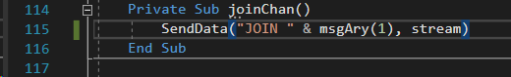

I can now join channels and message multiple people, and it works fine however if I switch tabs and switch back the colours go, I will leave this for the future as it may take some time creating this.

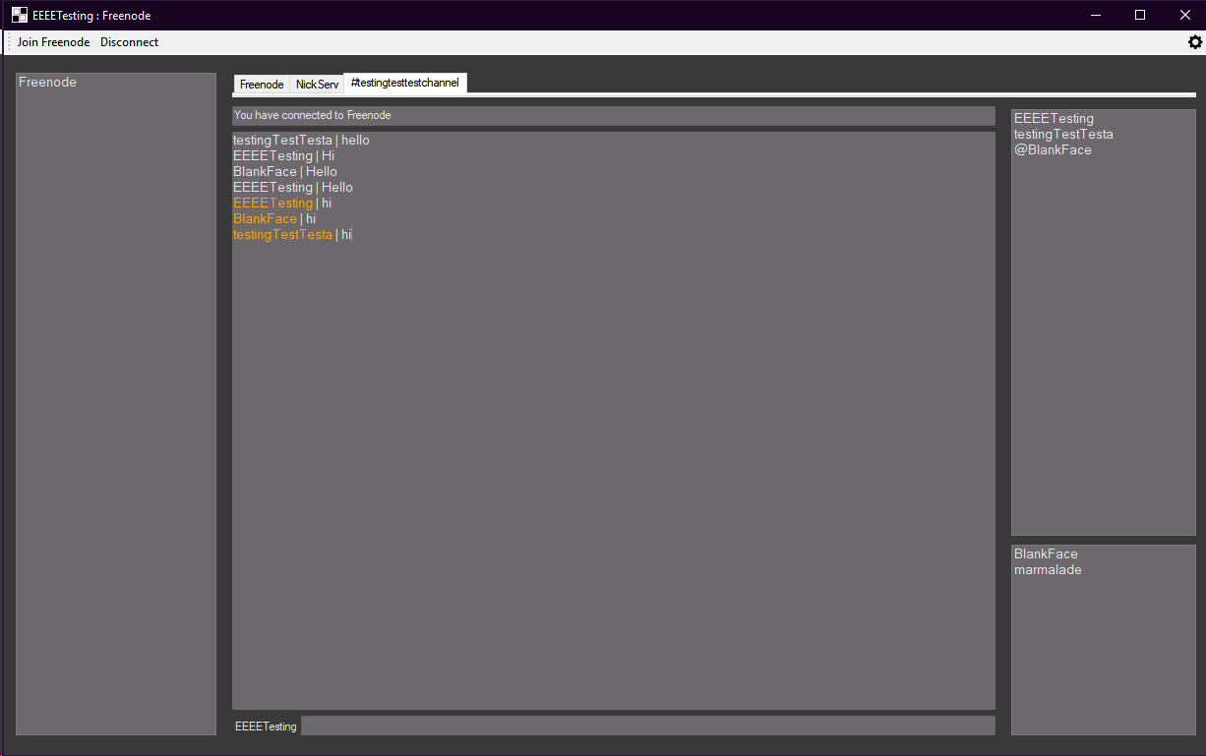

And leaving a channel I have to change the tab to the first to save the file, then remove the tab by key.

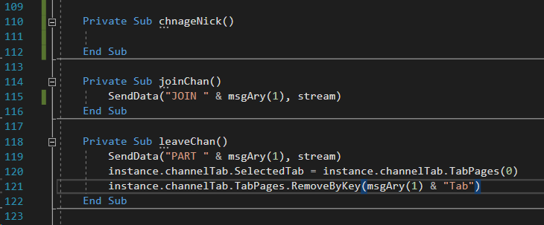

When closing the program then removes everything in the temporary directory.

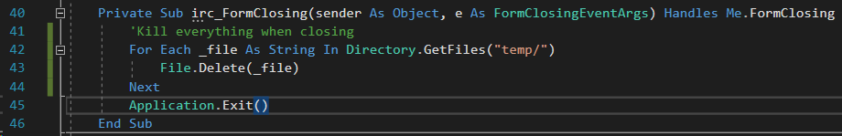

Add friend now shown an error when no text is submitted now too

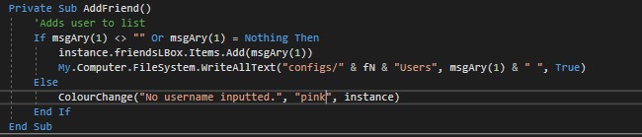

I then added comments to the new code afterwards which helped the readability, I will show this at the end of the document.

#### Testing

|  |  |  |  |  |  |
| --- | --- | --- | --- | --- | --- |
| Test no. | Criteria | Data type | User input | Expected outcome | Actual outcome |
| 5.1.2 | Click disconnect to freenode server | An action not a data type | Clicking disconnect button after connecting to the server | Disconnects from freenode server | Disconnects from the server theoretically but not implemented correctly. |
| 5.1.3 | Clicking settings icon opens settings | An action not a data type | Clicking setting icon | Opens up settings tab | Opens up settings form |
| 5.2.2.1 | Join command works | Valid String | “/join #channelNameTest” | Joins a channel | Joins a channel |
| 5.2.3.1 | Leave command works | Valid String | “/leave #channelNameTest” | Leaves a channel | Leaves the channel |
| 5.2.3.2 | Leave command without arguments gives warning | Extreme string | “/leave” | Doesn’t leave a channel and warning given | Doesn’t leave a channel and warning given |
| 5.2.4.2 | Add command without arguments gives warning | Extreme string | “/add” | Doesn’t add a user to the box and returns warning | Doesn’t add a user to the box and returns warning |
| 5.4 | Change colours of form on load | Action not data type | Logging in on menu | Colours of form are different to default | Colours of form are different to default |
| 5.5 | Switching tabs works | Valid string  Action not data type | “/join #channel”  Click on tab which is labeled channel | Tabs change as well as text and names | Tabs change as well as text and names |
| 5.4.2.1 | Users box store items | Valid string  Action not data type | “/join #channel”  Click on tab which is labeled channel | Users from channel stored in user list box | Users from channel stored in user list box |
| 5.4.2.2 | Switching tabs changes or removes items | Valid string  Action not data type | “/join #channel”  Click on tab which is labeled channel | When switching tabs text changes | When switching tabs text changes |

#### Review

What has been done:

Successfully implement tab switching as well as messaging channels, usernames in the text box switching when changing tab and commands being functional. Disconnects correctly too now.

How it meets the success criteria:

3.8.2 , 3.7.3 , 3.4.1 , 3.3.1 and 3.3.2 (Finished each point)

3.8.2: Switching tabs displays different users per channel

3.7.3: Sends messages to channels

3.4.1: Displays the usernames of people in the channel, and display in a seperate box

3.3.1: The RGB of the background can be changed in the settings

3.3.2: Font colour is also changeable

Changes in the design:

Adding usernames to a file to store to then load and unload when switching tabs

Summary of the prototype:

Finished the client, added tab switching correctly, added commands specified in limitations, disconnects correctly and over all functional as a client for one server currently, however in the future I will make the client connect to multiple at a time.

### Twelfth Iteration: Website

I used SSH to get into my pi and created 4 files: index.html for the website, IRC-Setup.zip which will contain the installer; logo.ico for the icon of the website and style.css for the formatting of the website.

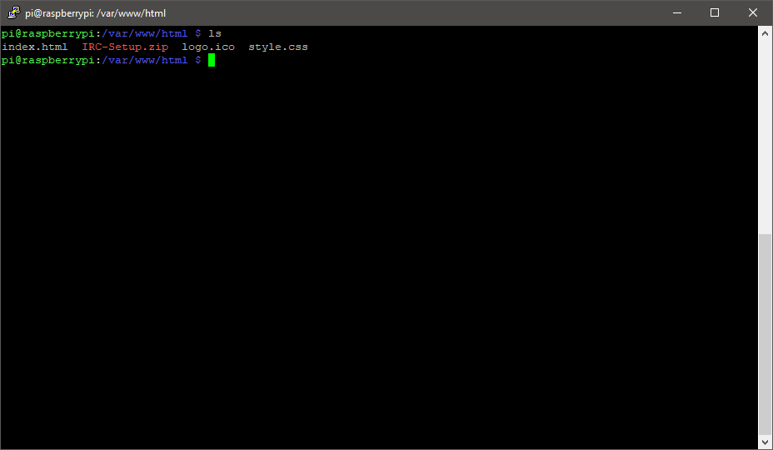

I used Vim to create this html file by using a simple boiler plate then adding to the body a div to center everything, a download link to the executable and a link to the server. The link tags create a reference to the css file and the website icon.

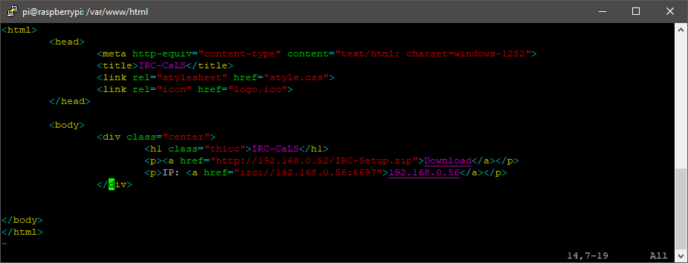

The center class centers the elements inside of the divider and aligns the text to be the center. The body I change the background colour to grey and the font family to a monospace font. The h1 is larger and has a different font family and a yellow colour. P tags have a different colour and size. Links have no text decoration and only when hovering it changes colour and adds an underline.

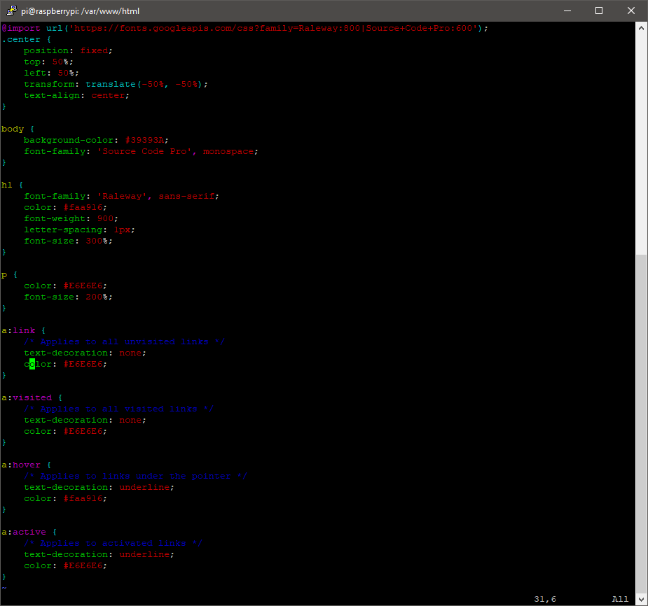

A preview of the site so far.

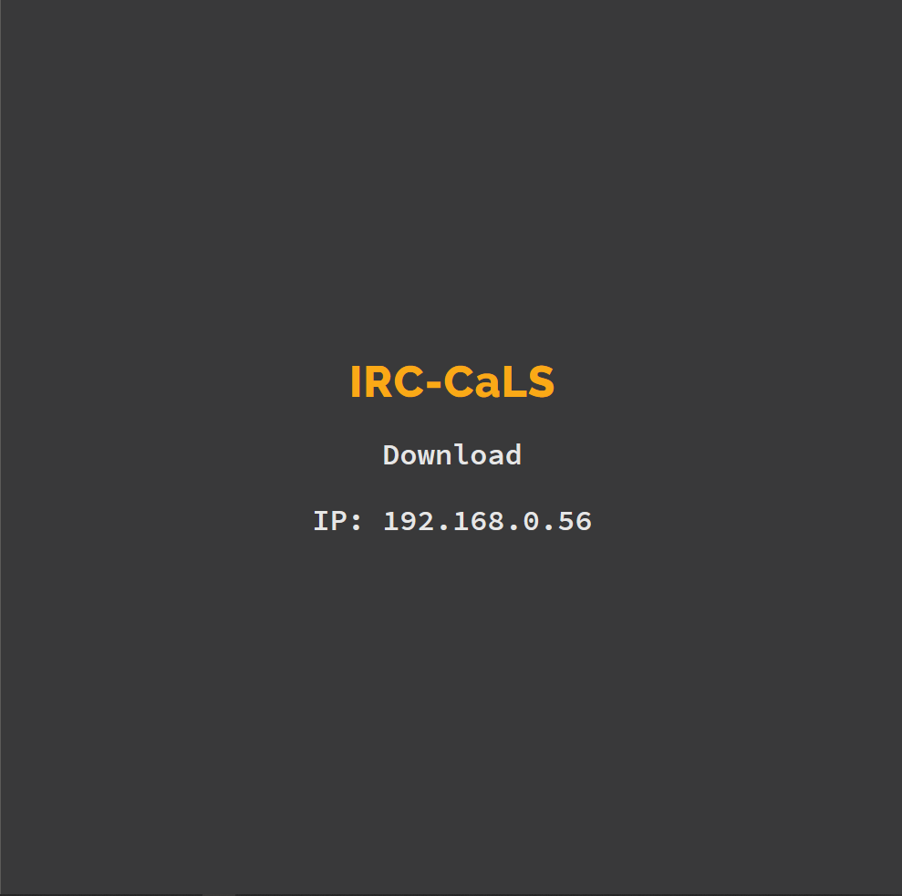

I wanted to add the logo from my client to the website so I changed the size of the image to be 25% of its actual size due to it being large.

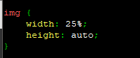

I put it above the other elements in the div tag so it appears first.

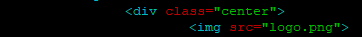

And added the logo.png into the file system.



This is the result of the html and css.

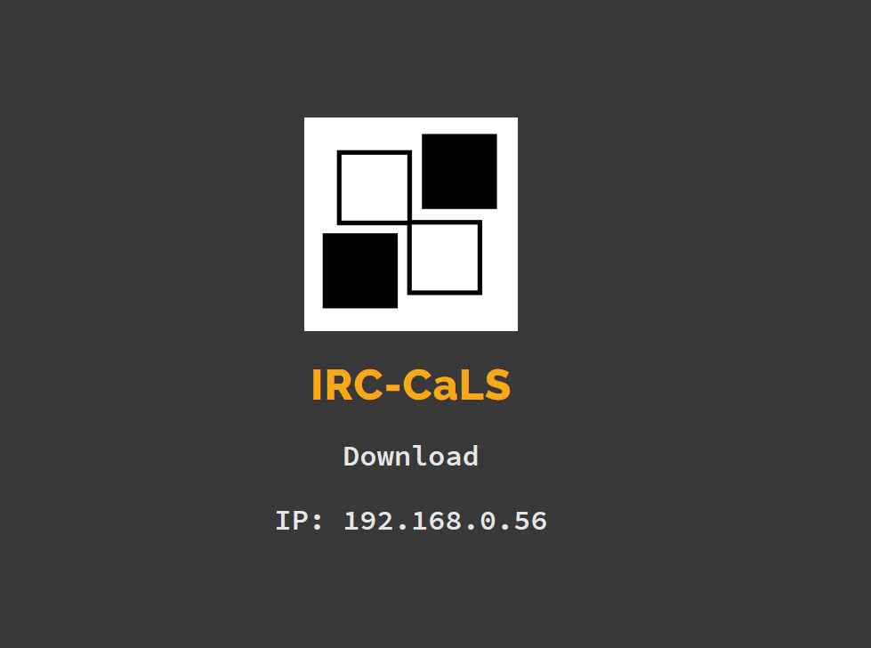

I wrote this javascript to change the ip shown on the website so it when the ip could possibly change, such as the ip not being static I will not have to change the html every time to reflect this.

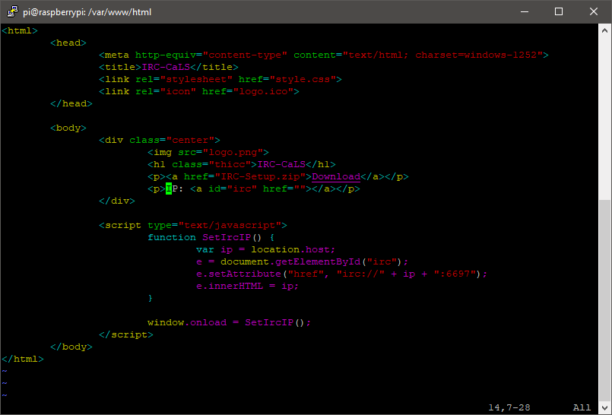

I moved my rpi to another house and the ip changed on the website which was intended.

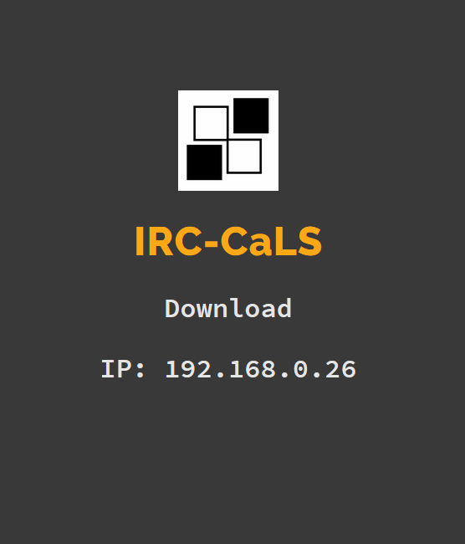

The code is now fully complete, I didn’t code everything which I wanted due to time constraints however the basics of the server is there and it functions as one. In the future I will allow multiple servers and more commands for the user to include, the config will also be uploaded to the server on exit as well which would conclude the program as a whole.

#### Review

What has been done:

This website was created so it is easier for the client to check if the server is up as it checks for port 80 or port 443 connection to see if it is online. It will serve as a hub to download the code and has a IP to connect to the server and the ip is a link to connect to the server over IRC.

# Post Development Testing

### Login window

(Video login.flv)

|  |  |  |  |  |
| --- | --- | --- | --- | --- |
| Test no. | Criteria | Expected outcome | Actual outcome | Time Stamp / Cross Reference |
| 1.1.1 | Check if logging in with registered username and password works | Message box or form opens | Opens form successfully | 0:49 - 1:16 |
| 1.1.2 | Test if sending incorrect username and correct password doesn’t work | Message appears that username or password is wrong | Shows error image correctly, when cursor stops for a longer period and then starts blinking the image was replaced. It is slower however works | 1:55 - 2:20 |
| 1.1.3 | Test if sending incorrect password and correct username doesn’t work | Message appears that username or password is wrong | Shows error image correctly | 1:35 - 1:53 |
| 1.1.4 | Test if no username or password works | Message appears that username or password is wrong | Shows error image correctly, when cursor stops for a longer period and then starts blinking the image was replaced. It is slower however works | 2:26 - 2:36 |
| 1.2.2 | Check if clicking register opens the register form | Register form opens | Opens successfully | 2:42 - 2:47 |
| 1.2.3 | Check if clicking forgot opens the forgot form | Forgot form opens | Opens successfully | 2:48 - 2:50 |
| 1.2.4 | Check if clicking reset opens the reset form | Reset form opens | Opens successfully | 2:52 - 2:54 |
| 1.2.5 | Check if clicking login sends data to the server using a valid | Logs into server and shows textbox or form | Logs in correctly and form shows | 2:56 - 3:09 |

### Register window

(Video register.flv and register-2.flv (register-2.flv is only for test 2.1.4))

|  |  |  |  |  |
| --- | --- | --- | --- | --- |
| Test no. | Criteria | Expected outcome | Actual outcome | Time Stamp / Cross Reference |
| 2.1.1 | Using a valid email, a valid username and a valid password into the boxes. | Creates account and displays success message | Displayed correctly and message shown | 0:06 - 0:44 |
| 2.1.2 | Using a invalid email valid username and valid password | Gives error and no account created | Displayed error no account created | 1:30 - 1:35 |
| 2.1.3 | Using valid email valid username and a password with a range of char | Creates account and displays success message | Gives success message and account created | 2:03 - 2:34 |
| 2.1.4 | Using a used email | Gives error no account created | Error displayed and account not created | The whole of Register-2.flv |
| 2.2.1 | Test if back button works | Goes back to first form | Works successfully | 2:49 - 2:54 |
| 2.2.2 | Test if register button works with valid strings. | Creates account and displays success message | Works successfully | 3:29 - 3:33 |

### Forgot window

(Video forgot.flv)

|  |  |  |  |  |
| --- | --- | --- | --- | --- |
| Test no. | Criteria | Expected outcome | Actual outcome | Time Stamp / Cross Reference |
| 3.1.1 | Enter valid username | Sends an email to the user and gives an success message | Successfully sends email and success shown | 0:04 - 0:41 |
| 3.1.2 | Enter email instead of text | Give error to user | Error received | 0:55 - 1:02 |
| 3.1.3 | Enter username who is not used | Give error to user | Error to user successfully | 1:15 - 1:21 |
| 3.2.1 | Check if back button works | Goes to main menu form | Works correctly | 1:10 - 1:14 |
| 3.2.2 | Check if send button works | Sends and email to the user | Works as intended | 1:29 - 1:58 |

### Reset window

(Video reset.flv)

|  |  |  |  |  |
| --- | --- | --- | --- | --- |
| Test no. | Criteria | Expected outcome | Actual outcome | Time Stamp / Cross Reference |
| 4.1.1 | Input valid into boxes | Changes the password of the account and displays success message | Changes password and displays message successfully. | 0:01 - 0:29 |
| 4.1.2 | Input all valid except from code | Shows error and nothing is changed | Error alert | 0:36 - 0:49 |
| 4.1.3 | Input all valid except from passwords being different | Shows error and nothing is changed | Errors shown, but didn’t realise it was not handled on the form itself. | 0:59 - 2:08 |
| 4.2.1 | Check if back button works | Go back to main menu | Works as intended | 0:29 - 32 |
| 4.2.2 | Check if reset button works | Changes the password of the account and displays success message | I changed the input to be incorrect but the clicking the button still sent the data meaning it is an success. | 1:57 - 2:06 |

### Client window

(Video client.flv)

|  |  |  |  |  |
| --- | --- | --- | --- | --- |
| Test no. | Criteria | Expected outcome | Actual outcome | Time Stamp / Cross Reference |
| 5.1.1 | Click join connects to freenode server | Connects to freenode server | Connects to freenode server | 0:05 - 0:18 |
| 5.1.2 | Click disconnect to freenode server | Disconnects from freenode server | Disconnects from freenode server | 0:25 - 0:38 |
| 5.1.3 | Clicking settings icon opens settings | Opens up settings tab | Opens up settings tab | 1:06 - 1:09 |
| 5.2.1.1 | Message command works | Sends a message to a user | Sends a message to a user | 1:28 - 1:57 |
| 5.2.1.2 | Message command without arguments gives warning | Doesn’t send anyone a message and warning given | Doesn’t show message, needs to be fixed within the future | 2:51 - 2:58 |
| 5.2.2.1 | Join command works | Joins a channel | Joins a channel | 2:26 - 2:37 |
| 5.2.2.2 | Join command without arguments gives warning | Doesn’t Join a channel and warning given | Didn’t work | 3:08 - 3:12 |
| 5.2.3.1 | Leave command works | Leaves a channel | Leaves the channel | 3:40 - 3:49 |
| 5.2.3.2 | Leave command without arguments gives warning | Doesn’t leave a channel and warning given | Didn’t work | 4:05 - 4:11 |
| 5.2.4.1 | Add command works | Adds user to list box | Adds user to list box | 4:23 - 4:30 |
| 5.2.4.2 | Add command without arguments gives warning | Doesn’t add a user to the box and returns warning | Doesn’t add a user to the box and returns warning | 4:30 - 4:33 |
| 5.2.5 | Message without any commands | Sends message to the channel or user they are currently on through tabs | Sends message to the channel or user they are currently on through tabs | 4:54 - 5:05 |
| 5.3.1 | Displays text from server | Displays text send from server into a text box | Displays text send from server into a text box | 0:07 - 0:17 |
| 5.3.2 | Displays usernames and errors in different colours | Shows username in colour and shows error in colour | Shows username in colour and shows error in colour | 5:13 - 5:18 and 8:05 - 8:08 |
| 5.4 | Change colours of form on load | Colours of form are different to default | Colours of form are different to default | 5:59 - 6:48 |
| 5.5 | Switching tabs works | Tabs change as well as text and names | Tabs change as well as text and names | 5:37 - 5:45 |
| 5.4.1 | Server list box holds items successfully | Shows “Freenode” in the server box | Shows “Freenode” in the server box | 7:32 - 7:35 and 9:00 - 9:05 |
| 5.4.2.1 | Users box store items | Users from channel stored in user list box | Users from channel stored in user list box | 8:51 - 8:57 |
| 5.4.2.2 | Switching tabs changes or removes items | When switching tabs text changes | When switching tabs text changes | 9:15 - 9:22 |
| 5.4.3 | Friends box added items successfully | When loading the form the colours change to the specific theme set in a file | When loading the form the colours change to the specific theme set in a file | 9:34 - 9:48 |

### Settings window

(Video settings.flv)

|  |  |  |  |  |
| --- | --- | --- | --- | --- |
| Test no. | Criteria | Expected outcome | Actual outcome | Time Stamp / Cross Reference |
| 6.1.1 | Input correct data types | It saves successfully into a file and changes the colour of the form. | It saves successfully into a file and changes the colour of the form. | 0:06 - 0:44 |
| 6.1.2 | Input text instead of numbers | Doesn’t save and shows error popup | Doesn’t save and shows error popup | 0:53 - 1:06 |
| 6.2 | Check if button works | Saves the data into a file and changes form colour. | Saves the data into a file and changes form colour. | 0:45 - 0:50 |
| 6.3.1 | Check if saves to a settings file | Settings stored in the file | Settings stored in the file | 2:18 - 1:26 |
| 6.3.2 | Check if settings load into form | Form changed colour | Form changed colour | 0:38 - 0:43 |

#### 

### Login server

(Video server-1.flv, server-receive.flv and server-2.flv)

|  |  |  |  |  |
| --- | --- | --- | --- | --- |
| Test no. | Criteria | Expected outcome | Actual outcome | Time Stamp / Cross Reference |
| 7.1 | Test if computer can connect, receive data | To receive the message and print if it was successful | To receive the message and print if it was successful | server-1.flv  0:02 - 0:14 |
| 7.2 | Send data | I will connect to the socket from terminal, and see when I connect it sends data. | I will connect to the socket from terminal, and see when I connect it sends data. | server-1.flv  0:15 - 0:23 |
| 7.3 | Test if database has correct tables in it | Create the database successfully with the tables inside | Create the database successfully with the tables inside | server-1.flv  0:23 - 0:28 |
| 7.4.1 | Register account, and add the username, email and password to the users table | The username, email and password added to the database | The username, email and password added to the database | server-1.flv  1:05 - 1:47 |
| 7.4.2 | Check if email is valid | Denies the account creation | Denies the account creation | server-1.flv  2:05 - 2:17 |
| 7.4.3 | Make a password longer than 72. | Adds account to the database successfully | Adds account to the database successfully | server-1.flv  2:22 - 3:37  (x2 speed on the video as typing is slow and I made errors) |
| 7.5.1 | Receive a file | Gets the text from a file, and sends it to the client successfully | Gets the text from a file, and sends it to the client successfully | server-1.flv  6:33 - 6:55  (The next 6 minutes I was messing up commands and away from my computer) |
| 7.5.2 | Send a file | A file from the client has been downloaded onto the server | A file from the client has been downloaded onto the server | The whole of server-receive.flv |
| 7.6.1 | Send email to users email | Look at emails to see if the code was sent | Look at emails to see if the code was sent | Server-2.flv  0:32 - 1:22 |
| 7.6.2 | Deny non-existent user | Don’t generate and send email | Don’t generate and send email | Server-2.flv  1:50 - 1:53 |
| 7.7.1 | Successfully login user | Server sends “ALLOW” to the user | Server sends “ALLOW” to the user | Server-2.flv  1:58 - 2:06 |
| 7.7.2 | Deny user if password or username is wrong | Send “DENY” to the user | Send “DENY” to the user | Server-2.flv  2:18 - 2:52 |
| 7.8.1 | Change password for the user | The hash has changed in the database | The hash has changed in the database | Server-2.flv  3:00 - 3:15 |
| 7.8.2 | Deny invalid reset code | Don’t change password | Don’t change password | Server-2.flv  3:23 - 3:42 |
| 7.9 | Accept multiple connections at once | Multiple clients communicating to one server | Multiple clients communicating to one server | Server-2.flv  4:06 - 4:16 |

## Points to improve on from testing:

Within the client testing test plan I came across three errors which I thought were handled, these were when the user inputs commands and don’t put anything after the text. In the future I will fix this with the addition of new commands.

# Evaluation

## Success Criteria

|  |  |  |  |
| --- | --- | --- | --- |
| Number | Criteria | Met? | Time stamp |
| 1.1 | Login screen appears when opening program | Yes | 0:42 - 0:52 |
| 1.2 | Buttons open up the respective form associated with it, e.g. forgot button opens up forgot form | Yes | 0:53 - 1:03 |
| 2.1.1 | If the username is already used don’t create a new account | Yes | 1:55 - 2:04 |
| 2.1.2.1 | The login server adds new users to the database when registering | Yes | 1:29 - 1:54 + 2:12 - 2:23 |
| 2.1.2.3 | The server stores the passwords as hashes on the server | Yes | 2:43 - 2:47 |
| 2.2.1 | If username or password is missing, an alert is sent to the screen | Yes | 2:58 - 3:05 |
| 2.2.2 | If the client enters correct username and password, as they are in the login server database, it allows them to pass the login | Yes | 3:13 - 3:23 |
| 2.2.3 | If the client enters the wrong username and password, they are not able to use the login server | Yes | 4:36 - 4:51 |
| 2.3.1 | When the client requests a recovery using forgot, the client receives a recovery email when requested | Yes | 5:09 - 6:11 |
| 2.3.2 | When using a username not used it shows an error | Yes | 6:23 - 6:27 |
| 2.4.1 | The login server adds the recovery code to the database with username | Yes | 6:51 - 7:06 |
| 2.4.2 | Resets the password when given correct code with username and other inputs filled correctly | Yes | 8:00 - 8:14 |
| 2.4.3 | Doesn’t reset the password when given incorrect code and credentials | Yes | 8:24 - 8:32 |
| 2.5 | Don’t allow users to enter invalid emails when registering | Yes | 9:00 - 9:12 |
| 3.1 | Have the client successfully send a message to the IRC server | Yes | 11:15 - 11:00 |
| 3.2 | Successfully receive a message from the IRC server | Yes | 10:49 - 11:28 |
| 3.3.1 | Able to change the RGB colour of the backgrounds | Yes | 11:48 - 12:25 |
| 3.3.2 | Able to change the font colour | Yes | 11:48 - 12:25 |
| 3.4.1 | Display the usernames of people in the channel, and display in a seperate box | Yes | 13:36 - 13:41 |
| 3.4.2 | Display channels and servers in different boxes | Yes | 13:42 - 13:54 |
| 3.4.3 | Able to favourite people, and adds it to another box | Yes | 13:55 - 13:58 |
| 3.5.1 | Communicate over SSL/TLS | Yes | 13:59 - 14:20 |
| 3.5.2 | Connects to the IRC server | Yes | 14:21 - 14:36 |
| 3.6 | Log the contents of what people are saying to a file | Yes | 15:10 - 15:40 |
| 3.7.1 | Display messages successfully | Yes | 17:00 - 17:05 |
| 3.7.2 | Send messages to users directly | Yes | 16:20 - 16:37 |
| 3.7.3 | Send messages to channels | Yes | 16:55 - 16:59 |
| 3.7.4 | Can join channels | Yes | 16:45 - 16:55 |
| 3.8.1 | When switching tabs display the messages sent from that user onto the message box | Yes | 17:35 - 17:47 |
| 3.8.2 | When switching to and from channel tabs remove the users from the user box | Yes | 17:48 - 18:00 |

Justifications are in the first time I showed the success criteria.

### Success Criteria Testing

I have recorded another video for the success criteria called success.flv, this will be used as a cross reference to create an accurate representation in my evidence column.

|  |  |  |
| --- | --- | --- |
| Number | Evidence | Time Stamp / Cross Reference |
| 1.1 | When I tested this, the program loaded correctly which was good however the program seems to take a long time to load which could be frustrating for the user making them possibly choose another option to their solution however it does start up faster compared to discord and slack but typical IRC clients load faster. | 0:42 - 0:52 |
| 1.2 | This works correctly but in the future I should make the location of the menus show in the same location as the form previous. | 0:53 - 1:03 |
| 2.1.1 | Works well but the text above showing the warning does not change fast enough. | 1:55 - 2:04 |
| 2.1.2.1 | The login server adds new users to the database when registering but once again the created message should be faster showing it. | 1:29 - 1:54 + 2:12 - 2:23 |
| 2.1.2.3 | The server stores the passwords as hashes on the server and is stored correctly, there is not much to criticize with this as it stores it well. | 2:43 - 2:47 |
| 2.2.1 | If a username or password is missing, an alert is sent to the screen, but is slow to show making it seem poorly constructed. | 2:58 - 3:05 |
| 2.2.2 | If the client enters correct username and password, as they are in the login server database, it allows them to pass the login, this responds faster than the other actions performed however the new form itself occasionally | 3:13 - 3:23 |
| 2.2.3 | If the client enters the wrong username and password, they are not able to use the login server, this works as intended. | 4:36 - 4:51 |
| 2.3.1 | When the client requests a recovery using forgot, the client receives a recovery email when requested | 5:09 - 6:11 |
| 2.3.2 | When using a username for the forgot form which is not used it shows an error, the error takes longer than i want to display to the user. | 6:23 - 6:27 |
| 2.4.1 | The login server adds the recovery code to the database with username successfully. | 6:51 - 7:06 |
| 2.4.2 | Resets the password when given correct code with username and other inputs filled correctly | 8:00 - 8:14 |
| 2.4.3 | Works correctly and doesn’t reset the code meaning it works well but text doesn’t adjust fast enough which could be improved on. | 8:24 - 8:32 |
| 2.5 | The server didn’t allow users to enter invalid emails when registering successfully but client showed error slowly again. | 9:00 - 9:12 |
| 3.1 | The client successfully send a message to the IRC server, however when switching tabs the colours are not saved which is an issue when switching back and forth form tabs. | 11:15 - 11:00 |
| 3.2 | Successfully receive a message from the IRC server, has the same issue as the point before. | 10:49 - 11:28 |
| 3.3.1 | Able to change the RGB colour of the backgrounds, works well and saves correctly however there could be more options in the settings form such as nickname and other options which can be added in the future. | 11:48 - 12:25 |
| 3.3.2 | The setting tab enables the user to change the font size however a good future option which should be added is to upload a font. | 11:48 - 12:25 |
| 3.4.1 | Usernames are successfully stored in another box, a way to develop this is to add different colours to the usernames, and display that colour when a user is speaking. | 13:36 - 13:41 |
| 3.4.2 | The servers and channels are displayed separately, instead of the channels being in a box they are now displayed in tabs making it easier to switch and making it easier to program. | 13:42 - 13:54 |
| 3.4.3 | The /add command successfully adds the user to the favourite / friend box. I could add it so when double clicking it makes a tab which the user can message them through. | 13:55 - 13:58 |
| 3.5.1 | I successfully communicate over SSL/TLS from my client, and proven from the HexChat client on the right. I should add a option where the user could choose if the port is ssl if it isn’t the default port for it. | 13:59 - 14:20 |
| 3.5.2 | Connects to the IRC server successfully, in the future it should connect to multiple servers as it will be useful for the users. | 14:21 - 14:36 |
| 3.6 | Logs the contents of what people are saying to a file, however it doesn’t store colours so when it is loaded in the client the colours do not show and switching tabs remove them. | 15:10 - 15:40 |
| 3.7.1 | Messages are displayed correctly. | 17:00 - 17:05 |
| 3.7.2 | The user can message the user directly, in the future I will make it more easier to us by the user clicking on their name and them being able to message them. | 16:20 - 16:37 |
| 3.7.3 | The client can send messages to channels successfully. | 16:55 - 16:59 |
| 3.7.4 | The client can join channels. | 16:45 - 16:55 |
| 3.8.1 | When switching tabs display the messages sent from that user onto the message box, however the colour is not saved when switching as you can see in the footage. | 17:35 - 17:47 |
| 3.8.2 | Switching to and from channel tabs remove the users from the user box, the user box in the future needs to update when a user leaves the channel. | 17:48 - 18:00 |

## Limitations

The biggest limitation is that I have not created a way a user can join a new server which is a predominant feature of an IRC client. Because of the time and that it would change the whole structure of the program to then add and remove tabs and then keep listening to two connections or more.

Another is that currently I have not implemented the send and receiving of the files, as it seems that it might of taken longer to implement in the program as well as there now being logs which need to be saved too. Overall more complex than I thought from more files than just one config file.

Next is the commands on the irc client. As there are so many commands, it would take many more weeks to create each function for the command the user sends and the new data the client receives. This makes the client not fully compatible with the protocol currently however in the future it will have these functions but will take a long time to develop.

Colours of the text are not saving as I am not saving the data of the colours and I am not sure how to store the text without adding more data to be used for the server.

The program is still only available for windows as the program is being compiled for my operating system and I would have to use another compiler or library for the program to work on linux and mac. However it will not be available for any mobile device as it is a large stretch from desktop software.

Lastly the server operates over plaintext still so it isn’t secure as connecting to the IRC server yet which will be done afterwards.

## Usability

Advanced users:

Hannah is an advanced user, she first looked at the README.md file which gives instructions for the commands and how to setup the server. When downloading the file this text will be in the file:

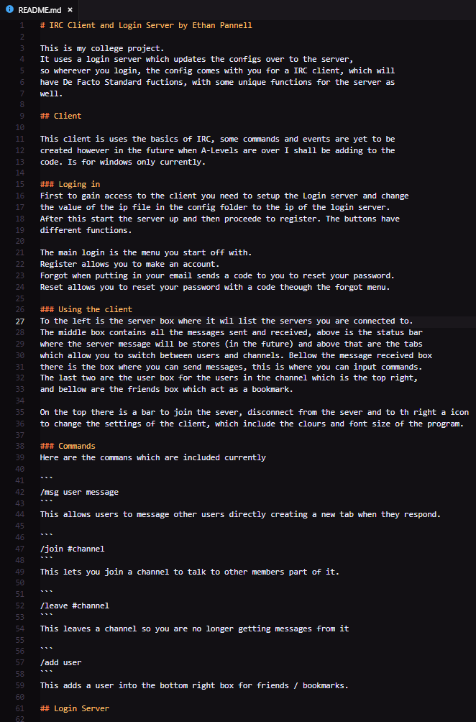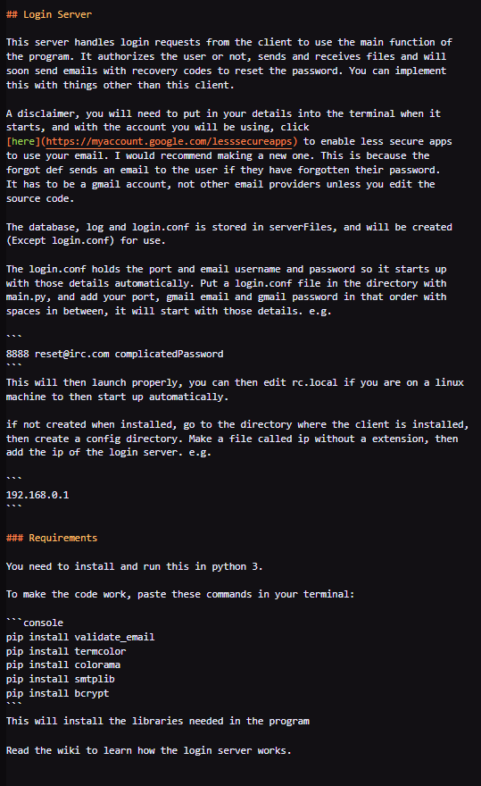

From there she set up all of the files and changed the ip file correctly, started a webserver on port 80 and the server started properly. She then opened the client program, registered and logged in. She looked at the commands and used them well. She also set up the form colours too to her preference scheme.

She found the buttons easy to use and was intuitive so she didn’t have to learn how to use the software except from the commands.

The text boxes in the menu were good, as well as the buttons however they were slow if incorrectly inputting text.

The client was good overall and the colours were good however the settings button was small and wasn’t registering every so often when clicking because of its size. They found it frustrating when

Intermediate users:

Kendrick falls under this bracket, he read the file, and setup the server but didn’t change the ip and didn’t set up the web server so the client can check that it is online. However he did understand the commands, he only needed some help so I will add to the file to clearly explain it more in the future. He left the colours and font size the same

This user found the buttons and text easy to use however found the settings button and the settings themselves difficult as they were more familiar with hex codes instead.

Beginner users:

George is a beginner user and he opened up the readme file but didn’t know how to set up the files or server correctly which is an issue as he will have to learn more about how to deploy the server and try and get help, and as it will be open source this could be difficult to get one to one help unless a forum is made.

After helping setup the server, he found the buttons and inputs easy to use but then had to remember the commands which they eventually got used to however in the future the client could have a help button or something else to list the

In conclusion, without the readme file it would be difficult for the user to set up correctly as you have to edit some files for it to work correctly and they have to know how to set up a webserver on port 80.

Usability features check:

I wrote the features I will include in the design section, this section is to check if I met those features in the program.

* Text boxes are large enough to be able to see the majority of the message, and scrolls across when it has reached the max width : Met
  + I have met this, as Kendrick, George and Hannah could easily read what they inputted and could read it as the font was large in the menus. The text does scroll across so the user can see what they are inputting. In the client form,
* Text is large enough to read : Met
  + The text in the menu is set a large font however the users cannot change it, but in the client form the user can change the font size correctly. They all thought that the IRC client was good and that they liked the menus however they would of liked to change the font size there too.
* Buttons and boxes are large enough to interact with : Met
  + The buttons are large in the menus making it easy to navigate and know what to press, however in the IRC client the top row there are several buttons however they are quite small making it harder to click and use. The users thought the menu buttons were good but they had some issues with the buttons on the client which made it harder to connect, disconnect and open the settings. The settings were the hardest to click.
* Links open in default browser : Not Met
  + Originally this was a feature built into the textbox type I was using however the colours of the links were not changing making it unappealing to the eye and doesn’t help the readability of the text. Because I am using WinForms it doesn’t allow me to change this so I would have to reprogram it using a different ui type.
* Should be fast and efficient on main memory : Partially Met
  + The program is efficient on memory as I force a gc collect, which removes unnecessary data from the RAM reducing the memory usage however the menu when inputting data incorrectly the menu takes longer to change the text on the form freezing the program.
* Users should be able to change fonts and colours in settings : Partially Met
  + Colours are easily changed within the settings menu and the font size however the fonts cannot be changed as I have not implemented this yet.

## Maintenance / In the Future

The stakeholders would first want to have the application fully fleshed out with all the commands, and then create the irc server to go along with the program so the institution has full control over the server and can do what they need to do with it.

They will also want better logging which will help find attackers as well as the login server using ssl. The IRC server would also need this too. Possibly the server blocks an IP if they inputted their password incorrectly five times for a certain amount of time. Security is needed as they will be transporting data which is needed to be kept private.

The IRC client could use more commands and have a better GUI as well as be using a better logging system to keep the colours within the text when loading them next time. And it could also be written in another language which is cross platform such as Java as it will be programmed once and will work on all machines however it would take up more RAM which is what we want to keep to a minimum of.

They need the server to be easy to set up as well as the client, so I would have to create install executables for both to install and start them correctly and give the users or admin instructions on how to use the pieces of the software as it could cause them more time and more issues which they could then switch to different software to use.

Lastly there could be the use of sending the files back to the login server so the configurations are stored and loaded when a user logs in, and also the logs could be stored on the server too meaning that if the stakeholders are suspicious of their employees they can check their logs and find out what they have been discussing.

## Code

I have attached a folder which has all the code within it as there is too much code to screenshot adding more necessary pages.